FC II

Group:

1. Harveen Oberoi
2. Daniel Rojas Coy
3. Lucas Duarte Bahia
4. Jordan Giebas

*Homework 2*

Problem 1

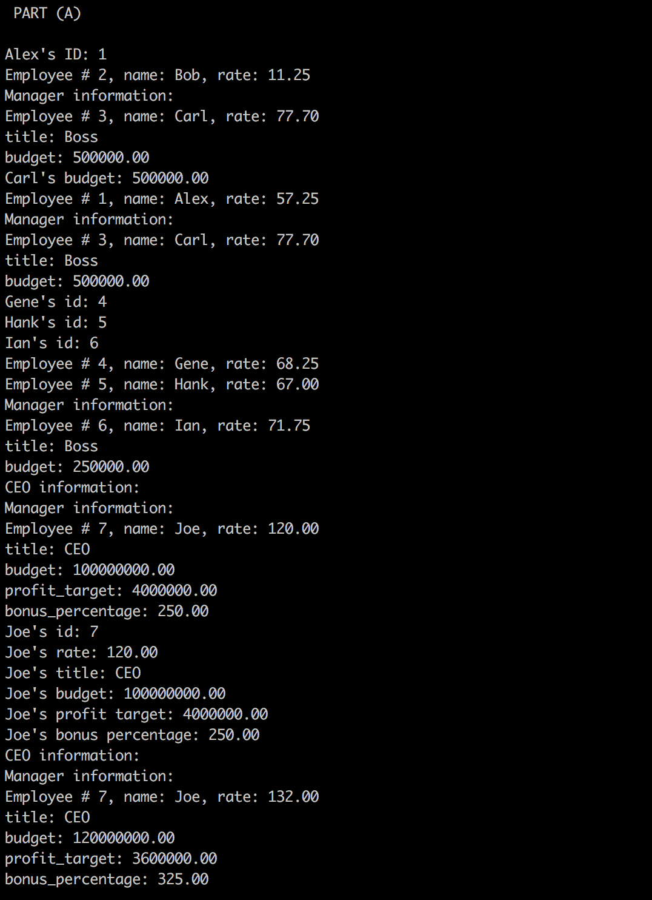

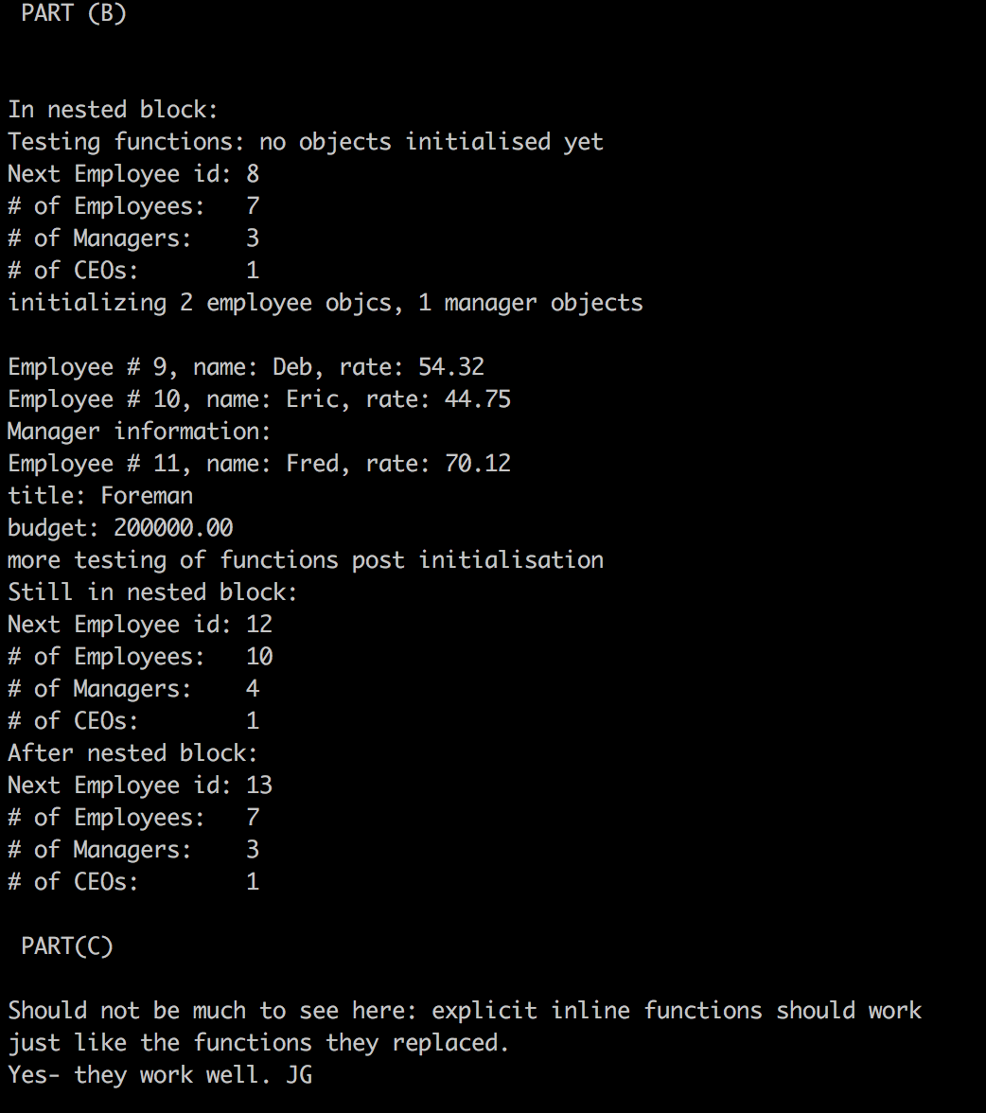

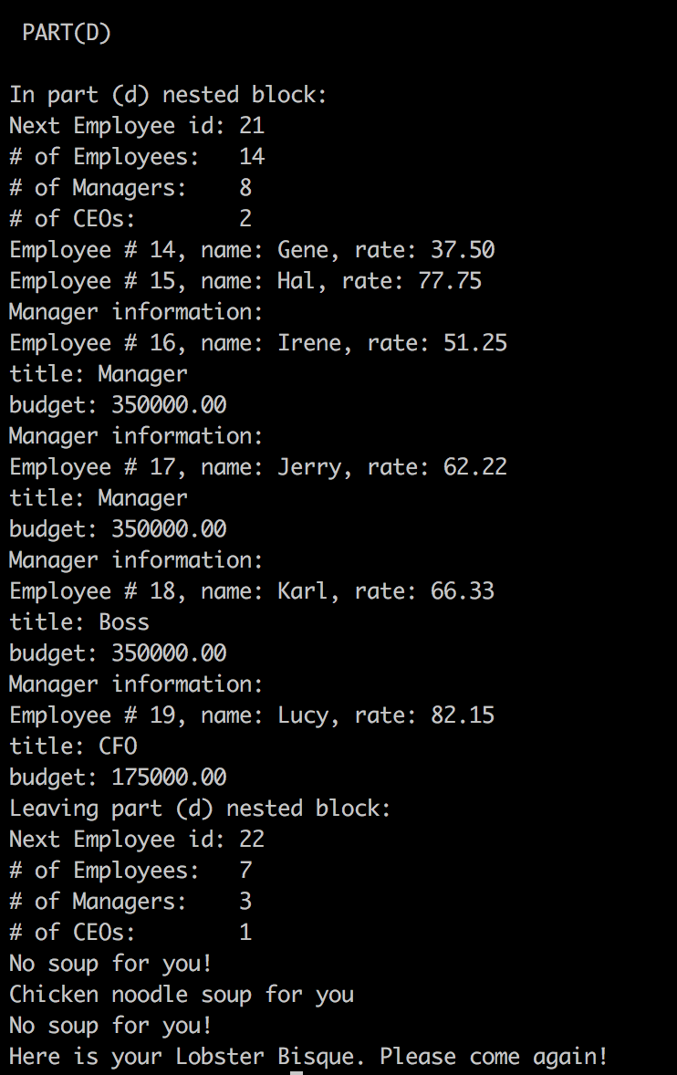

Problem 2

Done in the soure file.

Problem 3

