Jordan Giebas

CSE 331

HW Set 3

­­­­­

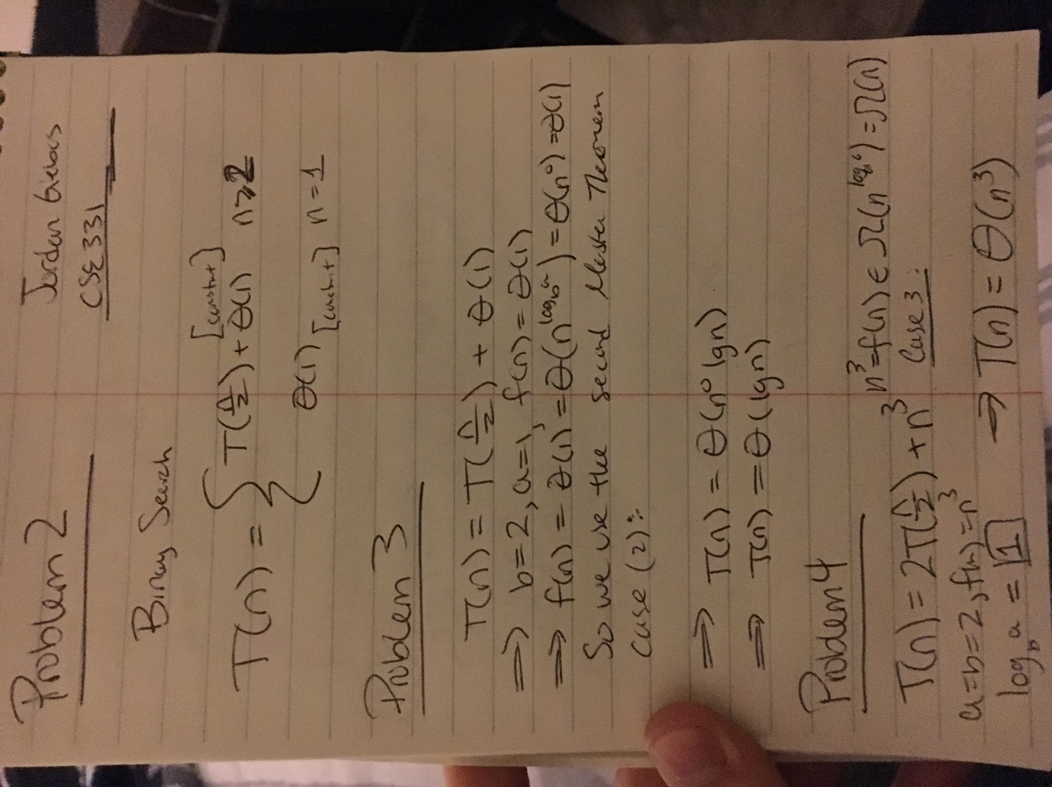

Binary Search:

Best Case Performance: O ( 1 )

Worst Case Performance: O ( n )

[Avg: O( lg (n) )]