Information Security for Southern Cross NZ: Threats, Impacts, and Mitigation Strategies
1. Introduction
In today’s age, Information Security (InfoSec) plays a vital role in the success of organizations, including insurance organizations. InfoSec can be defined as the protection of information, a valuable asset, from possible harm resulting from various threats and vulnerabilities throughout its entire lifecycle, including creation, processing, storage, transmission, and disposal (Ključnikov et al., 2019). It is a critical component of general security across national, sectoral, corporate, and personal levels (Lehenchuk et al., 2022).
In the insurance sector, Information Security (InfoSec) is a complex, double-sided issue: insurance companies must maintain robust internal security to protect the vast amounts of sensitive data they hold, while simultaneously acting as de facto regulators that influence the information security standards of the organizations they insure. Insurance companies are prime targets for cyberattacks because they often retain even more personal and sensitive data than banks, including health records, financial details, and behavior patterns (Sullivan & Nurse, 2021).
Southern Cross, the leader in providing health insurance to New Zealanders. Southern Cross has different cashflow or services such as pet insurance, travel insurance, health insurance, and life (Southern Cross Healthcare). Successful attacks on insurers can cause extensive social impacts, potentially affecting pension funds and health coverage, while leading to massive financial losses and reputational damage (Celestin & Vanitha, 2022).
This report will critically analyze the information security (InfoSec) for Southern Cross. Part two will discuss in detail the three threats/risks for Southern Cross in regard to InfoSec. Part three will discuss the mitigation and prevention strategies for the said risks and threats. And Part four will close with Summary and Conclusion.
2. Security Requirements
2.1 MFA and SETA for Ransomware Mitigation
Over the past several years, ransomware has shifted from opportunistic attacks to a highly specialized and professionalized criminal enterprise. A significant part of this growth is the "Ransomware as a Service" (RaaS) business model, where developers lease their malware to "affiliates" who execute the attacks in exchange for a share of the profits (Mott et al., 2023). Common methods for initial infection include phishing emails, exploiting vulnerabilities in internet-facing infrastructure, and compromised remote access services like Remote Desktop Protocol (MacColl et al., 2023). For Southern Cross, this is crucial as they could attack every single employee, and it just needs one to be penetrated.
In May 2021, AXA, one of the largest global insurers (AXA), was attacked by ransomware in their operations branches in Thailand, Malaysia, and Philippines (Mott et al., 2023). The attack was carried out by the Avaddon ransomware group. The group employed a "double extortion" scheme, which involved not only encrypting AXA’s files to disrupt operations but also exfiltrating sensitive data beforehand. The hackers successfully stole critical customer documents, which included highly sensitive medical records. To increase pressure on AXA to pay the ransom, the attackers uploaded samples of the stolen data to the public domain (Enjam, 2020).
Ransomware is a sophisticated form of malware that encrypts critical data and demands a ransom for the decryption key, often threatening to destroy or publicly release the information if demands are not met (Alharbi, 2020). To combat this growing threat, Southern Cross must adopt a holistic defense strategy involving technical, organizational, and procedural safeguards.
Implementing Multifactor Authentication (MFA) is highly effective at blocking unauthorized access, as stolen credentials alone are insufficient for network entry (Rodrigues et al., 2024). However, MFA can negatively affect system usability and introduces costs for hardware-based authenticators (Saleem & Naveed, 2020). Security Education, Training, and Awareness (SETA) overcomes the "human firewall" problem by teaching staff and employees to recognize phishing, the primary delivery system for ransomware (Bhadouria, 2022). However, humans remain the weakest link; 52% of breaches are still attributed to human error regardless of training (Rodrigues et al., 2024).

2.2 Encryption for Data Breaches and Unauthorized Access
The insurance industry is a high-value target due to the sensitive health and financial data it maintains (Celestin & Vanitha, 2022). This makes Southern Cross a high-value target of data breaches and unauthorized access.
Data breach can be defined as the unauthorized or unintentional disclosure of sensitive and confidential information by an organization (P. Wang et al., 2019). This typically results in the loss or exposure of Personally Identifiable Information (PII), such as Social Security numbers (SSN), credit card information, dates of birth, and medical records. Data breaches can be intentional, such as those caused by hacking or theft, or accidental, resulting from human error or system glitches (Alharbi, 2020).
On the other hand, unauthorized access is a form of security violation where individuals gain entry to a computing system, device, or network without permission (Raghupathi et al., 2023). It is frequently categorized as an internal threat when it involves an insider, such as an employee or contractor, who misuses their privileges to view or disclose data (Seh et al., 2020). It can also occur externally if an attacker steals authentication credentials to bypass security and access sensitive files (Nemec Zlatolas et al., 2024).
The Anthem Inc. data breach disclosed in February 2015 is recognized as the largest healthcare data breach in history, exposing the records of approximately 78.8 million individuals (Shankar & Mohammed, 2020). Investigation pointed to a state-sponsored Chinese cyber espionage group known as "Deep Panda" (also referred to as "Black Vine") (Saleem & Naveed, 2020). The attack began with spear-phishing emails targeting employees of Anthem’s subsidiary, Amerigroup. The attackers registered a deceptive domain, we11point.com (mimicking Anthem’s former name, Wellpoint Inc.), to host a phishing site that tricked users into downloading malware.
Two primary malware families were identified: Sakula, a remote access trojan that masqueraded as legitimate VPN software to gain entry, and Mivast, which was used for credential dumping and running remote commands (Saleem & Naveed, 2020). The data was stored in an unencrypted data warehouse. While no credit card numbers or actual medical records were believed to have been stolen, the Personally Identifiable Information (PII) taken was highly sensitive, including Social Security Numbers, Medical IDs, Birthdate and home addresses, Detailed employment & income data, etc. (Shankar & Mohammed, 2020). Anthem agreed to a $115 million settlement to resolve civil class lawsuits, which at the time was a record for a data breach. Additionally, the company paid $16 million to the Office for Civil Rights (OCR) for potential HIPAA violations (Hossain & Hong, 2020).
Southern Cross must adopt a multidimensional defense strategy to safeguard sensitive information, as security is not solely a technical problem but involves technical, organizational, and policy-driven practice (Tao et al., 2019). Encryption of data at rest and in transit ensures that even if data is exfiltrated, it remains unreadable without the decryption key (Alharbi, 2020). Encryption protects confidentiality even if data is stolen. However, it does not protect privacy from the server itself, it is irrelevant if administrative credentials with high privileges are stolen (Sharma et al., 2020). Intrusion Detection and Prevention Systems are good as these monitors endpoints and network traffic for policy violations or suspicious activity, raising alerts or blocking malicious attempts (Saleem & Naveed, 2020).These detects and blocks intrusions in real-time. However, high false-alarm rates can lead security teams to ignore critical warnings (Saleem & Naveed, 2020).
2.3 Machine Learning, Network Segmentation & Principle of Least Privilege for Mitigation of Phishing and Social Engineering Attack
The insurance industry is a high-value target for phishing and social engineering because it manages vast repositories of Personally Identifiable Information (PII), medical records, and financial data (Enjam, 2020). For Southern Cross, they should be wary of phishing and social engineering since most of their data are composed of PII.
Social engineering is a non-technical attack strategy that relies on the psychological manipulation and deception of individuals to gain unauthorized access to systems, sensitive information, or confidential data (Waelchli & Walter, 2025). Often described as "human hacking," it exploits inherent human vulnerabilities such as trust, curiosity, fear, and the tendency to obey authority rather than targeting technical software deficiencies (Naz et al., 2024). These attacks typically follow a four-step cycle: information gathering, relationship building (gaining trust), exploitation, and execution (Yu et al., 2024).
Phishing is the most prevalent form of social engineering. It involves sending fraudulent communications, typically emails, text messages, or phone calls, that impersonate a trustworthy entity to trick recipients into revealing credentials, financial details, or downloading malware (Olaniyan, 2024). Common variations include Spear Phishing, Whaling, Vishing & Smishing, Business Email Compromise (Akeiber, 2025; Kheruddin et al., 2024; Momoh et al., 2023).
Between 2013 and 2015, a Lithuanian hacker orchestrated a highly sophisticated scheme that exploited the Facebook and Google reliance on vendor relationships (Akeiber, 2025). The hacker impersonated an executive from a legitimate, real-world vendor to build a sense of trust and credibility with employees. The scheme relied on convincing employees to authorize payments for non-existent services (Akeiber, 2025). Through these deceptive communications, the attacker successfully tricked the companies into transferring more than $100 million (Akeiber, 2025).
Phishing is a prevalent initial attack vector used to trick employees into disclosing sensitive information, such as login credentials (Wheatley et al., 2021). Southern Cross can employ several strategies to combat this threat. First is the Machine Learning (ML) & Automated Detection Tools, these tools can detect phishing attempts in real-time by analyzing email content, behavior, and structural characteristics (Rodrigues et al., 2024). Some ML models have achieved a 92% detection rate with an average detection time of 0.15 seconds (Pimenta Rodrigues et al., 2024). However, attackers can use obfuscation techniques to hide malicious activities, and high false-alarm rates can lead security teams to ignore critical warnings. Second is the Network Segmentation & Principle of Least Privilege. It splits the infrastructure into isolated zones, which prevents attackers from moving laterally through the network if one employee's credentials are stolen (Enjam, 2020). The principle of least privilege ensures employees only have access to the specific data and systems required for their roles, limiting the scope of a potential breach (Shaikh et al., 2024). However, implementing these controls can be highly complex, especially for large organizations with legacy systems or those that have grown through mergers and acquisitions, leading to inconsistent security laws and integrated weaknesses (Enjam, 2020).
3. Analysis of Current Southern Cross’s Information Security Infrastructure
As leading health insurer in New Zealand, Southern Cross Health Insurance manages an extensive repository of sensitive medical and financial data for over 950,000 members (Arneil, 2025). Southern Cross’s current information security infrastructure is designed as a multi-layered defense-in-depth system, aligning with international standards such as ISO 31000 for risk management and NIST for technical controls.
Southern Cross Health Insurance’s information security infrastructure follows national standards such as Health Information Security Framework (HISF) and audit reports such as ISO 27001 and System and Organisation Controls (SOC). These sets of guidelines and standards helps Southern Cross in handling personal health information in New Zealand.
3. Analysis of Current Southern Cross Information Security Infrastructure
As a leading health insurer in New Zealand, Southern Cross Health Insurance manages an extensive repository of sensitive medical and financial data for over 950,000 members (Southern Cross Medical Care Society Group, 2025). Southern Cross’s current information security infrastructure is designed as a multi-layered defense-in-depth system, aligning with international standards such as ISO 27001 and System of Organization Controls (SOC) 2 (Southern Cross Health Insurance, b).
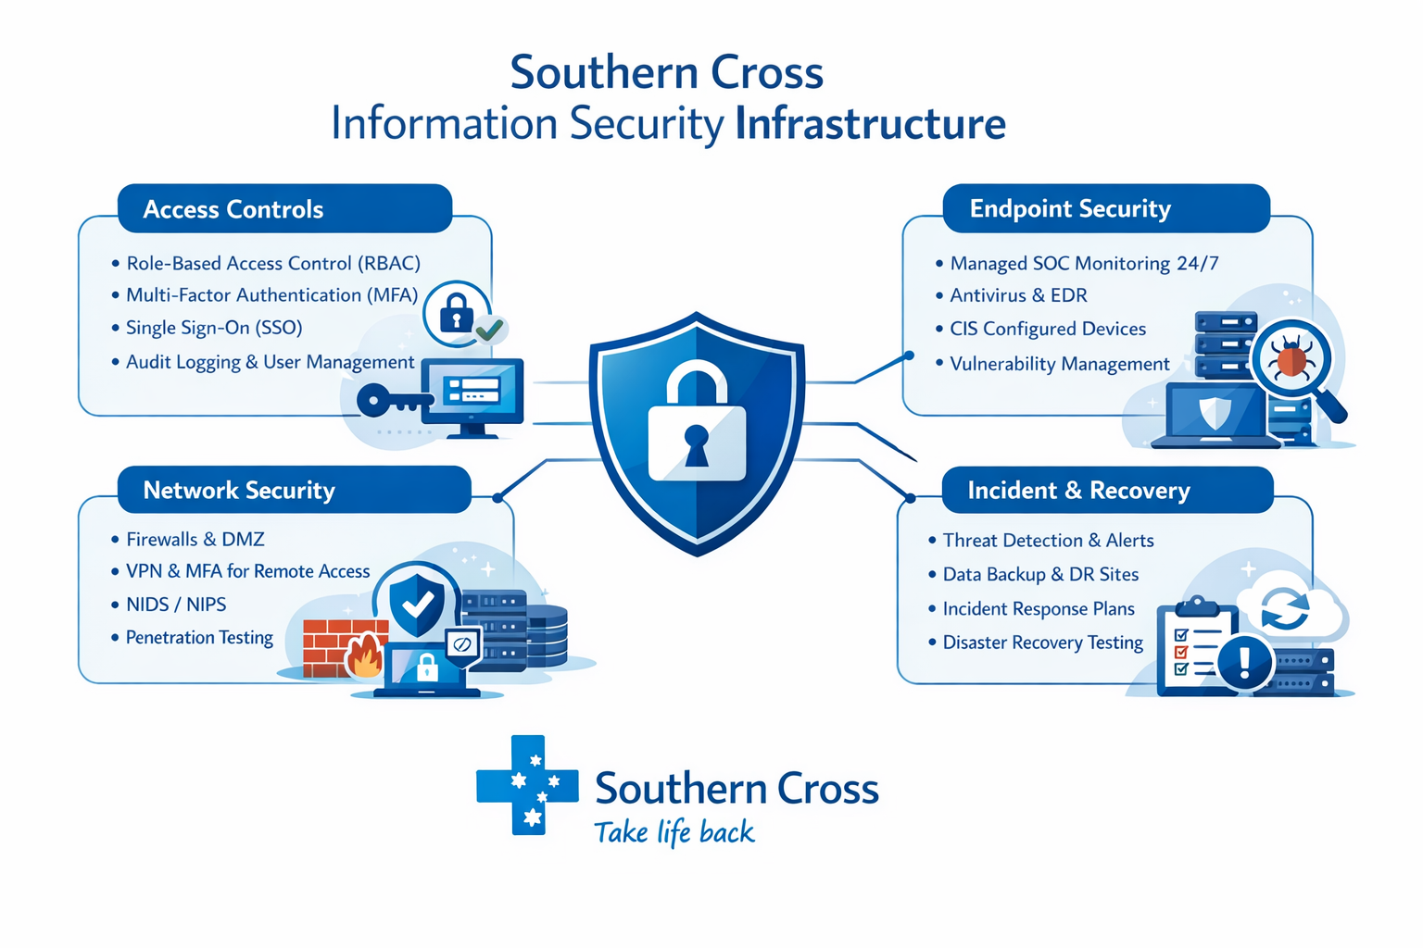
Figure 1 Southern Cross Information Security Infrastructure
The information security infrastructure covers access controls, endpoint security, network security, incident response and disaster recovery, and vulnerability and patch management which will be discussed in detail below.
3.1 Access Control
Southern Cross uses Role-Based Access Controls (RBAC). This ensures that users are authenticated and authorised based on their roles within Southern Cross, limiting access to the minimum information necessary for their functions (Southern Cross Health Insurance, a). By limiting access, RBAC makes large-scale data breaches more difficult. Even if a standard user's credentials are stolen, they cannot be used to access unauthorized areas of the system (Knowen et al., 2023). However, privileged users who have unfettered access to an organization’s network and servers represent the greatest security risk. They are primary targets for sophisticated spear-phishing and whaling attacks that use personalized information to gain their credentials (Camillo, 2017).
All privileged accounts require Multi-Factor Authentication (MFA), and everyone is assigned a unique user ID with Single Sign-On (SSO) for application access. For the password policy, it aligns with National Institute of Standards and Technology (NIST) guidelines, and Azure Active Directory (AD) password protection is implemented to enhance security (Southern Cross Health Insurance, a). Case studies show that MFA, when combined with strong passwords and network segmentation, has been decisive in stopping resourceful state-sponsored threat actors motivated by espionage (National Cyber Security Centre, 2025). However, MFA is susceptible to social engineering, sophisticated hacking groups, such as "Scattered Spider," use social engineering to trick employees into handing over MFA codes by posing as IT or helpdesk workers (National Cyber Security Centre, 2025). By centralizing authentication, SSO helps defend against many security incidents that involve adversaries accessing systems through exposed or stolen credentials. However, If an attacker successfully compromises an SSO account or bypasses the authentication hub, they potentially gain unfettered access to all systems and sensitive data connected to that identity (Kordia, 2025).
3.2 Endpoint Security
Southern Cross has endpoint protection agents are deployed to all devices on the network, their monitoring and alert response is provided by a managed Secure Operation Centre (SOC) service 24/7. The implemented endpoint security uses industry-standard configuration recommendations produced by the Centre for Internet Security (CIS) (Southern Cross Health Insurance, a). CIS benchmark aligns with major security and data privacy frameworks such as the following: National Institute of Standards and Technology (NIST) Cybersecurity Framework, Health Insurance Portability and Accountability Act (HIPAA), and the Payment Card Industry Data Security Standard (PCI DSS) (Amazon Web Services). NIST is a well-regarded set of standards, guidelines, and best practices designed to help Southern Cross manage and reduce their cybersecurity risk (S. S. Wang, 2019). The U.S. Securities and Exchange Commission (SEC) has expressed a preference for NIST as the standard for organizations contributing to critical national infrastructure (Egan et al., 2017). HIPAA bars healthcare providers, insurers, claims processors, and data clearinghouses from transferring sensitive health data without patient permission. HIPAA provides a baseline for what constitutes excellent cybersecurity behavior in the healthcare sector (Adriko & Nurse, 2023).
3.3 Incident Response and Disaster Recovery
All crucial IT systems and applications are equipped with alerts to notify Southern Cross security team of unusual behaviour or known threats (Southern Cross Health Insurance, a). Additionally, Southern Cross collaborate with third-party service providers to monitor our network and systems, collecting and analysing logs to identify suspicious activities for further investigation. Southern Cross also employs anti-malware and intrusion detection software on all workstations and servers (Southern Cross Health Insurance, a). Real-time monitoring and automated alerts enable organizations to identify security threats earlier, allowing them to take action before an actor can move laterally through the network or compromise backups (Egan et al., 2017). However, one of the most significant weaknesses are the waves of false positives generated by detection systems, which can cause security professionals to overlook actual indicators of a breach due to excessive information processing fatigue (S. S. Wang, 2019).
Southern Cross has documented procedures for detecting and responding to unauthorised access or data disclosure. These include defined team roles and responsibilities, incident management tools, and the necessary steps for investigation, communication, resolution, and stakeholder engagement (Southern Cross Health Insurance, a). To safeguard against data loss in the event of a serious incident, Southern Cross implements two key strategies: regularly back up the data securely and host the IT systems and data in data centres across multiple geographic regions. This approach minimises service disruptions caused by natural disasters, security breaches, or deliberate attacks (Southern Cross Health Insurance, a). Using this way, Southern Cross can strategically anchor their cloud infrastructure in specific regions, such as Europe, to take advantage of harmonized regulations like the GDPR, which may offer a more secure and privacy-centric legal environment (Taplin, 2016). However, risks like major outage of the cloud service provider can simultaneously disrupt the operations of millions of users across different geographies and sectors (Granato & Polacek, 2019). Southern Cross also conduct annual testing of our Disaster Recovery and Business Continuity plans for critical business systems, which includes transitioning from production to standby/disaster recovery environments to ensure effectiveness (Southern Cross Health Insurance, a).
3.4 Vulnerability and Patch Management
Southern Cross’s IT systems are subject to rigorous assessment activities, including penetration testing and vulnerability scans of websites, applications, and networks. The information security team continuously proactively monitors our environment for real-time threats and vulnerabilities so we can swiftly respond to any attempts to breach our network and safeguard sensitive information. Vulnerability management programme ensures ongoing assessment and verification of security risks, allowing us to implement immediate fixes for short-term issues while prioritising more significant threats.
4. Improved Information Security Architecture for Southern Cross
The proposed information security architecture for Southern Cross integrates Security Education, Training, & Awareness (SETA), Adaptive MFA, Encryption, Machine Learning, Network Segmentation & Principle of Least Privilege in improving risk mitigation, breach prevention, compliance, and intelligent detection which is shown in the diagram below.
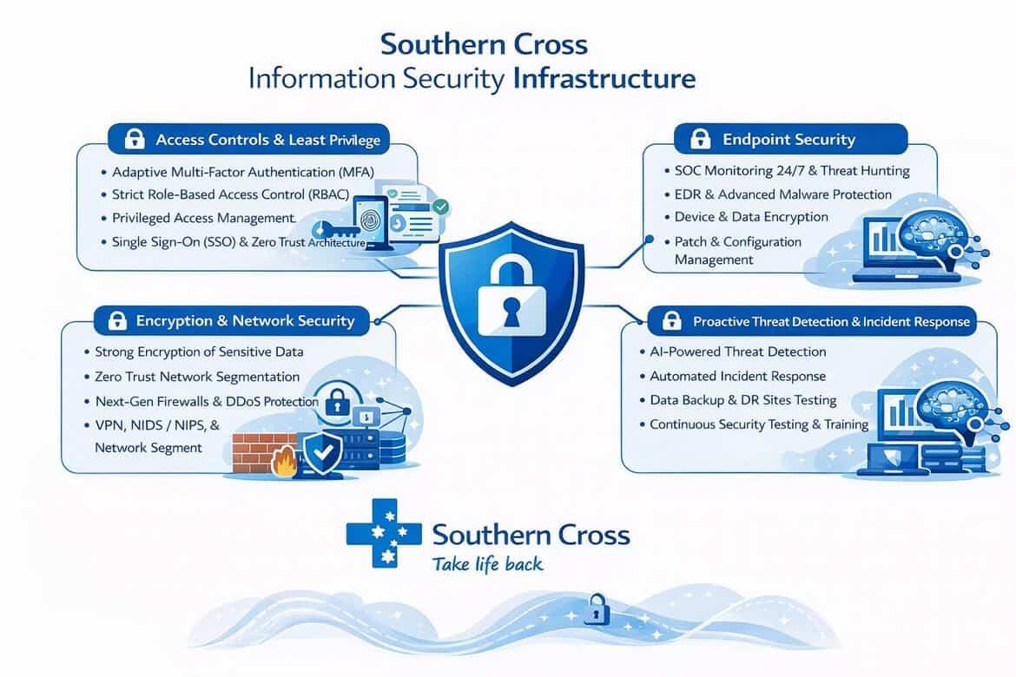
Figure 2 Southern Cross Improved Information Security Architecture
It starts with implementing SETA program to equip employees with information security skills and knowledge specific to their professional roles through practical instructional methods. It involves learning to identify Personally Identifiable Information (PII) and Protected Health Information (PHI). This involves mapping business processes, such as underwriting, insurance marketing, and loss settlement to their relevant cyber risks to identify where the employees or excessive dependence on IT systems is most vulnerable (Das et al., 2018). Then employees learn specific modules to address their specific roles, underwriters should be educated on the security of client data, while human resources should be trained to spot signs that a disgruntled employee may be in collusion with hackers (Taplin, 2016).
Then adaptive Multi-Factor Authentication (MFA) can be implemented by also including other authentication techniques(device fingerprint, etc.). IP address is also tracked to determine if user’s geographic location is within trusted organizational boundary. Time of login is also checked to monitor outside vs standard working hours. Other traits is also monitored to identify unusual behaviours(keystroke dynamics, mouse movement, navigation patterns, or gait) (Nag & Dasgupta, 2014).
Then Network Segmentation and the Principle of Least Privilege can be implemented. Implement network segmentation by splitting the entire computer networks into smaller subnetworks to improve security and performance (Sullivan & Nurse, 2021). By isolating segments, Southern Cross ensure that if one part of the network is compromised, such as an employee's laptop, the threat actor cannot easily move to more sensitive areas, such as the core servers or financial databases (Egan et al., 2017). Then Southern Cross can implement Privilege Control and Management (PCM) techniques and tools to impose strict control over elevated access for users, accounts, and processes. This ensures that even if credentials are stolen, they cannot be used to access unauthorized areas of the system (Knowen et al., 2023).
Then encryption can be implemented by encrypting data while data is at rest(hard disks, servers, laptop, USB, etc), while data is in transit, and while data is in use (Adriko & Nurse, 2023). For credit card transactions, the account information should be encrypted in databases. When it is used during point of sale, the data is tokenized or point-to-point encryption (Egan et al., 2017).
Then Machine Learning (ML) can be implemented by enabling automated supervised learning that tracks user behavior patterns. By learning the normal behavior of employees on a database, the system can detect data anomalies and outliers (Knowen et al., 2023). Once a suspicious user or unusual pattern is detected, such as a sudden interest in a high volume of medical records or logins at unusual hours, the system can automatically suppress user privileges or revoke sessions in real-time. ML algorithms can search for known-bad signs of compromise across network and host indicators, analyzing outcomes to eliminate false positives and identify real threats (Knowen et al., 2023).
5. Conclusion
From the perspective of Southern Cross, the three top risks regarding information security are Ransomware, Data Breaches & Unauthorized Access, and Phishing & Social Engineering Attacks. To address Ransomware, Southern Cross should implement Multi-Factor Authentication (MFA) and security education and training of their employees. To address data breaches and unauthorized access, Southern Cross should implement Encryption and intrusion detection and prevention system. To address Phishing and Social Engineering, Southern Cross should implement Machine Learning (ML) & Automated Detection Tools, and Network Segmentation & Principle of Least Privilege.
5. References
Adriko, R., & Nurse, J. R. C. (2023). Does Cyber Insurance Promote Cyber Security Best Practice? An Analysis Based on Insurance Application Forms. Digital Threats: Research and Practice, (2), 1–26. https://doi.org/10.1145/3579352
Akeiber, H. J. (2025). The evolution of social engineering attacks: A cybersecurity engineering perspective. Al-Rafidain Journal of Engineering Sciences, 294–316.
Alharbi, F. S. (2020). Dealing with data breaches amidst changes in technology. International Journal of Computer Science and Security (IJCSS), 14(3), 108–115.
Amazon Web Services. What are CIS benchmarks? Amazon Web Services. https://aws.amazon.com
Arneil, S. (2025, September 30). Delivering for members more than ever. Southern Cross Health Society. https://www.southerncross.co.nz/news/2025/delivering-for-members-more-than-ever
AXA. About us. AXA. https://www.axa.com/en/about-us
Bhadouria, A. S. (2022). Study of: Impact of malicious attacks and data breach on the growth and performance of the company and few of the world’s biggest data breaches. International Journal of Scientific and Research Publications, 10(10), 1–11.
Camillo, M. (2017). Cyber risk and the changing role of insurance. Journal of Cyber Policy, (1), 53–63. https://doi.org/10.1080/23738871.2017.1296878
Celestin, M., & Vanitha, N. (2022). Is your personal data safe? The cybersecurity crisis in insurance. Indo American Journal of Multidisciplinary Research and Review, 6(2), 192–199.
Das, S., Mitra, B., Atluri, V., Vaidya, J., & Sural, S. (2018). Policy Engineering in RBAC and ABAC. In From Database to Cyber Security (pp. 24–54). Springer International Publishing. https://doi.org/10.1007/978-3-030-04834-1_2
Egan, R., Cartagena, S., Mohamed, R., Gosrani, V., Grewal, J., Acharyya, M., Dee, A., Bajaj, R., Jaeger, V.-J., Katz, D., Meghen, P., Silley, M., Nasser-Probert, S., Pikinska, J., Rubin, R., & Ang, K. (2017, October). Cyber operational risk scenarios for insurance companies. Institute and Faculty of Actuaries’ Cyber Risk Investigation Working Party.
Enjam, G. R. (2020). Ransomware Resilience and Recovery Planning for Insurance Infrastructure. International Journal of AI, BigData, Computational and Management Studies, 1(4), 29–37.
Granato, A., & Polacek, A. (2019). The growth and challenges of cyber insurance. Chicago Fed Letter, (426). https://doi.org/10.21033/cfl-2019-426
Hossain, M. M., & Hong, Y. A. (2020). Trends and characteristics of protected health information breaches in the United States. 2019, 1081.
Kheruddin, M. S., Zuber, M. A. E. M., & Radzai, M. M. M. (2024). Phishing attacks: Unraveling tactics, threats, and defenses in the cybersecurity landscape. Authorea Preprints.
Ključnikov, A., Mura, L., & Sklenár, D. (2019). Information security management in SMEs: Factors of success. Entrepreneurship and Sustainability Issues, 6(4), 2081.
Knowen, C., Ronoh, L., & Mugalavai, A. (2023). Prioritizing Personal Data Protection in Insurance Organizations: A Review. Journal of Information Security and Cybercrimes Research, (1), 40–56. https://doi.org/10.26735/enpo6596
Kordia. (2025). New Zealand Business Cyber Security Report 2025. Kordia. https://www.kordia.co.nz/cyber-security-report-2025
Lehenchuk, S. F., Vygivska, I. M., & Hryhorevska, O. O. (2022). Protection of accounting information in the conditions of cyber security. Проблеми Теорії Та Методології Бухгалтерського Обліку, Контролю і Аналізу, (2(52)), 40–46. https://doi.org/10.26642/pbo-2022-2(52)-40-46
MacColl, J., Sullivan, J., Nurse, J. R. C., Mott, G., Turner, S., Cartwright, E., & Cartwright, A. (2023). Cyber Insurance and the Ransomware Challenge.
Momoh, I., Adelaja, G., & Ejiwumi, G. (2023). Analysis of the human factor in cybersecurity: Identifying and preventing social engineering attacks in financial institution. IEEE.
Mott, G., Turner, S., Nurse, J. R. C., MacColl, J., Sullivan, J., Cartwright, A., & Cartwright, E. (2023). Between a rock and a hard(ening) place: Cyber insurance in the ransomware era. Computers & Security, 128, 103162.
Nag, A. K., & Dasgupta, D. (2014). An Adaptive Approach for Continuous Multi-factor Authentication in an Identity Eco-System.
National Cyber Security Centre. (2025). Cyber Threat Report 2025: Pūrongo Tuma ā-Ipurangi 2025. National Cyber Security Centre. https://www.ncsc.govt.nz/assets/insights/cyber-threat-report/NCSC-CyberReport2025-FINAL.pdf
Naz, A., Sarwar, M., Kaleem, M., Mushtaq, M. A., & Rashid, S. (2024). A comprehensive survey on social engineering-based attacks on social networks. International Journal of Advanced and Applied Sciences, 11(4), 139–154.
Nemec Zlatolas, L., Welzer, T., & Lhotska, L. (2024). Data breaches in healthcare: Security mechanisms for attack mitigation. Cluster Computing, 27(7), 8639–8654.
Olaniyan, J. (2024). Leveraging IT tools to safeguard customer data from social engineering threats. International Journal of Research Publication and Reviews, 5(12), 1564–1575.
Pimenta Rodrigues, G. A., Marques Serrano, A. L., Lopes Espiñeira Lemos, A. N., Canedo, E. D., Mendonça, F. L. L. de, de Oliveira Albuquerque, R., & García Villalba, L. J. (2024). Understanding data breach from a global perspective: Incident visualization and data protection law review. Data, 9(2), 27.
Raghupathi, W., Raghupathi, V., & Saharia, A. (2023). Analyzing health data breaches: A visual analytics approach. AppliedMath, 3(1), 175–199.
Rodrigues, G. A. P., Serrano, A. L. M., Vergara, G. F., Albuquerque, R. de O., & Nze, G. D. A. (2024). Impact, compliance, and countermeasures in relation to data breaches in publicly traded US companies. Future Internet, 16(6), 201.
Saleem, H., & Naveed, M. (2020). SoK: Anatomy of data breaches. Proceedings on Privacy Enhancing Technologies.
Seh, A. H., Zarour, M., Alenezi, M., Sarkar, A. K., Agrawal, A., Kumar, R., & Ahmad Khan, R. (2020). Healthcare data breaches: Insights and implications. Healthcare, 8(2), 133.
Shaikh, M. R., Ullah, R., Akbar, R., Savita, K., & Mandala, S. (2024). Fortifying against ransomware: Navigating cybersecurity risk management with a focus on ransomware insurance strategies. International Journal of Academic Research in Business and Social Sciences, 14(1), 1415–1430.
Shankar, N., & Mohammed, Z. (2020). Surviving data breaches: A multiple case study analysis. Journal of Comparative International Management, 23(1), 35–54.
Sharma, N., Oriaku, E. A., & Oriaku, N. (2020). Cost and effects of data breaches, precautions, and disclosure laws. International Journal of Emerging Trends in Social Sciences, 8(1), 33–41.
Southern Cross Health Insurance. (a). Security approach and controls. Southern Cross Health Insurance. https://www.southerncross.co.nz/society/info-hub/data-protection/trust-centre/approach-and-controls
Southern Cross Health Insurance. (b). Security risk management. Southern Cross Health Insurance. https://www.southerncross.co.nz/society/info-hub/data-protection/trust-centre/risk-management
Southern Cross Healthcare. About us. Southern Cross Healthcare. https://healthcare.southerncross.co.nz/about-us
Southern Cross Medical Care Society Group. (2025). Annual Report 2025. Southern Cross Medical Care Society. https://www.southerncross.co.nz/-/media/files/corporate/annual-reports/schi_annual_report_2025.pdf
Sullivan, J., & Nurse, J. R. C. (2021). Cyber security incentives and the role of cyber insurance (RUSI Emerging Insights Paper). Royal United Services Institute for Defence and Security Studies.
Tao, H., Bhuiyan, M. Z. A., Rahman, M. A., Wang, G., Wang, T., Ahmed, Md. M., & Li, J. (2019). Economic perspective analysis of protecting big data security and privacy. Future Generation Computer Systems, 98, 660–671.
Taplin, R. (2016). Managing Cyber Risk in the Financial Sector: Lessons from Asia, Europe and the USA (1st, Ed.). Routledge. https://doi.org/10.4324/9781315675930
Waelchli, S., & Walter, Y. (2025). Reducing the risk of social engineering attacks using SOAR measures in a real world environment: A case study. Computers & Security, 148, 104137.
Wang, P., D’Cruze, H., & Wood, D. (2019). Economic costs and impacts of business data breaches. Issues in Information Systems, 20(2).
Wang, S. S. (2019). Integrated framework for information security investment and cyber insurance. Pacific-Basin Finance Journal, (C), 101173. https://doi.org/10.1016/j.pacfin.2019.06.007
Wheatley, S., Hofmann, A., & Sornette, D. (2021). Addressing insurance of data breach cyber risks in the catastrophe framework. The Geneva Papers on Risk and Insurance-Issues and Practice, 46(1), 53–78.
Yu, J., Yu, Y., Wang, X., Lin, Y., Yang, M., Qiao, Y., & Wang, F.-Y. (2024). The shadow of fraud: The emerging danger of AI-powered social engineering and its possible cure. arXiv, 2407.15912.

