Enhancing Information Security Architecture: A Strategic Framework for Spark NZ

- Introduction:
Information security involves safeguarding valuable data from potential damage caused by various threats and vulnerabilities (Von Solms & Van Niekerk, 2013). As stated by Andress (2014), information security refers to the protection of data and information systems from unauthorized access, use, disclosure, disruption, alteration, or destruction. A key goal of information security is to sustain business operations and reduce potential damage by mitigating the impact of security incidents (Von Solms & Van Niekerk, 2013). In the digital age, businesses encounter increasing security threats, making information security essential for maintaining operational resilience and business continuity.
Spark NZ, the largest telecommunications and digital services provider in New Zealand, faces growing cybersecurity challenges. As it continues to expand its services, including 5G networks, cloud computing, and Internet-of-things (IoT) solutions, the company must strengthen its security infrastructure to tackle emerging threats while supporting its business goals (Kiw, 2024). Spark NZ is exposed to various cyber threats, such as Distributed Denial of Service (DDoS) attacks, phishing schemes, and insider threats. Consequently, these challenges require a strong security framework to protect business operations and maintain consumer trust.
This report critically analyzes Spark NZ’s existing information security infrastructure, evaluates alternative designs, and proposes a tailored solution. It is structured as follows: Section 2 provides an overview of security requirements, Section 3 evaluates the current infrastructure, Section 4 proposes a design for a suitable security architecture, and the conclusion summarizes the findings and recommendations.

- Security Requirements
Security requirements form the foundation of Spark NZ’s defense against emerging cyber threats in the telecommunications industry. Understanding the information security needs of an organization is vital in selecting appropriate security measures to protect business information in its specific environment (Gerber et al., 2001). This section outlines key security requirements to mitigate risks associated with Distributed Denial-of-Service (DDoS) attacks, phishing attempts, and insider threats.

  - Firewall and Load Balancers for DDoS Mitigation
A Distributed Denial-of-Service (DDoS) attack is a type of cyberattack where attackers overwhelm a server with excessive Internet traffic, disrupting access to online services and websites for legitimate users (Fortinet, 2025c). The attacker identifies weak points in the network, installs malware on several devices, and takes control of them (Hoque et al., 2015). Firewalls and load balancers mitigate these risks by filtering malicious traffic and distributing incoming requests across multiple servers, reducing congestion and ensuring service availability (AWS, 2025; Fortinet, 2025). As Darnell (2023) stated, a firewall safeguards the entire network or system from various threats, such as unauthorized access, malware, DDoS attacks, and other types of network intrusion. However, relying solely on firewalls is insufficient to mitigate large-scale or multi-vector DDoS attacks, necessitating additional security layers (Netscout, 2018). While DDoS attacks aim to overwhelm a network by flooding it with traffic, load balancers are crucial in managing this traffic. Load balancing effectively allows network providers to boost bandwidth and prevent disruptions during an attack (Goldman, 2023). Moreover, load balancers defend against DDoS attacks by distributing traffic across servers, ensuring no single server becomes a target. This reduces vulnerabilities, limits attack exposure, and helps maintain system stability (Goldman, 2023).

Spark provides managed DDoS protection with continuous traffic monitoring, attack detection, and mitigation capabilities located securely in Spark’s internet core (Kiw, 2024). Although load balancers are not explicitly highlighted in their public framework, Spark relies on traffic baselining and manual mitigation to manage DDoS attacks (Spark NZ, 2018). Other organizations have effectively employed load balancers alongside firewalls to enhance resilience. For example, the Amazon Web Services application load balancer autonomously blocks synchronized flood and User Datagram Packet (UDP) reflection attacks while managing traffic surges, ensuring services stay online during attacks (AWS, 2025). These examples highlight how integrating load balancers with firewall infrastructure can strengthen DDoS protection.

  - Multi-Factor Authentication and Email Filtering for Phishing Protection
Phishing is a form of cyberattack where scammers use fake emails, text messages, phone calls, or websites to deceive individuals into revealing sensitive information, downloading harmful software, or becoming victims of cybercrime (Kosinski, 2024b). Businesses often face more significant losses, including recovery expenses, reputational damage, regulatory fines, and decreased productivity (Alkhalil et al., 2021). Multi-factor authentication (MFA) and email filtering are vital tools for safeguarding against phishing attacks and preventing unauthorized access. MFA is a method of identity verification that requires a user to provide at least two forms of proof, such as a password and a temporary passcode, to confirm their identity (Kosinski, 2024a). Additionally, it is designed to add multiple layers of protection, making it harder for unauthorized individuals to access a device, network, or database (Yasar, 2025).

Current methods of preventing phishing attacks mainly aim to keep emails out of users’ inboxes and prevent access to fraudulent websites (Suzuki & Monroy, 2022). Email filters are software that analyzes incoming messages to determine if they are legitimate or malicious. Legitimate emails are delivered to users, while malicious ones are either deleted, moved to the spam folder, or stored for further review (Suzuki & Monroy, 2022). Additionally, it reduces the risk of malicious emails and enhances productivity by managing high volumes of daily messages, prioritizing the important ones, and minimizing distractions from irrelevant or unwanted emails (Perception Point, 2025). Spark NZ combats phishing with an SMS scam firewall that blocks fraudulent messages with malicious Uniform Resource Locators (URLs), messages, and calls (McCaull, 2024). It also conducts regular mock phishing tests to train employees in identifying phishing attempts and enhancing their defense against social engineering threats (Spark NZ, 2025d). These strategies reduce the risk of unauthorized access and help maintain business continuity by preventing security breaches that could compromise sensitive data.

  - Security Education, Training, and Awareness (SETA) Programs for Insider Threat Mitigation
An insider threat refers to the risk that an individual with authorized access may intentionally or unintentionally cause harm to an organization’s mission, assets, staff, facilities, information, equipment, network, or systems. These threats can take various forms, such as violence, espionage, sabotage, theft, or cyberattacks (CISA, 2025). An effective insider threat mitigation strategy must consider human motivations, behaviors, and organizational factors like policies, hiring, and training practices. It should address technical vulnerabilities and implement best practices for detecting unauthorized insider activity (Greitzer et al., 2008). Security education, training, and awareness (SETA) programs are continuous initiatives designed to educate employees about information security. These programs equip staff with essential knowledge and skills, help them understand the importance of security measures, and raise awareness of potential security threats (Hu et al., 2022).

Spark NZ has an active SETA program that requires all employees to complete annual cybersecurity training, including their onboarding process (Spark NZ, 2025b). Another example of an organization offering comprehensive guidance on insider threat mitigation is the Cybersecurity and Infrastructure Security Agency (CISA) in the United States. Their SETA strategy emphasizes four key steps: Define, Detect and Identify, Assess, and Manage, combining human and technological measures to identify risky behaviors effectively (CISA, 2020). SETA programs educate individuals about IS security threats, available countermeasures, policy violation consequences, and their responsibilities in safeguarding the organization’s information assets (Alyami et al., 2023).

- Analysis of Existing Information Security Infrastructure
Spark NZ’s current information security infrastructure demonstrates a comprehensive and diverse approach to cybersecurity, reflecting the organization’s critical role in New Zealand’s digital landscape. Spark NZ has developed a strong information security architecture by investing significantly in advanced tools, certifications, and industry best-practice frameworks (Spark NZ, 2025b).

Spark has collaborated with Netskope to introduce a comprehensive Secure Access Service Edge (SASE) and Security Service Edge (SSE) framework powered by Netskope’s Zero Trust Engine (Cullerne, 2024). This managed service offers advanced cybersecurity solutions to New Zealand organizations, supporting secure remote work and cloud services. The Netskope One SASE platform integrates multiple security technologies, including Zero Trust Network Access (ZTNA), Next-Generation Secure Web Gateway (NG-SWG), Cloud Access Security Broker (CASB), and Cloud Firewall to protect users, devices, and data in real-time, regardless of location (Netskope, 2025d).

SASE is a cloud-based architecture integrating wide area network (WAN) capabilities with advanced security services, providing users with secure and optimized access to data applications from anywhere (Netskope, 2025d). With data moving to the cloud, more employees working remotely, and digital transformation driving change, IT teams must adapt quickly to seize new business opportunities (Netskope, 2025d).

In SASE architecture, network and security functions are combined on a single cloud platform, providing clear visibility, control, and consistent user experiences across all applications (Cloudflare, 2023). The platform combines network services such as firewalls, routing, and load balancing with security services controlling access and filtering traffic. Operational services support tasks like logging and API access, while the policy engine enables administrators to set rules that apply to all services. This setup ensures a reliable and secure network for users and applications (Cloudflare, 2023). However, implementing a complete SASE solution is a challenging and lengthy process (Rebbeck, 2022). Furthermore, there is resistance to the idea that a single vendor can deliver SASE, leading to the development of SSE as a separate concept. As Spark NZ defines it, SSE serves as a framework for security policies that ensure data protection and threat prevention throughout an organization’s infrastructure, including users, devices, applications, and locations. It follows the principle of least privilege, granting users access only to the applications and services necessary for their roles (Spark NZ, 2025e).

Figure 1
SASE Architecture (Cloudflare, 2023)
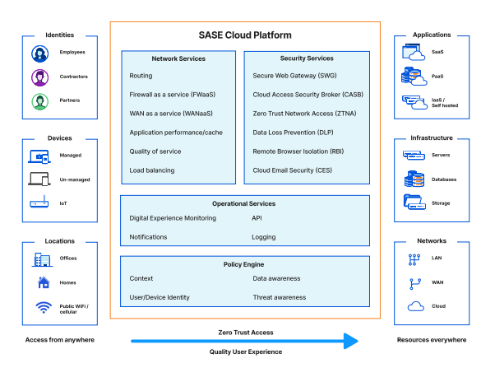
The Zero Trust Engine is central to the Netskope One platform, which decrypts and decodes traffic in real-time and constantly monitors risk information about users, devices, applications, and data without disrupting overall transaction performance (Netskope, 2025e). Moreover, it is unique in the industry for its ability to decrypt and re-encrypt large volumes of secure sockets layer (SSL) and fully decode JSON, the cloud’s language (Netskope, 2025e). This ensures that access to specific resources is granted only to authorized users, reducing security risks. The Netskope Zero Trust Engine enables context-aware SSE and SD-WAN features, enhancing security and improving network performance (Netskope, 2025c). Spark’s cloud-managed SSE services use this engine to deliver secure and efficient IT infrastructure with a simplified single-pass architecture (Cullerne, 2024). By adopting cloud-based security services, SSE ensures that the same security policies and rules are enforced across various networks, applications, and devices. Furthermore, Cloud Managed SSE Zero Trust Network Access eliminates slow Virtual Private Network (VPN) connections and multiple sign-ins to traditional VPNs. It provides threat protections against risks like malware and phishing across the network (Spark NZ, 2025a). Figure 2 illustrates how the Netskope One SSE is built on the Netskope One platform, which delivers exceptional visibility and real-time protection against data threats when accessing cloud services, websites, and private applications from any device and location (Netskope, 2025c).

Figure 2
Netskope One Platform (Spark NZ, 2025a)
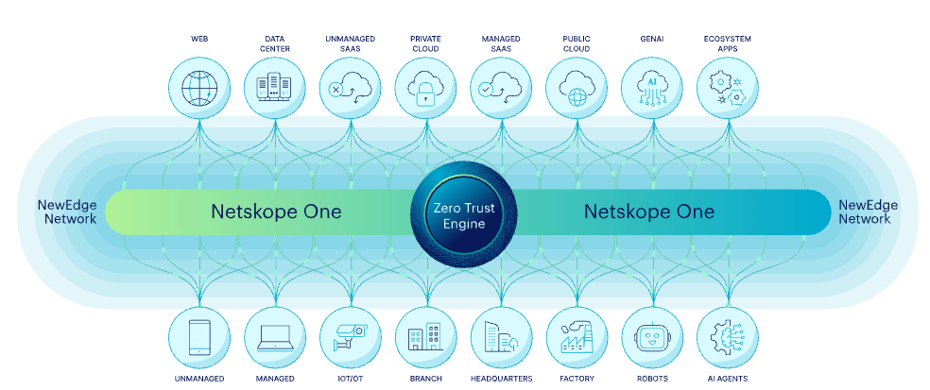
Spark NZ has integrated Fortinet secure software-defined wide area networking (SD-WAN) into its cybersecurity and networking framework, allowing the company to provide secure, scalable, and high-performance services to corporate, enterprise, and government clients (Fortinet, 2020). SD-WAN combines physical transport connections while actively monitoring and load-balancing traffic. VPN overlays can be created to control traffic between sites (Fortinet, 2025b). Additionally, it offers cost savings, simplified management, enhanced application performance, and improved user experience in software-as-a-service (SaaS) and cloud services (Fortinet, 2025b).

Figure 3
SD-WAN designs and architectures (Fortinet, 2025b)
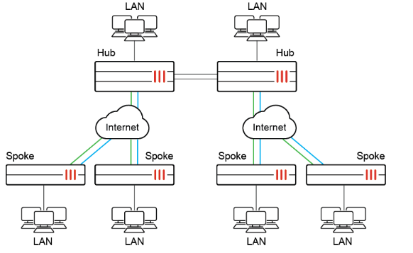
The key features of Fortinet’s SD-WAN solution are integrated within the FortiGate device. As shown in Figure 3, Fortinet’s SD-WAN architecture follows a hub and spoke design where branch locations connect to central gateways via secure VPN tunnels for optimized traffic routing (Fortinet, 2025b). It also incorporates advanced security features like a firewall, antivirus, IPsec encryption, and intrusion prevention systems (IPS) to provide secure connectivity from the edge to the cloud (Fortinet, 2018). By combining Fortinet’s strong security architecture with Netskope’s Zero Trust principles, Spark NZ demonstrates its leadership in providing cutting-edge cybersecurity solutions for New Zealand enterprises.

- Recommended Alternative Security Design
The proposed implementation plan for Spark NZ integrates Fortinet, Netskope, and Microsoft’s solutions to create a Zero Trust Security Architecture, improving business continuity, disaster recovery, and threat defense. Zero Trust is an advanced security model that treats every request as potentially compromised, requiring all requests to be verified regardless of their source (Microsoft, 2024c). It operates on the principle that no user or device is inherently trustworthy, requiring strict authentication and authorization for every access attempt (Fortinet, 2025d). Individuals are essential in identifying and defending against potential cybersecurity threats. To support this, all Spark employees must complete annual cybersecurity training, including upon joining, to equip them with the skills to recognize and address potential risks (Spark NZ, 2025b).

The design starts with Multi-Factor Authentication (MFA) to check user identities, helping to prevent attacks that rely on stolen credentials by using strict access controls. Typically, MFA involves sending a code to the user’s phone, which they must enter to access the system (Spark NZ, 2025c). Authorized users then proceed through a device security check to evaluate compliance and risk status, ensuring that only secure devices gain access to critical systems (Spark NZ, 2025b). Non-compliant devices are blocked from accessing the network, preventing potentially compromised endpoints from connecting.

Network traffic is managed through a multi-layered security framework that includes FortiGate Next-Generation Firewalls (NGFWs), Netskope’s Next Gen Secure Web Gateway (Next Gen SWG), and Azure Firewalls. FortiGate NGFWs safeguard data, assets, and users by delivering real-time, AI-powered security and network performance to defend against evolving cyber threats in hybrid environments (Fortinet, 2025a). Azure Firewall Premium is a next-generation firewall for sensitive environments, featuring Transport Layer Security (TLS) inspection to decrypt, process, and re-encrypt outbound traffic, and an Intrusion Detection and Prevention System (IDPS) to detect, log, report, and block malicious activities (Microsoft, 2025d). Netskope’s Next Gen SWG offers advanced capabilities to block malware, detect threats, filter websites, protect data, and manage applications and cloud services across all users, devices, and locations (Netskope, 2025b). A load balancer distributes traffic across resources, ensuring high availability and preventing overload on any single resource (Microsoft, 2025a).

The Policy Enforcement Checkpoint assesses user roles, device security, and location to verify compliance with organizational policies (Microsoft, 2024c). The application control layer manages traffic flow to either On-Premises or Software-as-a-Service (SaaS) applications, with Azure DDoS Protection securing these endpoints against volumetric attacks (Microsoft, 2025e). For data integrity, Microsoft Purview encrypts and classifies sensitive data, while Email Filtering Gateway and Microsoft Defender for Office 365 secure email with advanced protection against phishing, business email compromise, ransomware, and other cyber threats (Microsoft, 2024; Microsoft, 2025). Organizations are experiencing a growing number of disruptions, which may occur individually or simultaneously, each influencing organizational resources in different ways (Sahebjamnia et al., 2015). Business Continuity Planning seeks to create effective plans before a disaster occurs to quickly restore critical business operations to a predefined minimum level after disruption (Sahebjamnia et al., 2015). To improve application resilience within Spark NZ’s Zero Trust Security architecture, Azure Site Recovery (ASR) is integrated into the application control layer. Azure Site Recovery guarantees business continuity by maintaining the operation of business applications and workloads during disruptions (Microsoft, 2025c). It replicates workloads from physical and virtual machines (VMs) at the primary site to a secondary location, enabling failover during an outage and failback when the primary site is restored (Microsoft, 2025c).

The final layer, threat protection and monitoring, incorporates Microsoft Sentinel for proactive threat detection and incident response (Microsoft, 2024a). Microsoft Defender for Endpoint provides endpoint protection, while Netskope Threat Protection secures cloud data (Microsoft, 2024; Netskope, 2025). Automated Security and Control Assessment ensures real-time security updates and automated threat remediation (Picus, 2025). It enhances security posture by identifying and addressing misconfigurations, detection gaps, and policy weaknesses. Moreover, it automates the assessment of security controls to ensure they remain aligned with the changing threat landscape (Nagomi Security, 2024). At access control, all checks are verified before access is granted. This architecture enhances business continuity by ensuring that only authenticated and authorized users and devices can access resources, reducing the risk of breaches. The layered approach to threat protection, incorporating Fortinet, Netskope, and Microsoft’s solutions, offers strong defense against various cyber threats, safeguarding Spark NZ’s essential assets and data.

Figure 4
Proposed Zero Trust Security Architecture for Spark NZ: Enhancing Network Protection
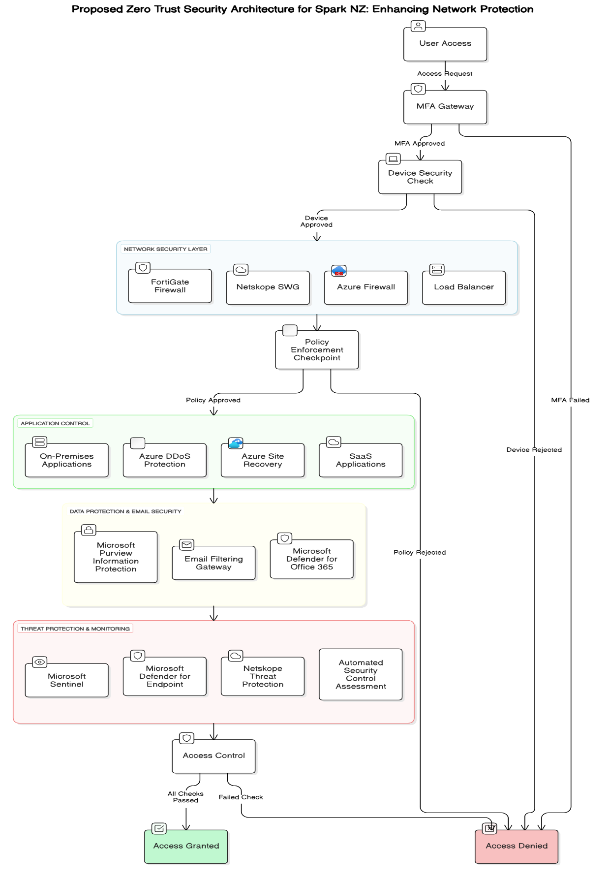
- Conclusion
The proposed Zero Trust architecture for Spark NZ addresses critical security challenges while aligning with the company’s commitment to strong cybersecurity measures. By implementing this framework, Spark NZ enhances its ability to protect against emerging threats, ensure business continuity, and maintain compliance with New Zealand regulations. Moreover, the proposed security architecture efficiently mitigates critical cybersecurity threats faced by the organization through the integration of effective protection strategies. Additionally, firewalls and load balancers provide strong DDoS protection, while MFA and email filtering enhance phishing prevention. The Security Education, Training and Awareness (SETA) program mitigates insider threats by improving user vigilance. By adopting a Zero Trust architecture, Spark NZ strengthens its cybersecurity posture, ensuring operational resilience and maintaining its leadership in the telecommunications sector. The proposed solutions offer a balanced approach, combining proactive protection with responsive threat mitigation, which is in line with Spark NZ’s dedication to securing its digital infrastructure.

References:
Alkhalil, Z., Hewage, C., Nawaf, L., & Khan, I. (2021). Phishing Attacks: A Recent Comprehensive Study and a New Anatomy. Frontiers in Computer Science, 3. https://doi.org/10.3389/fcomp.2021.563060
Alyami, A., Sammon, D., Neville, K., & Mahony, C. (2023). The critical success factors for Security Education, Training and Awareness (SETA) program effectiveness: A lifecycle model. Information Technology &amp; People, 36(8), 94–125. https://doi.org/10.1108/ITP-07-2022-0515
Andress, J. (2014). The Basics of Information Security: Understanding the Fundamentals of InfoSec in Theory and Practice. Syngress.
AWS. (2025). Managed DDos Protection—AWS Shield—AWS. Amazon Web Services, Inc. https://aws.amazon.com/shield/ddos-attack-protection/
CISA. (2020). Insider Threat Mitigation Guide.
CISA. (2025). Defining Insider Threats | CISA. https://www.cisa.gov/topics/physical-security/insider-threat-mitigation/defining-insider-threats
Cloudflare. (2023). Cloudfare Evolving to a Sase Architecture. https://developers.cloudflare.com/reference-architecture/static/cloudflare-evolving-to-a-sase-architecture.pdf
Cullerne, A. (2024, July 9). Spark becomes Netskope’s first managed services partner in New Zealand. https://www.spark.co.nz/online/about/our-company/news/spark-netskope-msp-new-zealand
Darnell, H. (2023, November 8). Firewall vs DDoS Protection: Why It Is Confused. DDoS-GUARD. https://ddos-guard.net/blog/what-is-a-firewall-and-how-it-works
Fortinet. (2018). The Network Leaders Guide to Secure SD-WAN. https://www.fortinet.com/content/dam/fortinet/assets/white-papers/eBook-The-Network-Leaders-Guide-to-Secure-SD-WAN.pdf
Fortinet. (2020, June 9). Spark NZ Chooses Fortinet Secure SD-WAN to Deliver Scalable, Secure Services. GlobeNewswire News Room. https://www.globenewswire.com/news-release/2020/06/09/2045670/0/en/Spark-NZ-Chooses-Fortinet-Secure-SD-WAN-to-Deliver-Scalable-Secure-Services.html
Fortinet. (2025a). Next Generation Firewall (NGFW)—See Top Products. Fortinet. https://www.fortinet.com/products/next-generation-firewall
Fortinet. (2025b). SD-WAN overview | Administration Guide. https://docs.fortinet.com/document/fortigate/7.6.2/administration-guide/431448/docs.fortinet.com/document/fortigate/7.6.2/administration-guide/431448/sd-wan-overview
Fortinet. (2025c). What is a DDoS Attack? DDoS Meaning, Definition & Types. Fortinet. https://www.fortinet.com/resources/cyberglossary/ddos-attack
Fortinet. (2025d). What is Zero Trust Architecture? Fortinet. https://www.fortinet.com/cn/resources/cyberglossary/zero-trust-architecture.html
Gerber, M., Von Solms, R., & Overbeek, P. (2001). Formalizing information security requirements. Information Management & Computer Security, 9(1), 32–37. https://doi.org/10.1108/09685220110366768
Goldman, L. (2023, March 17). Why Load Balancers Should be Part of Your Security Architecture—Spiceworks. https://www.spiceworks.com/it-security/network-security/guest-article/load-balancers-security-architecture/
Greitzer, F. L., Moore, A. P., Cappelli, D. M., Andrews, D. H., Carroll, L. A., & Hull, T. D. (2008). Combating the Insider Cyber Threat. IEEE Security & Privacy Magazine, 6(1), 61–64. https://doi.org/10.1109/MSP.2008.8
Hoque, N., Bhattacharyya, D. K., & Kalita, J. K. (2015). Botnet in DDoS Attacks: Trends and Challenges. IEEE Communications Surveys & Tutorials, 17(4), 2242–2270. https://doi.org/10.1109/COMST.2015.2457491
Hu, S., Hsu, C., & Zhou, Z. (2022). Security Education, Training, and Awareness Programs: Literature Review. Journal of Computer Information Systems, 62(4), 752–764. https://doi.org/10.1080/08874417.2021.1913671
Kiw, N. L. (2024, June 13). Combating cybercrime with a robust cybersecurity strategy. https://businessgroup.spark.co.nz/insight-engine/combating-cybercrime-with-a-robust-cybersecurity-strategy
Kosinski, M. (2024a, January 4). What is Multi-Factor Authentication? | IBM. https://www.ibm.com/think/topics/multi-factor-authentication
Kosinski, M. (2024b, May 17). What is Phishing? | IBM. https://www.ibm.com/think/topics/phishing
McCaull, A. (2024, March 21). Spark to introduce barriers to help stamp out objectionable material, cyber risks and scams. RNZ. https://www.rnz.co.nz/news/business/512333/spark-to-introduce-barriers-to-help-stamp-out-objectionable-material-cyber-risks-and-scams
Microsoft. (2024a, May 21). What is Microsoft Sentinel? https://learn.microsoft.com/en-us/azure/sentinel/overview
Microsoft. (2024b, June 6). Microsoft Purview Information Protection. https://learn.microsoft.com/en-us/purview/information-protection
Microsoft. (2024c, June 28). Zero Trust security in Azure. https://learn.microsoft.com/en-us/azure/security/fundamentals/zero-trust
Microsoft. (2024d, September 25). Microsoft Defender for Endpoint—Microsoft Defender for Endpoint. https://learn.microsoft.com/en-us/defender-endpoint/microsoft-defender-endpoint
Microsoft. (2025a). Load-balancing options—Azure Architecture Center. https://learn.microsoft.com/en-us/azure/architecture/guide/technology-choices/load-balancing-overview
Microsoft. (2025b). Microsoft Defender for Office 365 | Microsoft Security. https://www.microsoft.com/en-nz/security/business/siem-and-xdr/microsoft-defender-office-365
Microsoft. (2025c, January 24). Azure Site Recovery overview—Azure Stack Hub. https://learn.microsoft.com/en-us/azure-stack/operator/azure-site-recovery-overview?view=azs-2501
Microsoft. (2025d, February 10). Deploy and configure Azure Firewall Premium. https://learn.microsoft.com/en-us/azure/firewall/premium-deploy
Microsoft. (2025e, March 17). Azure DDoS Protection Overview. https://learn.microsoft.com/en-us/azure/ddos-protection/ddos-protection-overview
Nagomi Security. (2024, August 26). A CISO’s Guide to Evaluating Automated Security Controls Assessment (ASCA) Solutions. Nagomi Security. https://nagomisecurity.com/resources/a-cisos-guide-to-evaluating-automated-security-controls-assessment-asca-solutions
Netscout. (2018, July). How to Analyze and Reduce the Risk of DDoS Attacks. https://www.netscout.com/sites/default/files/2018-07/SECWP_005_EN-1802-How-to-Analyze-and-Reduce-the-Risk-of-DDoS-Attacks_0.pdf
Netskope. (2025a). Netskope One Threat Protection. Netskope. https://www.netskope.com/netskope-one/threat-protection
Netskope. (2025b). Next Generation Secure Web Gateway (SWG). Netskope. https://www.netskope.com/resources/solution-briefs/next-generation-secure-web-gateway
Netskope. (2025c). Secure Access Service Edge (SASE). Netskope. https://www.netskope.com/products/secure-access-service-edge
Netskope. (2025d). What is SASE? Netskope. https://www.netskope.com/security-defined/what-is-sase
Netskope. (2025e). Zero Trust Engine: Part of Netskope One Platform. Netskope. https://www.netskope.com/netskope-one/zero-trust-engine
Perception Point. (2025). Understanding Email Filtering: Types, Techniques, and Tools. Perception Point. https://perception-point.io/guides/email-security/understanding-email-filtering-types-techniques-and-tools/
Picus. (2025, January 30). What Is Automated Security Control Assessment (ASCA)? https://www.picussecurity.com/resource/glossary/what-is-automated-security-controls-assessment
Rebbeck, T. (2022). SSE or SASE: vendors need to consider the implications of a failed strategy. https://www.analysysmason.com/contentassets/e9cf9c4e1996473289cc03b53c75c107/analysys_mason_sase_sse_vendors_jun2022_ren01_ren04.pdf
Sahebjamnia, N., Torabi, S. A., & Mansouri, S. A. (2015). Integrated business continuity and disaster recovery planning: Towards organizational resilience. European Journal of Operational Research, 242(1), 261–273. https://doi.org/10.1016/j.ejor.2014.09.055
Spark NZ. (2018). Secure Internet Service Specification. https://www.sparkdigital.co.nz/content/dam/sparkdigital/pdfs/contracts/secure-internet.pdf
Spark NZ. (2025a). Cloud Managed SSE | Spark NZ. https://www.spark.co.nz/online/large-business-govt/products/secure/cloud-managed-sse
Spark NZ. (2025b). How we manage security | Spark NZ. https://www.spark.co.nz/help/privacy-and-safety/how-we-manage-security/
Spark NZ. (2025c). Implementing a zero trust network | Large Business and Government | Spark NZ. https://www.spark.co.nz/online/large-business-govt/why-choose-spark/insights/zero-trust-network
Spark NZ. (2025d). Keeping your networks safe | Large Business and Government | Spark NZ. https://www.spark.co.nz/online/large-business-govt/why-choose-spark/insights/keep-network-safe
Spark NZ. (2025e). SSE: Taking security to the edge | Large Business and Government | Spark NZ. https://www.spark.co.nz/online/large-business-govt/why-choose-spark/insights/sse
Suzuki, Y. E., & Monroy, S. A. S. (2022). Prevention and mitigation measures against phishing emails: A sequential schema model. Security Journal, 35(4), 1162–1182. https://doi.org/10.1057/s41284-021-00318-x
Von Solms, R., & Van Niekerk, J. (2013). From information security to cyber security. Computers & Security, 38, 97–102. https://doi.org/10.1016/j.cose.2013.04.004
Yasar, K. (2025, February). What is Multifactor Authentication (MFA)? | Definition from TechTarget. Search Security. https://www.techtarget.com/searchsecurity/definition/multifactor-authentication-MFA

