Multi-layered security architecture for Auckland Council’s cybersecurity requirements

1. Introduction
Information security (InfoSec) is the structured practice of safeguarding digital assets from unauthorized access, disruption, or tampering—preserving confidentiality, integrity, and availability (Khando et al., 2021). As cyber threats evolve in sophistication—particularly ransomware, phishing, and data breaches—public sector entities must adopt resilient, standards-aligned architectures to protect critical systems.
Auckland Council, tasked with delivering infrastructure, financial, and citizen services, operates within a complex digital ecosystem, making it a high-value target for cyberattacks. A robust information security framework is imperative to ensure uninterrupted service delivery and safeguard public trust.
This report critically evaluates Auckland Council’s existing information security infrastructure, identifies design gaps in mitigating contemporary threats, and proposes a comprehensive multi-layered architecture tailored to the Council’s operational context. Section 2 outlines the Council’s core security requirements. Section 3 analyzes current infrastructure and vulnerabilities. Section 4 presents a suitable, future-proofed security architecture designed to meet regulatory, operational, and technological demands.

2. Auckland Council’s security requirements
This section outlines Auckland Council’s key security requirements to mitigate cyber threats such as data breaches, ransomware, and phishing. It introduces three primary security measures: firewalls and VPNs for data protection, anti-ransomware for ransomware defense, and anti-malware for phishing prevention. Each measure is essential for strengthening the Council’s IT security framework and ensuring compliance with security regulations. The subsequent subsections provide a structured overview of these security measures, detailing their roles in safeguarding the Council’s digital infrastructure.

2.1. Next-Generation Firewalls and VPN against data breaches and unauthorized access
Auckland Council employs firewalls and Virtual Private Networks (VPNs) as critical components of its cybersecurity strategy to address data breaches and unauthorized access (Auckland Council, 2019). The council utilizes Next-Generation Firewalls (NGFWs), which integrate deep packet inspection (DPI) and intrusion prevention systems (IPS) to detect and block sophisticated cyber threats in real-time (Government Communications Security Bureau, 2018). These advanced firewalls prevent unauthorized data exfiltration and malware infiltration by continuously monitoring network traffic (Alicea & Alsmadi, 2021). To mitigate potential vulnerabilities from misconfigured firewall rules, Auckland Council conducts periodic audits and employs real-time monitoring and automated rule optimization (Landoll, 2021). Network segmentation policies enforced by firewalls further minimize the risk of lateral movement within the network by isolating unauthorized access within designated security zones (Khando et al., 2021).
Auckland Council also enforces robust VPN configurations to secure remote access, adhering to standards outlined in the New Zealand Information Security Manual (NZISM) (Government Communications Security Bureau, 2018). VPNs provide encrypted communication channels, ensuring data confidentiality and integrity, and are strengthened by multi-factor authentication (MFA) requirements (CertNZ, 2025a; Prabakaran & Ramachandran, 2021). While VPNs significantly enhance security, outdated encryption protocols, and improper configurations remain potential vulnerabilities (Fereidouni et al., 2025). To address these risks, Auckland Council continuously updates its encryption standards, enforces strict access control policies, and conducts regular penetration testing (Government Communications Security Bureau, 2018). The council's security posture is further enhanced by considering advanced strategies like Zero Trust Network Access (ZTNA) and AI-driven threat detection mechanisms, which provide real-time threat intelligence and continuous authentication (Dhayanidhi, 2022; Madsen, 2024; Santos et al., 2024). These enhancements enable the council to detect and mitigate potential breaches before they escalate proactively.

2.2. Multi-layered anti-ransomware protection against ransomware
Auckland Council employs a multi-layered anti-ransomware strategy to protect its systems from evolving cyber threats, emphasizing backup integrity, endpoint detection, and proactive system maintenance (Auckland Council, 2019; Pagán & Elleithy, 2021). The council utilizes immutable backups and offsite storage to ensure data recovery in case of an attack, aligning with best practices for ransomware resilience (Pagán & Elleithy, 2021). However, ransomware operators increasingly target backup systems, leveraging double extortion tactics (Ojo, 2025). To address this, the Auckland Council must integrate air-gapped backups and real-time anomaly detection to prevent unauthorized modifications or access attempts (Patel et al., 2024). Automated alerts for suspicious administrator activities enhance threat visibility, but robust encryption and access controls are essential to prevent unauthorized tampering with backup repositories (Kalinaki, 2024).
Auckland Council's anti-ransomware strategy also includes Endpoint Detection and Response (EDR), providing AI-driven threat analysis and automated response mechanisms to contain ransomware before widespread infection occurs (Hussain, 2025). EDR solutions improve real-time detection, significantly reducing dwell time and limiting the extent of an attack (Kaur et al., 2024). However, these systems often generate false positives, necessitating skilled personnel to fine-tune detection algorithms for optimal performance. To enhance EDR, the Auckland Council should complement it with deception technologies, such as honeypots, to detect and neutralize novel ransomware strains before execution (McIntosh et al., 2024). Additionally, integrating real-time threat intelligence into EDR platforms enhances predictive analytics, allowing the council to identify attack patterns and proactively reinforce security controls (Aminu et al., 2024). Regular software updates and robust patch management are also crucial, as they reduce exploitable vulnerabilities, minimizing the attack surface for ransomware operators (Ojo, 2025). By integrating these measures, Auckland Council can fortify its defenses against ransomware attacks, ensuring a proactive and adaptive cybersecurity posture aligned with evolving industry best practices.

2.3. Comprehensive anti-malware to protect against phishing
Auckland Council employs a comprehensive anti-malware strategy to mitigate phishing threats and prevent malware infiltration (OurAuckland, 2022). This includes using AI-driven email filtering solutions that analyze metadata, attachments, and embedded links to detect phishing attempts, reduce false positives, and improve adaptability to emerging threats (Gundoor et al., 2025; Meguro & Chong, 2025). The council integrates anti-malware software updates across all devices. It enforces anti-spam controls to monitor email traffic for phishing attempts, aligning with best practices outlined by the Government Communications Security Bureau (2018). However, as cybercriminals refine attack techniques, AI models require frequent updates to remain effective (Akhtar & Rawol, 2024). Without continuous refinement, phishing detection systems may fail to identify sophisticated phishing campaigns that mimic legitimate communication (Shanmugam & Sumathi, 2024).
To complement technical safeguards, Auckland Council conducts regular phishing simulations and user awareness training (CertNZ, 2025b; Dasari, 2025). These exercises reduce employee susceptibility to phishing attacks by reinforcing safe email practices and improving threat recognition (Yeoh et al., 2021). However, high-pressure social engineering tactics continue to deceive employees, necessitating a layered security approach integrating human oversight with AI-driven solutions (van Geest et al., 2024). The council pairs user training with technical measures like automatic phishing link deactivation and domain-based message authentication (Volkamer et al., 2020). Multi-factor authentication (MFA) also reduces the risk of credential-based phishing attacks, though traditional MFA methods remain susceptible to advanced phishing techniques (Ahmad et al., 2023). Transitioning to phishing-resistant authentication mechanisms, such as FIDO2 security keys and biometric authentication, can provide enhanced protection against credential theft (Al Kabir & Elmedany, 2022; Kondakrindi, 2024). By combining these measures, Auckland Council can strengthen its cybersecurity posture and mitigate the risks of phishing-based malware attacks.

3. Auckland Council’s existing infosec infrastructure
Auckland Council’s information security infrastructure provides layered cyber defenses aligned with national standards (NZISM) and international frameworks (ISO 27001). This architecture spans network, software, hardware, data, and people domains, each utilizing specialized controls to secure the council’s extensive digital ecosystem (Auckland Council, 2019; Government Communications Security Bureau, 2018). Maintaining this complex infrastructure is vital due to the council’s public-facing operations and legacy IT environments, which heighten vulnerabilities (Gharaibeh et al., 2017).
The council's network security is fortified by Next-Generation Firewalls (NGFWs) and Intrusion Prevention Systems (IPS), which conduct deep packet inspection (DPI) and real-time threat intelligence analysis to block malicious traffic (Stewart & Kinsey, 2020). These are enhanced by automated firewall audits that mitigate the risks of misconfigurations—one of the most common exploit vectors in public sector systems (Landoll, 2021). However, research by Alicea and Alsmadi (2021) warns that even sophisticated firewall systems are susceptible to configuration drift without ongoing policy audits—table 1. Auckland Council's multi-domain security infrastructure components present a breakdown of this multi-layered defense structure and associated technologies supporting each domain.
Table 1. Auckland Council's multi-domain security infrastructure components
COMPONENT DOMAIN | SECURITY INFRASTRUCTURE COMPONENT | DESCRIPTION
Network | Next-Generation Firewalls (NGFWs), Intrusion Prevention Systems (IPS), and automated firewall audits. | NGFWs and IPS offer deep packet inspection and real-time threat intelligence (Stewart & Kinsey, 2020). Automated firewall audits reduce misconfiguration risks (Landoll, 2021).
Software | Enterprise-grade anti-malware, Endpoint Detection and Response (EDR) systems, patch management solutions. | Software tools detect and mitigate malware and ransomware attacks. EDR uses AI for automated response (Patel et al., 2024). Patch management addresses vulnerabilities (Hughes & Robinson, 2024).
Hardware | Security-enhanced endpoints, backup storage devices (air-gapped), and honeypots for deception-based defense. | Hardware security is ensured through hardened devices and deception tools like honeypots (Kaur et al., 2024). Air-gapped backups ensure ransomware resilience (McIntosh et al., 2024).
Data | Immutable backup solutions, data encryption, data access control, and anomaly detection systems. | Data protection includes encryption, integrity checks, and access restrictions (Pagán & Elleithy, 2021). Anomaly detection flags suspicious patterns (Dhayanidhi, 2022).
People | Multi-Factor Authentication (MFA), Role-Based Access Control (RBAC), phishing simulations, and adaptive training. | People-centered defenses include MFA, RBAC, and ongoing phishing awareness training (Ahmad et al., 2023; CertNZ, 2025b; Dasari, 2025).
Complementing network defenses, the council implements advanced software-based controls. Endpoint Protection is enabled through enterprise-grade anti-malware solutions and AI-powered Endpoint Detection and Response (EDR) systems that identify, isolate, and remediate suspicious activities (Patel et al., 2024). However, ensuring patch consistency across diverse systems poses logistical challenges that can lead to vulnerability exposure (Parmar, 2024). According to McIntosh et al. (2024), automated patch management based on vulnerability severity and system criticality is crucial to maintaining endpoint security without compromising availability.
Hardware security includes hardened endpoints, honeypots for deception-based defense, and air-gapped backup systems that ensure business continuity during ransomware events (Kaur et al., 2024; McIntosh et al., 2024). In the data domain, encryption, anomaly detection, and access control mechanisms protect against exfiltration, manipulation, and loss of data integrity (Dhayanidhi, 2022; Pagán & Elleithy, 2021). However, even these measures rely on proper access governance and real-time alerting to prevent unauthorized internal activities.
The people domain incorporates identity-focused strategies, including Multi-Factor Authentication (MFA), Role-Based Access Control (RBAC), and security awareness programs (Ahmad et al., 2023). However, as phishing remains a dominant attack vector, traditional training is no longer sufficient. Adaptive learning platforms and simulated phishing tests are increasingly necessary to counter evolving tactics (CertNZ, 2025b; Dasari, 2025).
Real-time monitoring and response are achieved using SIEM (Security Information and Event Management) systems and SOAR (Security Orchestration, Automation, and Response) tools, which correlate alerts and automate mitigation workflows. Still, as Gundoor et al. (2025) note, SIEM tools are only as effective as their configuration, and poorly tuned systems can produce alert fatigue. To offset this, Auckland Council leverages Cyber Threat Intelligence (CTI) platforms that contextualize alerts based on global threat feeds (Taherdoost, 2024).
Figure 1. Auckland Council’s InfoSec infrastructure flow diagram
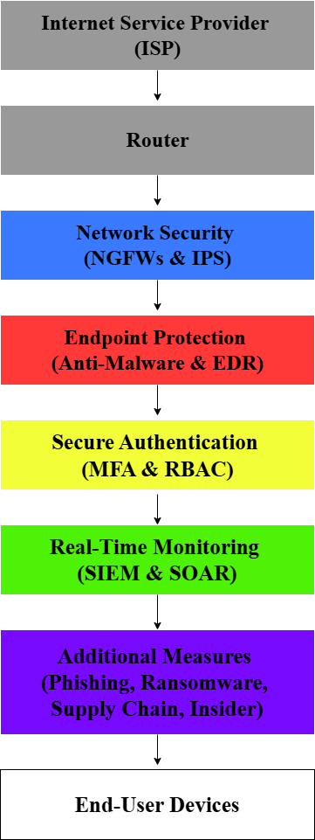
The visual architecture in Figure 1 illustrates the sequential integration of each layer—from the ISP and router to end-user devices—showcasing how perimeter, endpoint, authentication, monitoring, and threat-specific controls are implemented. This structured yet interconnected model ensures data confidentiality, availability, and integrity across Auckland Council’s services.
While the foundational infrastructure is robust, Auckland Council must invest in continued security modernization, including AI-based automation, zero-trust verification models, and threat-intelligence-driven controls (Dhayanidhi, 2022; Gundoor et al., 2025; Santos et al., 2024). As cyber threat actors adopt increasingly advanced tactics, ongoing improvements in real-time analytics, anomaly detection, and behavioral monitoring will be essential to maintaining resilience across all five domains (Dhayanidhi, 2022; Gundoor et al., 2025; Mandru, 2024; Taherdoost, 2024).

4. Suitable infosec architecture for implementation and maintenance
Auckland Council's suitable information security architecture adopts a layered defense-in-depth strategy to ensure digital assets' confidentiality, integrity, and availability while mitigating complex and evolving cyber threats. This architecture, illustrated in Figure 2, integrates preventive, detective, and responsive mechanisms across six strategic layers, from perimeter security to compliance governance.
Figure 2. Auckland Council suitable infosec architecture
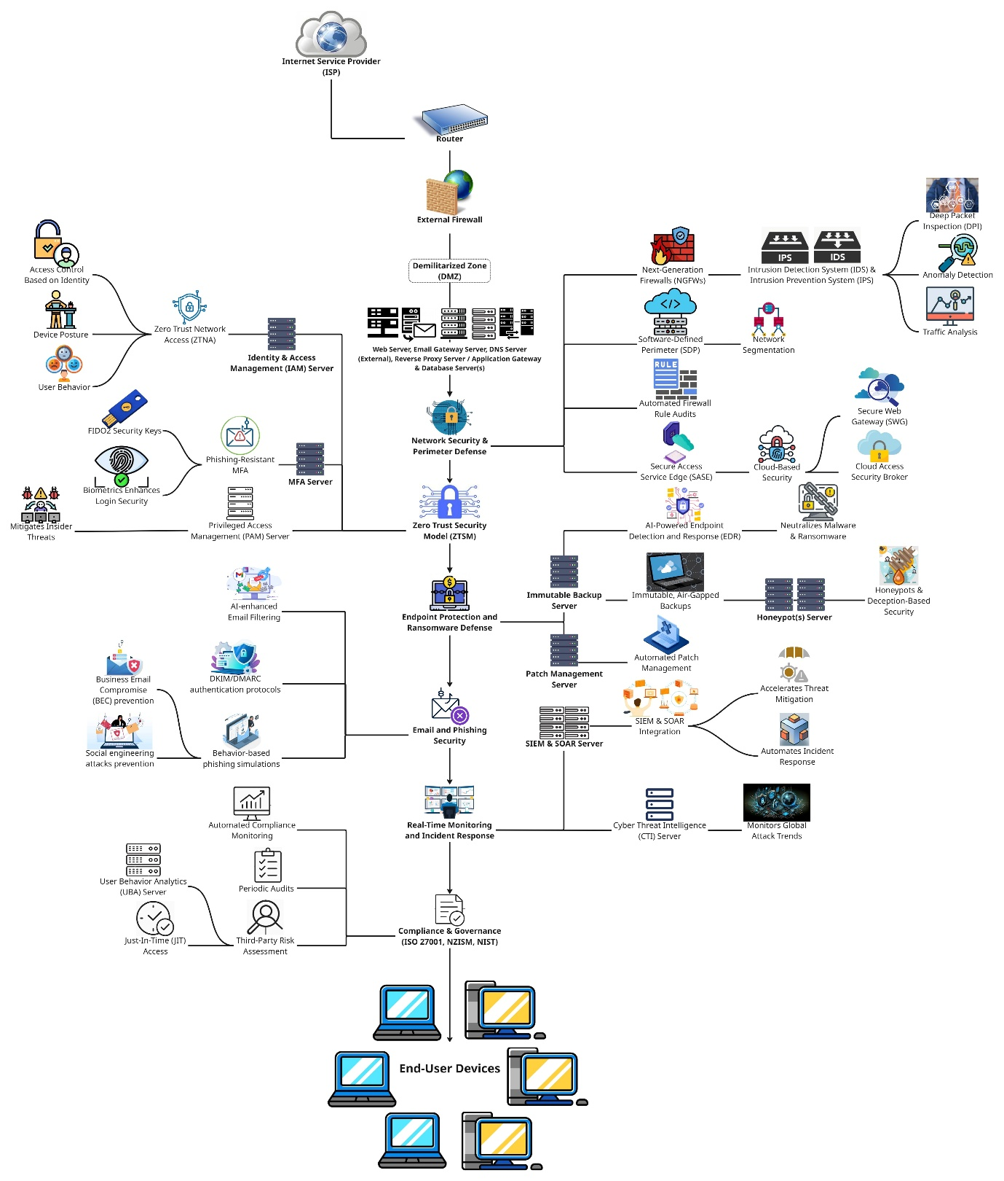
The first architectural layer initiates after the Internet Service Provider (ISP) and router, where perimeter defenses are enforced through Next-Generation Firewalls (NGFWs) embedded with Intrusion Detection and Prevention Systems (IDS/IPS). These systems apply Deep Packet Inspection (DPI), traffic analytics, and anomaly detection to identify and block unauthorized activity in real time (Dhayanidhi, 2022; Stewart & Kinsey, 2020). Network segmentation is achieved via Software-Defined Perimeter (SDP) protocols. At the same time, Secure Access Service Edge (SASE) integrates cloud-native security, including Secure Web Gateways (SWG) and Cloud Access Security Brokers (CASB), which are essential for hybrid and remote operations (Santos et al., 2024). Automated firewall rule audits prevent configuration drift and reduce exposure to known vulnerabilities (Landoll, 2021).
The second layer integrates a Zero Trust Security Model (ZTSM), which eliminates implicit trust and mandates continuous authentication via Zero Trust Network Access (ZTNA). ZTNA contextually verifies identity, device posture, and user behavior before granting access (Botwright, 2023; Madsen, 2024). Multi-factor authentication (MFA), including phishing-resistant options like FIDO2 security keys and biometric logins, reinforces secure access (Al Kabir & Elmedany, 2022; Kondakrindi, 2024). Privileged Access Management (PAM) enforces least privilege principles and mitigates insider threats through granular role-based access (Mandru, 2024).
Layer three encompasses Endpoint Protection and Ransomware Defense. AI-powered Endpoint Detection and Response (EDR) solutions autonomously detect, isolate, and neutralize threats (Hussain, 2025). Immutable, air-gapped backups safeguard data integrity during ransomware incidents (McIntosh et al., 2024), while honeypots and deception-based technologies delay attackers and collect threat intelligence (Kaur et al., 2024). An automated patch management server ensures timely security updates without disrupting operations (Hughes & Robinson, 2024).
The fourth layer addresses email and phishing threats. AI-enhanced email filtering inspects metadata, links, and attachments, supported by DKIM and DMARC authentication protocols, to prevent email spoofing (Meguro & Chong, 2025; Shanmugam & Sumathi, 2024). To sustain human-centered resilience, quarterly phishing simulations and adaptive training modules are deployed to reduce the risk of Business Email Compromise (BEC) and social engineering attacks (Dasari, 2025; Volkamer et al., 2020).
The fifth layer facilitates real-time monitoring and automated incident response. Security Information and Event Management (SIEM) and Security Orchestration, Automation, and Response (SOAR) platforms detect and correlate threat activity, minimizing mean time to detect and respond (MTTD/MTTR) (Gundoor et al., 2025; van Geest et al., 2024). Cyber Threat Intelligence (CTI) systems ingest global indicators to inform proactive threat hunting and defense posture (Santos et al., 2024).
The final layer is Compliance and Governance, ensuring alignment with ISO 27001, NZISM, and the NIST Cybersecurity Framework. This is operationalized via automated compliance monitoring, periodic audits, and third-party risk assessments (Government Communications Security Bureau, 2018; Yeoh et al., 2021). User Behavior Analytics (UBA) and Just-In-Time (JIT) access policies further reduce lateral movement and privilege escalation risks (Tsanov, 2024).
The implementation plan of the information security architecture follows a phased implementation strategy to ensure structured deployment across multiple layers. The approach begins with foundational audits and progresses through perimeter defense, identity controls, endpoint protection, and advanced threat monitoring before concluding with governance, compliance, and ongoing system optimization. As shown in Table 2. Phased implementation timeline for Auckland Council’s information security architecture, the first three phases focus on infrastructure audit, NGFW, Zero Trust set up, and EDR deployment (Berry, 2025; Hussain, 2025; Madsen, 2024). This is followed by email and phishing protection, SIEM and SOAR integration, and regulatory alignment with ISO 27001, NZISM, and NIST (Government Communications Security Bureau, 2018; Meguro & Chong, 2025). The final stages emphasize red-teaming, awareness training, and innovation through AI-driven automation and quantum-ready technologies (Dhayanidhi, 2022; Kondakrindi, 2024).
Table 2. Phased implementation timeline for Auckland Council’s information security architecture
PHASE | DESCRIPTION | TIMEFRAME
Phase 1: Assessment & Planning | Conduct audits, risk assessments, gap analysis; define policies and KPIs; plan procurement (Berry, 2025; Government Communications Security Bureau, 2018). | 1–2 months
Phase 2: Perimeter Defense & ZT Integration | Deploy NGFWs, IDS/IPS, SASE and SDP technologies; implement Zero Trust policies and MFA (Botwright, 2023; Dhayanidhi, 2022; Madsen, 2024; Stewart & Kinsey, 2020). | 2–3 months
Phase 3: Endpoint Security & Backup | Install EDR platforms, backup servers, honeypots, and patch management tools (Hughes & Robinson, 2024; Hussain, 2025; Kaur et al., 2024; McIntosh et al., 2024). | 2 months
Phase 4: Email & Phishing Defense | Integrate AI-enhanced filters, DKIM/DMARC, and launch adaptive phishing simulations (Dasari, 2025; Meguro & Chong, 2025; Shanmugam & Sumathi, 2024; Volkamer et al., 2020). | 1–2 months
Phase 5: SIEM, SOAR, CTI Integration | Implement SIEM and SOAR systems, and CTI integration for real-time threat management (Gundoor et al., 2025; Santos et al., 2024; van Geest et al., 2024). | 2 months
Phase 6: Compliance & Governance | Embed ISO 27001/NZISM/NIST compliance tools; conduct audits and third-party risk assessments (Government Communications Security Bureau, 2018; Yeoh et al., 2021). | 1 month
Phase 7: Testing, Training & Optimization | Run red-teaming, simulations, awareness training, and optimize system configurations (Kondakrindi, 2024; Volkamer et al., 2020). | Quarterly & Bi-annually
Phase 8: Continuous Maintenance & Innovation | Ongoing system updates, threat intelligence tuning, AI adoption, and future-proofing (Dhayanidhi, 2022; Santos et al., 2024). | Continuous
This structured, layered rollout not only supports the integrity and maturity of the information security architecture but also ensures minimal operational disruption. It allows for concurrent staff upskilling, policy refinement, and stakeholder engagement, reinforcing Auckland Council’s long-term resilience and adaptability in the face of emerging cyber threats. The total implementation timeframe for Phases 1 to 6 is estimated at approximately 9 to 12 months, with ongoing efforts embedded in the final phases to support continuous improvement and future-proofing.

5. Summary and conclusion
Auckland Council’s multi-layered security architecture effectively aligns with the needs of a large-scale digital public entity. Utilizing a Zero Trust Security Model (ZTSM), the architecture prioritizes continuous identity verification and dynamic access control to significantly reduce unauthorized lateral movements (Botwright, 2023; Madsen, 2024). Additionally, transitioning to phishing-resistant Multi-Factor Authentication (MFA), such as FIDO2 keys and biometrics, enhances resilience against credential phishing and brute-force attacks (Al Kabir & Elmedany, 2022; Kondakrindi, 2024).
Privileged Access Management (PAM) supports the Zero Trust paradigm by enforcing least privilege principles and tightening control over administrative roles. This reduces insider threat risks and helps contain potential breaches by restricting over-privileged access (Mandru, 2024). ZTNA, MFA, and PAM strengthen identity governance and form the backbone of user-centric security.
At the network level, Auckland Council employs Next-Generation Firewalls (NGFWs) integrated with Intrusion Detection and Prevention Systems (IDS/IPS) for real-time traffic analysis and anomaly detection, vital for mitigating zero-day exploits (Dhayanidhi, 2022; Stewart & Kinsey, 2020). Dynamic segmentation via Software-Defined Perimeter (SDP) further reduces threat exposure by isolating compromised systems (Yeoh et al., 2021). Secure Access Service Edge (SASE), including Secure Web Gateways (SWG) and Cloud Access Security Brokers (CASB), ensures secure remote connectivity without sacrificing network control (Santos et al., 2024). Regular firewall rule audits and automated threat intelligence updates maintain perimeter integrity (Landoll, 2021).
Ransomware resilience forms a crucial aspect of the architecture. Immutable, air-gapped backups enable data recovery without yielding to ransom demands (McIntosh et al., 2024). AI-driven Endpoint Detection and Response (EDR) tools promptly detect and isolate compromised systems, reducing potential damage (Hussain, 2025). Additionally, honeypots offer valuable intelligence by attracting attackers into controlled environments, facilitating analysis and diverting threats from critical assets (Kaur et al., 2024). Automated patch management swiftly addresses vulnerabilities, minimizing attack vectors without disrupting operations (Hughes & Robinson, 2024).
Phishing remains a persistent threat vector, and the Council’s mitigation strategy is appropriately robust. AI-driven email filters analyze headers, links, and attachments in real-time to identify and block sophisticated phishing campaigns (Meguro & Chong, 2025). Complementing this, email authentication protocols like DKIM and DMARC help prevent domain spoofing (Shanmugam & Sumathi, 2024). Employee-focused controls, including simulated phishing campaigns and behavior-driven cybersecurity training, build a resilient workforce that recognizes and responds to threats (Dasari, 2025; Volkamer et al., 2020).
For real-time threat management, the integration of Security Information and Event Management (SIEM) and Security Orchestration, Automation, and Response (SOAR) solutions provides centralized visibility and automation of detection, investigation, and response workflows (Gundoor et al., 2025; Taherdoost, 2024). Cyber Threat Intelligence (CTI) platforms complement these systems by supplying external indicators of compromise (IOCs) and contextualizing alerts, ensuring analysts respond to relevant and prioritized incidents (Santos et al., 2024).
Governance and compliance complete the security architecture, embedding ISO 27001, NZISM, and NIST cybersecurity standards across all operations. Automated compliance monitoring, periodic audits, and third-party risk assessments promote accountability and alignment with legal and regulatory expectations (Government Communications Security Bureau, 2018; Yeoh et al., 2021). User Behavior Analytics (UBA) and Just-In-Time (JIT) access provisioning further reduce the attack surface by limiting access to critical systems and detecting anomalous activity (Tsanov, 2024).
Security must be operationalized through a phased implementation plan, ongoing monitoring, and capacity building to ensure sustainability. Weekly firewall reviews, monthly SIEM tuning, quarterly phishing simulations, and biannual red teaming exercises must be embedded in operational workflows (Kondakrindi, 2024). Staff must receive continuous adaptive training, while future investments should prioritize AI-driven security automation, quantum-resistant cryptography, and decentralized identity models (Dhayanidhi, 2022).
By aligning technological innovation with human-centered policies and regulatory compliance, Auckland Council is positioned to build a resilient, adaptive, and forward-looking cybersecurity architecture that safeguards public services and data against sophisticated and persistent threats.

6. References
Ahmad, M. O., Tripathi, G., Siddiqui, F., Alam, M. A., Ahad, M. A., Akhtar, M. M., & Casalino, G. (2023). BAuth-ZKP—A blockchain-based multi-factor authentication mechanism for securing smart cities. Sensors, 23(5), Article 5. https://doi.org/10.3390/s23052757
Akhtar, Z. B., & Rawol, A. T. (2024). Enhancing cybersecurity through AI-powered security mechanisms. IT Journal Research and Development, 9(1), 50–67. https://doi.org/10.25299/itjrd.2024.16852
Al Kabir, M. A., & Elmedany, W. (2022). An overview of the present and future of user authentication. 2022 4th IEEE Middle East and North Africa COMMunications Conference (MENACOMM), 10–17. https://doi.org/10.1109/MENACOMM57252.2022.9998304
Alicea, M., & Alsmadi, I. (2021). Misconfiguration in firewalls and network access controls: Literature review. ResearchGate, 13(11), 283. https://doi.org/10.3390/fi13110283
Aminu, M., Akinsanya, A., Oyedokun, O., & Dako, D. A. (2024). Enhancing cyber threat detection through real-time threat intelligence and adaptive defense mechanisms. International Journal of Computer Applications Technology and Research, 13(08), 11–27. https://doi.org/10.7753/IJCATR1308.1002
Auckland Council. (2019, July 25). Governing body meeting held on 25/07/2019. Auckland Council. https://infocouncil.aucklandcouncil.govt.nz/Open/2019/07/GB_20190725_AGN_6783_AT_files/GB_20190725_AGN_6783_AT_Attachment_69777_1.PDF
Berry, K. (2025, March 26). A phased approach to project management implementation. PMAlliance, Inc. https://pm-alliance.com/phased-project-management-implementation/
Botwright, R. (2023). Zero trust security: Building cyber resilience & robust security postures. Rob Botwright.
CertNZ. (2025a, March 12). Multi-factor authentication and verification. CERT NZ. https://www.cert.govt.nz/information-and-advice/critical-controls/multi-factor-authentication/
CertNZ. (2025b, March 13). Phishing disruption service. CERT NZ. https://www.cert.govt.nz/partners-and-programmes/phishing-disruption-service/
Dasari, K. (2025). Email phishing simulations serve as a valuable tool in fostering a culture of cybersecurity awareness. International Journal for Modern Trends in Science and Technology, 10(02), 151–157. https://doi.org/10.46501.IJMTST1002021
Dhayanidhi, G. (2022). Research on IoT threats & implementation of AI/ML to address emerging cybersecurity issues in IoT with cloud computing (pp. 1–119). University of Alberta. https://era.library.ualberta.ca/items/72d03629-a6ac-4e5d-8528-3f10b552cda7/view/1b076ecd-286f-4020-b1da-490b6f088036/Dhayanidhi_Glory_MINT%20709%20Capstone%20Project%20-%203-31-2022.pdf#page=114.09
Fereidouni, H., Fadeitcheva, O., & Zalai, M. (2025). IoT and Man-in-the-Middle attacks. Security and Privacy, 8(2), e70016. https://doi.org/10.1002/spy2.70016
Gharaibeh, A., Salahuddin, M. A., Hussini, S. J., Khreishah, A., Khalil, I., Guizani, M., & Al-Fuqaha, A. (2017). Smart cities: A survey on data management, security, and enabling technologies. IEEE Communications Surveys & Tutorials, 19(4), 2456–2501. IEEE Communications Surveys & Tutorials. https://doi.org/10.1109/COMST.2017.2736886
Government Communications Security Bureau. (2018, October). NZISM New Zealand information security manual. Government Communications Security Bureau. https://nzism.gcsb.govt.nz/assets/Previous-versions/v3-1/NZISM-Part-Two-v3.1-October-2018.pdf
Gundoor, T. K., Sridevi, & Mulimani, R. (2025). AI-based solutions for malware detection and prevention. In Machine Intelligence Applications in Cyber-Risk Management (pp. 107–134). IGI Global Scientific Publishing. https://doi.org/10.4018/979-8-3693-7540-2.ch006
Hughes, C., & Robinson, N. (2024). Effective vulnerability management: Managing risk in the vulnerable digital ecosystem (1st ed.). John Wiley & Sons.
Hussain, S. (2025). Ransomware mitigation strategies: Lessons learned from recent cyber attacks. 1–12. https://doi.org/10.13140/RG.2.2.26538.53446
Kalinaki, K. (2024). Ransomware threat mitigation strategies for protecting critical iInfrastructure assets. In Ransomware Evolution (1st ed., p. 24). CRC Press. https://www.taylorfrancis.com/chapters/edit/10.1201/9781003469506-10/ransomware-threat-mitigation-strategies-protecting-critical-infrastructure-assets-kassim-kalinaki
Kaur, H., SL, D., Paul, T., Thakur, R., Reddy, K., Mahato, J., & Naveen, K. (2024). Evolution of endpoint detection and response (EDR) in cyber security: A comprehensive review. EDP Sciences, 556, 01006. https://doi.org/10.1051/e3sconf/202455601006
Khando, K., Gao, S., Islam, S. M., & Salman, A. (2021). Enhancing employees information security awareness in private and public organisations: A systematic literature review. Computers & Security, 106, 102267. https://doi.org/10.1016/j.cose.2021.102267
Kondakrindi, R. (2024). FIDO2: A new era in secure web authentication. International Journal of Computer Engineering and Technology (IJCET), 15(4), 841–858. https://doi.org/10.5281/ZENODO.13479154
Landoll, D. (2021). The security risk assessment handbook: A complete guide for performing security risk assessments (3rd ed.). CRC Press. https://doi.org/10.1201/9781003090441
Madsen, T. (2024). Zero-trust – An introduction. CRC Press.
Mandru, S. K. (2024). Privileged user behavior analytics (PUBA) for insider threat detection. Journal of Artificial Intelligence, Machine Learning and Data Science, 2(2), 724–727. https://doi.org/10.51219/JAIMLD/Srikanth-mandru/181
McIntosh, T., Susnjak, T., Liu, T., Xu, D., Watters, P., Liu, D., Hao, Y., Ng, A., & Halgamuge, M. (2024). Ransomware reloaded: Re-examining its trend, research and mitigation in the era of data exfiltration. ACM Comput. Surv., 57(1), 18:1-18:40. https://doi.org/10.1145/3691340
Meguro, R., & Chong, N. S. T. (2025). AdaPhish: AI-powered adaptive defense and education resource against deceptive emails. 2025 IEEE 4th International Conference on AI in Cybersecurity (ICAIC), 1–7. https://doi.org/10.1109/ICAIC63015.2025.10848878
Ojo, A. (2025). Ransomware trends and mitigation strategies: A comprehensive review. Global Journal of Engineering and Technology Advances, 22(03), 009–016. https://doi.org/10.30574/gjeta.2025.22.3.0038
OurAuckland. (2022, February 24). Council saves $12.8 million with technology innovation [Government Website]. OurAuckland. https://ourauckland.aucklandcouncil.govt.nz/news/2022/02/council-saves-12-8-million-with-technology-innovation/
Pagán, A. Jr., & Elleithy, K. (2021). A multi-layered defense approach to safeguard against ransomware. In 2021 IEEE 11th Annual Computing and Communication Workshop and Conference (CCWC) (pp. 0942–0947). https://doi.org/10.1109/CCWC51732.2021.9375988
Parmar, B. S. (2024). Improving cyber defence for critical national infrastructure in New Zealand [The University of Waikato]. https://researchcommons.waikato.ac.nz/server/api/core/bitstreams/d1c6b6b7-3c26-4c3c-a0aa-f603fa960334/content#page=4.09
Patel, S., Bhadouria, A., Dodiya, K., & Patel, A. (2024). Evaluating modern ransomware and effective data backup and recovery solutions. International Journal for Science and Advance Research in Technology (IJSART), 10(9), 50–57.
Prabakaran, D., & Ramachandran, S. (2021). Multi-factor authentication for secured financial transactions in cloud environment. Computers, Materials & Continua, 70(1), 1781–1798. https://doi.org/10.32604/cmc.2022.019591
Santos, O., Salam, S., & Dahir, H. (2024). The AI revolution in networking, cybersecurity, and emerging technologies. Addison-Wesley Professional.
Shanmugam, K., & Sumathi, D. (2024). Staying ahead of phishers: A review of recent advances and emerging methodologies in phishing detection. Artificial Intelligence Review, 58, 1–46. https://doi.org/10.1007/s10462-024-11055-z
Stewart, J. M., & Kinsey, D. (2020). Network security, firewalls, and VPNs. Jones & Bartlett Learning.
Taherdoost, H. (2024). A critical review on cybersecurity awareness frameworks and training models. Procedia Computer Science, 235, 1649–1663. https://doi.org/10.1016/j.procs.2024.04.156
Tsanov, I. (2024). Social engineering threats in cybersecurity: Risk mitigation through behavioral insights. 2024 International Conference Automatics and Informatics (ICAI), 136–141. https://doi.org/10.1109/ICAI63388.2024.10851536
van Geest, R. J., Cascavilla, G., Hulstijn, J., & Zannone, N. (2024). The applicability of a hybrid framework for automated phishing detection. Computers & Security, 139(5), 103736. https://doi.org/10.1016/j.cose.2024.103736
Volkamer, M., Sasse, M. A., & Boehm, F. (2020). Analysing simulated phishing campaigns for staff. Computer Security, 12580, 312–328. https://doi.org/10.1007/978-3-030-66504-3_19
Yeoh, W., Huang, H., Lee, W.-S., Jafari, F., & Mansson, R. (2021). Simulated phishing attack and embedded training campaign. Journal of Computer Information Systems, 62(4), 1–20. https://doi.org/10.1080/08874417.2021.1919941

