Table of Contents
Introduction 1
Interactive Visualization for Monitoring Employee Performance 1
Predicting Employee Attrition using Logistic Regression 1
Improving Employee Engagement and Satisfaction using K-Means 4
Conclusion 4
References 4

Introduction
300 words

Interactive Visualization for Monitoring Employee Performance
700 words
Application of tools
Application of techniques
Recommendations

Predicting Employee Attrition using Decision Tree
700 words
Application of tools
Application of techniques
Recommendations
Until today, employee attrition is still a widespread challenge across many companies, including Xero. Also known as employee turnover, it involves staff leaving a company for a variety of reasons. Employee attrition is considered a serious and critical issue for organizations. It has adverse effects on productivity, overall workflow, and business performance (Dutta & Bandyopadhyay, 2020). When employees leave, organizations face significant financial losses associated with costs in hiring and training new staff to fill vacant positions. Organizations also lose invaluable tacit knowledge, skills, and experience that employees take with them (Fallucchi et al., 2020). Minimizing employee attrition is crucial for organizations to maintain a competitive advantage and achieve objectives in time (Yang & Islam, 2020).
In this report, prediction will be utilized. Identifying employees who might leave can be important to companies, early prediction of employee attrition before it occurs can help reduce its influence or prevent it (Al-Darraji et al., 2021).
The dataset that will be used in this report will come from Kaggle (https://www.kaggle.com/datasets/rushikeshghate/capstone-projectibm-employee-attrition-prediction). First, coding was executed in RapidMiner to convert all categorical values to numerical. The table below shows the coding done for the variables that will be used in this dataset.
Table 1 Coding for Employee Attrition Prediction Dataset
Variables | Coding
Attrition | 0 = 'Current Employee', 1 = 'Voluntary Resignation'
BusinessTravel | 0 = 'Non-Travel', 1 = 'Travel_Rarely', 2 = 'Travel_Frequently'
Department | 0 = 'Sales', 1 = 'Human Resources', 2 = 'Research & Development'
EducationField | 0 = 'Life Sciences', 1 = 'Human Resources', 2 = 'Marketing', 3 = 'Medical', 4 = 'Technical Degree', 5 = 'Other'
Gender | 0 = 'Male', 1 = 'Female'
Job Role | 0 = 'Healthcare Representative', 1 = 'Human Resources', 2 = 'Laboratory Technician', 3 = 'Manager', 4 = 'Manufacturing Director', 5 = 'Research Director', 6 = 'Research Scientist', 7 = 'Sales Executive', 8 = 'Sales Representative'
Marital Status | 0 = 'Single', 1 = 'Divorced', 2 = 'Married'
Over18 | 0 = 'No', 1 = 'Yes'
Overtime | 0 = 'No', 1 = 'Yes'
EmployeeSource | 0 = 'Adzuna', 1 = 'Company Website', 2 = 'GlassDoor', 3 = 'Indeed', 4 = 'Jora', 5 = 'Linkedin', 6 = 'Recruit.net', 7 = 'Referral', 8 = 'Seek'

Second, since the attrition column will be predicted in this study, it is set as label. Third, the redundant columns are removed to avoid misrepresentation (ie. ‘Over18’, ‘EmployeeCount’, ‘EmployeeNumber’). Fourth, rows with empty values are removed. Fifth, the dataset is split into 70% and 30%, with 70% used to train the model, and 30% for predicting the attrition. The image below shows the coding design in RapidMiner.
Figure 1 Coding for the dataset
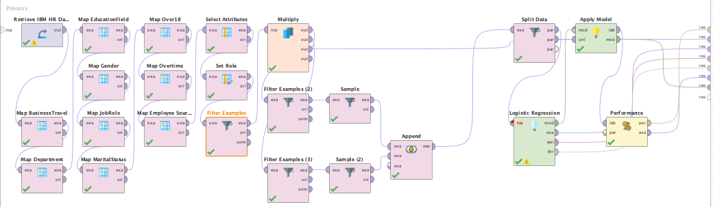
After the coding and cleaning of data, the result below shows the number of resigned and current employees.
Figure 2 Current and Resigned Employee Count
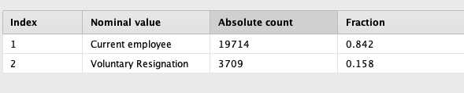
There is still discrepancy as the number of current employees (19714) outnumber the resigned employees (3709) by a huge amount. This is bad as the dataset is imbalanced. For imbalanced datasets, overall accuracy can be misleading because the high accuracy achieved might simply reflect good performance on the abundant majority class, while the minority class is misclassified (Susan & Kumar, 2021). To address imbalanced dataset, we can use undersampling, a data-level technique used to address the class imbalance problem in datasets by reducing the number of samples in the majority class to achieve a more balanced distribution of class labels (Susan & Kumar, 2021). In RapidMiner, we can utilize filter by examples and sample operator to undersample the data with current employees. This way, we can get equal number of current and resigned employees
The prediction model was used to predict the attrition column. Then the result is monitored for accuracy. For the technique, logistic regression will be utilized in this report. To monitor the accuracy of the model, the image below shows the result of the logistic regression in RapidMiner.
Figure 3 Logistic Regression result in RapidMiner
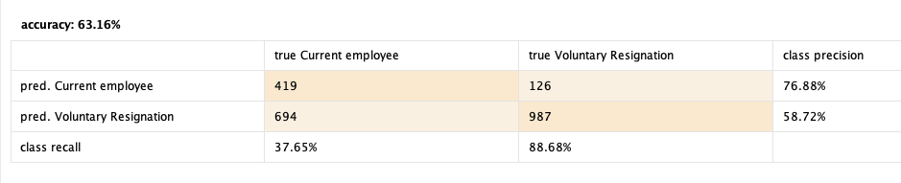
According to the result of decision tree, the accuracy is 63.16% which is moderately good to use as a model. And while the model predicted only 37.65% of current employees, which is a weak prediction, the model predicted 88.68% of all the resigned employees, which is an excellent prediction.
Since the goal of the study is to catch as many resigning employees as we can, even if we have mistakenly flagged some employees who do not initially plan to resign, this is a good model for Xero.
For the correlation we can check the coefficient and p-value of the logistic regression result. The figure below contains the result of logistic regression which contains the attribute, coefficient, standard coefficient, standard error, z-value, and p-value.
Figure 4 Logistic Regression Model Result
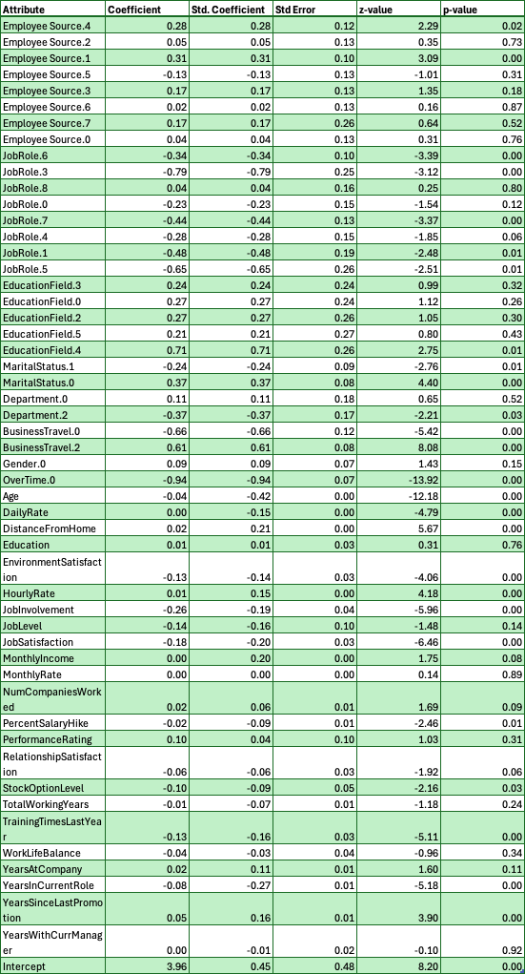
Based on the result above, we can check for attributes with p-value less than 0.02. When performing statistical tests, such as logistic regression, it is good to check p-value for null hypothesis. The p-value in statistics quantifies the evidence against a null hypothesis. A low p-value suggests data is inconsistent with the null, potentially favoring an alternative hypothesis (McLeod, 2023). When the p-value is greater than the threshold (0.02), it could signify that the results are due to chance and are not significant in supporting the idea being investigated. Thus, the null hypothesis assumes that whatever you try to prove did not happen, which means there might be no relationship between two variables being studied (ie. jobLevel and attrition) (McLeod, 2023). For the values with p-value less than 0.02, we can also check the coefficient, which is the odds that it is likely to happen, which is in this scenario, the odds that the employee might resign (Sperandei, 2014).
Based on the coefficient and the p-value, the table below contains the attributes that positively impacts attrition. Odds is also added which is computed from the coefficient (Sperandei, 2014). This is an easy indicator of what is the impact of the attribute.
Table 2 Attributes with Positive relationship with Attrition
Attribute | p-value | Coefficient | Odds = EXP(Coefficient)
BusinessTravel.2 | 0.00 | 0.61 | 1.84
DistanceFromHome | 0.00 | 0.02 | 1.02
YearsSinceLastPromotion | 0.00 | 0.05 | 1.05

Based on the table above, these 3 attributes are some of the columns with the highest odds of affecting attrition. For example, the odds increase by 84% if the employee travels frequently (BusinessTravel = 2).
We can also get the columns that negatively impact attrition. These are attributes that if we promote, it could probably increase the likelihood of employee staying. The table below contains the attributes that negatively impact attrition.
Table 3 Attributes with Negative relationship with Attrition
Attribute | p-value | Coefficient | Odds = EXP(Coefficient)
BusinessTravel.0 | 0.00 | -0.66 | 0.52
OverTime.0 | 0.00 | -0.94 | 0.39
EnvironmentSatisfaction | 0.00 | -0.13 | 0.88
JobInvolvement | 0.00 | -0.26 | 0.77
JobSatisfaction | 0.00 | -0.18 | 0.84
TrainingTimesLastYear | 0.00 | -0.13 | 0.88

Based on the table above, these 6 attributes are some of the columns with the highest odds of negatively affecting attrition. For example, employees not doing overtime (Overtime = 0), reduce the odds of the employee resigning by 61%.
For Xero, they could try to reduce or lessen these attributes (business travel, distance from home, years since last promotion) to reduce the odds of employees resigning. And Xero could also promote these attributes (training times last year, environment satisfaction, job involvement, job satisfaction, no business travel, no overtime) to increase the odds of employees staying in Xero.

Improving Employee Engagement and Satisfaction using K-Means
700 words
Application of tools
Application of techniques
Recommendations

Conclusion
150 words

References
Al-Darraji, S., Honi, D. G., Fallucchi, F., Abdulsada, A. I., Giuliano, R., & Abdulmalik, H. A. (2021). Employee Attrition Prediction Using Deep Neural Networks. Computers, 10(11), 141.
Dutta, S., & Bandyopadhyay, S. (2020). Employee attrition prediction using neural network cross validation method. International Journal of Commerce and Management, 6, 80–85.
Fallucchi, F., Coladangelo, M., Giuliano, R., & William De Luca, E. (2020). Predicting Employee Attrition Using Machine Learning Techniques. Computers, 9(4). https://doi.org/10.3390/computers9040086
McLeod, S. (2023, October 13). P-Value And Statistical Significance: What It Is & Why It Matters. Simply Psychology. https://www.simplypsychology.org/p-value.html
Sperandei, S. (2014). Understanding logistic regression analysis. Biochemia Medica (Zagreb), 24(1), 12–18. https://doi.org/10.11613/BM.2014.003
Susan, S., & Kumar, A. (2021). The balancing trick: Optimized sampling of imbalanced datasets—A brief survey of the recent State of the Art. Engineering Reports, 3(4), e12298. https://doi.org/10.1002/eng2.12298
Yang, S., & Islam, M. T. (2020). IBM Employee Attrition Analysis. arXiv Preprint arXiv:2012.01286.

