Table of Contents
Introduction 1
Interactive Visualization for Monitoring Employee Performance 1
Predicting Employee Attrition using Logistic Regression 6
Improving Employee Engagement and Satisfaction using K-Means 14
Conclusion 14
References 14

Introduction
300 words

Interactive Visualization for Monitoring Employee Performance
For managers working for Xero, utilizing business intelligence to monitor employee performance can be a huge asset. You may ask, what is employee performance monitoring? It is the use of technological means to observe, record, and analyze information that directly or indirectly relates to job performance. This type of monitoring captures employee behavior in great detail, generating rich, permanent records and can track individuals continuously, randomly, intermittently, discreetly, or intrusively, with or without warning or consent (Ravid et al., 2020). Impact of employee performance monitoring includes improving productivity and efficiency, gaining detailed insights in employee performance, helping manage human resources effectively, protecting the company from costly litigation claims and minimizing theft (McParland & Connolly, 2019). For the employees, employee performance monitoring provides constructive performance feedback and helps identify strengths, and weaknesses and training needs. It improves skill acquisition and employee performance over time (Ravid et al., 2020). Due to this, monitoring can help both employees and managers as it provides managers employee data to make business decisions based on objectives, and it helps employees with immediate feedback on their performance and in what area should employees need improvement.
In this report, visualization will be utilized. The visualization will have a dashboard that displays the employees and their respective performance. This enables managers and employees to track Key Performance Indicators (KPIs) and support decision-making (Ain et al., 2019).
For the tools, there are many popular tools for visualizations like Tableau, Microsoft Excel, Power BI, etc. But Power BI will be used in this study because even though Tableau is frequently mentioned as a business intelligence tool for rapid dashboard prototyping, live querying, and automated data blending (Kobi, 2024), and Microsoft Excel is used for various analytical tasks, including creating management reports and as a statistical package (Shoaib & Nandi, 2022). This study will use Power BI because it allows users to leverage various data sources and create reports for business intelligence. Power BI is also known for its flexibility in report editing, dashboard creation, design, and sharing applications (Shoaib & Nandi, 2022).
For the techniques, there are many BI techniques available such as association, classification, visualization, etc. Visualization will be used in this study, because even though association is a technique seeks to discover statistically relevant relationships among variables in a large dataset (Ajah & Nweke, 2019), and classification is a supervised learning method in data mining used to organize data into predefined categories or classes, which can be used to predict employee performance as "good" or "bad" based on various attributes (Mellisa, 2019). This study will use visualization because managers frequently report difficulties in understanding complex data, making interactive visualizations or graphs essential for analyzing details and potential applications (Božič & Dimovski, 2019). Visual cues, like charts, reduce mental burdens and aid decision-making by enabling automatic visual perception(Ballard, 2020).
The dataset that will be used in this report will come from a public repository in GitHub (https://github.com/abroniewski/Jira-Dataset-Time-Estimate-Study/blob/main/data/processed/clean_data_v2.csv). For the data cleaning, rows with missing employee assignee are removed since it is almost impossible to identify who did the task. For the data coding, two conditional columns are added to the dataset using Power BI to categorize the time spent on each task and the priority of each task. The table below shows the conditional column used in this study.
Table 1 Data Coding for Data visualization
Variable | Coding
resolution_range | timespent <= 1440, "less than 1 day"  timespent <= 4320 AND timespent > 1440, "1 to 3 days"  timespent <= 10080 AND timespent > 4320, "4 to 7 days"  timespent <= 20160 AND timespent > 10080, "2 weeks"  timespent <= 30240 AND timespent > 20160, "3 weeks"  timespent <= 40320 AND timespent > 30240, "4 weeks"  timespent <= 80640 AND timespent > 40320, "greater than 1 month"  timespent <= 120960 AND timespent > 80640, "greater than 2 months"  timespent >= 120960, "3 months or more"
Priority_severity_range | priority = "Blocker" OR priority = "P0" OR priority="Highest" OR priority = "Severe" OR priority = "P0: Blocker", "Highest"  priority = "P1: Critical" OR priority = "P1" OR priority = "Critical" OR priority = "High" OR priority = "Major", "High"  priority = "P2: Important" OR priority = "P2" OR priority = "Medium" OR priority = "Normal", "Medium"  priority = "P3: Somewhat important" OR priority = "P3" OR priority = "Low" OR priority = "Minor", "Low"  priority = "P4" OR priority = "Unprioritized" OR priority = "Optional" OR priority = "Not a Priority", "Unprioritized"  priority = "Trivial" OR priority = "Not Evaluated" OR priority = "Unset" OR priority = "", "Unset"

For the columns that will be used in the study, the table below shows the column names and description.
Table 2 Variables used for employee performance monitoring
Variable | Description
repo_name | Name of Repository or project
resolution_range | Period for how long the time spent on the ticket
Priority_severity_range | Priority of each task
assignee_id | Name of the employee assigned on the task

To create the dashboard in Power BI, four column names are used for the report. Assignee name, time spent per task, repository name, and priority. The figure below shows the count of tickets resolved and the time spent.
Figure 1 Count of tickets resolved and time spent
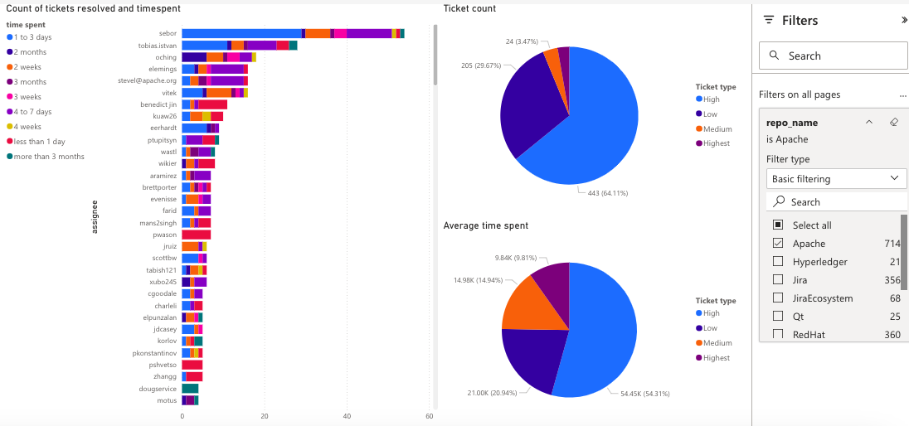
Based on the figure above, it shows the leaderboard of the employees who have resolved the most tickets for the repository ‘Apache’. It also shows the breakdown of the number of tickets resolved as well as the average time spent per ticket. For managers, this can be helpful to know the tasks resolved by each of their employees as well as if they are hitting their KPIs. Managers can leverage real-time insights from visualization tools to "set objectives, assign resources, and develop realistic budgets that align with the long-term strategy of the company by examining financial data (Nesterak & Ziębicki, 2024). For a similar dashboard that shows the tickets resolved and the ticket priorities, a figure below is shown.

Figure 2 Top 10 assignees based on tickets resolved
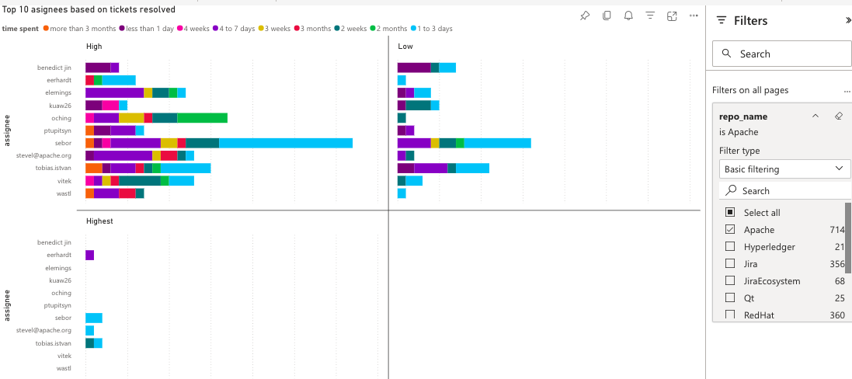
Based on the figure above, it shows the leaderboard of top ten employees based on tickets resolved and the priority. Based on the figure we can say that, within the top ten employees, only four employees have tasks with the ‘Highest’ priority. Majority of them focused on the ‘High’ and ‘Low’ priority tasks. This could mean many things, either there are few ‘Highest’ priority tasks, or the rest of the employees did not take any ‘Highest’ tasks on purpose. For a similar dashboard that shows the average time spent and the ticket priority, a figure below is shown.
Figure 3 Top 10 assignees based on average time spent
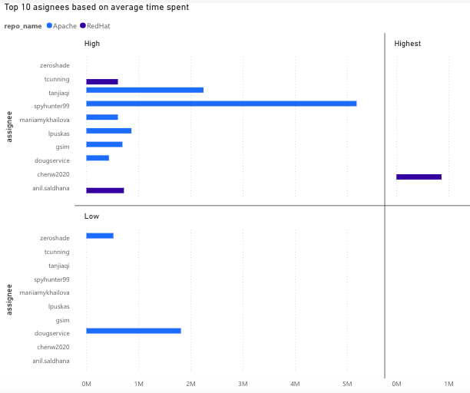
Based on the figure above, we can say that only one employee spent all their effort on ‘Highest’ priority tasks, and the rest allocated their time on ‘High’ and ‘Low’ priority tasks.
For the recommendation, managers working for Xero could try to implement these dashboards similarly, but include other attributes such as productivity, quality, and number of tickets closed per period of time (Agyepong et al., 2020).

Predicting Employee Attrition using Logistic Regression
Until today, employee attrition is still a widespread challenge across many companies, including Xero. Also known as employee turnover, it involves staff leaving a company for a variety of reasons. Employee attrition is considered a serious and critical issue for organizations. It has adverse effects on productivity, overall workflow, and business performance (Dutta & Bandyopadhyay, 2020). When employees leave, organizations face significant financial losses associated with costs in hiring and training new staff to fill vacant positions. Organizations also lose invaluable tacit knowledge, skills, and experience that employees take with them (Fallucchi et al., 2020). Minimizing employee attrition is crucial for organizations to maintain a competitive advantage and achieve objectives in time (Yang & Islam, 2020).
In this report, prediction will be utilized. Identifying employees who might leave can be important to companies, early prediction of employee attrition before it occurs can help reduce its influence or prevent it (Al-Darraji et al., 2021).
The dataset that will be used in this report will come from Kaggle (https://www.kaggle.com/datasets/rushikeshghate/capstone-projectibm-employee-attrition-prediction). First, coding was executed in RapidMiner to convert all categorical values to numerical. The table below shows the coding done for the variables that will be used in this dataset.
Table 3 Coding for Employee Attrition Prediction Dataset
Variables | Coding
Attrition | 0 = 'Current Employee', 1 = 'Voluntary Resignation'
BusinessTravel | 0 = 'Non-Travel', 1 = 'Travel_Rarely', 2 = 'Travel_Frequently'
Department | 0 = 'Sales', 1 = 'Human Resources', 2 = 'Research & Development'
EducationField | 0 = 'Life Sciences', 1 = 'Human Resources', 2 = 'Marketing', 3 = 'Medical', 4 = 'Technical Degree', 5 = 'Other'
Gender | 0 = 'Male', 1 = 'Female'
Job Role | 0 = 'Healthcare Representative', 1 = 'Human Resources', 2 = 'Laboratory Technician', 3 = 'Manager', 4 = 'Manufacturing Director', 5 = 'Research Director', 6 = 'Research Scientist', 7 = 'Sales Executive', 8 = 'Sales Representative'
Marital Status | 0 = 'Single', 1 = 'Divorced', 2 = 'Married'
Over18 | 0 = 'No', 1 = 'Yes'
Overtime | 0 = 'No', 1 = 'Yes'
EmployeeSource | 0 = 'Adzuna', 1 = 'Company Website', 2 = 'GlassDoor', 3 = 'Indeed', 4 = 'Jora', 5 = 'Linkedin', 6 = 'Recruit.net', 7 = 'Referral', 8 = 'Seek'

Second, since the attrition column will be predicted in this study, it is set as label. Third, the redundant columns are removed to avoid misrepresentation (ie. ‘Over18’, ‘EmployeeCount’, ‘EmployeeNumber’). Fourth, rows with empty values are removed. Fifth, the dataset is split into 70% and 30%, with 70% used to train the model, and 30% for predicting the attrition. The image below shows the coding design in RapidMiner.
For the columns used, the table below contains the name and description of each variable used in this study.
Table 4 Variables used
Variable | Description
Employee Source | Where the employee was hired
OverTime | If employee did overtime or not
MaritalStatus | If employee is single, married or widow
JobRole | The position held by the employee in the organization
Gender | Gender of the employee
BusinessTravel | Frequency of business travel
Attrition | Whether the employee left the company
Age | Age of the employee
DailyRate | Daily rate of pay
DistanceFromHome | Distance from home to workplace
Education | Level of education attained (1=Below College, 5=Doctor)
EnvironmentSatisfaction | Satisfaction with the work environment (1=Low, 4=Very High)
HourlyRate | Hourly wage
JobInvolvement | Level of involvement in the job (1=Low, 4=Very High)
JobLevel | Job level within the organization
JobSatisfaction | Satisfaction with the job (1=Low, 4=Very High)
MonthlyIncome | Monthly income
MonthlyRate | Monthly rate of pay
NumCompaniesWorked | Number of companies the employee has worked for
PercentSalaryHike | Percentage increase in salary
PerformanceRating | Performance rating (1=Low, 4=Outstanding)
RelationshipSatisfaction | Satisfaction with relationships at work (1=Low, 5=Very High)
StockOptionLevel | Level of stock options granted
TotalWorkingYears | Total years of professional experience
TrainingTimesLastYear | Number of training sessions attended last year
WorkLifeBalance | Satisfaction with work-life balance (1=Bad, 5=Best)
YearsAtCompany | Total years spent in the company
YearsInCurrentRole | Years spent in the current role
YearsSinceLastPromotion | Years since last promotion
YearsWithCurrManager | Years spent with the current manager

Figure 4 Coding for the dataset
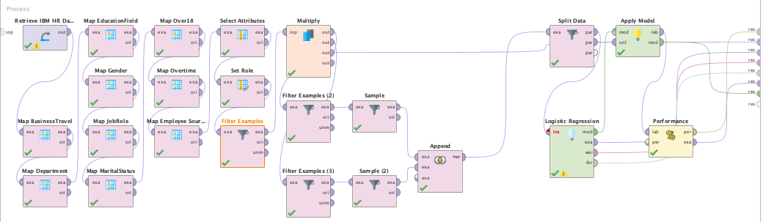
After the coding and cleaning of data, the result below shows the number of resigned and current employees.
Figure 5 Current and Resigned Employee Count
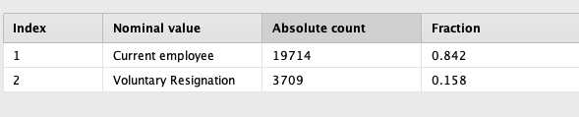
There is still discrepancy as the number of current employees (19714) outnumber the resigned employees (3709) by a huge amount. This is bad as the dataset is imbalanced. For imbalanced datasets, overall accuracy can be misleading because the high accuracy achieved might simply reflect good performance on the abundant majority class, while the minority class is misclassified (Susan & Kumar, 2021). To address imbalanced dataset, we can use undersampling, a data-level technique used to address the class imbalance problem in datasets by reducing the number of samples in the majority class to achieve a more balanced distribution of class labels (Susan & Kumar, 2021). In RapidMiner, we can utilize filter by examples and sample operator to undersample the data with current employees. This way, we can get equal number of current and resigned employees
The prediction model was used to predict the attrition column. Then the result is monitored for accuracy. For the technique, logistic regression will be utilized in this report. To monitor the accuracy of the model, the image below shows the result of the logistic regression in RapidMiner.
Figure 6 Logistic Regression result in RapidMiner
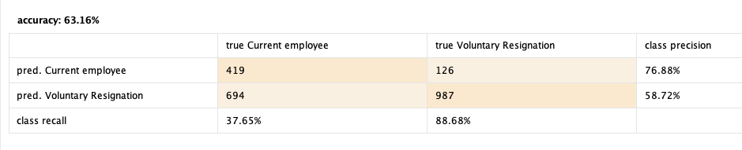
According to the result of decision tree, the accuracy is 63.16% which is moderately good to use as a model. And while the model predicted only 37.65% of current employees, which is a weak prediction, the model predicted 88.68% of all the resigned employees, which is an excellent prediction.
Since the goal of the study is to catch as many resigning employees as we can, even if we have mistakenly flagged some employees who do not initially plan to resign, this is a good model for Xero.
For the correlation we can check the coefficient and p-value of the logistic regression result. The figure below contains the result of logistic regression which contains the attribute, coefficient, standard coefficient, standard error, z-value, and p-value.

Figure 7 Logistic Regression Model Result
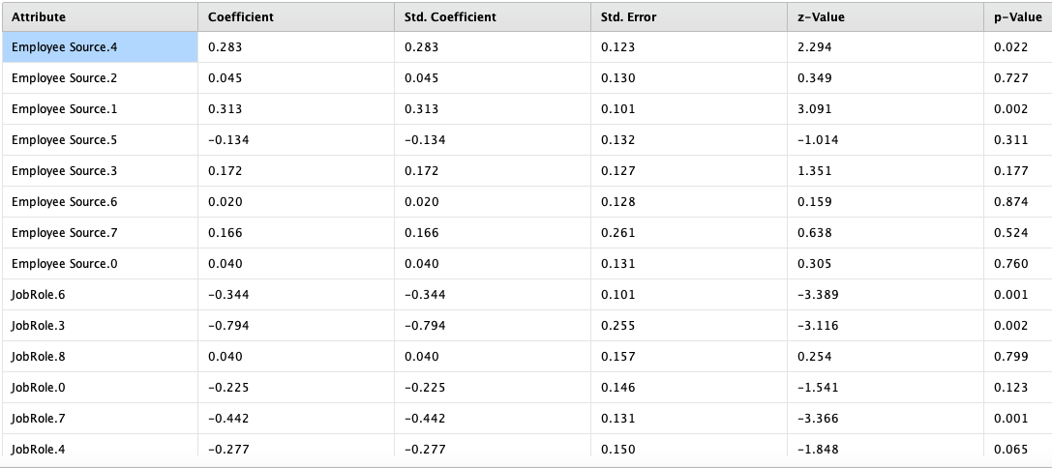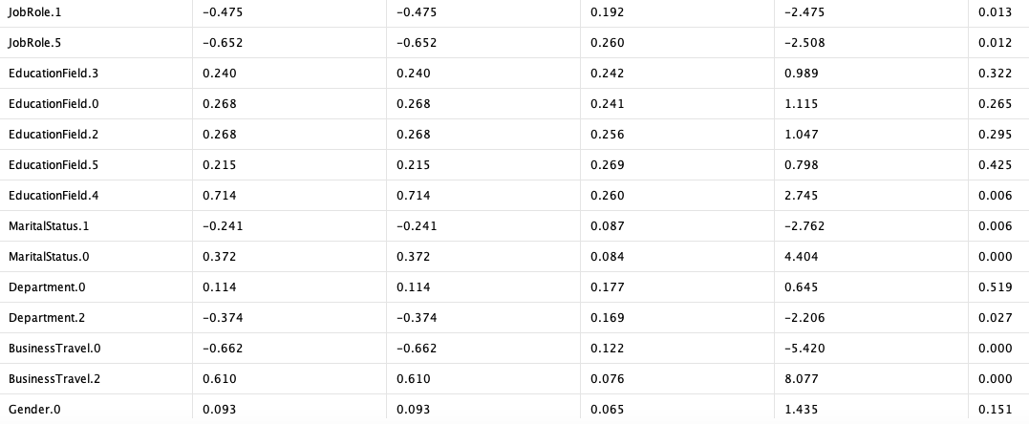
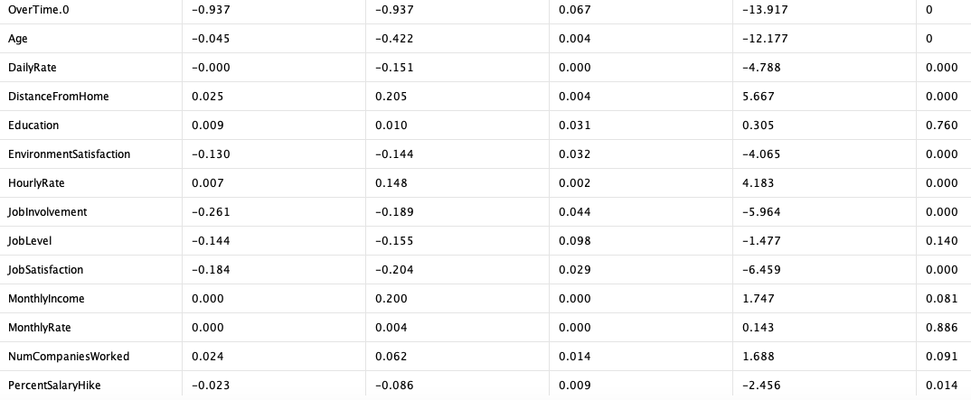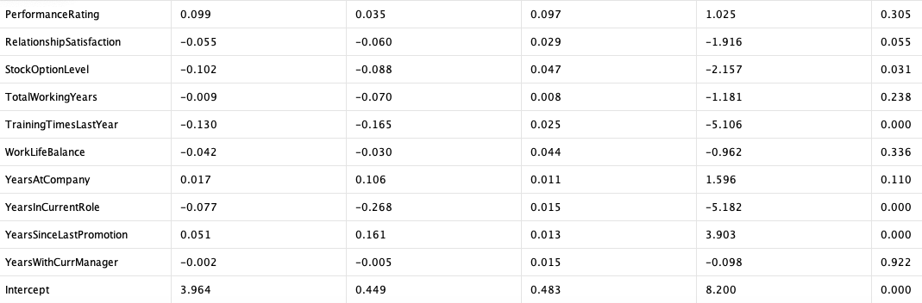
Based on the result above, we can check for attributes with p-value less than 0.02. When performing statistical tests, such as logistic regression, it is good to check p-value for null hypothesis. The p-value in statistics quantifies the evidence against a null hypothesis. A low p-value suggests data is inconsistent with the null, potentially favoring an alternative hypothesis (McLeod, 2023). When the p-value is greater than the threshold (0.02), it could signify that the results are due to chance and are not significant in supporting the idea being investigated. Thus, the null hypothesis assumes that whatever you try to prove did not happen, which means there might be no relationship between two variables being studied (ie. jobLevel and attrition) (McLeod, 2023). For the values with p-value less than 0.02, we can also check the coefficient, which is the odds that it is likely to happen, which is in this scenario, the odds that the employee might resign (Sperandei, 2014).
Based on the coefficient and the p-value, the table below contains the attributes that positively impacts attrition. Odds is also added which is computed from the coefficient (Sperandei, 2014). This is an easy indicator of what is the impact of the attribute.
Table 5 Attributes with Positive relationship with Attrition
Attribute | p-value | Coefficient | Odds = EXP(Coefficient)
BusinessTravel.2 | 0.00 | 0.61 | 1.84
DistanceFromHome | 0.00 | 0.02 | 1.02
YearsSinceLastPromotion | 0.00 | 0.05 | 1.05

Based on the table above, these 3 attributes are some of the columns with the highest odds of affecting attrition. For example, the odds increase by 84% if the employee travels frequently (BusinessTravel = 2).
We can also get the columns that negatively impact attrition. These are attributes that if we promote, it could probably increase the likelihood of employee staying. The table below contains the attributes that negatively impact attrition.
Table 6 Attributes with Negative relationship with Attrition
Attribute | p-value | Coefficient | Odds = EXP(Coefficient)
BusinessTravel.0 | 0.00 | -0.66 | 0.52
OverTime.0 | 0.00 | -0.94 | 0.39
EnvironmentSatisfaction | 0.00 | -0.13 | 0.88
JobInvolvement | 0.00 | -0.26 | 0.77
JobSatisfaction | 0.00 | -0.18 | 0.84
TrainingTimesLastYear | 0.00 | -0.13 | 0.88

Based on the table above, these 6 attributes are some of the columns with the highest odds of negatively affecting attrition. For example, employees not doing overtime (Overtime = 0), reduce the odds of the employee resigning by 61%.
For Xero, they could try to reduce or lessen these attributes (business travel, distance from home, years since last promotion) to reduce the odds of employees resigning. And Xero could also promote these attributes (training times last year, environment satisfaction, job involvement, job satisfaction, no business travel, no overtime) to increase the odds of employees staying in Xero.

Improving Employee Engagement and Satisfaction using K-Means
700 words
Application of tools
Application of techniques
Recommendations

Conclusion
150 words

References
Agyepong, E., Cherdantseva, Y., Reinecke, P., & Burnap, P. (2020). Challenges and Performance Metrics for Security Operations Center Analysts: A Systematic Review. Journal of Cyber Security Technology, 4(3), 125–152. https://doi.org/10.1080/23742917.2020.1766135
Ain, N., Vaia, G., DeLone, W. H., & Waheed, M. (2019). Two decades of research on business intelligence system adoption, utilization and success – A systematic literature review. Decision Support Systems, 125, 113113.
Ajah, I. A., & Nweke, H. F. (2019). Big Data and Business Analytics: Trends, Platforms, Success Factors and Applications. Big Data and Cognitive Computing, 3(2), 32. https://doi.org/10.3390/bdcc3020032
Al-Darraji, S., Honi, D. G., Fallucchi, F., Abdulsada, A. I., Giuliano, R., & Abdulmalik, H. A. (2021). Employee Attrition Prediction Using Deep Neural Networks. Computers, 10(11), 141.
Ballard, A. (2020). Promoting Performance Information Use Through Data Visualization: Evidence from an Experiment. Public Performance & Management Review, 43(1), 109–128. https://doi.org/10.1080/15309576.2019.1691023
Božič, K., & Dimovski, V. (2019). Business intelligence and analytics for value creation: The role of absorptive capacity. International Journal of Information Management, 46, 93–103.
Dutta, S., & Bandyopadhyay, S. (2020). Employee attrition prediction using neural network cross validation method. International Journal of Commerce and Management, 6, 80–85.
Fallucchi, F., Coladangelo, M., Giuliano, R., & William De Luca, E. (2020). Predicting Employee Attrition Using Machine Learning Techniques. Computers, 9(4). https://doi.org/10.3390/computers9040086
Kobi, J. (2024). Developing dashboard analytics and visualization tools for effective performance management and continuous process improvement. International Journal of Innovative Science and Research Technology.
McLeod, S. (2023, October 13). P-Value And Statistical Significance: What It Is & Why It Matters. Simply Psychology. https://www.simplypsychology.org/p-value.html
McParland, C., & Connolly, R. (2019). Employee monitoring in the digital era: Managing the impact of innovation. ENTRENOVA-ENTerprise REsearch InNOVAtion, 5(1), 474–483.
Mellisa, I. (2019). Building Data Mining Decision Tree Model for Predicting Employee Performance. Journal of Applied Information, Communication and Technology, 6(2), 75–86.
Nesterak, J., & Ziębicki, B. (Eds.). (2024). Integrated Approaches to Sustainable Management. Krakow University of Economics Press. https://wydawnictwo.uek.krakow.pl
Ravid, D. M., Tomczak, D. L., White, J. C., & Behrend, T. S. (2020). EPM 20/20: A review, framework, and research agenda for electronic performance monitoring. Journal of Management, 46(1), 100–126.
Shoaib, G., & Nandi, S. (2022). Power Bi Dashboard for Data Analysis. International Research Journal of Engineering and Technology (IRJET), 9(07), 2395–0056.
Sperandei, S. (2014). Understanding logistic regression analysis. Biochemia Medica (Zagreb), 24(1), 12–18. https://doi.org/10.11613/BM.2014.003
Susan, S., & Kumar, A. (2021). The balancing trick: Optimized sampling of imbalanced datasets—A brief survey of the recent State of the Art. Engineering Reports, 3(4), e12298. https://doi.org/10.1002/eng2.12298
Yang, S., & Islam, M. T. (2020). IBM Employee Attrition Analysis. arXiv Preprint arXiv:2012.01286.

