Table of Contents
Introduction 1
Interactive Visualization for Monitoring Employee Performance 1
Predicting Employee Attrition using Logistic Regression 6
Improving Employee Productivity using K-Means 15
Conclusion 19
References 19

Introduction
The use of Business Intelligence (BI) in today’s age has been more crucial than ever before. For Xero, leader in cloud-based accounting software, can utilize BI in different tasks such as utilizing data to find opportunities, manage risk, and make business decisions based on data (Niu et al., 2021).
This study will explain in detail the three business requirements for how BI will be used at Xero. And it will be closed by the conclusion where it will briefly discuss the business requirements, and recommendations for Xero.

Interactive Visualization for Monitoring Employee Performance
For managers working for Xero, utilizing business intelligence to monitor employee performance can be a huge asset. You may ask, what is employee performance monitoring? It is the use of technological means to observe, record, and analyze information that directly or indirectly relates to job performance. This type of monitoring captures employee behavior in great detail, generating rich, permanent records and can track individuals continuously, randomly, intermittently, discreetly, or intrusively, with or without warning or consent (Ravid et al., 2020). Impact of employee performance monitoring includes improving productivity and efficiency, gaining detailed insights in employee performance, helping manage human resources effectively, protecting the company from costly litigation claims and minimizing theft (McParland & Connolly, 2019). For the employees, employee performance monitoring provides constructive performance feedback and helps identify strengths, and weaknesses and training needs. It improves skill acquisition and employee performance over time (Ravid et al., 2020). Due to this, monitoring can help both employees and managers as it provides managers employee data to make business decisions based on objectives, and it helps employees with immediate feedback on their performance and in what area should employees need improvement.
For the tools, there are many popular tools for visualizations like Tableau, Microsoft Excel, Power BI, etc. But Power BI will be used in this study because even though Tableau is frequently mentioned as a business intelligence tool for rapid dashboard prototyping, live querying, and automated data blending (Kobi, 2024), and Microsoft Excel is used for various analytical tasks, including creating management reports and as a statistical package (Shoaib & Nandi, 2022). This study will use Power BI because it allows users to leverage various data sources and create reports for business intelligence. Power BI is also known for its flexibility in report editing, dashboard creation, design, and sharing applications (Shoaib & Nandi, 2022).
For the techniques, there are many BI techniques available such as association, classification, visualization, etc. Visualization will be used in this study, because even though association is a technique seeks to discover statistically relevant relationships among variables in a large dataset (Ajah & Nweke, 2019), and classification is a supervised learning method in data mining used to organize data into predefined categories or classes, which can be used to predict employee performance as "good" or "bad" based on various attributes (Mellisa, 2019). This study will use visualization because managers frequently report difficulties in understanding complex data, making interactive visualizations or graphs essential for analyzing details and potential applications (Božič & Dimovski, 2019). Visual cues, like charts, reduce mental burdens and aid decision-making by enabling automatic visual perception(Ballard, 2020).
In this report, visualization will be utilized. The visualization will have a dashboard that displays the employees and their respective performance. This enables managers and employees to track Key Performance Indicators (KPIs) and support decision-making (Ain et al., 2019).
The dataset that will be used in this report will come from a public repository in GitHub (https://github.com/abroniewski/Jira-Dataset-Time-Estimate-Study/blob/main/data/processed/clean_data_v2.csv). For the data cleaning, rows with missing employee assignee are removed since it is almost impossible to identify who did the task. For the data coding, two conditional columns are added to the dataset using Power BI to categorize the time spent on each task and the priority of each task. The table below shows the conditional column used in this study.
Table 1 Data Coding for Data visualization
Variable | Coding
resolution_range | timespent <= 1440, "less than 1 day"  timespent <= 4320 AND timespent > 1440, "1 to 3 days"  timespent <= 10080 AND timespent > 4320, "4 to 7 days"  timespent <= 20160 AND timespent > 10080, "2 weeks"  timespent <= 30240 AND timespent > 20160, "3 weeks"  timespent <= 40320 AND timespent > 30240, "4 weeks"  timespent <= 80640 AND timespent > 40320, "greater than 1 month"  timespent <= 120960 AND timespent > 80640, "greater than 2 months"  timespent >= 120960, "3 months or more"
Priority_severity_range | priority = "Blocker" OR priority = "P0" OR priority="Highest" OR priority = "Severe" OR priority = "P0: Blocker", "Highest"  priority = "P1: Critical" OR priority = "P1" OR priority = "Critical" OR priority = "High" OR priority = "Major", "High"  priority = "P2: Important" OR priority = "P2" OR priority = "Medium" OR priority = "Normal", "Medium"  priority = "P3: Somewhat important" OR priority = "P3" OR priority = "Low" OR priority = "Minor", "Low"  priority = "P4" OR priority = "Unprioritized" OR priority = "Optional" OR priority = "Not a Priority", "Unprioritized"  priority = "Trivial" OR priority = "Not Evaluated" OR priority = "Unset" OR priority = "", "Unset"

For the columns that will be used in the study, the table below shows the column names and description.
Table 2 Variables used for employee performance monitoring
Variable | Description
repo_name | Name of Repository or project
resolution_range | Period for how long the time spent on the ticket
Priority_severity_range | Priority of each task
assignee_id | Name of the employee assigned on the task

To create the dashboard in Power BI, four column names are used for the report. Assignee name, time spent per task, repository name, and priority. The figure below shows the count of tickets resolved and the time spent.
Figure 1 Count of tickets resolved and time spent
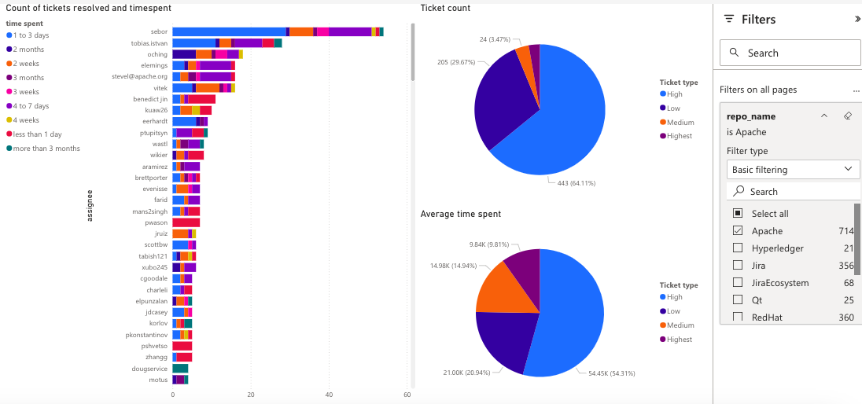
Based on the figure above, it shows the leaderboard of the employees who have resolved the most tickets for the repository ‘Apache’. It also shows the breakdown of the number of tickets resolved as well as the average time spent per ticket. For managers, this can be helpful to know the tasks resolved by each of their employees as well as if they are hitting their KPIs. Managers can leverage real-time insights from visualization tools to "set objectives, assign resources, and develop realistic budgets that align with the long-term strategy of the company by examining financial data (Nesterak & Ziębicki, 2024). For a similar dashboard that shows the tickets resolved and the ticket priorities, a figure below is shown.
Figure 2 Top 10 assignees based on tickets resolved
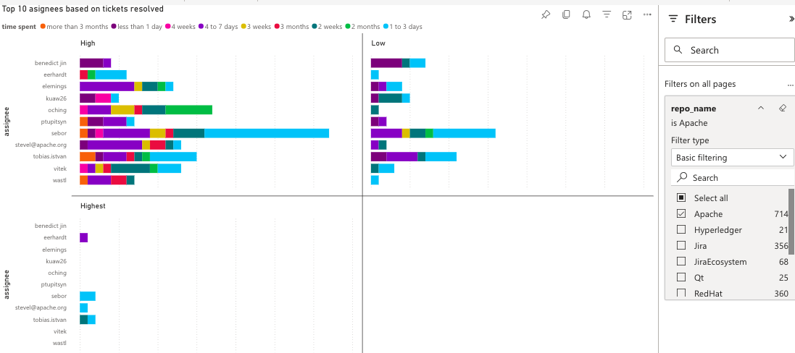
Based on the figure above, it shows the leaderboard of top ten employees based on tickets resolved and the priority. Based on the figure we can say that, within the top ten employees, only four employees have tasks with the ‘Highest’ priority. Majority of them focused on the ‘High’ and ‘Low’ priority tasks. This could mean many things, either there are few ‘Highest’ priority tasks, or the rest of the employees did not take any ‘Highest’ tasks on purpose. For a similar dashboard that shows the average time spent and the ticket priority, a figure below is shown.
Figure 3 Top 10 assignees based on average time spent
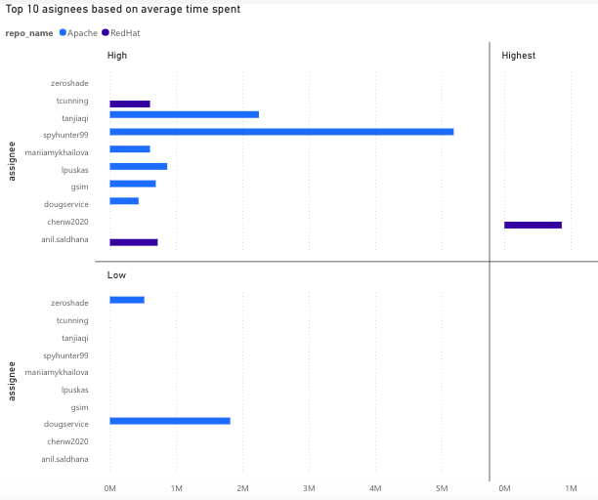
Based on the figure above, we can say that only one employee spent all their effort on ‘Highest’ priority tasks, and the rest allocated their time on ‘High’ and ‘Low’ priority tasks.
For the recommendation, managers working for Xero could try to implement these dashboards similarly, but include other attributes such as productivity, quality, and number of tickets closed per period of time (Agyepong et al., 2020).

Predicting Employee Attrition using Logistic Regression
Until today, employee attrition is still a widespread challenge across many companies, including Xero. Also known as employee turnover, it involves staff leaving a company for a variety of reasons. Employee attrition is considered a serious and critical issue for organizations. It has adverse effects on productivity, overall workflow, and business performance (Dutta & Bandyopadhyay, 2020). When employees leave, organizations face significant financial losses associated with costs in hiring and training new staff to fill vacant positions. Organizations also lose invaluable tacit knowledge, skills, and experience that employees take with them (Fallucchi et al., 2020). Minimizing employee attrition is crucial for organizations to maintain a competitive advantage and achieve objectives in time (Yang & Islam, 2020).
For the tools that can be used in this study, various tools such as clustering, association, prediction etc. can be helpful in employee attrition. In the context of employee attrition, clustering can be used to identify natural groupings of employees within an organization without prior knowledge of labels (e.g., who resigned or not). This can help classify which types of people are more likely to quit (Yang & Islam, 2020). Association can be used to identify frequent co-occurring features or patterns that lead to attrition, helping to understand causal or influential relationships (e.g., working overtime and low income might frequently associate with employee departures) (S. M. Alhashmi, 2019). Prediction can be used by companies to identify employees with the highest retention risk or those who might be highly targeted for poaching. The goal is to help companies improve retention strategies on crucial employees and boost employee satisfaction (Qutub et al., 2021). Prediction will be used in this study as a proactive intervention since prediction models can directly identify individual employees at high risk of leaving before they do (Pratt et al., 2021). This is useful for Xero as they could implement initiatives on these employees to prevent attrition.
For the techniques, techniques such as decision tree, Naïve Bayes, logistic regression, etc. are effective in predicting employee attrition. In the context of employee attrition, decision tree can predict outcomes like "Leave" or "Stay" by examining feature values. For example, a decision tree might reveal paths where employees working overtime with low income and no recent promotion are likely to leave (S. M. Alhashmi, 2019). Naïve Bayes can classify instances based on the probabilities of each attribute within each class. It is used to predict the likelihood of an employee departing from a company (Fallucchi et al., 2020). Logistic regression can predict the probability of an event (e.g., an employee leaving) and can analyze the influencing factors of the problem. It models the relationship between dependent (attrition) and independent variables (e.g., age, job satisfaction, monthly income, years at company) (Ponnuru et al., 2020). For this study, logistic regression will be used for multiple reasons such as it simple to implement and interpret (El-Rayes et al., 2020), and it directly predicts the probability of an event (attrition) (Nandal et al., 2024). This output is highly valuable to HR departments, allowing them to not only classify employees as "at risk" but also quantify how much at risk they are. This allows for prioritization of interventions on employees with the highest attrition probability.
In this report, prediction will be utilized. Identifying employees who might leave can be important to companies, early prediction of employee attrition before it occurs can help reduce its influence or prevent it (Al-Darraji et al., 2021).
The dataset that will be used in this report will come from Kaggle (https://www.kaggle.com/datasets/rushikeshghate/capstone-projectibm-employee-attrition-prediction). First, coding was executed in RapidMiner to convert all categorical values to numerical. The table below shows the coding done for the variables that will be used in this dataset.
Table 3 Coding for Employee Attrition Prediction Dataset
Variables | Coding
Attrition | 0 = 'Current Employee', 1 = 'Voluntary Resignation'
BusinessTravel | 0 = 'Non-Travel', 1 = 'Travel_Rarely', 2 = 'Travel_Frequently'
Department | 0 = 'Sales', 1 = 'Human Resources', 2 = 'Research & Development'
EducationField | 0 = 'Life Sciences', 1 = 'Human Resources', 2 = 'Marketing', 3 = 'Medical', 4 = 'Technical Degree', 5 = 'Other'
Gender | 0 = 'Male', 1 = 'Female'
Job Role | 0 = 'Healthcare Representative', 1 = 'Human Resources', 2 = 'Laboratory Technician', 3 = 'Manager', 4 = 'Manufacturing Director', 5 = 'Research Director', 6 = 'Research Scientist', 7 = 'Sales Executive', 8 = 'Sales Representative'
Marital Status | 0 = 'Single', 1 = 'Divorced', 2 = 'Married'
Over18 | 0 = 'No', 1 = 'Yes'
Overtime | 0 = 'No', 1 = 'Yes'
EmployeeSource | 0 = 'Adzuna', 1 = 'Company Website', 2 = 'GlassDoor', 3 = 'Indeed', 4 = 'Jora', 5 = 'Linkedin', 6 = 'Recruit.net', 7 = 'Referral', 8 = 'Seek'

Second, since the attrition column will be predicted in this study, it is set as label. Third, the redundant columns are removed to avoid misrepresentation (ie. ‘Over18’, ‘EmployeeCount’, ‘EmployeeNumber’). Fourth, rows with empty values are removed. Fifth, the dataset is split into 70% and 30%, with 70% used to train the model, and 30% for predicting the attrition. The image below shows the coding design in RapidMiner.
For the columns used, the table below contains the name and description of each variable used in this study.
Table 4 Variables used
Variable | Description
Employee Source | Where the employee was hired
OverTime | If employee did overtime or not
MaritalStatus | If employee is single, married or widow
JobRole | The position held by the employee in the organization
Gender | Gender of the employee
BusinessTravel | Frequency of business travel
Attrition | Whether the employee left the company
Age | Age of the employee
DailyRate | Daily rate of pay
DistanceFromHome | Distance from home to workplace
Education | Level of education attained (1=Below College, 5=Doctor)
EnvironmentSatisfaction | Satisfaction with the work environment (1=Low, 4=Very High)
HourlyRate | Hourly wage
JobInvolvement | Level of involvement in the job (1=Low, 4=Very High)
JobLevel | Job level within the organization
JobSatisfaction | Satisfaction with the job (1=Low, 4=Very High)
MonthlyIncome | Monthly income
MonthlyRate | Monthly rate of pay
NumCompaniesWorked | Number of companies the employee has worked for
PercentSalaryHike | Percentage increase in salary
PerformanceRating | Performance rating (1=Low, 4=Outstanding)
RelationshipSatisfaction | Satisfaction with relationships at work (1=Low, 5=Very High)
StockOptionLevel | Level of stock options granted
TotalWorkingYears | Total years of professional experience
TrainingTimesLastYear | Number of training sessions attended last year
WorkLifeBalance | Satisfaction with work-life balance (1=Bad, 5=Best)
YearsAtCompany | Total years spent in the company
YearsInCurrentRole | Years spent in the current role
YearsSinceLastPromotion | Years since last promotion
YearsWithCurrManager | Years spent with the current manager
For the data coding in RapidMiner, the figure below shows the design used.
Figure 4 Coding for the dataset
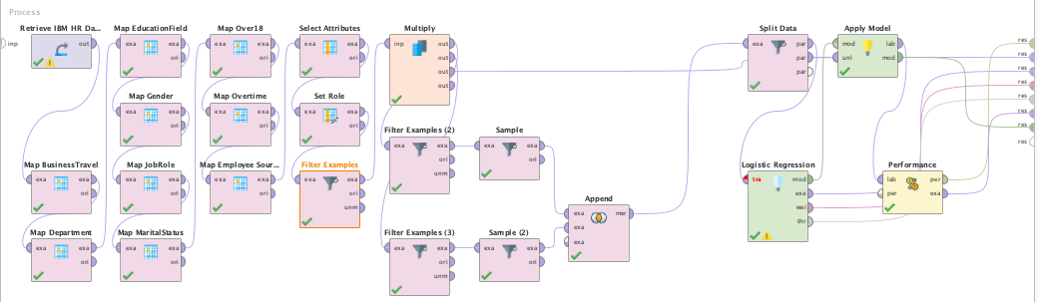
After the coding and cleaning of data, the result below shows the number of resigned and current employees.
Figure 5 Current and Resigned Employee Count
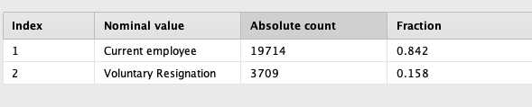
There is still discrepancy as the number of current employees (19714) outnumber the resigned employees (3709) by a huge amount. This is bad as the dataset is imbalanced. For imbalanced datasets, overall accuracy can be misleading because the high accuracy achieved might simply reflect good performance on the abundant majority class, while the minority class is misclassified (Susan & Kumar, 2021). To address imbalanced dataset, we can use undersampling, a data-level technique used to address the class imbalance problem in datasets by reducing the number of samples in the majority class to achieve a more balanced distribution of class labels (Susan & Kumar, 2021). In RapidMiner, we can utilize filter by examples and sample operator to undersample the data with current employees. This way, we can get equal number of current and resigned employees
The prediction model was used to predict the attrition column. Then the result is monitored for accuracy. For the technique, logistic regression will be utilized in this report. To monitor the accuracy of the model, the image below shows the result of the logistic regression in RapidMiner.
Figure 6 Logistic Regression result in RapidMiner
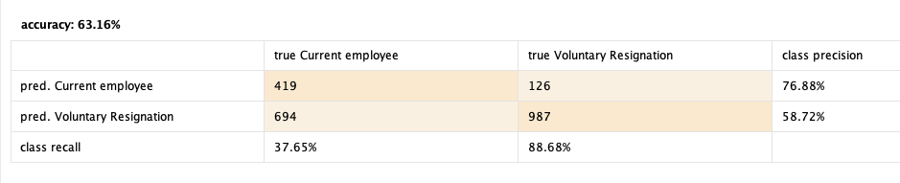
According to the result of decision tree, the accuracy is 63.16% which is moderately good to use as a model. And while the model predicted only 37.65% of current employees, which is a weak prediction, the model predicted 88.68% of all the resigned employees, which is an excellent prediction.
Since the goal of the study is to catch as many resigning employees as we can, even if we have mistakenly flagged some employees who do not initially plan to resign, this is a good model for Xero.
For the correlation we can check the coefficient and p-value of the logistic regression result. The figure below contains the result of logistic regression which contains the attribute, coefficient, standard coefficient, standard error, z-value, and p-value.
Figure 7 Logistic Regression Model Result
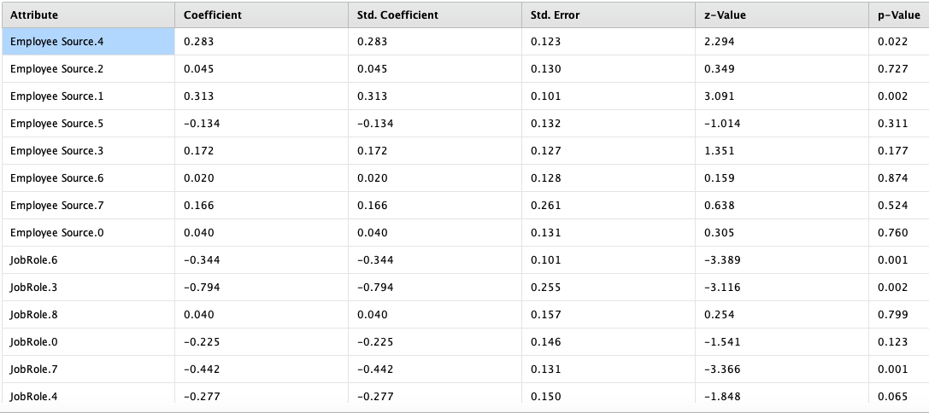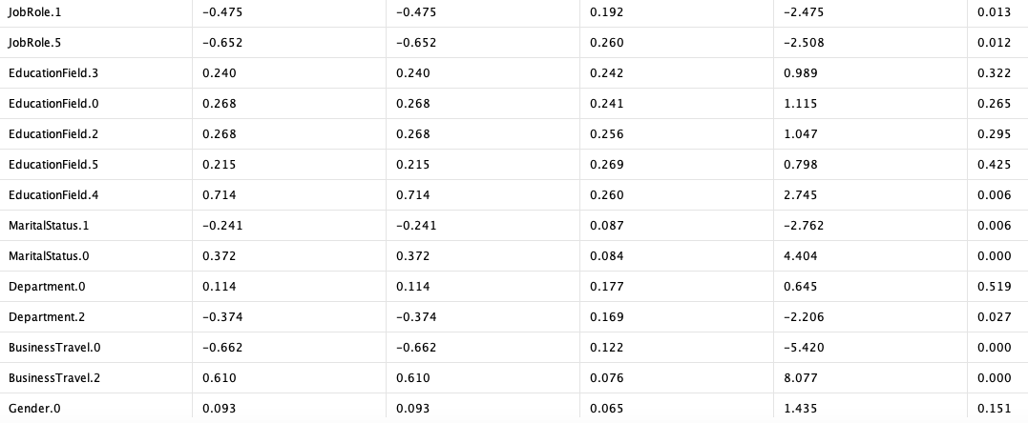
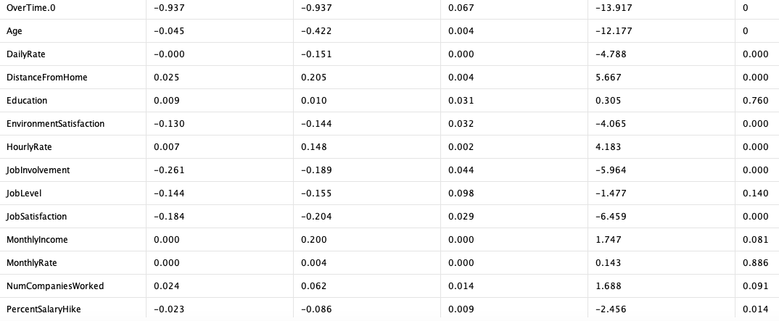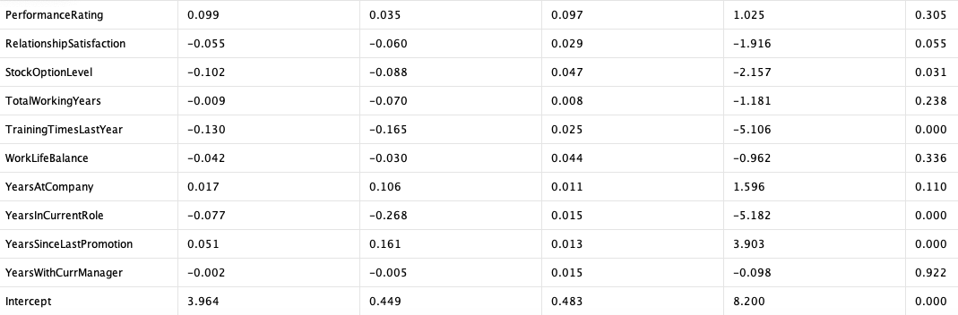
Based on the result above, we can check for attributes with p-value less than 0.02. When performing statistical tests, such as logistic regression, it is good to check p-value for null hypothesis. The p-value in statistics quantifies the evidence against a null hypothesis. A low p-value suggests data is inconsistent with the null, potentially favoring an alternative hypothesis (McLeod, 2023). When the p-value is greater than the threshold (0.02), it could signify that the results are due to chance and are not significant in supporting the idea being investigated. Thus, the null hypothesis assumes that whatever you try to prove did not happen, which means there might be no relationship between two variables being studied (ie. jobLevel and attrition) (McLeod, 2023). For the values with p-value less than 0.02, we can also check the coefficient, which is the odds that it is likely to happen, which is in this scenario, the odds that the employee might resign (Sperandei, 2014).
Based on the coefficient and the p-value, the table below contains the attributes that positively impacts attrition. Odds is also added which is computed from the coefficient (Sperandei, 2014). This is an easy indicator of what is the impact of the attribute.
Table 5 Attributes with Positive relationship with Attrition
Attribute | p-value | Coefficient | Odds = EXP(Coefficient)
BusinessTravel.2 | 0.00 | 0.61 | 1.84
DistanceFromHome | 0.00 | 0.02 | 1.02
YearsSinceLastPromotion | 0.00 | 0.05 | 1.05

Based on the table above, these 3 attributes are some of the columns with the highest odds of affecting attrition. For example, the odds increase by 84% if the employee travels frequently (BusinessTravel = 2).
We can also get the columns that negatively impact attrition. These are attributes that if we promote, it could probably increase the likelihood of employee staying. The table below contains the attributes that negatively impact attrition.
Table 6 Attributes with Negative relationship with Attrition
Attribute | p-value | Coefficient | Odds = EXP(Coefficient)
BusinessTravel.0 | 0.00 | -0.66 | 0.52
OverTime.0 | 0.00 | -0.94 | 0.39
EnvironmentSatisfaction | 0.00 | -0.13 | 0.88
JobInvolvement | 0.00 | -0.26 | 0.77
JobSatisfaction | 0.00 | -0.18 | 0.84
TrainingTimesLastYear | 0.00 | -0.13 | 0.88

Based on the table above, these 6 attributes are some of the columns with the highest odds of negatively affecting attrition. For example, employees not doing overtime (Overtime = 0), reduce the odds of the employee resigning by 61%.
For Xero, they could try to reduce or lessen these attributes (business travel, distance from home, years since last promotion) to reduce the odds of employees resigning. And Xero could also promote these attributes (training times last year, environment satisfaction, job involvement, job satisfaction, no business travel, no overtime) to increase the odds of employees staying in Xero.

Improving Employee Productivity using K-Means
Including Xero, one of the problems of managers is improving productivity of their employees. Improving productivity of employees is a difficult task that involves a comprehensive understanding of various factors influencing employee performance, the strategic role of Human Resource Management, and the potential of technological advancements. Improving employee productivity has a wide range of positive impacts for Xero, these effects include enhanced operational efficiency, increased profits and revenue, strengthened organizational health and sustainability, higher job satisfaction and motivation, reduced turnover and absenteeism, stronger organizational commitment, positive work environment, customer satisfaction and loyalty, etc. (Diamantidis & Chatzoglou, 2019; Fan, 2022; Wikhamn, 2019). Optimal employee performance is crucial for an organization's success, profitability, and competitive advantage, as employees are considered invaluable assets (Elrayah & Zakariya, 2023).
For the tools, there are a few tools applicable in this study such as prediction, association, and clustering. In terms of employee productivity, prediction can be used to anticipate future scenarios, such as who will perform well, who might leave the company, or what might happen to employee mental health given certain conditions (Fadhil, 2021). Association can be used to understand what factors are linked to employee performance, mental health, or other relevant outcomes, and what personality characteristics are shown to be associated with work engagement, job performance, and mental health (Elrayah & Zakariya, 2023; Tisu et al., 2020). Clustering can be used to understand underlying patterns and segment the workforce or work environment. This allows for a detailed description of the characteristics within each identified group (Wang, 2022). While association identifies relationships and prediction forecasts outcomes, clustering is exceptionally powerful for improving employee productivity and mental health because it enables targeted and actionable strategies (Yuwono & Hariyanti, 2024).
For the technique, there are many techniques applicable in this study such as Two-Step Cluster Analysis, Fuzzy C-Means, K-Means, etc. In the context of employee productivity, step cluster analysis can be used to identify different patterns of relationships between employee well-being and performance, considering various operationalizations (hedonic vs. eudaimonic well-being, self-rated vs. supervisor ratings, etc.) (Peiró et al., 2019). Fuzzy C-Means can be used to generate outcome variables from factor-analyzed firm performance data (turnover, profitability, market share) over a long period of time (Battisti et al., 2019). K-Means can be used to classify appraisal results into distinct categories like "excellent," "good," "qualified," and "unsatisfactory" (Fan, 2022). While Fuzzy C-Means and Step Cluster Analysis are highly suitable and widely adopted for specific aspects of employee performance and productivity management. K-Means is lauded for its simplicity and ease of implementation and interpretation, efficient and effective in handling large datasets(Yuwono & Hariyanti, 2024), excels at partitioning data into distinct, natural groups, which directly aligns with common HR practices like performance appraisal (Wang, 2022).
The dataset that will be used in this report will come from Kaggle (https://www.kaggle.com/datasets/mahdimashayekhi/mental-health). First, coding is executed in RapidMiner to convert all categorical values into numerical. After the coding, the output is written on an Excel CSV file. The figure below shows the RapidMiner design used in this study.
Figure 8 RapidMiner design for improving employee productivity
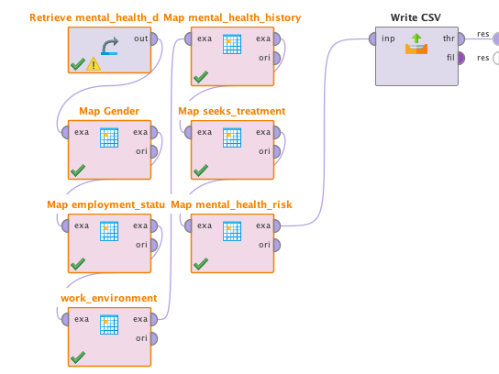
The table below shows the coding done for the variables that will be used in this study.
Table 7 Data Coding
Variable | Coding
Gender | 0 = 'Female', 1 = 'Female', 2 = 'Prefer not to say', 3 = 'Non-binary'
employment_status | 0 = 'Student', 1 = 'Unemployed', 2 = 'Self-employed', 3 = 'Employed'
work_environment | 0 = 'On-site', 1 = 'Hybrid', 2 = 'Remote'
mental_health_history | 0 = 'No', 1 = 'Yes'
seeks_treatment | 0 = 'No', 1 = 'Yes'
mental_health_risk | 0 = 'No', 1 = 'Yes'

The table below contains the variables that will be used in this study.
Variable | Description
age | Age of the individual (in years)
gender | Gender identity (e.g., Male, Female, Non-binary, Prefer not to say)
employment_status | Employment type (e.g., Employed, Student, Self-employed, Unemployed)
work_environment | Work setting (e.g., On-site, Remote, Hybrid)
mental_health_history | Whether the individual has a history of mental health issues (Yes/No)
seeks_treatment | Whether the individual is seeking mental health treatment (Yes/No)
stress_level | Self-reported stress level (scale 1–10)
sleep_hours | Average number of hours of sleep per night
physical_activity_days | Number of days per week the individual engages in physical activity (0–7)
depression_score | Score on a depression assessment scale (e.g., PHQ-9, range: 0–30)
anxiety_score | Score on an anxiety assessment scale (e.g., GAD-7, range: 0–21)
social_support_score | Perceived level of social support (scale: 0–100)
productivity_score | Self-reported or assessed productivity score (scale: 0–100)
mental_health_risk | Overall mental health risk level (e.g., Low, Medium, High)

The output Excel CSV file is then used as input for Auto Model for Clustering. The figure below shows the result of K-Means clustering with 2 clusters.
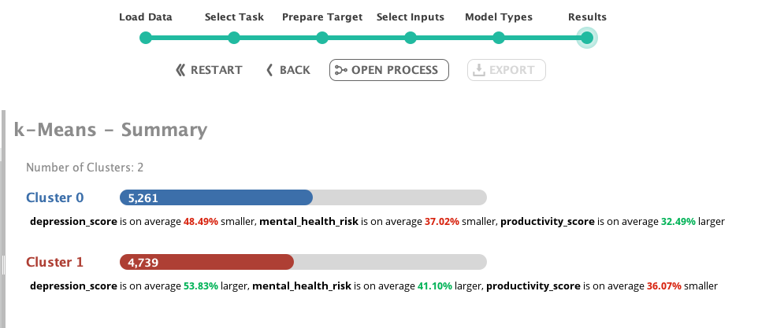
Based on the figure above, the two clusters are pretty similar, as both affects the productivity score. Cluster zero says that if we decrease depression score, and decrease mental health risk, the productivity could increase, while cluster one says that if depression score is increasing, and mental health risk is increasing, the productivity score could decrease. But since we are focused on improving the productivity, we will use cluster zero. According to cluster zero, if we lessen the depression score, lessen mental health risk, we could improve our productivity score. There are many ways to lessen depression and mental health risk. According to Elrayah & Zakariya, (2023), tackling factors such as heavy workloads, undue pressure, imbalanced work-life equilibrium, inadequate support or acknowledgment, instances of bullying or harassment, and insufficient job control or autonomy, which contribute to poor mental health. Managers and decision-makers can combat depression and mental health risk by tasks such as allocating attention to the well-being of their workforce, reviewing current working practices to ensure satisfaction with mental and physical health conditions, implementing work life balance arrangements. including options such as flexible working hours, compressed work weeks, and teleworking, which are associated with enhanced job performance and reduced turnover intention (Mansor et al., 2021). The HR management is also pivotal the establishment of these new working conditions. The HR should employ management techniques and approaches to uphold the wellbeing and collaborate with managers to develop tailored productivity improvement plans (Wang, 2022).
For the recommendation, Xero could launch these activities and initiatives in hopes to lessen depression and mental health risk, and hopefully could improve productivity of Xero’s employees.

Conclusion
Business Intelligence (BI) is an important tool for Xero. In this study, it details how visualization is used to monitor employee performance and help both managers and employees improve their team and themselves respectively, prediction is used as a proactive tool to detect at risk employees who might resign, whom Xero can initiate interventions and activities, and clustering is used to know the characteristics employees with good productivity which can be useful for initiatives and activities for other employees, in the hopes of improving productivity.
The limitation of this study is that it is lacking to vast amounts of data such as attendance, lates, etc. which most companies have these kinds of data. Xero or future researchers can tap into these missing employee data and hopefully provide a more accurate and precise interpretation of these data to further find opportunities, manage risk, and make business decisions.

References
Agyepong, E., Cherdantseva, Y., Reinecke, P., & Burnap, P. (2020). Challenges and Performance Metrics for Security Operations Center Analysts: A Systematic Review. Journal of Cyber Security Technology, 4(3), 125–152. https://doi.org/10.1080/23742917.2020.1766135
Ain, N., Vaia, G., DeLone, W. H., & Waheed, M. (2019). Two decades of research on business intelligence system adoption, utilization and success – A systematic literature review. Decision Support Systems, 125, 113113.
Ajah, I. A., & Nweke, H. F. (2019). Big Data and Business Analytics: Trends, Platforms, Success Factors and Applications. Big Data and Cognitive Computing, 3(2), 32. https://doi.org/10.3390/bdcc3020032
Al-Darraji, S., Honi, D. G., Fallucchi, F., Abdulsada, A. I., Giuliano, R., & Abdulmalik, H. A. (2021). Employee Attrition Prediction Using Deep Neural Networks. Computers, 10(11), 141.
Ballard, A. (2020). Promoting Performance Information Use Through Data Visualization: Evidence from an Experiment. Public Performance & Management Review, 43(1), 109–128. https://doi.org/10.1080/15309576.2019.1691023
Battisti, M., Beynon, M., Pickernell, D., & Deakins, D. (2019). Surviving or Thriving: The Role of Learning for the Resilient Performance of Small Firms. Journal of Business Research, 100, 38–50. https://doi.org/10.1016/j.jbusres.2019.03.006
Božič, K., & Dimovski, V. (2019). Business intelligence and analytics for value creation: The role of absorptive capacity. International Journal of Information Management, 46, 93–103.
Diamantidis, A. D., & Chatzoglou, P. (2019). Factors Affecting Employee Performance: An Empirical Approach. International Journal of Productivity and Performance Management, 68(1), 171–193. https://doi.org/10.1108/IJPPM-01-2018-0012
Dutta, S., & Bandyopadhyay, S. (2020). Employee attrition prediction using neural network cross validation method. International Journal of Commerce and Management, 6, 80–85.
Elrayah, M., & Zakariya, A. (2023). Effects of Employees Mental Health, Physical Health and Work Life-Balance on Employees Performance and Turnover Intention. Archives of Clinical Psychiatry, 50(6).
El-Rayes, N., Fang, M., Smith, M., & Taylor, S. M. (2020). Predicting Employee Attrition Using Tree-Based Models. International Journal of Organizational Analysis, 28(6), 1273–1291.
Fadhil, Z. M. (2021). Hybrid of K-Means Clustering and Naive Bayes Classifier for Predicting Performance of an Employee. Periodicals of Engineering and Natural Sciences, 9(2), 799–807.
Fallucchi, F., Coladangelo, M., Giuliano, R., & William De Luca, E. (2020). Predicting Employee Attrition Using Machine Learning Techniques. Computers, 9(4). https://doi.org/10.3390/computers9040086
Fan, C. (2022). Evaluating Employee Performance with an Improved Clustering Algorithm. Informatica, 46(5).
Kobi, J. (2024). Developing dashboard analytics and visualization tools for effective performance management and continuous process improvement. International Journal of Innovative Science and Research Technology.
Mansor, N., Sani, N. S., & Aliff, M. (2021). Machine learning for predicting employee attrition. International Journal of Advanced Computer Science and Applications (IJACSA), 12(11).
McLeod, S. (2023, October 13). P-Value And Statistical Significance: What It Is & Why It Matters. Simply Psychology. https://www.simplypsychology.org/p-value.html
McParland, C., & Connolly, R. (2019). Employee monitoring in the digital era: Managing the impact of innovation. ENTRENOVA-ENTerprise REsearch InNOVAtion, 5(1), 474–483.
Mellisa, I. (2019). Building Data Mining Decision Tree Model for Predicting Employee Performance. Journal of Applied Information, Communication and Technology, 6(2), 75–86.
Nandal, M., Grover, V., Sahu, D., & Dogra, M. (2024). Employee Attrition: Analysis of Data Driven Models. EAI Endorsed Transactions on Internet of Things, 10, 1–10.
Nesterak, J., & Ziębicki, B. (Eds.). (2024). Integrated Approaches to Sustainable Management. Krakow University of Economics Press. https://wydawnictwo.uek.krakow.pl
Niu, Y., Ying, L., Yang, J., Bao, M., & Sivaparthipan, C. B. (2021). Organizational business intelligence and decision making using big data analytics. Information Processing & Management, 58(6).
Peiró, J. M., Kozusznik, M. W., Rodríguez-Molina, I., & Tordera, N. (2019). The Happy-Productive Worker Model and Beyond: Patterns of Wellbeing and Performance at Work. International Journal of Environmental Research and Public Health, 16(3), 479. https://doi.org/10.3390/ijerph16030479
Ponnuru, S. R., Merugumala, G. K., Padigala, S., Vanga, R., & Kantapalli, B. (2020). Employee Attrition Prediction using Logistic Regression. International Journal of Research in Applied Science and Engineering Technology, 8(5), 2871–2875.
Pratt, M., Boudhane, M., & Cakula, S. (2021). Employee attrition estimation using random forest algorithm. Baltic Journal of Modern Computing, 9(1), 49–66.
Qutub, A., Al-Mehmadi, A., Al-Hssan, M., Aljohani, R., & Alghamdi, H. S. (2021). Prediction of Employee Attrition Using Machine Learning and Ensemble Methods. International Journal of Machine Learning and Computing, 11(2), 110–114.
Ravid, D. M., Tomczak, D. L., White, J. C., & Behrend, T. S. (2020). EPM 20/20: A review, framework, and research agenda for electronic performance monitoring. Journal of Management, 46(1), 100–126.
S. M. Alhashmi. (2019). Towards Understanding Employee Attrition using a Decision Tree Approach. 2019 International Conference on Digitization (ICD), 44–47. https://doi.org/10.1109/ICD47981.2019.9105767
Shoaib, G., & Nandi, S. (2022). Power Bi Dashboard for Data Analysis. International Research Journal of Engineering and Technology (IRJET), 9(07), 2395–0056.
Sperandei, S. (2014). Understanding logistic regression analysis. Biochemia Medica (Zagreb), 24(1), 12–18. https://doi.org/10.11613/BM.2014.003
Susan, S., & Kumar, A. (2021). The balancing trick: Optimized sampling of imbalanced datasets—A brief survey of the recent State of the Art. Engineering Reports, 3(4), e12298. https://doi.org/10.1002/eng2.12298
Tisu, L., Lupșa, D., Vîrgă, D., & Rusu, A. (2020). Personality Characteristics, Job Performance and Mental Health: The Mediating Role of Work Engagement. Personality and Individual Differences, 153, 109644. https://doi.org/10.1016/j.paid.2019.109644
Wang, R. (2022). Optimization of Human Resource Performance Management System Based on Improved R-Means Clustering Algorithm. Journal of Mathematics, 2022(1), 3321421. https://doi.org/10.1155/2022/3321421
Wikhamn, W. (2019). Innovation, Sustainable HRM and Customer Satisfaction. International Journal of Hospitality Management, 76, 102–110. https://doi.org/10.1016/j.ijhm.2018.04.009
Yang, S., & Islam, M. T. (2020). IBM Employee Attrition Analysis. arXiv Preprint arXiv:2012.01286.
Yuwono, D. T., & Hariyanti, A. (2024). Applying Clustering and Recommendation System for Effective Supervision in Central Kalimantan Inspectorate. Jurnal Informatika Teknologi Dan Sains (Jinteks), 6(2), 367–374.

