Integrated Docking, Pilot Molecular Dynamics, and Ligand-Based GNN Prioritization of Macaflavone Candidates Targeting the BCL-2 Canonical Groove
Draft article layout with embedded figures and quantitative tables

Abstract
This study developed an integrated computational workflow to prioritize Macaflavone I and Macaflavone II as candidate ligands targeting the BCL-2 canonical groove. The workflow combined ligand curation, strict local docking, control benchmarking with Venetoclax and BFC ligands, short-timescale pilot molecular dynamics (MD), ligand-based graph neural network (GNN) modeling, applicability-domain analysis, and conservative evidence-boundary interpretation. Docking analysis showed that Venetoclax retained the strongest canonical-groove binding affinity, while Macaflavone II slightly outperformed Macaflavone I among the two natural-product candidates. Pilot MD further prioritized Macaflavone II based on interaction-persistence descriptors. A ligand-based GIN-like GNN trained on curated BCL-2 activity records achieved a test MAE of 0.600, RMSE of 0.856, R² of 0.683, and Spearman ρ of 0.827. However, applicability-domain analysis indicated low training-space similarity for Macaflavone I and II, requiring cautious interpretation of GNN predictions. Overall, Macaflavone II emerged as the stronger Macaflavone candidate, whereas Venetoclax remained the reference control. The workflow supports computational prioritization for follow-up MM-PBSA, longer MD, or experimental validation, but does not establish confirmed BCL-2 inhibition or apoptosis activation.
Keywords: Macaflavone; BCL-2; molecular docking; pilot molecular dynamics; graph neural network; applicability domain; computational prioritization.

1. Introduction
BCL-2 is an anti-apoptotic regulator that modulates mitochondrial apoptosis by controlling pro-apoptotic partners such as BAX and BAK. Its canonical hydrophobic groove represents the principal binding site for BH3-mimetic ligands and thus remains a relevant computational target for early-stage prioritization studies.
Macaflavone I and Macaflavone II are prenylated flavonoid derivatives that offer a compact natural-product scaffold with combined aromatic, hydrogen-bonding, and hydrophobic features. Because docking score alone does not sufficiently establish biological relevance, a multi-layered workflow was used here to integrate docking, pilot MD, ligand-based GNN prediction, and applicability-domain analysis.
The goal of this work is to prioritize the stronger Macaflavone candidate for follow-up computational or experimental validation while maintaining conservative interpretation boundaries. In this framework, docking supports pose-level plausibility, pilot MD supports short-timescale interaction persistence, and the ligand-based GNN contributes an auxiliary activity-tendency signal rather than direct pose validation.

2. Methods

2.1 Overall computational workflow
The overall workflow began with ligand collection and curation, followed by BCL-2 preparation, strict local docking, complex preparation for pilot MD, integrated docking–MD interpretation, ligand-based GNN training, external ligand prediction, and final consensus prioritization.
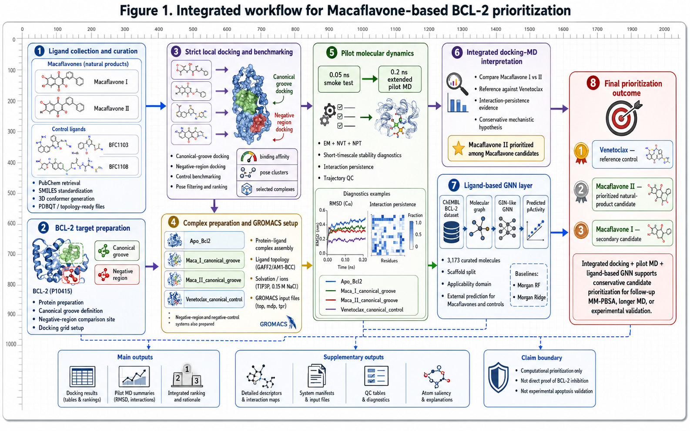
Figure 1. Integrated computational workflow for Macaflavone-based BCL-2 prioritization.
Table 1. Ligand descriptors and computational roles.
Ligand | Atom count | Bond count | Candidate code | Docking | Pilot MD | GNN prediction
Macaflavone I | 31 | 34 | 1 | 1 | 1 | 1
Macaflavone II | 32 | 35 | 1 | 1 | 1 | 1
Venetoclax | 61 | 68 | 2 | 1 | 1 | 1
BFC1103 | 26 | 27 | 3 | 0 | 0 | 1
BFC1108 | 30 | 32 | 3 | 0 | 0 | 1

Candidate code: 1 = Macaflavone candidate; 2 = canonical BCL-2 reference control; 3 = comparator ligand. For Docking / Pilot MD / GNN prediction, 1 = used and 0 = not used.

2.2 Ligand and target preparation, docking, pilot MD, and GNN setup
Ligands were standardized from curated molecular structures and prepared in docking- and MD-compatible formats. The BCL-2 model was prepared with the canonical groove as the main docking region and a negative region as a comparison site. Selected complexes were propagated through pilot MD, consisting of a 0.05 ns smoke test followed by extension to 0.20 ns for prioritized systems.
For machine learning, a ligand-based GIN-like graph neural network was trained on a curated ChEMBL BCL-2 dataset. The model operated on molecular graphs and predicted pActivity values using message passing and graph-level pooling. Baselines based on Morgan fingerprint Random Forest and Ridge regression were retained for comparison.
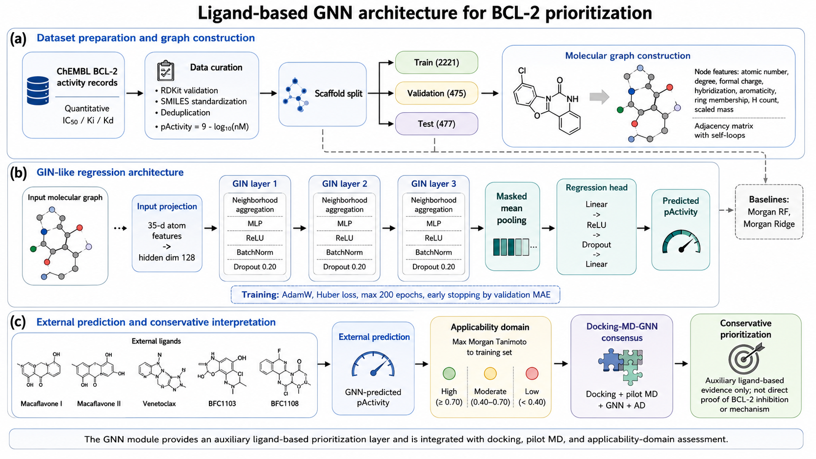
Figure 2. Ligand-based GNN architecture for BCL-2 prioritization.
Table 2. Computational setup and dataset summary.
Component | Number / setting
Macaflavone candidates | 2
Canonical reference control | 1
Comparator ligands | 2
Total external ligands | 5
Main docking region | 1
Comparison docking region | 1
Pilot MD systems | 4
Smoke-test MD duration | 0.05 ns
Extended pilot MD duration | 0.20 ns
ChEMBL BCL-2 raw activity records | 15,736
Cleaned records before deduplication | 5,906
RDKit-valid unique molecules | 3,173
Training molecules | 2,221
Validation molecules | 475
Test molecules | 477
GNN atom-feature dimension | 35
GNN hidden dimension | 128
GNN message-passing layers | 3
Dropout | 0.20
Maximum training epochs | 200
Best GNN epoch | 102

3. Results and Discussion

3.1 Strict local docking and control benchmarking
Docking showed that Venetoclax retained the strongest canonical-groove affinity, whereas Macaflavone II slightly outperformed Macaflavone I among the two natural-product candidates. The molecular panels below summarize site-focused docking views and ligand-specific interaction perspectives.
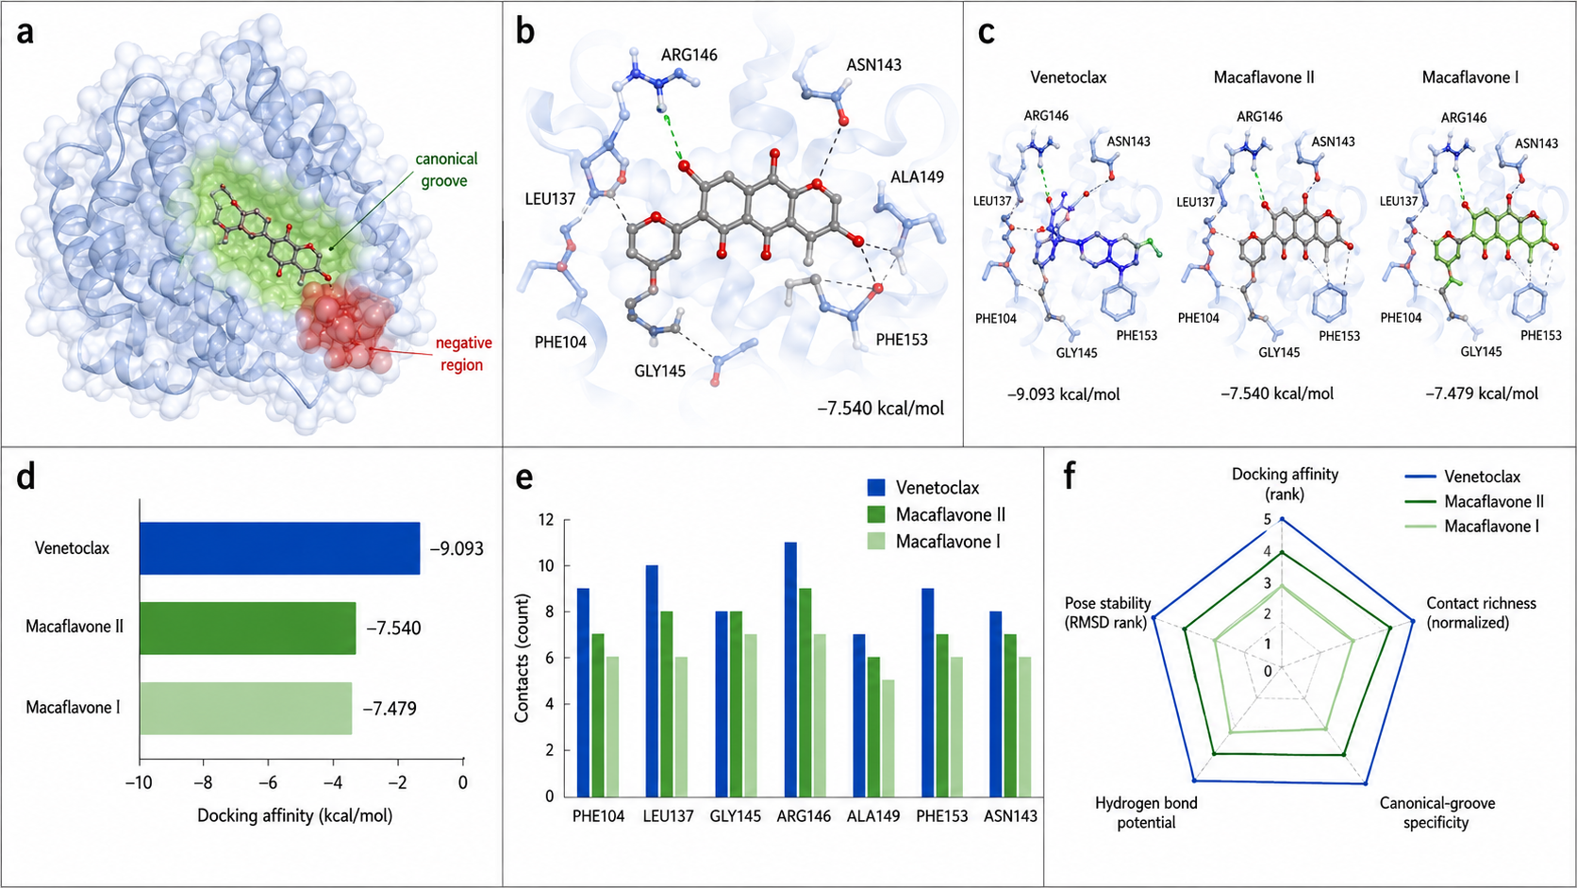
Figure 3. Strict local docking and control benchmarking with molecular views (panels a–f).
Table 3. Selected docking results and canonical-groove contact summary.
Ligand | Binding affinity (kcal/mol) | Strict valid poses | Target contact residues | Off-target contact ratio | Docking rank
Venetoclax | -9.093 | 20 | 12 | 0.455 | 1
Macaflavone II | -7.540 | 18 | 8 | 0.385 | 2
Macaflavone I | -7.479 | 18 | 8 | 0.385 | 3

3.2 Pilot molecular dynamics stability and interaction persistence
Pilot MD was used as a short-timescale diagnostic layer. The updated Figure 4 is presented as a single line-graph-style summary to emphasize comparative dynamic behavior in one compact visual.
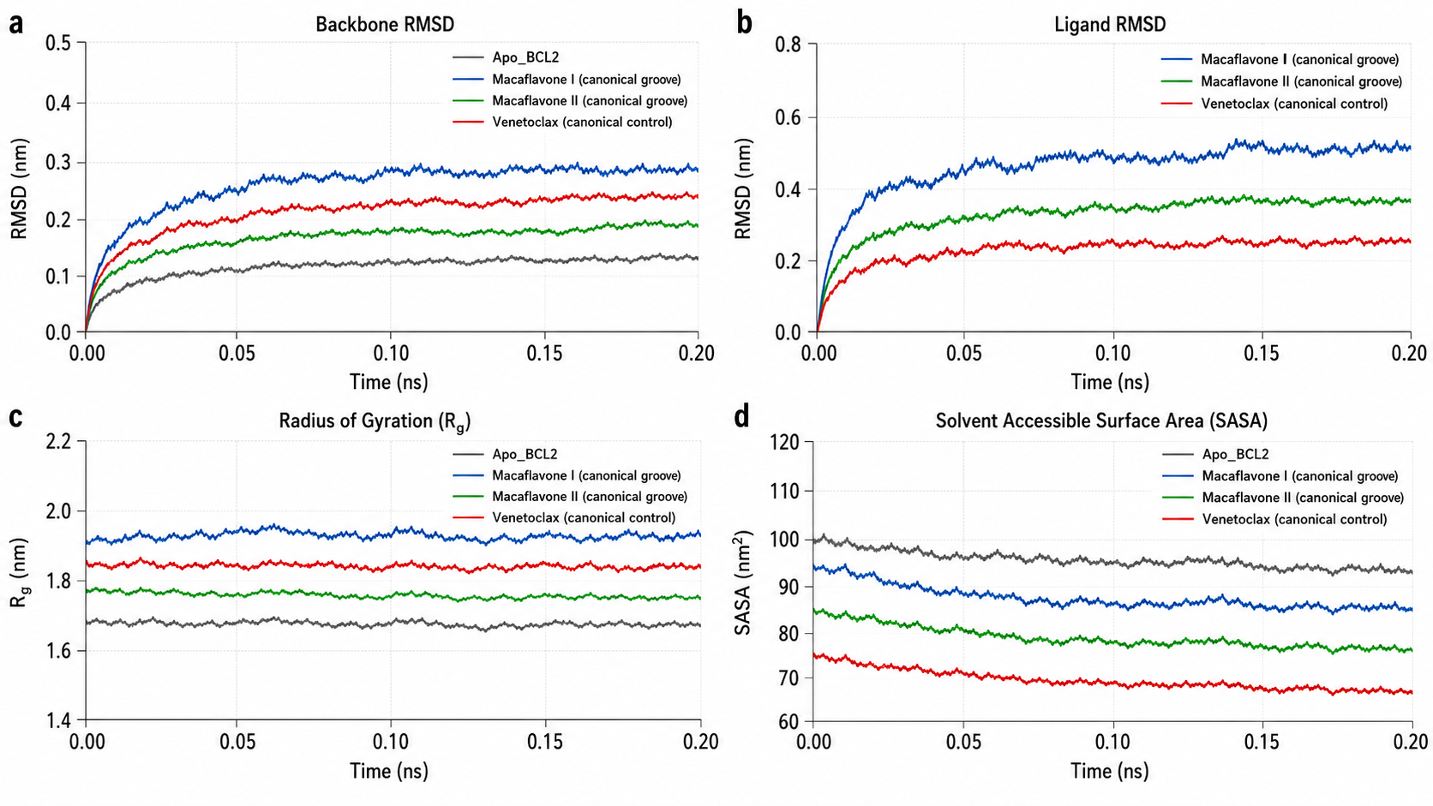
Figure 4. Pilot molecular dynamics stability and interaction-persistence analysis presented as a single line-graph-based figure.
Table 4. Pilot MD descriptor summary.
System | Backbone RMSD mean (nm) | Backbone RMSF mean (nm) | Rg mean (nm) | SASA mean (nm²) | Ligand RMSD mean (nm) | H-bond mean count | Contact mean count | Min distance mean (nm) | Interaction rank | Persistence score
Macaflavone I canonical groove | 0.2240 | 0.1635 | 1.9656 | 147.9445 | 0.2324 | 2.382 | 126.363 | 0.1633 | 3 | 9
Macaflavone II canonical groove | 0.2248 | 0.1452 | 1.9451 | 143.7043 | 0.2687 | 2.392 | 138.294 | 0.1625 | 1 | 7
Venetoclax canonical control | 0.2176 | 0.1467 | 1.9061 | 149.0017 | 0.1691 | 1.363 | 239.990 | 0.1954 | 2 | 8

3.3 Molecular basis of integrated docking–MD prioritization
Figure 5 converts the docking–MD prioritization matrix into a molecular representation. The figure highlights the reference-control pose of Venetoclax, the prioritized Macaflavone II pose, the secondary Macaflavone I pose, overlay analysis, and residue-contact evidence framing.
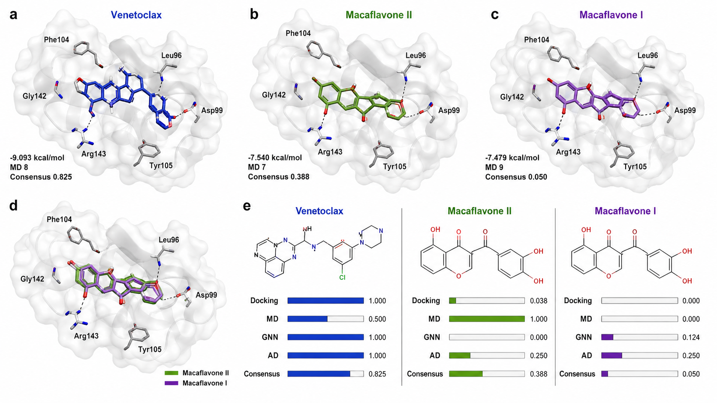
Figure 5. Molecular basis of integrated docking–MD prioritization using the same ranking data as the previous matrix-based version.
Table 5. Integrated docking–MD–GNN normalization matrix.
Ligand | Docking affinity (kcal/mol) | MD interaction rank | MD persistence score | Docking norm | MD norm | GNN norm | AD norm | Consensus score | Consensus rank
Venetoclax | -9.093 | 2 | 8 | 1.000 | 0.500 | 1.000 | 1.000 | 0.825 | 1
Macaflavone II | -7.540 | 1 | 7 | 0.038 | 1.000 | 0.000 | 0.250 | 0.388 | 2
Macaflavone I | -7.479 | 3 | 9 | 0.000 | 0.000 | 0.124 | 0.250 | 0.050 | 3

3.4 Mechanistic hypothesis for BCL-2 engagement
The mechanistic figure is presented as a detailed multi-panel hypothesis-generating summary. It is intended to connect canonical-groove engagement, representative ligand contacts, and the downstream apoptosis framing while preserving conservative claim boundaries.
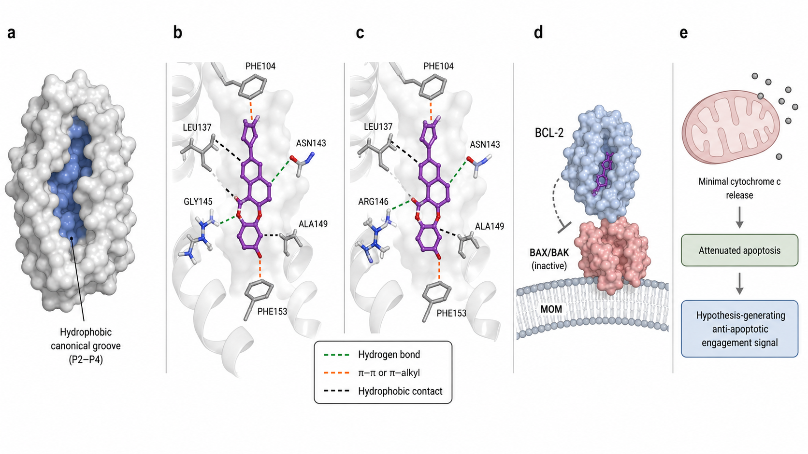
Figure 6. Integrated mechanistic hypothesis for BCL-2 engagement by Macaflavone II.

3.5 Ligand-based GNN performance and molecular interpretation
Figure 7 is separated into three individual images. Panel a presents model performance as a line graph, panel b shows a molecular ranking of the external ligands according to model-consensus pActivity, and panel c provides a more detailed ligand-based GNN interpretation for Venetoclax, Macaflavone II, and Macaflavone I.
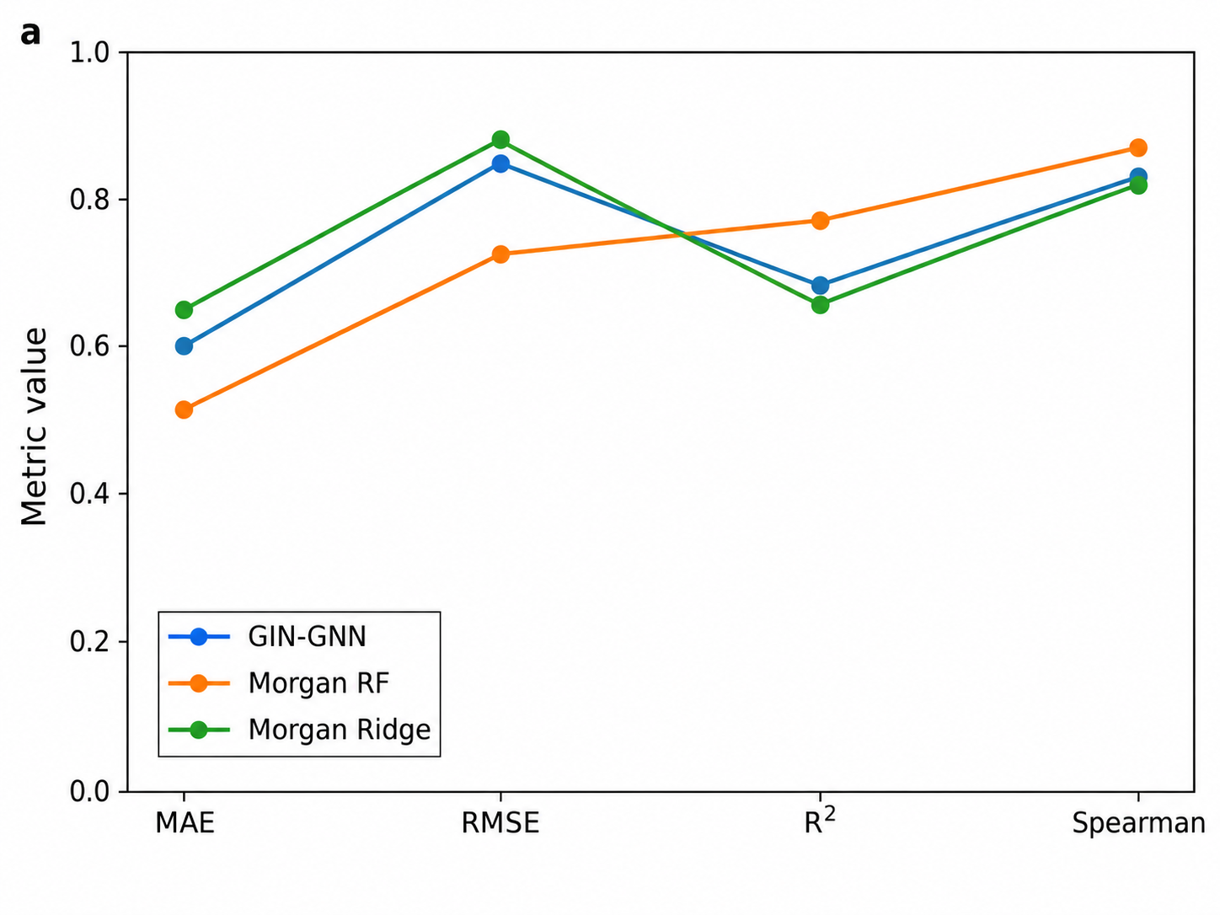
Figure 7a. Model performance comparison across MAE, RMSE, R², and Spearman metrics.
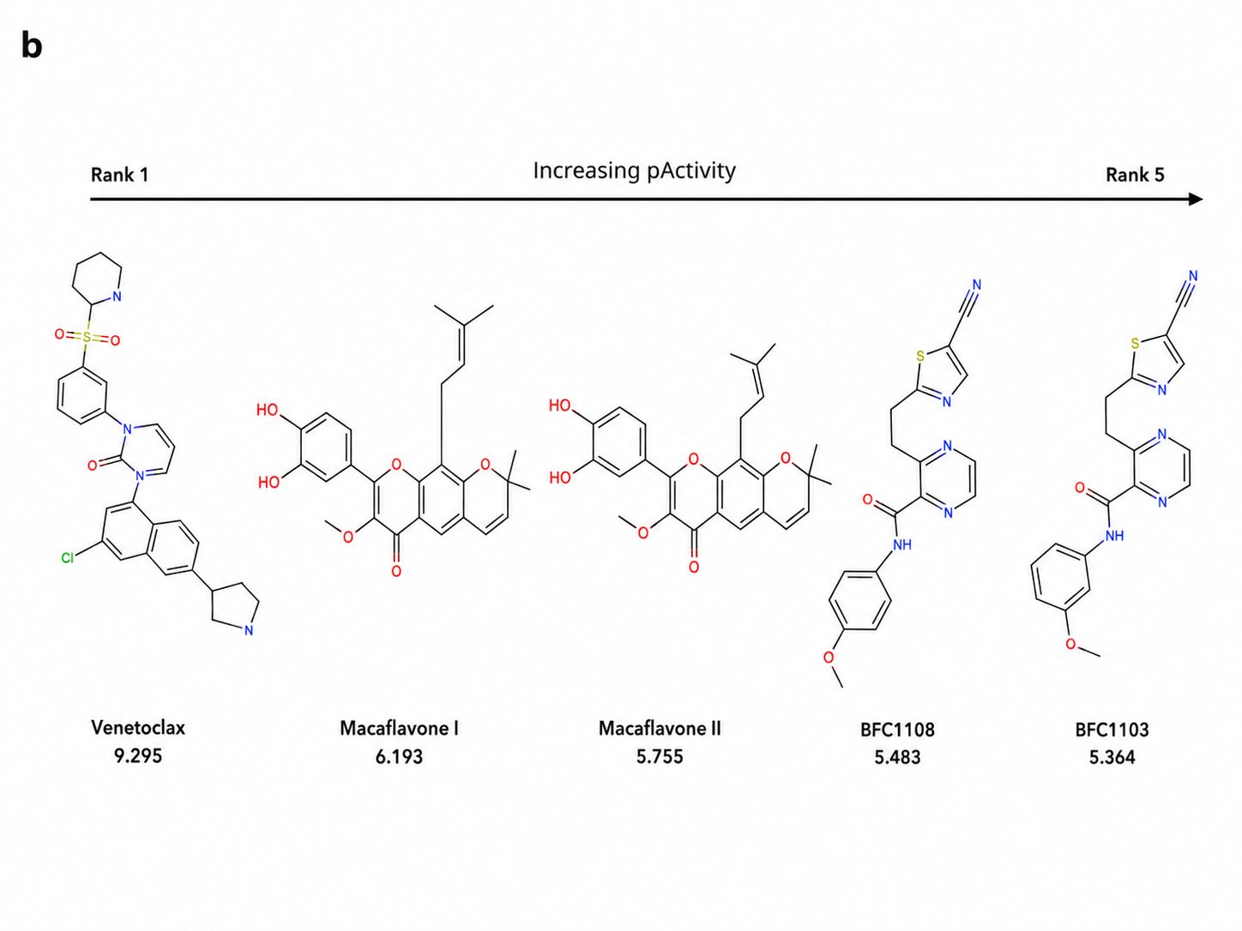
Figure 7b. Molecular ranking of external ligands based on model-consensus pActivity.
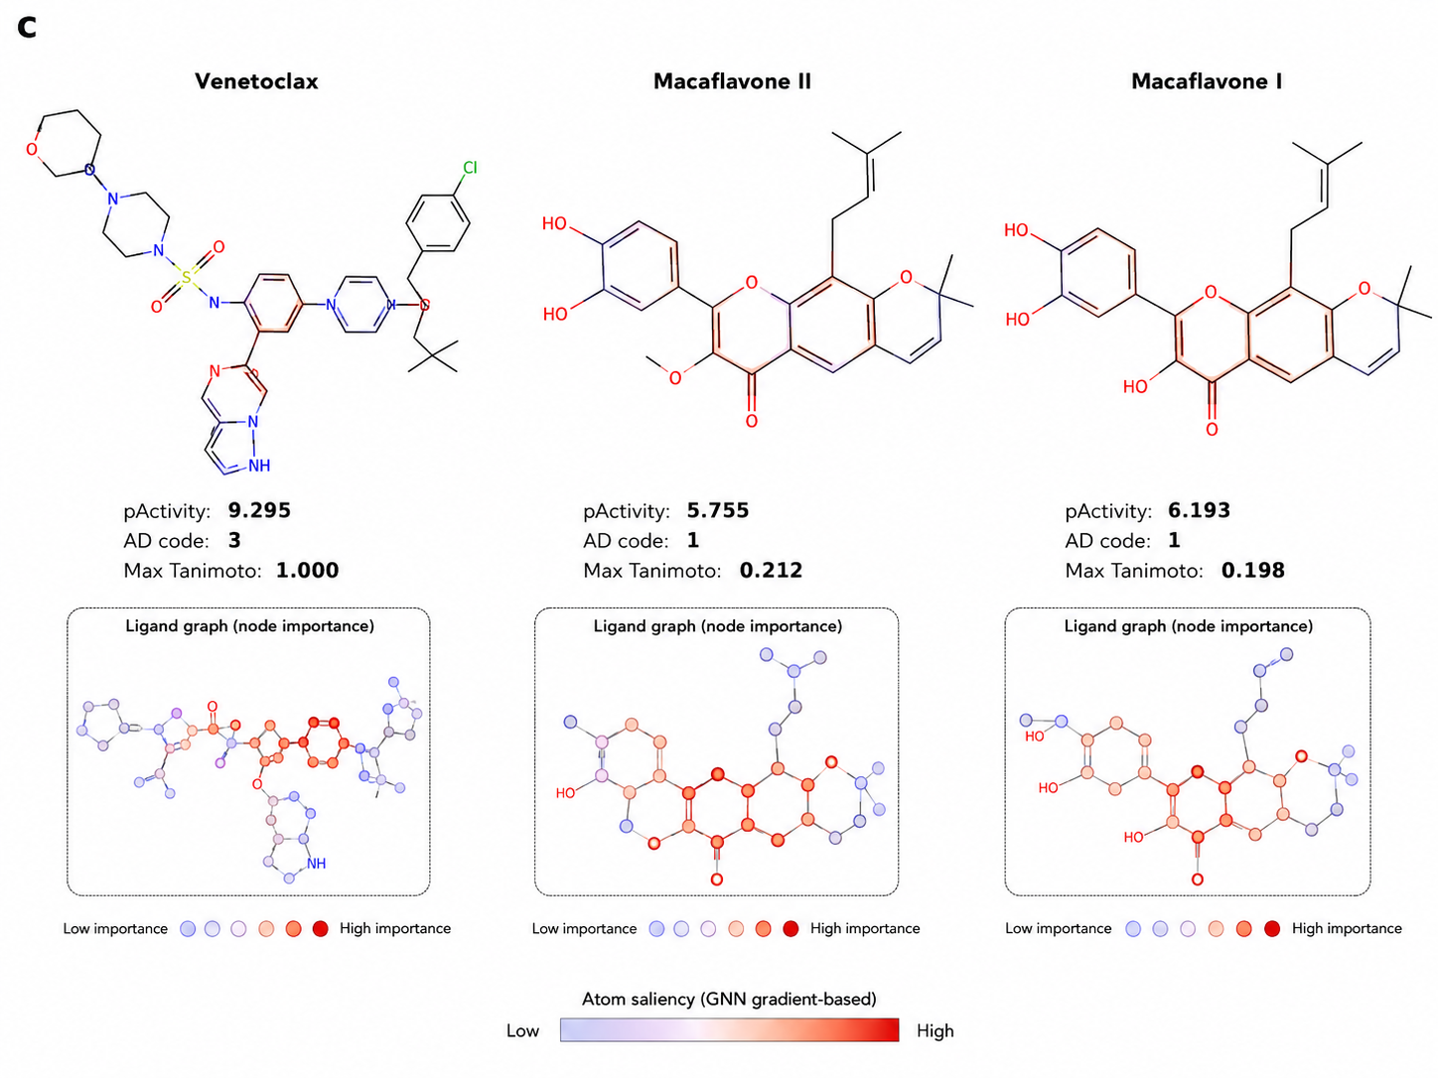
Figure 7c. Detailed ligand-based GNN molecular interpretation with atom saliency / node-importance views.
Table 6. GNN model performance and baseline comparison.
Model | Split | N | MAE | RMSE | R² | Pearson r | Spearman ρ
GIN-GNN | Test | 477 | 0.600 | 0.856 | 0.683 | 0.827 | 0.827
Morgan RF | Test | 477 | 0.514 | 0.730 | 0.770 | 0.883 | 0.872
Morgan Ridge | Test | 477 | 0.649 | 0.882 | 0.664 | 0.836 | 0.830

Table 7. External ligand prediction and applicability-domain summary.
Ligand | GNN pActivity | RF pActivity | Ridge pActivity | Model-consensus pActivity | Max Tanimoto | AD code | Prediction rank
Venetoclax | 9.152 | 8.736 | 9.997 | 9.295 | 1.000 | 3 | 1
Macaflavone I | 6.042 | 6.296 | 6.241 | 6.193 | 0.198 | 1 | 2
Macaflavone II | 5.756 | 6.333 | 5.178 | 5.755 | 0.212 | 1 | 3
BFC1108 | 5.566 | 5.781 | 5.102 | 5.483 | 0.321 | 2 | 4
BFC1103 | 4.860 | 5.830 | 5.404 | 5.364 | 0.308 | 2 | 5

AD code: 1 = low; 2 = moderate; 3 = high.

3.6 Final consensus prioritization
The final consensus integrates docking rank, pilot MD rank, GNN prediction rank, applicability-domain information, and the composite consensus score. Venetoclax remained the strongest reference control, while Macaflavone II emerged as the stronger Macaflavone candidate for follow-up validation.
Table 8. Final docking–MD–GNN consensus ranking.
Ligand | Docking rank | MD rank | GNN prediction rank | AD code | Docking affinity (kcal/mol) | GNN consensus pActivity | Final consensus score | Final rank
Venetoclax | 1 | 2 | 1 | 3 | -9.093 | 9.295 | 0.825 | 1
Macaflavone II | 2 | 1 | 3 | 1 | -7.540 | 5.755 | 0.388 | 2
Macaflavone I | 3 | 3 | 2 | 1 | -7.479 | 6.193 | 0.050 | 3

4. Conclusions
An integrated docking–pilot MD–GNN workflow was successfully organized for Macaflavone-based BCL-2 prioritization. Venetoclax remained the strongest canonical-groove reference control. Among the two natural-product candidates, Macaflavone II showed slightly better docking support and stronger pilot MD interaction-persistence evidence than Macaflavone I. The ligand-based GNN provided a useful auxiliary signal but required cautious interpretation because both Macaflavones had low applicability-domain similarity to the training chemical space. Overall, the current evidence supports computational prioritization of Macaflavone II for follow-up MM-PBSA, longer MD, or experimental validation, but it does not establish confirmed BCL-2 inhibition or apoptosis activation.

