Rancangan Artikel Ilmiah
Macaflavone-BCL-2 Docking, Pilot MD, and Ligand-Based GNN Prioritization
Draft layout with main figures and numerical tables

Proposed title
Integrated Docking, Pilot Molecular Dynamics, and Ligand-Based GNN Prioritization of Macaflavone Candidates Targeting the BCL-2 Canonical Groove

Article placement overview
- Methods: Figure 1, Figure 2, Table 1, and Table 2.
- Results and Discussion: Figure 3 to Figure 7 and Table 3 to Table 8.
- All main tables are numerical. Narrative claim-boundary material should be moved to supplementary text or supplementary tables.
- The article should claim computational prioritization only; it should not claim confirmed BCL-2 inhibition, apoptosis activation, or functional conversion.

2. Methods

2.1 Overall computational workflow
The workflow integrates ligand curation, BCL-2 target preparation, strict local docking, complex preparation, short-timescale pilot molecular dynamics, ligand-based GNN modeling, applicability-domain analysis, and final conservative prioritization.
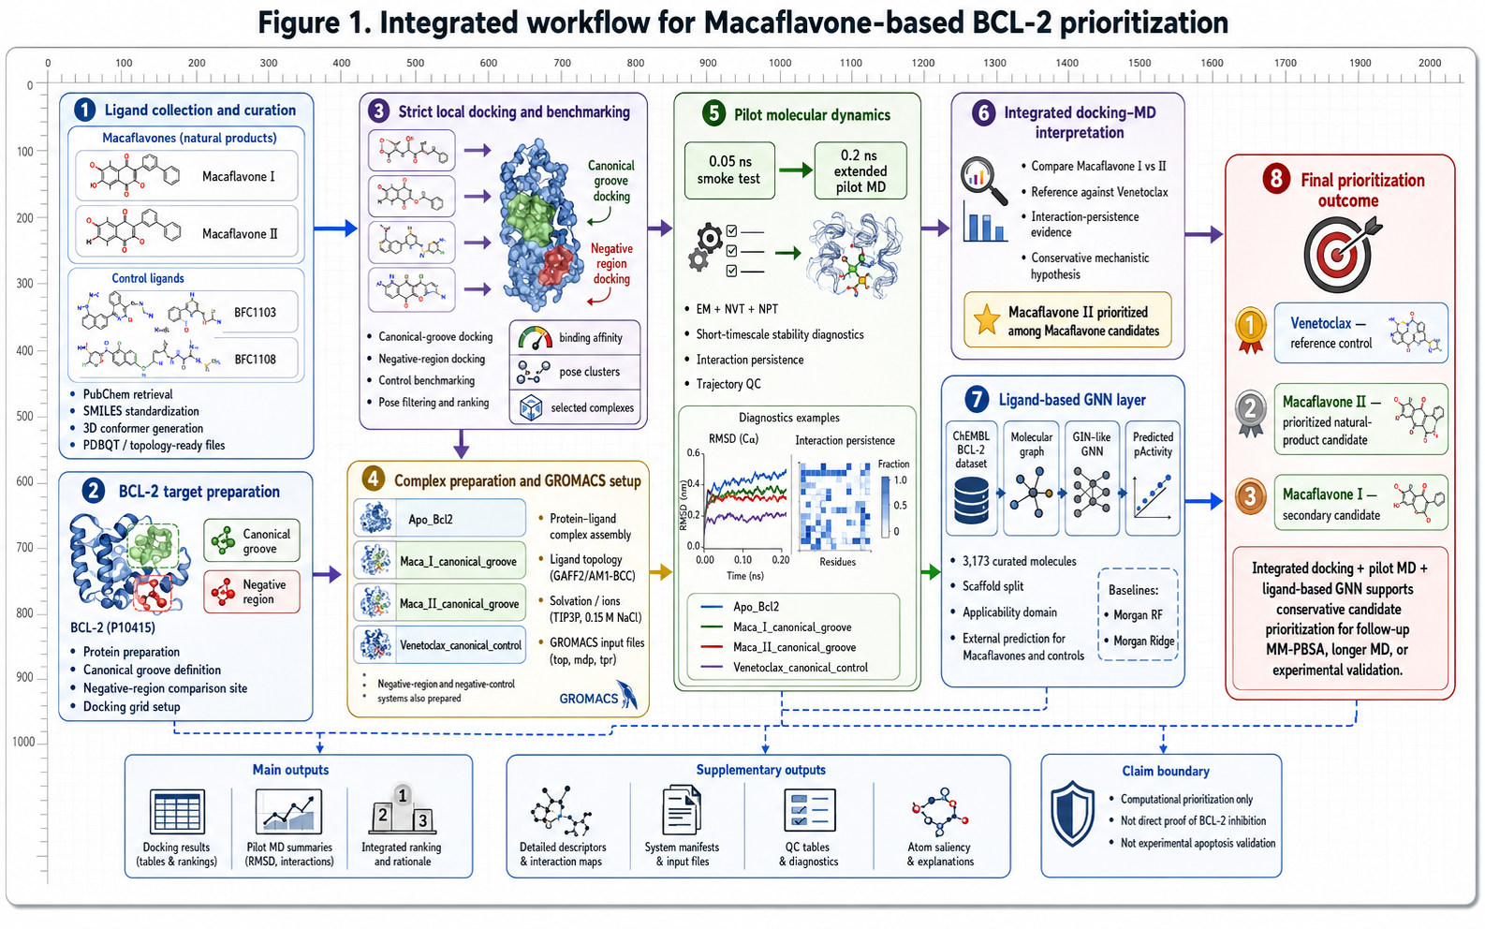
Figure 1. Integrated computational workflow for Macaflavone-based BCL-2 prioritization.

Table 1. Ligand descriptors and computational roles.
Ligand | Atom count | Bond count | Role code | Docking | Pilot MD | GNN prediction
Macaflavone I | 31 | 34 | 1 | 1 | 1 | 1
Macaflavone II | 32 | 35 | 1 | 1 | 1 | 1
Venetoclax | 61 | 68 | 2 | 1 | 1 | 1
BFC1103 | 26 | 27 | 3 | 0 | 0 | 1
BFC1108 | 30 | 32 | 3 | 0 | 0 | 1

2.2 Ligand and BCL-2 target preparation
Macaflavone I, Macaflavone II, Venetoclax, BFC1103, and BFC1108 were standardized from molecular structures and used according to their computational roles. BCL-2 was prepared for canonical-groove docking, with a comparison region used for specificity checking.

2.3 Strict local docking and pilot MD setup
Strict local docking was performed at the BCL-2 canonical groove. Selected protein-ligand complexes were then prepared for short-timescale pilot MD diagnostics. The extended pilot MD duration was 0.20 ns; therefore, MD-derived interpretations must remain short-timescale and hypothesis-generating.
Table 2. Computational setup and dataset summary.
Component | Number / setting
Macaflavone candidates | 2
Canonical reference control | 1
Comparator ligands | 2
Total external ligands | 5
Main docking region | 1
Comparison docking region | 1
Pilot MD systems | 4
Smoke-test MD duration (ns) | 0.05
Extended pilot MD duration (ns) | 0.2
ChEMBL BCL-2 raw activity records | 15,736
Cleaned records before deduplication | 5,906
RDKit-valid unique molecules | 3,173
Training molecules | 2,221
Validation molecules | 475
Test molecules | 477
GNN atom-feature dimension | 35
GNN hidden dimension | 128
GNN message-passing layers | 3
Dropout | 0.2
Maximum training epochs | 200
Best GNN epoch | 102

2.4 Ligand-based GNN architecture and training
The GNN was implemented as a ligand-based GIN-like molecular graph regression model. It used RDKit molecular graphs, 35-dimensional atom features, 128 hidden units, three message-passing layers, masked mean pooling, and a regression head for pActivity prediction. Morgan fingerprint Random Forest and Morgan Ridge were included as baselines.
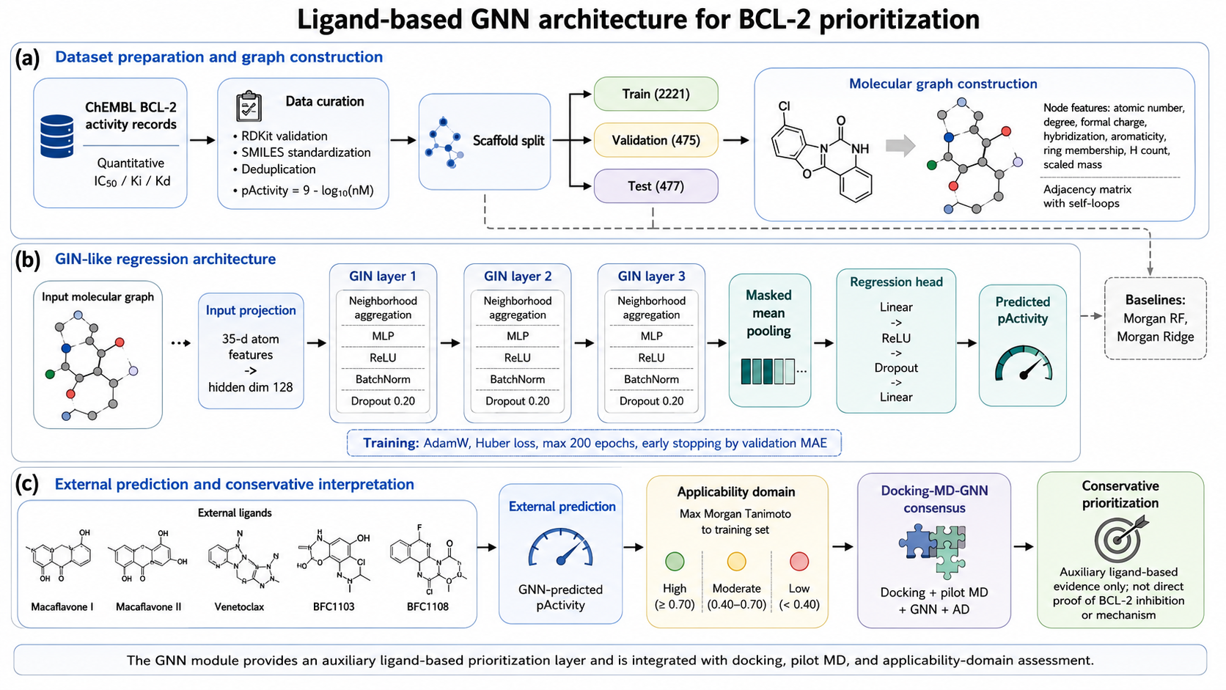
Figure 2. Ligand-based GNN architecture for BCL-2 prioritization.

3. Results and Discussion

3.1 Strict local docking and control benchmarking
Venetoclax retained the strongest canonical-groove docking affinity. Among the natural-product candidates, Macaflavone II slightly outperformed Macaflavone I in the canonical groove.
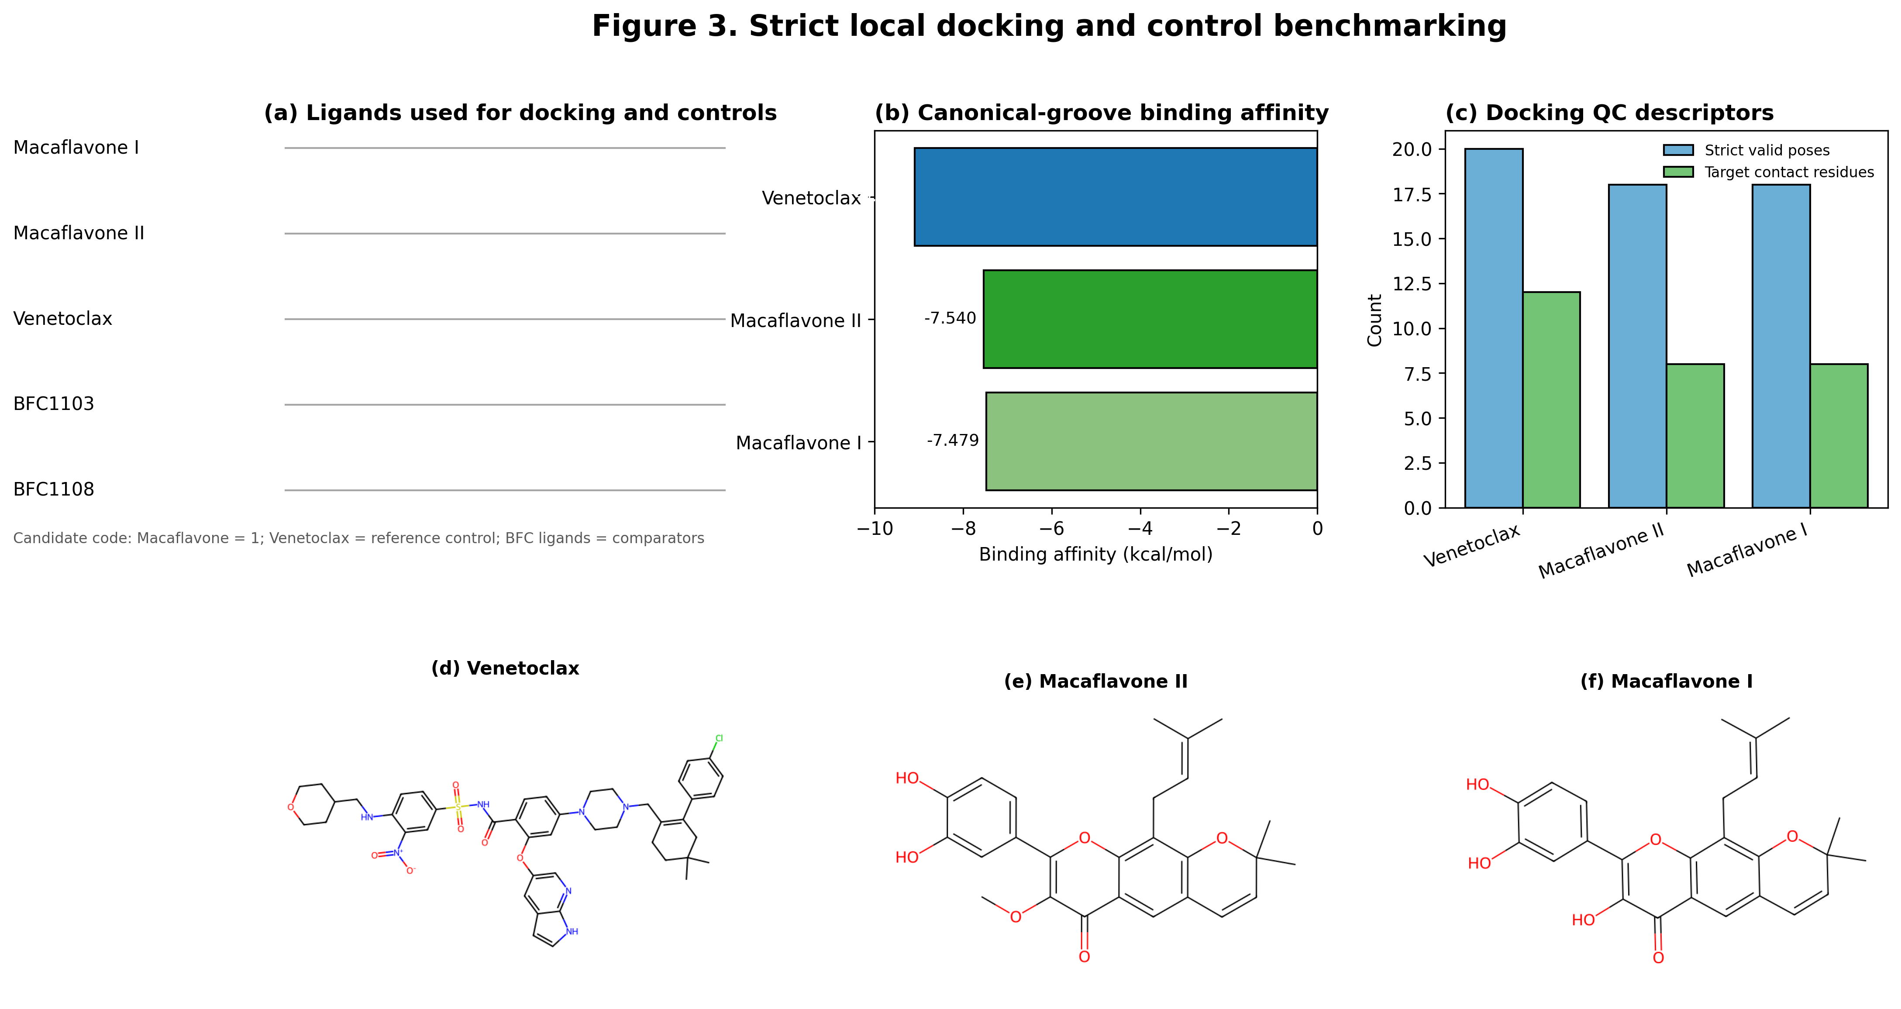
Figure 3. Strict local docking and control benchmarking.

Table 3. Selected docking results and canonical-groove contact summary.
Ligand | Binding affinity kcal/mol | Strict valid poses | Target contact residues | Off-target contact ratio | Docking rank
Venetoclax | -9.093 | 20 | 12 | 0.455 | 1
Macaflavone II | -7.54 | 18 | 8 | 0.385 | 2
Macaflavone I | -7.479 | 18 | 8 | 0.385 | 3

3.2 Pilot MD descriptor summary
Pilot MD descriptors were used as short-timescale stability and interaction-persistence diagnostics. These descriptors support ranking within the computational workflow but do not establish long-timescale binding stability.
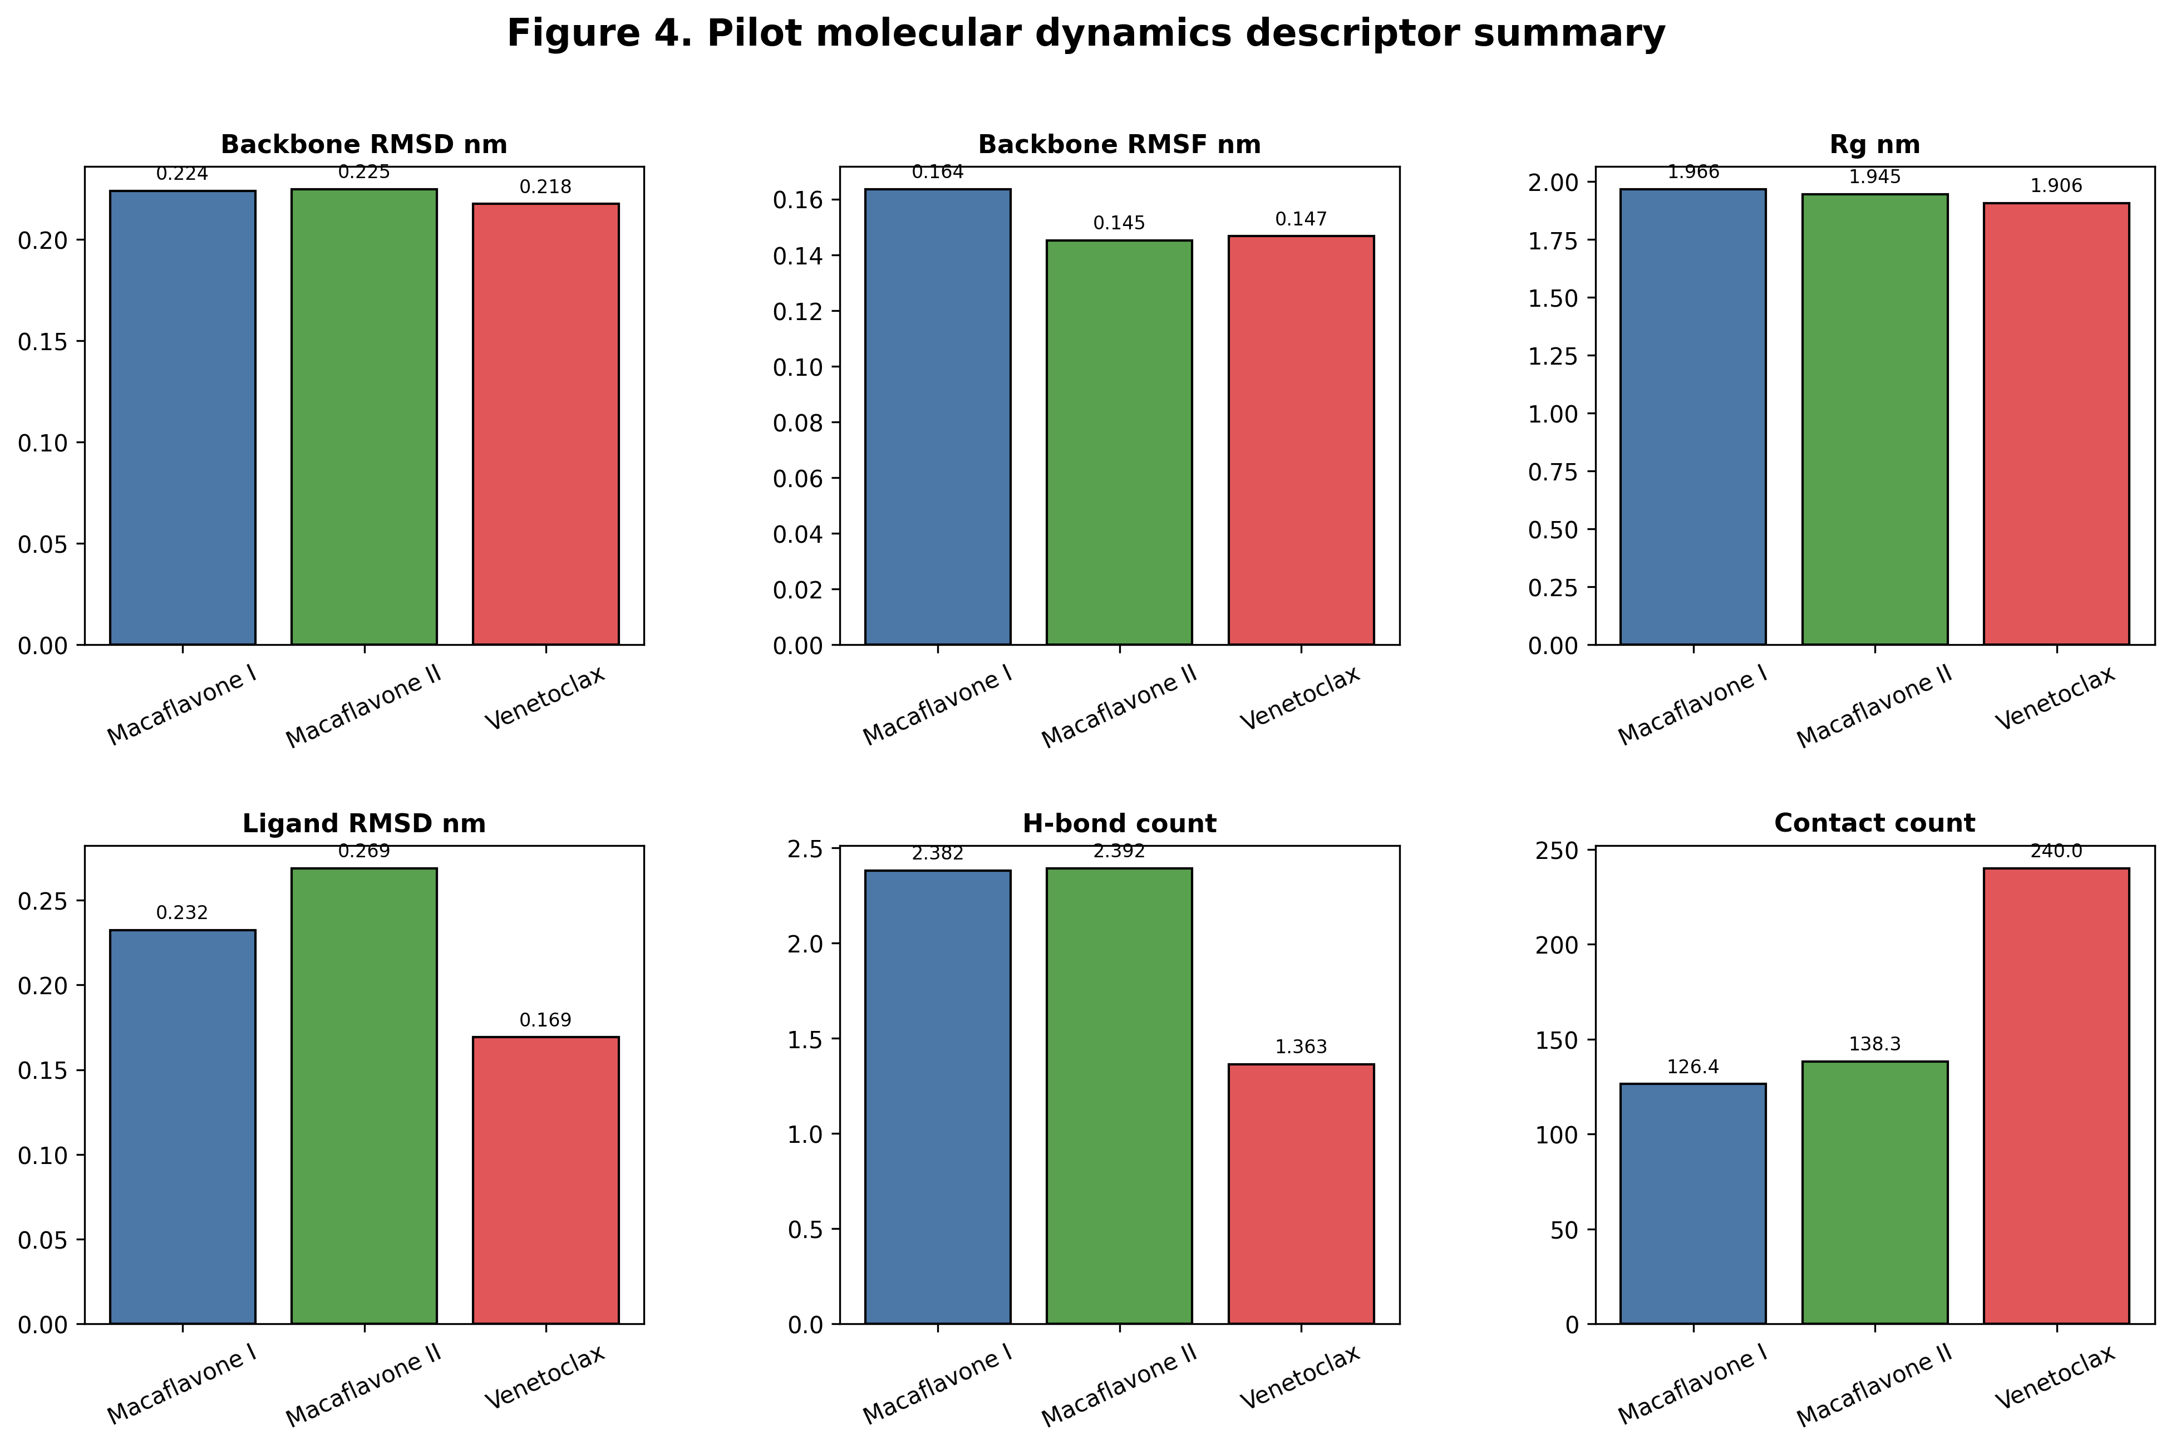
Figure 4. Pilot molecular dynamics descriptor summary.

Table 4. Pilot MD descriptor summary.
System | Backbone RMSD mean nm | Backbone RMSF mean nm | Rg mean nm | SASA mean nm2 | Ligand RMSD mean nm | H-bond mean count | Contact mean count | Min distance mean nm | Interaction rank | Interaction persistence score
Macaflavone I canonical groove | 0.224 | 0.164 | 1.966 | 147.945 | 0.232 | 2.382 | 126.363 | 0.163 | 3 | 9
Macaflavone II canonical groove | 0.225 | 0.145 | 1.945 | 143.704 | 0.269 | 2.392 | 138.294 | 0.163 | 1 | 7
Venetoclax canonical control | 0.218 | 0.147 | 1.906 | 149.002 | 0.169 | 1.363 | 239.99 | 0.195 | 2 | 8

3.3 Integrated docking-MD-GNN prioritization
The integrated numerical matrix combines docking normalization, MD normalization, GNN support, applicability-domain support, and the final consensus score. Venetoclax remained the strongest reference control, while Macaflavone II was prioritized over Macaflavone I among the Macaflavone candidates.
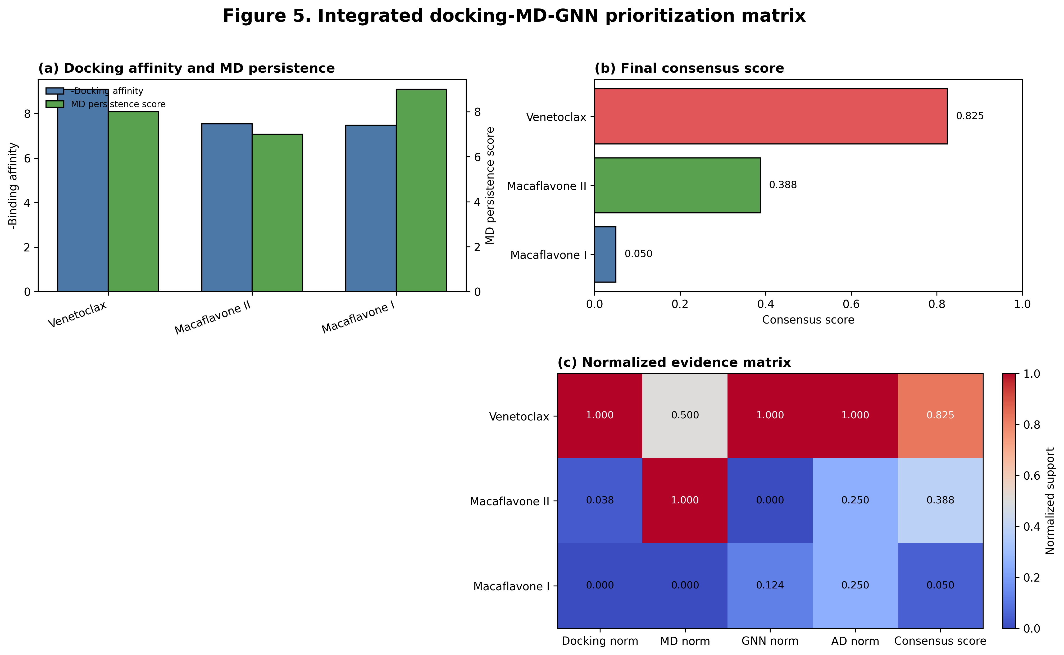
Figure 5. Integrated docking-MD-GNN prioritization matrix.

Table 5. Integrated docking-MD-GNN normalization matrix.
Ligand | Docking affinity kcal/mol | MD interaction rank | MD persistence score | Docking norm | MD norm | GNN norm | AD norm | Consensus score | Consensus rank
Venetoclax | -9.093 | 2 | 8 | 1 | 0.5 | 1 | 1 | 0.825 | 1
Macaflavone II | -7.54 | 1 | 7 | 0.038 | 1 | 0 | 0.25 | 0.388 | 2
Macaflavone I | -7.479 | 3 | 9 | 0 | 0 | 0.124 | 0.25 | 0.05 | 3

3.4 Mechanistic hypothesis for BCL-2 engagement
The mechanistic model should be interpreted as a hypothesis. The figure illustrates possible canonical-groove engagement and potential anti-apoptotic pathway implication, but it must not be written as confirmed biological mechanism.
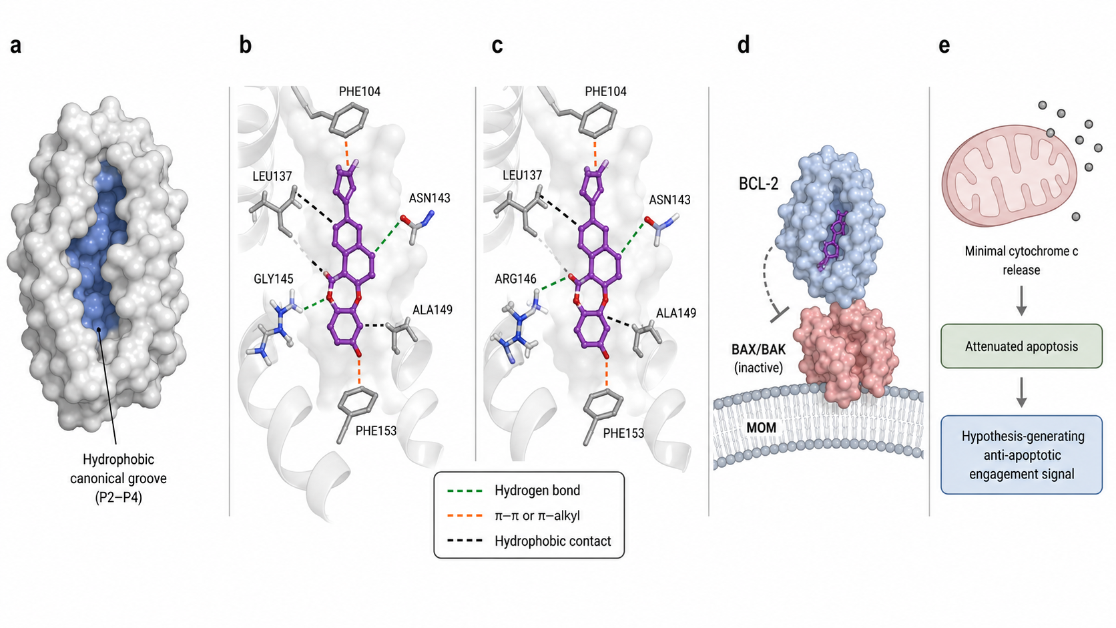
Figure 6. Integrated mechanistic hypothesis for BCL-2 engagement by Macaflavone II.

3.5 Ligand-based GNN performance and external prediction
The GIN-GNN produced useful ligand-based predictions but did not outperform the Morgan RF baseline by test MAE. External Macaflavone predictions had low applicability-domain similarity and therefore require conservative interpretation.
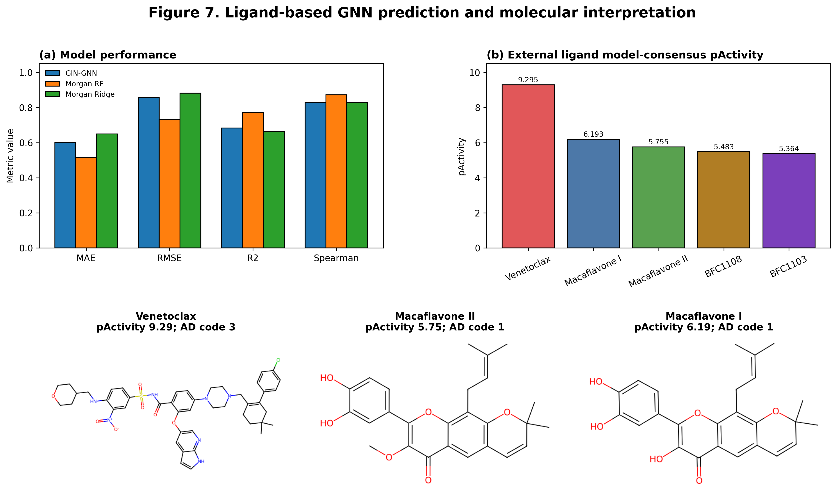
Figure 7. Ligand-based GNN prediction and molecular interpretation.

Table 6. GNN model performance and baseline comparison.
Model | Split | N | MAE | RMSE | R2 | Pearson r | Spearman rho
GIN-GNN | Test | 477 | 0.6 | 0.856 | 0.683 | 0.827 | 0.827
Morgan RF | Test | 477 | 0.514 | 0.73 | 0.77 | 0.883 | 0.872
Morgan Ridge | Test | 477 | 0.649 | 0.882 | 0.664 | 0.836 | 0.83

Table 7. External ligand prediction and applicability-domain summary.
Ligand | GNN pActivity | RF pActivity | Ridge pActivity | Model-consensus pActivity | Max Tanimoto | AD code | Prediction rank
Venetoclax | 9.152 | 8.736 | 9.997 | 9.295 | 1 | 3 | 1
Macaflavone I | 6.042 | 6.296 | 6.241 | 6.193 | 0.198 | 1 | 2
Macaflavone II | 5.756 | 6.333 | 5.178 | 5.755 | 0.212 | 1 | 3
BFC1108 | 5.566 | 5.781 | 5.102 | 5.483 | 0.321 | 2 | 4
BFC1103 | 4.86 | 5.83 | 5.404 | 5.364 | 0.308 | 2 | 5

3.6 Final consensus ranking
The final ranking supports Macaflavone II as the stronger Macaflavone candidate for follow-up MM-PBSA, longer MD, or experimental validation. Venetoclax remains the reference control. The workflow does not establish confirmed BCL-2 inhibition or apoptosis activation.
Table 8. Final docking-MD-GNN consensus ranking.
Ligand | Docking rank | MD rank | GNN prediction rank | AD code | Docking affinity kcal/mol | GNN consensus pActivity | Final consensus score | Final rank
Venetoclax | 1 | 2 | 1 | 3 | -9.093 | 9.295 | 0.825 | 1
Macaflavone II | 2 | 1 | 3 | 1 | -7.54 | 5.755 | 0.388 | 2
Macaflavone I | 3 | 3 | 2 | 1 | -7.479 | 6.193 | 0.05 | 3

4. Conclusion draft
This article should be framed as a computational prioritization study. Macaflavone II is prioritized over Macaflavone I by docking-MD evidence, while GNN prediction provides an auxiliary ligand-based signal with low applicability-domain confidence for Macaflavones. Follow-up MM-PBSA, longer molecular dynamics, and experimental validation are required before biological mechanism claims are made.

