Rancangan Manuscript dan Paket Gambar-Tabel
Integrated Docking, Pilot Molecular Dynamics, and Ligand-Based GNN Prioritization of Macaflavone Candidates Targeting BCL-2
Status singkat
Dataset dan output komputasi sudah cukup untuk artikel in silico berbasis prioritization workflow. Klaim harus dibatasi pada computational prioritization; bukan bukti langsung inhibisi BCL-2, aktivasi apoptosis, atau functional conversion. Stage 9E perlu dirapikan karena ada indikasi duplikasi/mapping Macaflavone I/II pada tabel molecular docking-GNN validation.

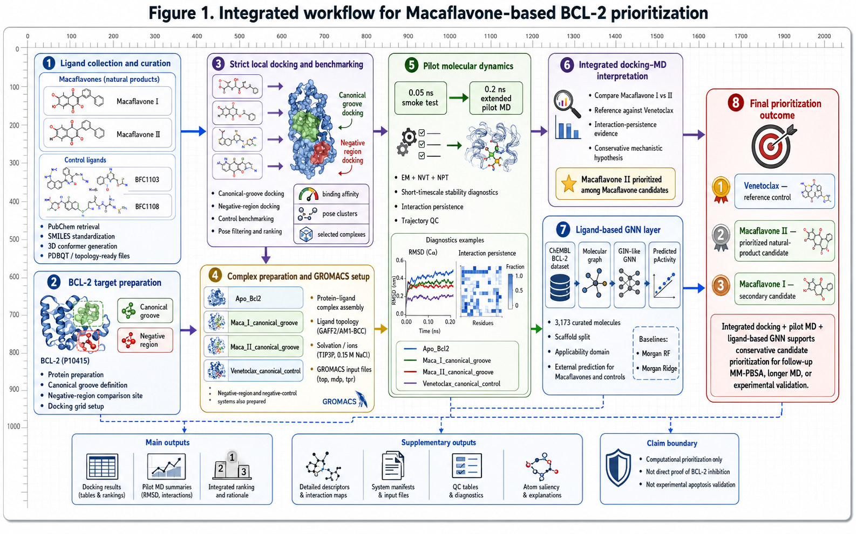
Figure 1. Integrated workflow for Macaflavone-based BCL-2 prioritization. Draft architecture-style workflow figure inserted for manuscript planning.

1. Rancangan artikel
Table 1. Manuscript positioning and claim boundary
Aspek | Rancangan yang disarankan | Batas klaim
Article type | Computational screening / in silico prioritization workflow | Bukan artikel validasi biologis atau preclinical anticancer claim
Core novelty | Integrasi docking, control benchmarking, pilot MD, ligand-based GNN, applicability domain, dan claim-boundary matrix | GNN hanya auxiliary ligand-based signal
Main candidate framing | Macaflavone II diprioritaskan di antara kandidat Macaflavone berdasarkan docking dan pilot MD | Tidak menyatakan Macaflavone II terbukti inhibitor BCL-2
Reference control | Venetoclax digunakan sebagai canonical-groove reference control | Bukan untuk menyetarakan potensi Macaflavone dengan Venetoclax
Recommended target journal level | Computational chemistry, molecular modeling, natural product informatics, or cheminformatics journal | Hindari jurnal dengan tuntutan validasi eksperimen wajib

Table 2. Proposed manuscript structure
Section | Isi utama | Figure/Table terkait
Abstract | Masalah BCL-2 prioritization, Macaflavone candidates, integrated docking-pilot MD-GNN workflow, conservative conclusion | Tidak perlu figure
1. Introduction | BCL-2 target relevance, natural products, Macaflavone rationale, gap pada docking-only studies | Figure 1 sebagai overview
2. Methods | Ligand preparation, target preparation, strict local docking, complex preparation, pilot MD, GNN architecture, AD, consensus ranking | Figure 2 GNN architecture; Table 3/4/5
3. Results | Docking benchmark, pilot MD descriptors, integrated interpretation, GNN prediction, claim boundary | Figures 3-7; Tables 4-7
4. Discussion | Macaflavone II prioritization, comparison to Venetoclax, limits of 0.2 ns MD and low AD GNN predictions | Claim-boundary table
5. Conclusions | Macaflavone II sebagai candidate for follow-up; perlu MM-PBSA, longer MD, or experimental validation | Tidak perlu figure
Supplementary Information | Full docking outputs, manifests, QC, GNN saliency, Stage 9E after correction | Figures S1-S2; Tables S1-S41

2. Rancangan gambar
Table 3. Recommended figure allocation
Figure | Judul/isi | Status penggunaan
Figure 1 | Integrated workflow for Macaflavone-based BCL-2 prioritization | Main manuscript - already inserted in this document
Figure 2 | Ligand-based GNN architecture for BCL-2 prioritization | Main Methods figure - inserted below
Figure 3 | Strict local docking and control benchmarking | Main Results figure
Figure 4 | Pilot MD diagnostic descriptors: RMSD/RMSF/Rg/SASA and interaction persistence | Main Results figure
Figure 5 | Integrated docking-MD ranking and evidence matrix | Main Results figure
Figure 6 | Integrated mechanistic hypothesis and evidence boundary | Main or Supplementary depending journal space
Figure 7 | GNN-assisted prioritization and applicability-domain interpretation | Main Results figure
Figure S1 | Molecular-GNN visualization / atom saliency | Supplementary
Figure S2 | Molecular docking-GNN validation | Supplementary after Stage 9E mapping correction

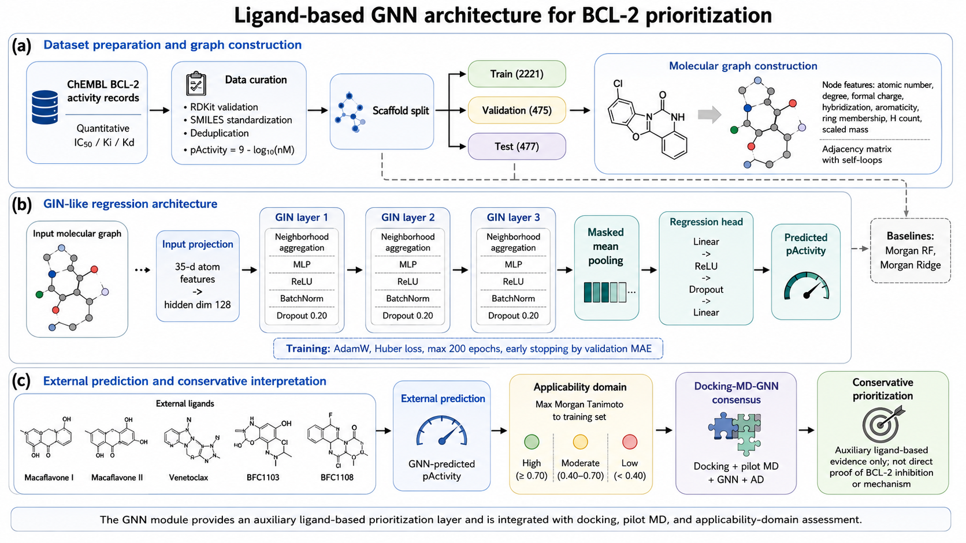
Figure 2. Ligand-based GNN architecture for BCL-2 prioritization. This figure should be placed in the Methods section to make the GNN architecture reproducible.

3. Rancangan tabel utama
Table 4. Proposed main tables for the manuscript
Main table | Isi | Sumber output
Table 1 | Ligands, roles, source, and computational status | Ligand curation outputs
Table 2 | Docking regions, selected affinity, valid pose count, and target contact residues | Docking ranking tables / Table 16
Table 3 | Pilot MD summary descriptors for Apo, Macaflavone I, Macaflavone II, and Venetoclax | Stage 7D / Table 16
Table 4 | Integrated docking-MD interpretation and evidence class | Table 16
Table 5 | GNN model performance versus Morgan RF and Morgan Ridge baselines | Stage 9C / Table 30
Table 6 | External GNN prediction and applicability-domain class | Stage 9C / Table 28
Table 7 | Claim-boundary and safe interpretation matrix | Stage 9C/9E claim boundary tables

Table 5. Selected docking and pilot MD evidence to retain in main article
System | Docking affinity (kcal/mol) | MD interaction rank | Interpretation
Maca_I_canonical_groove | -7.479 | 3 | Stable but lower-ranked Macaflavone candidate; short-timescale evidence only
Maca_II_canonical_groove | -7.540 | 1 | Prioritized Macaflavone candidate from docking + 0.2 ns pilot MD
Venetoclax_canonical_control | -9.093 | 2 | Canonical-groove reference control

Table 6. GNN model and external prediction summary
Item | Value | Interpretation
RDKit-valid ChEMBL BCL-2 molecules | 3,173 | Adequate for auxiliary ligand-based model
Train / validation / test split | 2,221 / 475 / 477 | Scaffold split used to reduce analogue leakage
GIN-GNN test MAE / RMSE / R2 / Spearman | 0.600 / 0.856 / 0.683 / 0.827 | Acceptable model performance for prioritization
Best baseline by test MAE | Morgan_RF; MAE 0.514 | Do not claim GNN outperformed all baselines
Venetoclax model-consensus pActivity / AD | 9.295 / high | Reference control behaves as expected
Macaflavone I model-consensus pActivity / AD | 6.193 / low | Auxiliary low-domain signal only
Macaflavone II model-consensus pActivity / AD | 5.755 / low | Auxiliary low-domain signal only

Table 7. Supplementary material allocation
Supplementary item | Isi yang disarankan | Catatan
Tables S1-S10 | Ligand curation, structure files, docking input/output manifests | Reproducibility
Tables S11-S20 | Docking pose-level results and contact maps | Keep full data outside main text
Tables S21-S30 | MD QC, trajectory metrics, interaction persistence descriptors | Support pilot MD claims
Tables S31-S41 | GNN dataset, model performance, external prediction, AD, atom saliency, claim boundary | Stage 9C-D-E outputs; clean Stage 9E first
Figures S1-S2 | Molecular-GNN visualization and molecular docking-GNN validation | Use after correcting Stage 9E duplicate/mapping issue

4. Methods subsection yang harus dimasukkan

2.x Ligand-based graph neural network modeling
A ligand-based graph neural network was implemented as an auxiliary bioactivity-prioritization layer for BCL-2 ligand candidates. The GNN was not designed as a protein-ligand pose-aware model, but as a molecular graph regression model trained to estimate BCL-2 activity tendency from ligand structure.
Curated BCL-2 activity records were obtained from ChEMBL and filtered to retain compounds with valid canonical SMILES and quantitative IC50, Ki, or Kd values reported in nM. Activity values were converted to pActivity using pActivity = 9 - log10(activity in nM). Molecules that failed RDKit parsing were removed, and duplicate molecular structures were aggregated using the median pActivity value.
Each ligand was represented as an atom-bond graph, where atoms were encoded as nodes and covalent bonds as edges. Atom-level input features included atomic number, degree, formal charge, hybridization state, aromaticity, ring membership, total hydrogen count, and scaled atomic mass. Bond connectivity was represented using an adjacency matrix with self-loops.
The GNN architecture followed a GIN-like regression design. Atom features were projected into a hidden representation with 128 hidden units. Three message-passing layers were applied, followed by masked mean pooling and a regression head predicting pActivity. The model was trained using AdamW, Huber loss, maximum 200 epochs, and early stopping based on validation MAE.
Because the GNN model was ligand-based rather than protein-ligand complex-based, its output was interpreted as an auxiliary molecular bioactivity tendency rather than direct validation of docking pose or binding mechanism.
Table 8. GNN architecture settings for Methods
Component | Setting
Model type | GIN-like ligand-based graph regression
Input | RDKit molecular graph from SMILES
Node features | Atomic number, degree, formal charge, hybridization, aromaticity, ring membership, H count, scaled mass
Edge representation | Adjacency matrix with self-loops
Hidden dimension | 128
Message-passing layers | 3
Dropout | 0.20
Pooling | Masked mean pooling
Output | Predicted pActivity
Loss / optimizer | Huber loss / AdamW
Baselines | Morgan Random Forest and Morgan Ridge

5. Audit kelayakan dan kekurangan
Table 9. Article readiness audit
Aspek | Status | Perbaikan sebelum submit
Docking and control benchmarking | Cukup untuk artikel komputasi | Pastikan parameter grid, exhaustiveness, valid pose criteria, dan control comparison dijelaskan rinci
Pilot MD | Cukup sebagai pilot evidence, tetapi belum kuat untuk mekanisme | Tambahkan MM-PBSA/MM-GBSA atau longer MD jika menargetkan jurnal lebih kuat
GNN | Cukup sebagai auxiliary layer | Jangan klaim GNN superior karena Morgan_RF memiliki MAE lebih baik
Applicability domain | Sudah sangat baik untuk claim control | Tekankan Macaflavone I/II low-domain sehingga interpretasi konservatif
Molecular docking-GNN validation | Menarik tetapi perlu perbaikan | Perbaiki Stage 9E Table 33: duplikasi dan mapping ligand key Macaflavone I/II
Figures | Sudah ada desain workflow dan architecture | Perlu cek ejaan/keterbacaan final sebelum submit karena gambar AI dapat memiliki teks kecil yang keliru
Supplementary information | Cukup kaya | Susun ulang agar tidak terlalu banyak file mentah; gunakan manifest dan table index

Keputusan akhir
Dokumen dan output yang ada sudah cukup untuk disusun menjadi artikel komputasi. Prioritas perbaikan adalah: (1) bersihkan Stage 9E mapping/duplikasi, (2) tempatkan GNN architecture di Methods, (3) gunakan Figure 1 sebagai workflow utama, (4) pindahkan molecular-GNN saliency ke Supplementary, dan (5) tulis semua klaim sebagai computational prioritization, bukan biological validation.

