Sanjay Shinde

B.Sc.(Tech) Chemical Engineering Technologist In Plastics

* Polymer Chemistry from Institute of

Chemical Technology (ICT) from Matunga Mumbai India. A 1985 Batch Student

PERSONAL DETAILS

sanjay.shinde62@rediffmail.com

Nasik, Maharashtra

+91 8087148843

+91 8975050668

SUMMARY

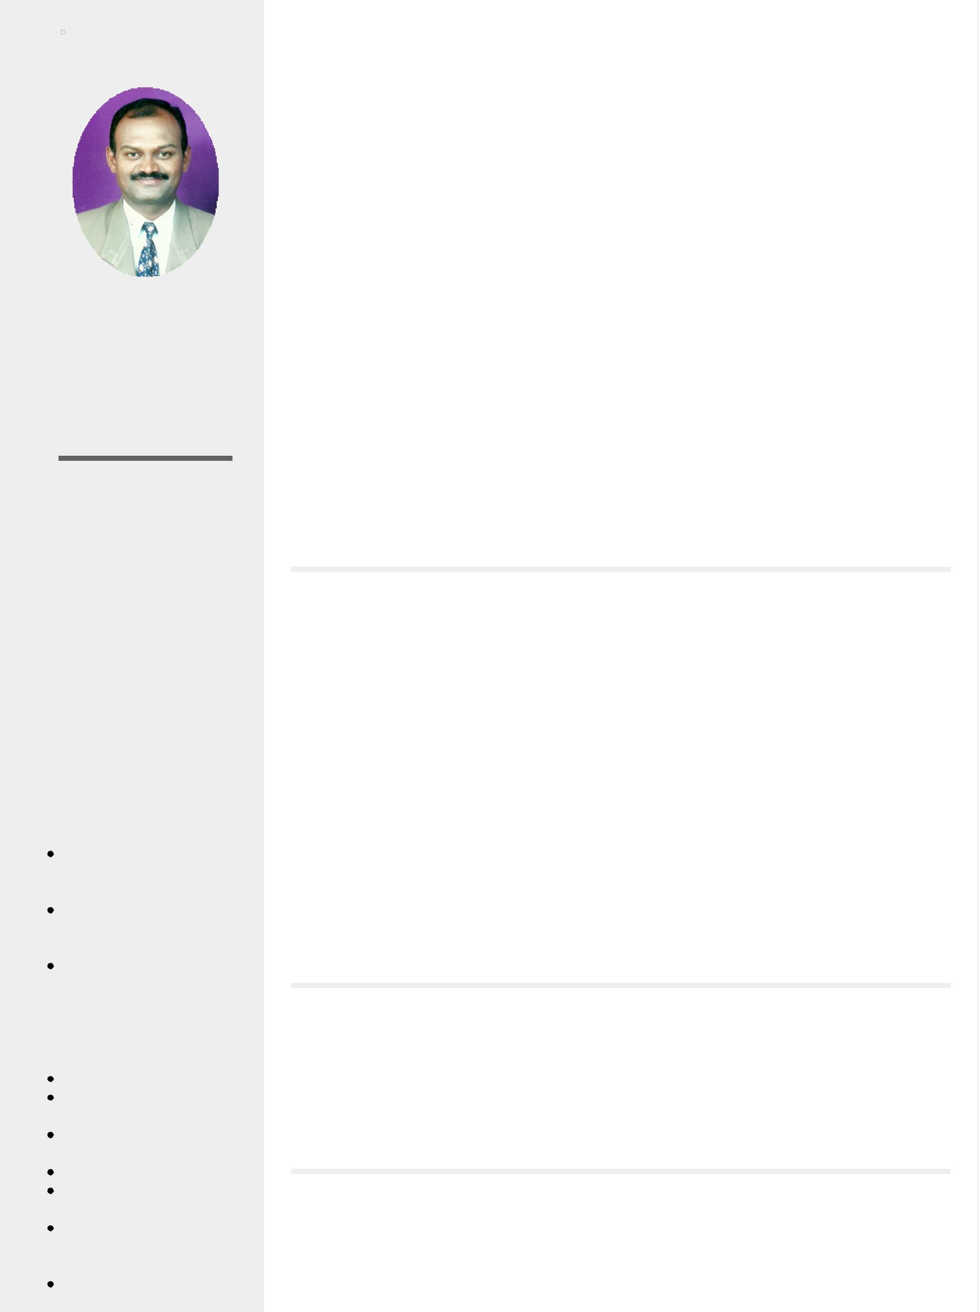

A seasoned Project Manager with rich experience of over 30 years in Plastics Product Development and Engineering Plastics Project Developer and Manager in Automobile Ancillary, Refrigeration, Irrigation and Beverage Industries across various District of Maharashtra India. ( Mumbai, Nagpur, Pune , Nasik )

Professional Achievements :

* Selected to Evaluate for bench marking of 3D CAD/CAM/CNC softwares among the UG , Auto surf, Catia and TEBIS –II for 3D-Modeling and NC path generation for manufacturing of CNC mold of Automobile components – FY 1992-93.
* Selected to Design and Manufacture, 12 cavity PET Prefrom Hot runner CNC Injection mould suitable for one liter Bisleri bottle, in association with US based Cincinnati Millacron Injection molding machine at Hong Kong in FY 2000-01.
* Nominated as Project proponent for registering India’s First biggest A/R CDM Project to reduce GHG reduction emission in Nasik District by PCCF (R, E &T) Forest department Pune Maharashtra in FY 2009-10.
* Selected as Project coordinator for developing Food cluster in Nasik Districts by Nasik Engineering Cluster Nasik in consultation with DIC Mumbai and as per guidelines of MoFPI Govt.of India, New Delhi. FY 2013-14.
* Selected as Project Developer for establishment for India’s first fragrance drinking water manufacturing MWP by Public limited company to make revolution in drinking technology & to promote Ayurveda globally.- FY 2014-15.

EXPERIENCE

Authentic Ayurvedic Remedies India Ltd

SEEKING STATUS

Currently Seeking

AVAILABLE FROM

17/07/2017

LANGUAGES

English

* Full Professional proficiency

Hindi

* Professional working proficiency

Marathi

* Full Professional proficiency

SKILLS

Project Management Tool Room Management and Mould Manufacturing Processing of Plastics on Injection Molding M/c CAD/CAM/CNC/CAE Automobile/Auto ancillary/Refrigeration/Breverage Export- Import

Management with Global Marketing

Tebis -II CAD/CAM/ and NC program generation

Technical director (Projects)

September 2014 - Current

Project Establishment and Management of India’s first patented fragrance drinking water technology having capacity of MWP 6000 LPH (Lit per hr) at 16 locations in various districts of Maharashtra State India.

Key Responsibilities:

* Unique Design development of PET bottle with Crown cap for Revolution in drinking technology
* Establishment of MWP 6000 lits/ hr project with 90 BPM filling capacity Machine
* Steer business : Development Franchisee and Channel partners activities to boost sales and Applications
* Development of Ayurvedic Soaps, Flavored Soda, Masala Essence sticks, and many others
* Daily RM procurement and Production management as per business channel partners requirement.

EDUCATION

Institute of Chemical Technology (ICT) Matunga Mumbai India

B.Sc.(Tech) Chemical Engineering Technologist In Plastics & Polymer Chemistry (Postgraduate)

Mumbai , Maharashtra, India June 1982 - Current

CERTIFICATIONS & MEMBERSHIPS

Tebis International Germany

TEBIS -II Basic Training CAD/CAM/CNC

Certificate/Membership Does Not Expire

Business Development Management

Back Office Management FMCG Products development

A/R CDM Project development Certified Emission Reduction (Carbon Credicts )

PET Preform Processing PET Bottle designing and Blow molding Beverage Project development and Management Engineering Plastics Product Development Processing of ABS, NYLON, PET, ACETAL, PPCP, HDPE Production and Manufacturing Strategic Planning Vendor development Project Feasibility and Appraisal

Design Engineering and Model Degitising

Udhyog Wardhini Nasik (MS) India



Export Import Management with Global Marketing

Certificate/Membership Does Not Expire

LICENSES

Parmanent

Import Export

Nasik, Maharashtra , India March 2017 - Current

ROLES

Annual - 4000000 to 5100000

Custom Location 09 - Custom Area 201

Automotive / Automotive Parts

Program Manager / Project Manager

Work type

Temp-To-Perm, Contract

Eligible to work in:

Australia, Canada, China, Ethiopia, Fiji, France, Germany, Greece, Hong Kong, Italy, Japan, Saudi Arabia, Singapore, South Africa, United Arab Emirates, United Kingdom, United States