Program **COMPANOVA2**  is a programfor the analysis of paired comparisons (Gies Bouwman/Toni Rietveld, Radboud University Nijmegen), on the basis of: Scheffé, H. (1952). An analysis of variance for paired comparisons. *Journal of the American Statistical Association* 47, 381-400.

*A) Procedure:*

1. In case you haven’t already done so, install **git**.from http://git-scm.com/downloads

2. After starting **RStudio**, pick New Project… from the **File** menu.

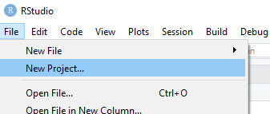

3. In the first screen of the wizard, choose **Version Control**

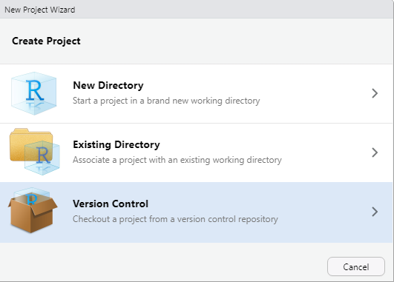

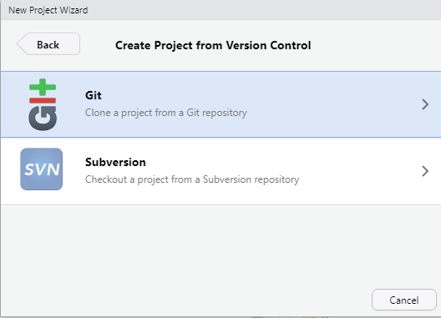

4. On the next screen, click on **Git**

5. On the final screen, enter the URL of the **companova2** git repository.

A project directory name is automatically suggested, just like the default directory

on the file system of your computer. Click **Create Project** to clone the repository locally and open the project.



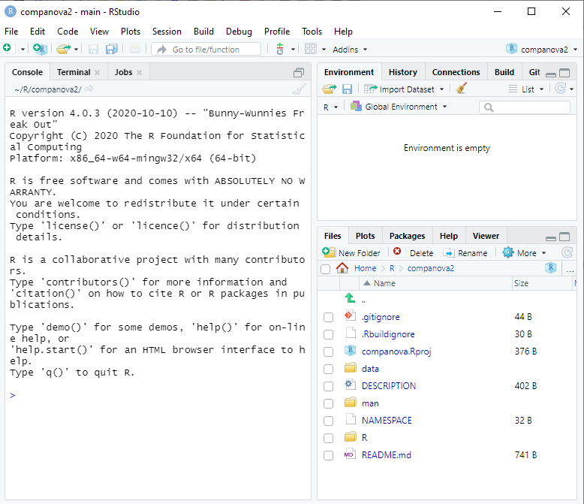

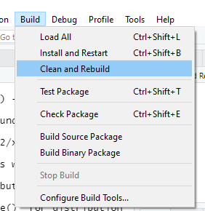6. Next, build the package: choose Clean and Rebuild from the Build menu.

The Console panel should display a text that the R session has been restarted and the *companova2* library is loaded as a library.

7. As a final step, run the analysis using the included sample data file

scheffeSTANDAARD.dat

companova2::run("data/scheffeSTANDAARD.dat")

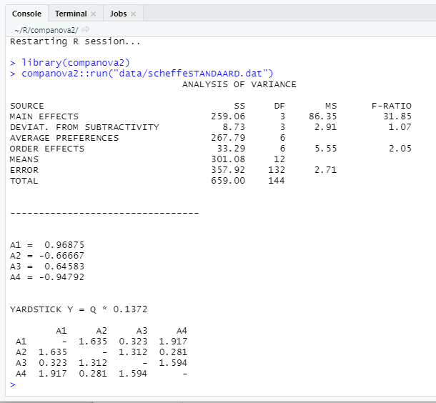

The output should look like the screenshot above.

*Scale values:* The scale values (A1…) represent preferences, going from left (highest preference) to the right (lowest preference). For more details, see Scheffé (1952), and Rietveld (2021).

*B) Format input file (example)*

For the assessment of 4 Items (A, B, C and D) two groups of raters have to be arranged:

One group assesses the pairs AB, AC, AD, BC, BD etc;

The other group assesses the pairs BA, CA, DA, CB, DB etc.

For the assessments the following scale is used:

-3

-2

-1

0

1

2

3

Item A better

Item B better

If Item A is strongly preferred to Item B, -3 should be scored. If Item B is moderately preferred to Item A, a 2 should be scored, if Item A is slightly preferred to B, -1 should be scored etc. When there is no preference, category 0 should be used.

The results are stored in a data matrix with the extension .DAT, and the following format:

* The data are separated by a blank.
* The 1st column indicates the number *i* of the item of a pair (*i,j*), in which *i* is the first member of a pair that was assessed. The next 7 columns represent the frequencies of the judges who assessed the first item (A) as better etc (-3, -2, -1) than B, and assessed the Item B as better etc. than item A
* Thus, with four items there will be 12 rows, *m  (m-1)*, with in the first column:

1

2

1

3

1

4

2

3

2

4

3

4

These numbers stand for (1,2), (2,1), (1,3), (3,1)…….. (3,4), (4,3)

As an example we present here the first two rows of a matrix with 12 judges per order:

1 0 0 0 3 3 2 4

2 6 3 1 0 1 1 0

Item B is clearly preferred over Item A in both presentation orders: AB (1,2) and BA (2,1).

*C) References*

Beijer, L.J., Rietveld, A.C.M., Ruiter, M.B. & Geurts, A.C.H. (2014). Preparing an E-learning-based Speech Therapy (EST) efficacy study: Identifying suitable outcome measures to detect within-subject changes of speech intelligibility in dysarthric speakers. *Clinical Linguistics & Phonetics,* 28 (12), 927-950.

Rietveld, Toni (2021). *Human Measurement Techniques for Speech and Language Pathology*: London: Routledge

Ozaki, K. (2008). Twin Analysis on Paired Comparison Data. *Behavioral Genetics*, 38, 212-222.

Scheffé, H. (1952). An analysis of variance for paired comparisons*. Journal of the American Statistical Association* 47, 381-400.