1. After starting Rstudio, pick New Project… from the File menu.
2. 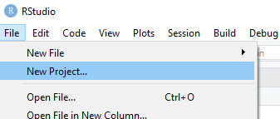In the first screen of the wizard, choose Version Control
3. 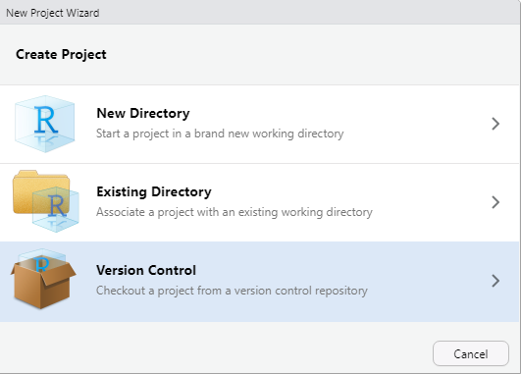In the next screen, click on Git

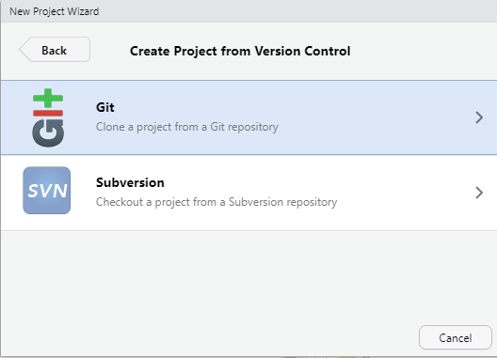

1. On the final screen, enter the URL of the companova git repository. A project directory name is automatically suggested, just like the default directory on the file system of your computer.  
   Click Create Project to clone the repository locally and open the project.

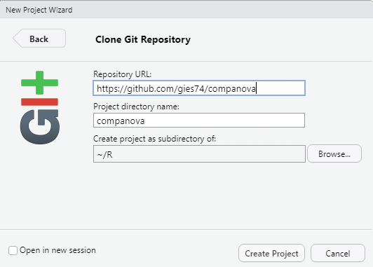

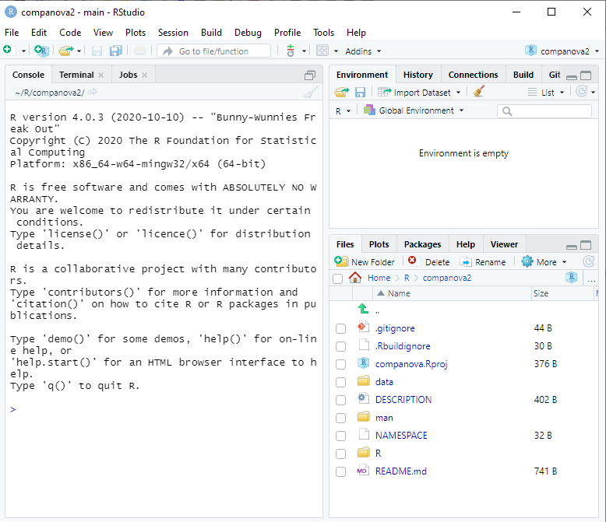

1. Next, build the package: choose Clean and Rebuild from the Build menu.

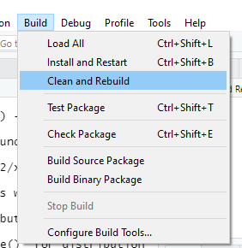The Console panel should display a text that the R session has been restarted and the companova library is loaded as a library.

1. As a final step, run the analysis using the included sample data file scheffeSTANDAARD.dat

companova::run("data/scheffeSTANDAARD.dat")

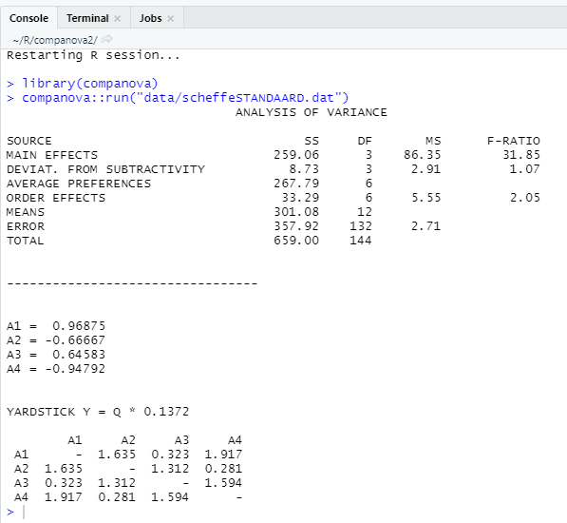

The output should look like the screenshot above.