Designing Modules
How to create your own module

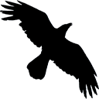

Written by Robert Jan van der Waals | April 25, 2008 |
Version 1.0 | Based on Data Crow 3.2

Introduction
Since Data Crow 3 it is possible to create your own modules. I have had many requests to add additional modules like a coin and a wine module. Using the module creation wizard you can now easily create the modules you are missing from the standard Data Crow installation.
Using the module creation wizard you can quickly create a new module. This manual has been created to ensure you are creating the module you want.

General tips

- Always create a module in a clean installation of Data Crow. Just install a version of Data Crow to a different location then your production version. In this new and empty version you can experiment without having to worry about messing up your current installation.
- You can share a module with someone else or copy a module you have created in your test installation to the production version. Modules are stored as JAR files in the modules folder of your installation. Simply copy the JAR file having the name of your module to the modules folder of another installation. Data Crow needs to restart in order to see the new module.
- Describe on a piece of paper the fields you will need. Also define if you need lists of options a user can select from. You can create managed lists within your module. Meaning you can define a field called “genres” and make the content (the genres) manageable from within Data Crow.
- If you want to use lists as described in point 3, create the modules which will hold the items first. Most common these will be simple property modules for items like categories, genres, etc. Items of these modules have a name and an icon, nothing else. This will be explained further on in this document. Just remember that the fastest way to create your module is from the bottom to the top.

Module Types
One of the first things you need to know is what every module type is and what it can be used for. There are three types of modules; property modules, media module and ‘other’ modules.
The type of module determines how the module can be accessed and which predefined fields a module has. Predefined fields (such as the ID) cannot be removed from the module (though they can be hidden using the normal field settings editor).

Property module type
A property module is the simplest module type. Examples of property modules are the movie and music genres, the software category, the storage media and the platforms.
A property module will never show up in the module bar. In fact it will not show up anywhere until used within another module. Its existence depends on other modules. This will be discussed later on in this document when we get to the field creation.
When a property module has been used within another module you can manage its items via the tools menu. Note that this is the tools menu of the module using this property module.

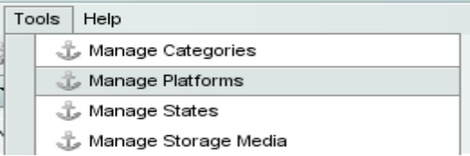
Managing referenced property module items

Predefined fields
      - Created (item creation date)
      - ID (system ID)
      - Item (module item name)
      - Modified (item modification date)
      - Name (name of the item)
      - Icon (icon to represent the item)

Media module type
This type of module is a fully functioning module. After its creation it will show up in the module bar from where it can be opened and used.
Items created within this module can also be managed by using the media module.

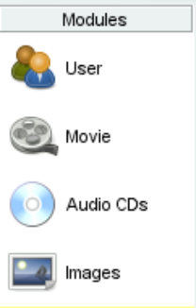
Module List

Predefined fields
- Created (item creation date)
- ID (system ID)
- Item (module item name)
- Modified (item modification date)
- Description (item description, long text)
- Location (free form location description of the item)
- Rating (10 star based rating)
- Title (title of the item)
- Year (year of release of the item)

‘Other’ Module type
The other module type is almost the same as the media module type. The only difference is that it has no predefined fields (such as rating, title) and its items cannot be managed by using the media module.

Predefined fields
- Created (item creation date)
- ID (system ID)
- Item (module item name)
- Modified (item modification date)

Starting a new module
There are two ways to create a new module. One way is to manually create a XML file which describes the module and its fields. The second and easiest way is to use the module creation wizard. This document will describe the creation process using the wizard.

Step 1: select the module type
As described in the previous chapter you need to select the correct module type for your purposes. I cannot stress this enough as this information cannot be changed later on.

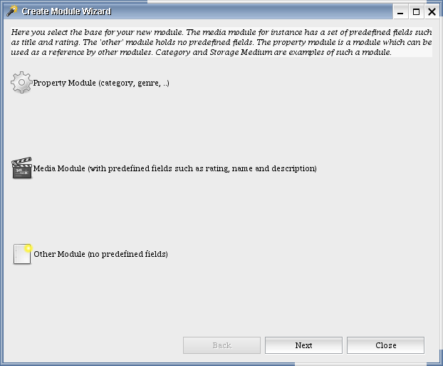Module wizard step 1 of 3

Step 2: enter the basic module information
In this step you have to enter the basic information for the module such as its name, its icons and a description. Most of this information can be changed after the module has been created.

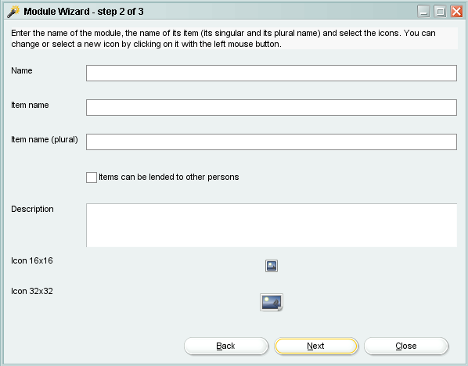 Module wizard step 2 of 3
Below you find an overview of the information you have to fill here and whether this information can be changed at a later stage or not.
Field | Description | Can be changed later?
Name | Name of the module. Example: Coins. | N
Item name | Name of an item belonging to the module. Example: Coin. | N
Item name (plural) | Plural name of items belonging to the module. Example: Coins. | N
Items can be lend to other persons | Indicates if the loan system should be activated for this module. If so, contact persons can lend items belonging to this module. This option is not available for property modules. | Y
Description | A short description of this module. The description is shown when you move your mouse over the module in the module list panel. | Y
Icon 16x16 | Small icon. This icon is used for the item form, reports, the table view and various settings panels. | Y
Icon 32x32 | Large icon. This icon is used for the module list panel. | Y

Some of the information cannot be changed at a later stage as Data Crow uses the information to create for example the database tables.

Step 3: Creating fields
The third step of this wizard is where you can define the fields for your module. These fields will hold the information for each of your items. In the upper part of the screen you can see the predefined fields for the module. These fields are fixed and cannot be removed or changed. In the lower part all fields are shown which have been defined by you.
To create a new field you click the “Add Field” button. To remove a field you select the field in the list and press the “Remove Field” button. You can only remove fields from the “New Field” section.
The ordering of the fields can be changed by using the green arrow buttons. Note that it is not necessary for you to change the ordering as you can change this by using the field settings (see the internal help for more information on this).

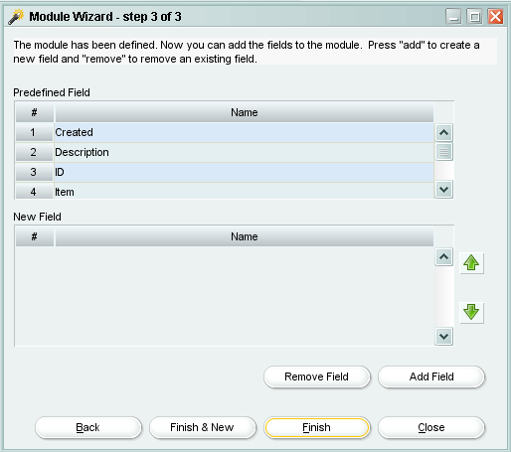
Module wizard step 3 of 3

Creating a new field
After clicking on the “Add Field” button a dialog is opened. This dialog is used to define / create your field. It is very important to know that created fields cannot be changed at a later stage. They can only be removed and recreated.
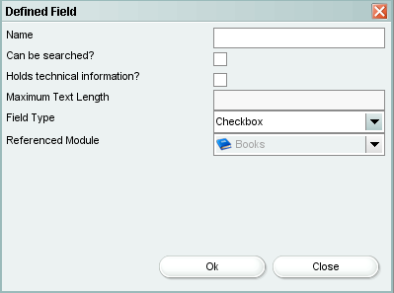
Dialog for defining a field
The information to enter is detailed below.
- Name.
The label for this field.
- Can be searched.
Indicates whether users should be able to search on this.
- Holds technical information.
If the field holds technical information (indicated by checking this setting) it will be displayed in the technical information tab of the item form.
- Maximum text length.
The maximum length of the value to enter.
- Field type.
Indicates what kind of value the field can hold and how it’s displayed. Each of the options here will be discussed in the next chapter.
- Referenced module.
Some of the field type can shown items from other modules. The appropriate module, the module of the items you want to display, should be selected here.

Field Types
The field type decides what kind of value you are going to store in the field (number, text, etc), how it will be displayed and it even determines how other modules are displayed!
Field Type | Description
Checkbox | Stores a yes / no value.
Date Field | A date field with a calendar or date selection.
Decimal Field | Numeric field, decimal representation. The representation of the value (example: 1,000,000.00) depends on the locale settings.
File Field | A simple file field. Contains a browse button.
File Launcher Field | Can store a filename and is able to launch the associated file using the launch button. A file can be selected by using the browse button.
Number Field | Numeric field (example: 1000000).
Picture Field | Holds an image and is displayed in a separate tab of the item form.
Rating Field | A 10 star-based rating field.
Reference Field, Dropdown | This field allows you to select items belonging to another module. The items of the module are displayed in this list. The module from which the items should be displayed should be selected as the referenced module. A good example of such a field is the state field of the movie module.
Reference Field, Multi-select | Same as above but allows multiple items to be selected. Example: the genres field of the audio CD module.
Text Field, Multi-line | A large text field.
Text Field, Single-line | A single line text field.
URL Field | This field stores HTTP URLS and is able to launch them in your browser.

Reference Fields
As shown above you have the option to use information from other modules in your own module. It is very common within Data Crow to use other modules to allow list content to be edited. Deciding to reference another module will also change the way that module is displayed.
Essentially creating a reference to another module makes your module the owner or parent of the referenced module.

Referencing a property module
The property module type has been described earlier. One of the most important things to know is that this module will only be displayed once it has been referenced by another module. After you have created a reference to a property module it will become available from the tools menu. A menu option called ‘manage X’ will be shown there. Using this option you can manage the items for this property module and thus also the content of the reference field.

Referencing any other type of module
Creating a reference to any other kind of module works exactly the same as for property modules. However the result is little bit different. The referenced module will be displayed in the module bar, under your module. An example is shown below. The software module has two reference fields, one to the developer module and one to the publisher module. These modules are only shown after the software module has been selected.
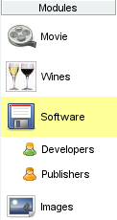
Module list

Relating modules
It is possible to create a parent child relation between two modules. A parent child relationship is something different then creating a reference between two modules. When a module becomes a child module its items can only exist when they have a relationship with a parent item. An example of this is the audio track module, which has a parent child relationship with the audio CD modules. Audio tracks can simply not exist when there is no audio CD.
In case of a reference between two modules this is not the case. An actor can exist even when it is not referenced by a movie.
Creating a parent child relationship can be accomplished by using the “Relate Module” wizard (as can be found in the modules menu).
After the relationship has been created the items belonging to the child module can only be managed via the parent module. The item form of the parent module now has a separate tab where the child items are shown. This tab also allows you to create, update and remove child items. In case you want to manage the child items using a view the table view would be your only choice. The table view is capable of showing the parent item and its children in one view. The audio CD module and the music album module are good examples where you can see this in action.

Deleting modules
Custom modules, modules not delivered with the Data Crow product, can be deleted by using the “Delete module” wizard (which can be found in the module menu). The last step of this wizard shows all the changes that have to be performed before the module can be deleted. Sometimes a module is referenced by other modules or the module is part of a parent child relationship. The wizard will alter these modules so that they remain functional after the selected module has been removed.

As stated before you cannot remove a standard module (delivered with the Data Crow product). However you can hide this module via the settings.

Distributing your module
After you have created and tested your module you might want to distribute it to other persons. The easiest way to do this is to copy the JAR file from the modules folder and copy to the modules folder of any other installation. But what if you have changed the settings to set the correct field order etc?
If you look at the module folder of your current installation you might notice that every module JAR file also comes with a property file. These property files contain the default settings for the modules.
The settings file for your module is located in the data folder. It will have the same name as the JAR file. If you copy this properties file to the modules folder together with the module JAR file you are sure that it has the correct settings.

