

**MASENO UNIVERSITY**

**SCHOOL OF COMPUTING AND INFORMATICS**

**CCS 403: PROJECT**

**BY:**

**STUDENT NAME: WANGIRA GIFT LAMECK**

**COURSE : BSC COMPUTER SCIENCE**

**REG NO: CCS/00035/021**

A project submitted to the Department of Computer Science in the School of Computing and Informatics in partial fulfillment of the requirements for the award of the degree of Maseno University.

# DECLARATION

I, **Wangira Gift Lameck**, declare that this project titled **"University Student Elections System"** is my original work and has not been submitted to any other institution or university for the award of a degree or any other academic qualification.

All the information, ideas, and content presented in this document are a result of my own effort, except where explicitly acknowledged and cited. I have adhered to the academic standards of originality, integrity, and honesty in the development and documentation of this project.

Signature: __________________________  
Date: ____________________________

**Supervisor’s Declaration**  
This project proposal has been submitted for examination with my approval as the university supervisor.

Name: **Vivian Oloo**  
Signature: ________________________  
Date: ____________________________

Contents

DECLARATION ii

CHAPTER ONE: INTRODUCTION 2

1.1 Background 2

1.2 Problem Statement 3

1.3 Objectives 4

1.4 Research Questions 6

1.5 Scope 8

1.6 Limitations 11

CHAPTER TWO: LITERATURE REVIEW 14

CHAPTER 3: METHODOLOGY 18

3.1 Requirements Analysis 18

3.1.1 Functional Requirements 18

3.1.2 Non-Functional Requirements 18

3.2 Data Collection 19

3.2.1 Sources of Data 19

3.3 System Specifications 19

3.3.1 Hardware Requirements 19

3.3.2 Software Requirements 19

3.4 System Design 19

3.4.1 Design Diagrams 19

3.4.2 Implementation Plan 25

3.5 Testing 25

3.6.1 Types of Testing 25

3.6.2 Sample Test Cases 25

3.7 Maintenance 25

CHAPTER 4: CONCLUSION 26

# CHAPTER ONE: INTRODUCTION

## Background

Elections are a fundamental part of democratic governance, serving as the primary means through which citizens select their leaders. In educational institutions like universities, student elections provide a platform for students to choose representatives who will act as their voice in institutional matters. These representatives are critical in ensuring that student concerns, such as academic welfare, social activities, and financial support, are adequately addressed.

In Kenya, universities, including Maseno University, primarily rely on manual voting systems. This method typically involves students casting their votes via paper ballots, which are later counted manually by election officials. Although this system has been in place for decades, it has become increasingly inefficient and prone to several issues. The process of manual vote counting can be slow, leading to delays in the announcement of election results. Furthermore, manual systems are vulnerable to human error and, in some cases, manipulation or tampering, which can lead to disputes and mistrust in the election outcomes.

As universities grow in size, the logistical challenges associated with managing manual voting systems have also increased. More students mean longer queues, higher costs for materials (such as ballot papers), and more personnel required to oversee the process. These challenges have prompted a need for innovation to streamline and secure the election process.

With advancements in technology, many institutions around the world have shifted toward digital voting systems. These systems offer numerous advantages, including faster vote tallying, increased transparency, and improved security measures to prevent voter fraud. However, most universities in Kenya, including Maseno University, have yet to adopt such systems. The lack of technological infrastructure, combined with concerns about the potential risks of online voting (e.g., security vulnerabilities), has slowed the adoption of digital solutions.

This project proposes the development of a **University Student Elections Voting System** that will be integrated into the existing student portal(s). The integration aims to leverage the portal's existing security features, ensuring that only registered students can participate in the voting process. By digitizing the voting system, the university will be able to address inefficiencies and security concerns inherent in the manual system. This will improve the overall election experience for students and increase trust in the results.

In light of the growing student population and the technological advancements available, the move toward a digital voting system is both timely and necessary. This project seeks to provide a solution that is not only secure and efficient but also scalable, allowing other Kenyan universities to potentially adopt it in the future.

## Problem Statement

The current manual voting system used for student elections at Maseno University, and some other universities in Kenya presents significant challenges that hinder the efficiency, transparency, and security of the election process. As the student population grows, the limitations of this system become increasingly apparent, leading to various operational and trust issues.

One of the primary problems with the manual system is **inefficiency**. During election periods, students are required to cast their votes using physical paper ballots. This process is time-consuming, as it involves long queues, extensive coordination, and the manual tallying of votes. The manual vote counting process is particularly problematic, as it is prone to human error and delays in announcing results, which can create confusion and frustration among students. In some cases, these delays may even lead to disputes regarding the fairness of the results, further undermining confidence in the election process.

Furthermore, the manual voting system is vulnerable to **security concerns**. There have been cases where the integrity of the voting process has been called into question due to the potential for ballot tampering, duplicate voting, or misplacement of ballot papers. These issues not only threaten the credibility of the election process but also compromise the fairness and transparency that are essential for a democratic election.

Additionally, the manual system lacks the ability to **scale efficiently**. With an increasing number of students enrolling each year, the resources required to manage the voting process (including personnel, time, and materials) continue to grow. This makes the current system increasingly unsustainable for future elections. There is also a lack of integration between the voting system and the university’s digital infrastructure, making it difficult to track voter participation and verify voter eligibility in real-time.

To address these issues, there is a need to transition to a **digital voting system** that integrates with the university's existing student portal. By leveraging technology, the proposed system aims to eliminate inefficiencies, reduce the risk of human error, and enhance the security of the voting process. The digital system will also streamline the administration of elections, making the entire process more accessible, transparent, and trustworthy.

Without such a solution, the university risks facing continued operational challenges, diminished trust in the election process, and an increasing burden on resources as the student population continues to grow. This project will fill the gap by providing a secure, scalable, and efficient platform for conducting student elections.

## Objectives

The primary aim of this project is to design and implement a secure and efficient digital voting system integrated within University’s student portal, which will modernize the election process by addressing the challenges posed by the current manual voting system. Specifically, the system will improve the speed, security, and transparency of student elections, ensuring that every eligible student can participate in a fair and democratic process.

**Main Objective:**

* To develop and deploy a secure, scalable, and user-friendly **University Student Elections Voting System** that is fully integrated into the University student portal, enabling efficient and transparent elections while addressing the inefficiencies, security vulnerabilities, and limitations of the current manual voting system.

**Specific Objectives:**

1. **To enhance the efficiency of the voting process** by automating vote casting and tallying, reducing the time and human effort required to manage elections and announce results.
   * This objective focuses on streamlining the voting and result computation process, ensuring that election results are available immediately after the voting period closes.
2. **To improve the security of the election process** by integrating encryption protocols, session management, and multi-factor authentication to prevent unauthorized access, duplicate voting, and vote tampering.
   * This objective ensures that only eligible students can vote and that their votes are securely transmitted and stored, safeguarding the integrity of the election process.
3. **To promote transparency and trust in the election process** by providing an auditable digital trail that allows for post-election verification and independent review of results.
   * This objective ensures that all stakeholders (students, candidates, and administrators) can trust the election outcome by allowing for transparent review mechanisms.
4. **To integrate the voting system with the existing student portal** to ensure ease of access for all students, leveraging their current login credentials for a seamless user experience.
   * By utilizing the existing student portal, this objective ensures that the system is familiar to users and can be easily accessed by all eligible voters without the need for additional software or accounts.
5. **To ensure scalability and adaptability** by developing the system to accommodate an increasing number of students and potential future expansions to other universities or election types within Maseno University.
   * This objective ensures that the system is designed with future growth in mind, so it can handle larger elections and potentially be adapted for use in other university departments or campuses.
6. **To foster inclusivity and accessibility** by ensuring the system is user-friendly and mobile-responsive, enabling students to vote from any device (laptop, tablet, or mobile phone) with internet access.
   * This objective ensures that the voting system is inclusive and accessible to all students, regardless of their technical proficiency or the device they use.
7. **To conduct thorough testing and stakeholder training** to ensure that both system administrators and students understand how to use the system effectively before the official election period.
   * This objective involves organizing training sessions and mock elections to familiarize students and staff with the system, ensuring that it functions correctly and that all users are confident in using it.
8. **To maintain data privacy and compliance with relevant regulations** by ensuring that the system meets all legal and institutional data protection requirements, including Kenya's Data Protection Act.
   * This objective ensures that the system is designed and implemented in full compliance with relevant laws governing data protection, maintaining student privacy throughout the election process.

## Research Questions

This project seeks to address the challenges posed by the manual student elections process at Maseno University and other universities holding elections manually. The following research questions have been formulated to guide the development and evaluation of the proposed digital voting system:

1. **How can the efficiency of student elections be improved through an automated voting system?**
   * This question relates to the first objective of enhancing the voting process by reducing the time and effort required to manage elections, vote casting, and result tallying. It seeks to explore the extent to which automation can reduce delays and human errors in the election process.
2. **What security measures are necessary to ensure that the voting system is secure from unauthorized access and tampering?**
   * This question focuses on the second objective, which aims to improve the security of the voting process. It explores the types of security protocols (such as encryption, authentication, and session management) needed to ensure the integrity and confidentiality of votes.
3. **How can the proposed digital voting system increase transparency and trust in the election results among students and stakeholders?**
   * This question relates to the third objective, which deals with ensuring transparency and trust in the voting process. It examines how providing an auditable digital trail, open access to results, and transparent vote tallying can build trust in the election outcomes.
4. **How can the voting system be integrated seamlessly into University’s existing student portal without compromising the portal’s current functionality?**
   * This question addresses the fourth objective, which involves integrating the voting system into the student portal. It explores the technical requirements and best practices for ensuring a smooth integration without disrupting other portal services.
5. **How can the voting system be designed to scale and handle future increases in the student population and possible expansion to other university elections?**
   * This question relates to the fifth objective of ensuring scalability and adaptability. It investigates the system’s ability to manage a growing number of users and votes and explores strategies for accommodating different types of elections within the university.
6. **What design features are necessary to ensure that the voting system is inclusive and accessible to all students, including those using mobile devices?**
   * This question addresses the sixth objective of fostering inclusivity and accessibility. It explores the system’s user interface design, mobile responsiveness, and usability to ensure that all students, regardless of device or technical skill, can participate in the elections.
7. **What training and testing strategies are required to ensure that both students and administrators can use the voting system effectively?**
   * This question relates to the seventh objective of training stakeholders. It examines the methods needed to educate students and administrators on using the system, as well as strategies for conducting mock elections to ensure familiarity and smooth operation during actual elections.
8. **How can the voting system comply with Kenya's Data Protection Act and other relevant institutional data privacy regulations?**
   * This question addresses the eighth objective of ensuring legal compliance. It explores the data handling, storage, and processing protocols necessary to meet data privacy laws and regulations, ensuring that students’ personal information is protected.

## Scope

The proposed **University Student Elections Voting System** will focus on digitizing the voting process at Universities by developing a secure, efficient, and transparent online platform integrated into the university’s student portal. The system will aim to streamline the entire election process—from candidates application to vote casting, tallying, and result announcement—by eliminating the challenges associated with the current manual system.

Specifically, the scope of this project will include:

1. **User Registration and Authentication**:
   * The system will authenticate users using the existing student portal credentials (student ID and password). Only registered and eligible students will be able to log in and vote, ensuring that only legitimate users participate in the election.
   * The system will support single sign-on (SSO) integration with the student portal, providing seamless access.
2. **Election Configuration and Management**:
   * University administrators will be able to configure elections, including specifying positions (e.g., President, Vice-President, etc.), candidate lists, and eligibility rules.
   * The system will include an interface for election administrators to schedule election dates, define eligible voter groups, and manage the electoral process.
3. **Voting Process**:
   * Students will be able to cast votes online through a secure, intuitive voting interface. The system will support a ballot-style interface, displaying candidates for each position and allowing voters to select their preferred candidates.
   * The system will ensure that each voter can only vote once and that they must select candidates for all relevant positions before submitting their ballot.
4. **Vote Tallying and Result Announcement**:
   * After the voting period ends, the system will automatically tally votes and generate election results in real-time. The results will be securely stored and displayed to the election administrators for review before public announcement.
   * The system will provide an option for administrators to publish election results on the student portal.
5. **Security Features**:
   * The system will employ encryption, multi-factor authentication (MFA), and session management to prevent unauthorized access, ballot tampering, and multiple voting by the same user.
   * It will provide a secure audit trail, allowing administrators to review the election process and results.
6. **Integration with the Student Portal**:
   * The system will be fully integrated into the existing University’s student portal, allowing students to access the voting system without needing separate accounts or credentials.
   * The system will leverage the portal’s user management and authentication features to ensure smooth functionality and security.
7. **System Accessibility and Usability**:
   * The voting system will be accessible via web browsers on laptops, tablets, and mobile devices, ensuring that students can participate in elections regardless of their location or device.
   * The interface will be designed to be user-friendly, with clear instructions to guide students through the voting process.
8. **Eligible Users**:
   * The system will be available to all registered students at the University who meet the eligibility criteria defined by the election administrators.
   * Only students identified as eligible voters will have access to the voting system during the election period.

**Out of Scope:**

* The system will not handle offline voting or paper ballots; it is purely a digital solution.
* The system will not manage political campaign activities or candidate registration outside of the election configuration module.
* The project will not cover elections outside of Maseno University’s student body, although future scalability for other elections within the university can be considered.
* Budgeting, campaign management, or any financial aspects of the elections will not be part of the system’s scope.

Bottom of Form

## 1.6 Limitations

While the proposed **University Student Elections Voting System** aims to revolutionize the voting process at University by improving efficiency, security, and transparency, certain limitations must be acknowledged. These limitations reflect the challenges and constraints that may impact the system’s development, deployment, and overall success:

1. **Financial Constraints**:
   * Due to limited financial resources, the project may not be able to cover advanced features such as biometric authentication or blockchain-based vote verification, which could further enhance security. The system will instead rely on more accessible and affordable security measures, such as encryption and multi-factor authentication (MFA).
   * Budget limitations may also restrict the ability to conduct comprehensive usability testing across a broad range of devices, potentially impacting the system's optimization for less common devices or older browsers.
2. **Time Constraints**:
   * Given the time available to complete this project as part of the final-year requirement, there may be insufficient time to fully implement certain advanced features or scalability options. For instance, while the system will support University’s student elections, further expansions to other elections (e.g., departmental or national university elections) may not be fully realized within the project’s timeframe.
   * The time constraint may also limit the depth of user training and system testing, meaning that while basic functionalities will be covered, more extensive testing phases might be deferred to later iterations of the system.
3. **Technical Limitations**:
   * The system's reliance on existing infrastructure, specifically the University student portal, may introduce technical dependencies that could limit flexibility in system design and functionality. For example, the portal’s current architecture may restrict how deeply the voting system can be integrated, or the portal may lack certain APIs necessary for seamless interaction with the voting module.
   * While the system will support web browsers across multiple devices (laptops, tablets, and mobile phones), limitations in mobile responsiveness or compatibility with less common browsers may affect user experience on certain devices. Comprehensive device compatibility testing will be constrained by time and resources.
4. **Internet Dependency**:
   * The digital voting system will be entirely internet-based, meaning it will not support offline voting. As such, any internet connectivity issues during the election period could disrupt access to the system for some students. While University is expected to provide sufficient internet infrastructure, unforeseen network outages could affect the voting process.
   * Students in remote areas with limited or poor internet access may face challenges participating in elections. Although the system will be optimized for low-bandwidth environments, internet speed and reliability could still be a barrier for some users.
5. **User Adoption and Resistance**:
   * The transition from a manual voting system to a fully digital platform may encounter resistance from some students or administrators who are unfamiliar with or hesitant to embrace new technology. Although the system will provide user training, ensuring full adoption across all users may prove difficult within the scope of this project.
   * Limited training opportunities and the need for a simplified user interface may result in fewer advanced features being included to ensure ease of use, particularly for less tech-savvy students.
6. **Limited Testing Environments**:
   * Due to resource constraints, the system will undergo testing in a limited set of real-world environments. The project will focus on testing the voting system with a smaller group of students and administrators before full deployment. While every effort will be made to identify potential issues, large-scale or stress testing (with thousands of concurrent users) may not be feasible within the project scope.
7. **Legal and Regulatory Constraints**:
   * Although the system will be designed to comply with Kenya’s Data Protection Act and relevant university regulations, the interpretation and implementation of these laws could change, potentially introducing new requirements that the project may not be able to fully address due to time and budget limitations.
   * The system will be confined to University’s student body, and expanding it to other universities would require substantial legal reviews and agreements, which are outside the scope of this project.

# CHAPTER TWO: LITERATURE REVIEW

**1. Manual Paper-Based Voting System in Kenyan Universities**

Most universities in Kenya, including Maseno University, currently rely on a manual, paper-based voting system for student elections. This traditional system involves physical ballot papers where students manually select their candidates, deposit the ballots in a box, and election officials tally the results at the end of the voting period.

**Strengths**:

* **Simplicity**: The manual voting system is straightforward and familiar to most students. It doesn’t require technical knowledge or infrastructure, making it accessible to all students, including those with limited access to technology.
* **Transparency**: Physical ballot papers and public counting sessions (in some cases) contribute to perceived transparency, as anyone can witness the vote counting process.

**Limitations**:

* **Inefficiency**: Manual voting processes are time-consuming and labor-intensive. Voters must be physically present at the voting location, leading to logistical challenges, especially for students not on campus during election days.
* **Voter Turnout**: The need for physical presence often leads to low voter turnout, as students off-campus or attending satellite campuses may not be able to participate.
* **Human Error and Fraud**: Manual counting is prone to human errors, including miscounting, misplacing ballots, or even tampering. Fraudulent activities like ballot stuffing or voter impersonation can undermine the integrity of the election.
* **Delayed Results**: The manual process results in significant delays in tallying votes and announcing results, which can lead to tensions and disputes.

Despite its continued use, the paper-based voting system faces many challenges that hinder its efficiency and reliability in modern-day elections. As universities grow and embrace digital transformation, there is a growing demand for more secure, efficient, and accessible voting systems.

**2. Electronic Voting System in the University of Nairobi (UoN)**

In response to the limitations of manual voting, some Kenyan universities, like the University of Nairobi (UoN), have begun adopting electronic voting systems for student elections. UoN implemented an online voting platform as part of its student portal, which allows students to log in with their credentials, select candidates for various positions, and cast their votes electronically.

**Strengths**:

* **Efficiency and Speed**: The electronic voting system allows for quick vote casting and real-time tallying of results. Election outcomes can be announced within hours of the voting period closing, eliminating delays associated with manual counting.
* **Accessibility**: Students can vote from any location with internet access, increasing voter turnout and participation, especially for students who are off-campus or at satellite locations.
* **Security**: The system uses secure authentication methods (student ID and passwords) to ensure that only eligible students can vote. Additionally, electronic systems provide a secure audit trail, reducing the risk of tampering and fraud.
* **Cost-Effective**: In the long run, electronic voting eliminates the need for physical materials such as ballot papers, boxes, and polling booths, reducing the overall cost of conducting elections.

**Limitations**:

* **Technical Challenges**: The system is highly dependent on internet availability and technical infrastructure. Any network outages or system failures during the voting period can disrupt the process and disenfranchise students.
* **Cybersecurity Risks**: While electronic systems can improve security, they also introduce vulnerabilities to cyberattacks, including hacking, data breaches, and denial-of-service attacks. Protecting voter data and ensuring the integrity of the system are critical challenges.
* **Digital Divide**: Not all students have equal access to the internet or the necessary devices for voting. This digital divide can disadvantage certain groups of students, particularly those in remote areas with limited connectivity.
* **System Usability**: User interface design and ease of use are critical in ensuring high voter participation. If the system is not user-friendly or intuitive, students may struggle to complete the voting process or make mistakes.

Although the UoN system has demonstrated the potential for efficient and transparent elections, it still faces challenges in ensuring inclusivity, security, and reliability. Lessons learned from UoN's experience can inform the design and implementation of similar systems in other universities, including Maseno University.

**3. Comparative Review of International E-Voting Systems**

Globally, universities and governments are increasingly adopting electronic voting systems to streamline electoral processes. Systems such as **Helios**, an open-source, web-based voting platform, have been widely used in academic and non-governmental organizations to conduct secure, transparent elections.

**Helios E-Voting System**:

* **Strengths**:
  + **End-to-End Verifiability**: Helios ensures that votes can be independently verified without compromising voter privacy, allowing for transparency throughout the voting process.
  + **Public Auditing**: The system is open-source, meaning that anyone can audit the code for vulnerabilities, enhancing trust in its security and transparency.
* **Limitations**:
  + **Technical Complexity**: While Helios is a robust platform, its implementation can be technically complex for universities or organizations without adequate IT resources.
  + **Internet Dependence**: Like other electronic systems, Helios relies on stable internet connections, which can be a barrier in regions with poor connectivity.

By reviewing the success and challenges of Helios and other international systems, this project can identify best practices for implementing a secure and scalable e-voting system tailored to the needs of Maseno University.

**4. Rationale for Developing a Custom University Voting System**

Given the limitations of both manual and existing electronic voting systems, this project aims to design a system specifically tailored to respective University’s student body. The system will combine the efficiency and accessibility of electronic voting with strong security protocols and usability features to address the unique needs of the university’s diverse student population.

The proposed system will leverage lessons from both manual and digital voting systems, improving on areas such as security, accessibility, and voter engagement. By integrating the voting system into the student portal, it will also reduce barriers to participation and ensure that the election process is streamlined and secure.

Here is a table summarizing the system analysis/literature review:

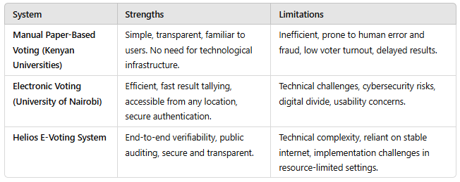

# CHAPTER 3: METHODOLOGY

Chapter Three covers the System Development Process, including requirements analysis, data collection, system specifications, design, implementation, testing, and maintenance. This chapter outlines how the proposed system will be developed and managed throughout its lifecycle. This chapter is crucial for understanding how the system is created and ensures it meets the objectives outlined in Chapter 1.

## 3.1 Requirements Analysis

This section defines the functional and non-functional requirements of the system, based on the goals established earlier.

### 3.1.1 Functional Requirements

These are the specific functionalities the system must provide to meet user needs:

* + Enable students to log in securely using their portal credentials.
  + Allow only students in session to view and vote for delegates.
  + Restrict voting access to eligible voters (e.g., Only eligible delegates can vote for specific aspirants).
  + Provide real-time validation to ensure no duplicate votes.
  + Generate and display election results in real time.
  + Admin functionality to create election events, manage users, and view reports.
  + Maintain a log of activities for transparency and accountability.

### 3.1.2 Non-Functional Requirements

These define the system's quality attributes:

* + Performance: The system should process votes in real-time.
  + Security: End-to-end encryption must ensure voter data confidentiality.
  + Usability: A user-friendly interface for students and administrators.
  + Scalability: The system should handle a growing number of users and elections.
  + Availability: High system availability during the voting period.
  + Accessibility: Ensure the system is accessible across devices and platforms, including desktops and mobile phones.

## 3.2 Data Collection

Data collection ensures the system is informed by accurate and relevant information about the current voting process.

### 3.2.1 Sources of Data

* Observation: Studied the current manual voting process to identify inefficiencies.
* Interviews: Conducted with university election officials and students to identify challenges with the current system
* Document Analysis: Review existing systems, student records, and voting guidelines for integration purposes.

## 3.3 System Specifications

This section defines the technical framework and tools used in system development.

### 3.3.1 Hardware Requirements

* + Server with adequate storage and processing power to host the application.
  + User devices (laptops, smartphones) for accessing the system.

### 3.3.2 Software Requirements

* + Programming Languages: PHP, HTML, CSS, JavaScript.
  + Database: MySQL for storing user data and votes.
  + Frameworks: Laravel or a similar PHP framework for enhanced functionality.
  + Web server (e.g., Apache or NGINX)
  + Tools: IDEs (e.g., Visual Studio Code), testing frameworks, and debugging tools.

## 3.4 System Design

This section describes how the system is structured and functions. It explains the conceptual and physical design of the system, it includes diagrams and models.

### 3.4.1 Design Diagrams

1. **Use Case Diagram:**

The Use Case Diagram captures the functional requirements of the university student election system by identifying the interactions between users (actors) and the system. It outlines the key activities that can be performed by different system users, such as students, election commissioners, and admins.

* ***Actors***: Represent the system's users (e.g., students, commissioners, admins).
* ***Use Cases***: Represent the specific actions or functionalities provided by the system (e.g., submit application, vote, manage elections).

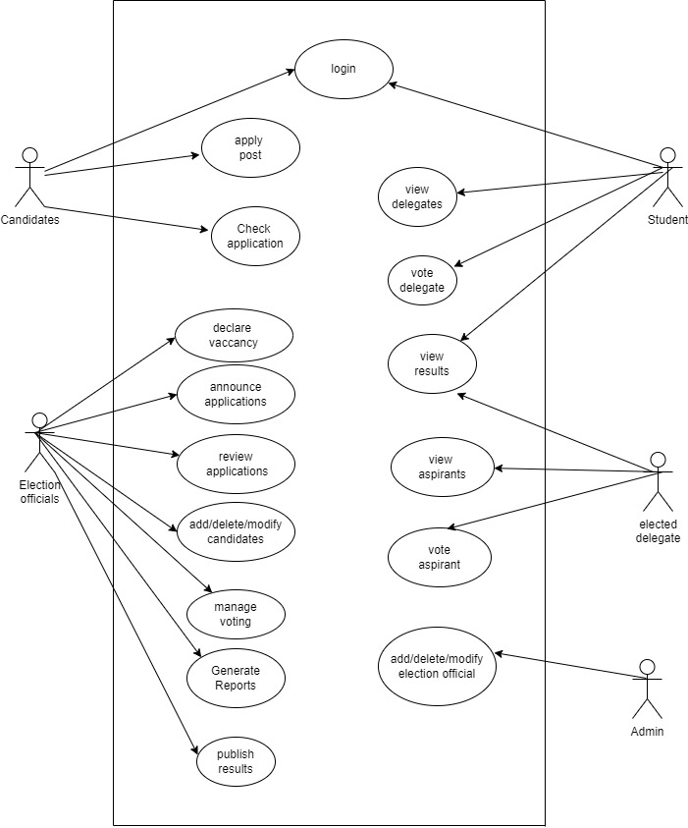

1. **Entity Relationship diagram:**

The Entity-Relationship Diagram (ERD) provides a conceptual representation of the data structure and the relationships between various entities in the university student election system. It is used to model the database schema and forms the foundation of data design. The ERD highlights the following key elements:

* The entities involved, such as users, candidates, elections, votes, etc.
* The attributes associated with each entity.
* The relationships between entities and the cardinalities defining these relationships.

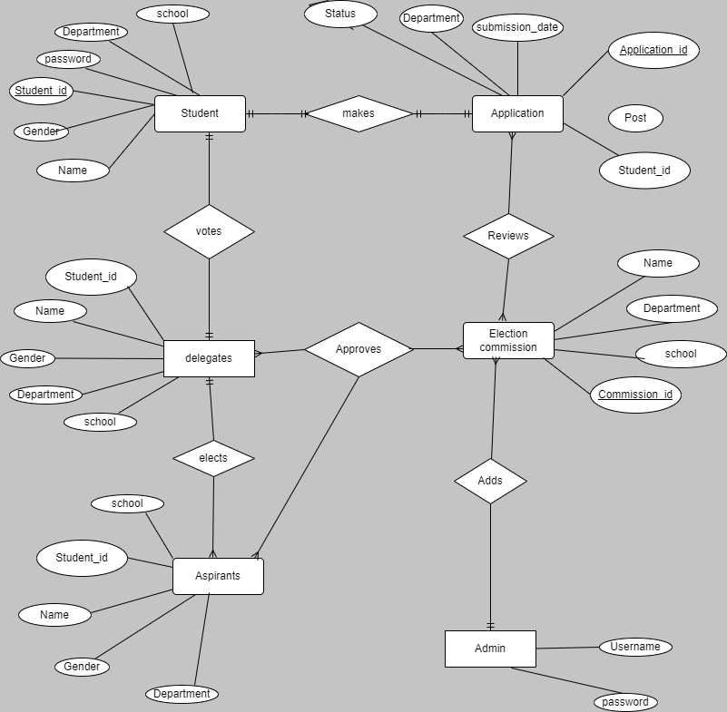

1. **Level 0 DFD diagram:**

The Level 0 Data Flow Diagram (DFD), also known as the Context Diagram, provides an overview of the entire system. It shows the system as a single process and its interactions with external entities such as students, election commissioners, and the database.

* **External Entities**: Represent system users or other systems interacting with the election system.
* **Data Flows**: Show the flow of data between the system and its external entities.
* **Processes**: At Level 0, the entire system is represented as one process.

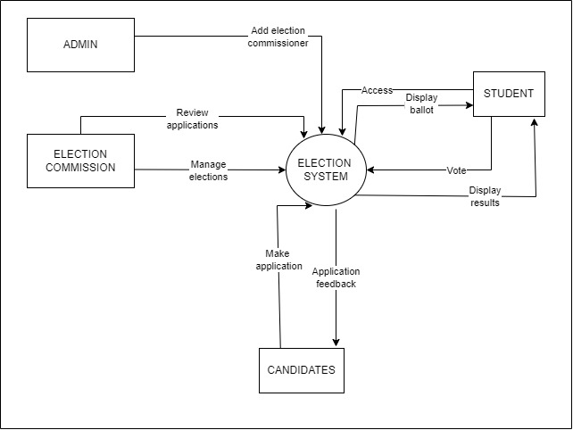

1. **Level 1 Data Flow Diagram:**

The Level 1 Data Flow Diagram (DFD) decomposes the single process in the Level 0 DFD into sub-processes, showing the detailed functionality of the university student election system. It provides a deeper insight into the flow of data within the system and highlights how different components interact.

* **Sub-processes**: Represent individual functionalities such as application submission, voting, result computation, etc.
* **Data Stores**: Represent data storage points, such as the database for user, candidate, and vote information.
* **Data Flows**: Show the movement of data between sub-processes, data stores, and external entities.

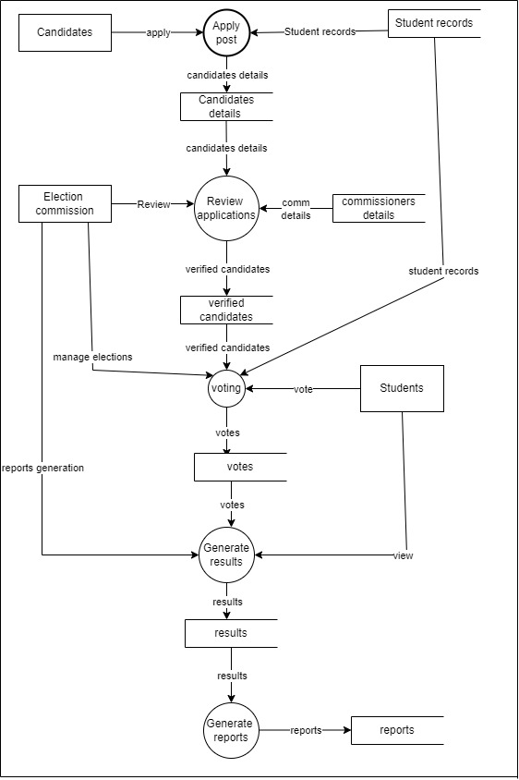

### 3.4.2 Implementation Plan

* Database Setup: Create tables for students, votes, aspirants, and results.
* Frontend Development: Build the user interface using HTML, CSS, and JavaScript.
* Backend Development: Develop system logic for vote casting, validation, and result calculation using PHP and MySQL.
* Programming Approach: Use an agile development methodology to iteratively build and refine the system.

## 3.5 Testing

Testing ensures the system is functional, reliable, and meets user expectations.

### 3.6.1 Types of Testing

* Unit Testing: Test individual components, such as user authentication and vote tallying.
* Integration Testing: Ensure that components, such as the voting module and database, work together.
* System Testing: Test the entire system to confirm it meets functional and non-functional requirements.
* User Acceptance Testing (UAT): Conduct tests with students and administrators to ensure usability and functionality.

### 3.6.2 Sample Test Cases

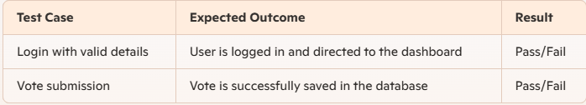

## 3.7 Maintenance

Maintenance outlines how the system will be maintained post-deployment.

Corrective Maintenance: Fix bugs and errors identified post-deployment.

Adaptive Maintenance: Update the system to accommodate changes, such as new election rules or policies.

Perfective Maintenance: Add new features to improve user experience.

User Support: Provide documentation and a helpdesk for troubleshooting.

# CHAPTER 4: CONCLUSION

The proposed **University Student Elections System** is a solution designed to address the inefficiencies and challenges associated with manual voting processes currently prevalent in many universities in Kenya. By integrating this system into the existing student portal, it ensures enhanced security, transparency, and accessibility while fostering student participation in governance activities.

This project is built upon comprehensive research, user-centered design principles, and robust technological frameworks to meet the unique needs of the university community. The implementation of this system will streamline election processes, eliminate human error, and promote trust and confidence in the election results.

Additionally, this project contributes to the broader goal of leveraging technology for improved governance and democratic processes within academic institutions. While resource and time constraints limit the scope of the project, the foundation laid here provides ample opportunity for future enhancements and scalability.

In conclusion, the **University Student Elections System** aligns with the objectives of providing a secure, efficient, and user-friendly platform for conducting elections. It demonstrates the potential of technology in solving real-world problems and sets a precedent for modernizing other administrative functions within the university.