LAB 9: DOCUMENTATION GENERATION
AI Assisted Coding: Docstrings and pydoc
Student detail | Value
Name | N.Gifty Taniksha
Batch | 38
Roll No. | 2503A51107
Part A: Google-Style Docstrings
Task 1: Simple calculator
PROMPT
Generate a python code for a simple calculator that can perform arithmetic operations and add a module docstring and a Google-style docstring to every function.
CODE
1 """A simple command-line calculator for two numbers.
2
3 The calculator supports addition, subtraction, multiplication, and division.
4 Run this file and follow the prompts to choose an operation and enter numbers.
5 """
6
7
8 def calculate(first_number: float, operator: str, second_number: float) -> float:
9 """Perform a basic arithmetic operation on two numbers.
10
11 Args:
12 first_number: The left-hand number in the calculation.
13 operator: One of ``+``, ``-``, ``*``, or ``/``.
14 second_number: The right-hand number in the calculation.
15
16 Returns:
17 The result of the selected arithmetic operation.
18
19 Raises:
20 ValueError: If the operator is unsupported or division by zero is attempted.
21 """
22 if operator == "+":
23 return first_number + second_number
24 if operator == "-":
25 return first_number - second_number
26 if operator == "*":
27 return first_number * second_number
28 if operator == "/":
29 if second_number == 0:
30 raise ValueError("Cannot divide by zero.")
31 return first_number / second_number
32 raise ValueError("Unsupported operator. Choose +, -, *, or /.")
33
34
35 def main() -> None:
36 """Prompt for a calculation and display its result."""
37 first_number = float(input("Enter the first number: "))
38 operator = input("Choose an operation (+, -, *, /): ").strip()
39 second_number = float(input("Enter the second number: "))
40 try:
41 result = calculate(first_number, operator, second_number)
42 except ValueError as error:
43 print(f"Error: {error}")
44 else:
45 print(f"Result: {result}")
46
47
48 if __name__ == "__main__":
49 main()
OUTPUT
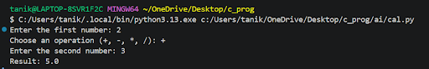
Task 2: Multiplication tables
PROMPT
Generate a python code that prints the multiplication tables for 1 to 10 and add Google-style docstrings for the module and for each function.
CODE
1 """Print multiplication tables for the numbers 1 through 10.
2
3 Run this script to display all ten tables. No user input is required.
4 """
5
6
7 def format_multiplication_table(number: int) -> list[str]:
8 """Create the multiplication table for a number.
9
10 Args:
11 number: The number whose multiplication table will be created.
12
13 Returns:
14 A list of formatted table rows for multipliers 1 through 10.
15 """
16 return [
17 f"{number} * {multiplier} = {number * multiplier}"
18 for multiplier in range(1, 11)
19 ]
20
21
22 def main() -> None:
23 """Run the program and display all multiplication tables.
24
25 Prints tables for numbers 1 through 10, with each table showing
26 multipliers 1 through 10.
27 """
28 for number in range(1, 11):
29 print(f"\nMultiplication table for {number}:")
30 for row in format_multiplication_table(number):
31 print(row)
32
33
34 if __name__ == "__main__":
35 main()
OUTPUT
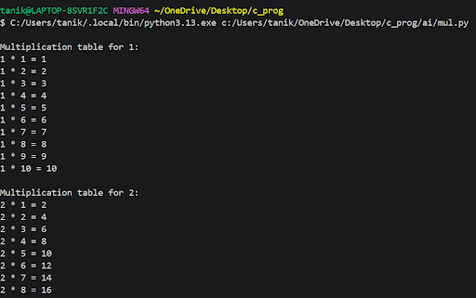
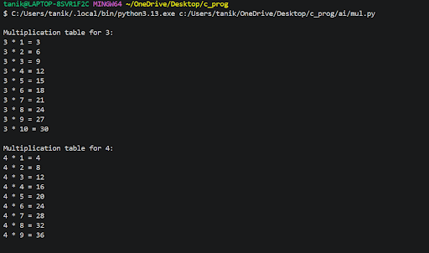
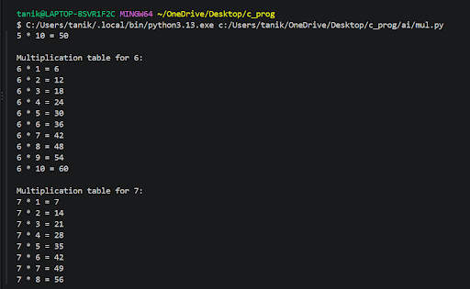
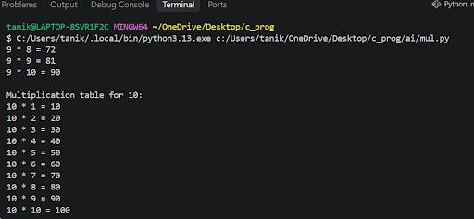
Part B: Documentation with pydoc
Task 3: Multiplication tables module
PROMPT
Generate a python module that prints the multiplication tables for 1 to 5, add a module-level docstring and function-level docstrings, and show how to view the documentation using pydoc.
CODE
1 # 4 nov 2026
2 # pydoc documentation: to view in terminal run python -m pydoc ai.mult_pydoc
3 # to create an HTML file run python -m pydoc -w ai.mult_pydoc
4 """Display multiplication tables for the numbers 1 through 5.
5
6 Run this module as a script to print five tables, each covering multipliers
7 from 1 through 10. Generate or view the documentation with Python's built-in
8 ``pydoc`` module.
9 """
10
11
12 def print_multiplication_tables() -> None:
13 """Print multiplication tables for numbers 1 through 5.
14
15 Each table displays the products of its number and the integers 1 through
16 10.
17
18 Returns:
19 None.
20 """
21 for number in range(1, 6):
22 print(f"\nMultiplication table for {number}:")
23 for multiplier in range(1, 11):
24 print(f"{number} * {multiplier} = {number * multiplier}")
25
26
27 def main() -> None:
28 """Run the program and print all five multiplication tables.
29
30 Returns:
31 None.
32 """
33 print_multiplication_tables()
34
35
36 if __name__ == "__main__":
37 main()
PROGRAM OUTPUT
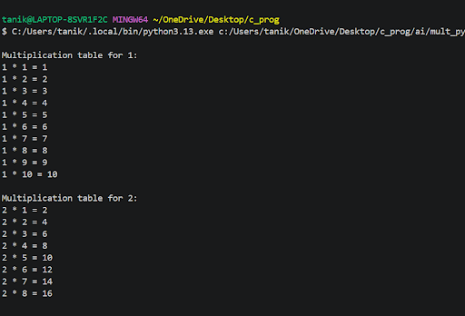
PYDOC IN THE TERMINAL: PYTHON -M PYDOC AI.MULT_PYDOC
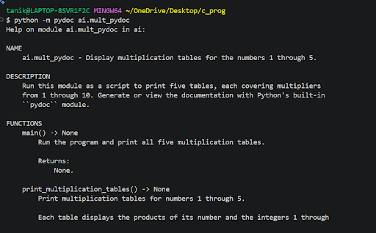
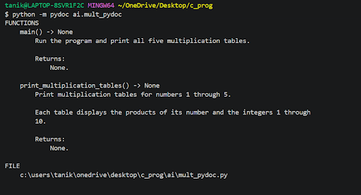
HTML DOCUMENTATION: PYTHON -M PYDOC -W AI.MULT_PYDOC


