NAVIGATOR
Walk into every appointment prepared.
Product & Engineering Proposal
A local-first PWA for parents managing a child’s complex psychiatric care
Powered by NovaSapien Labs
Internal stakeholder brief · 2026

Contents

1. Executive summary
Navigator is a local-first progressive web app that helps a parent manage a child’s complex psychiatric care — ADHD, mood disorders, IEPs — and walk into every appointment with a clinical-grade report instead of a reconstruction from memory.
The parent of a child on a multi-medication psychiatric regimen is, in effect, an unpaid case manager: tracking doses, school incidents, side effects, and provider relationships across five disconnected places, none designed for it. The average psychiatrist visit is fifteen minutes; the gap between visits is thirty to ninety days. Navigator closes that gap by turning everyday logging — done in seconds, often one-handed — into a structured 90-day clinical summary generated with a single tap.
This brief documents what NovaSapien Labs has built and shipped (Phase 1 MVP, production-hardened), the engineering posture that makes it trustworthy with sensitive health data, and the roadmap from here. It is organized as Built → Building → Envisioned.
15 min  Average psychiatrist visit | 30–90 days  Between every appointment | 150+  Medications tracked | 1 tap  To a 90-day report

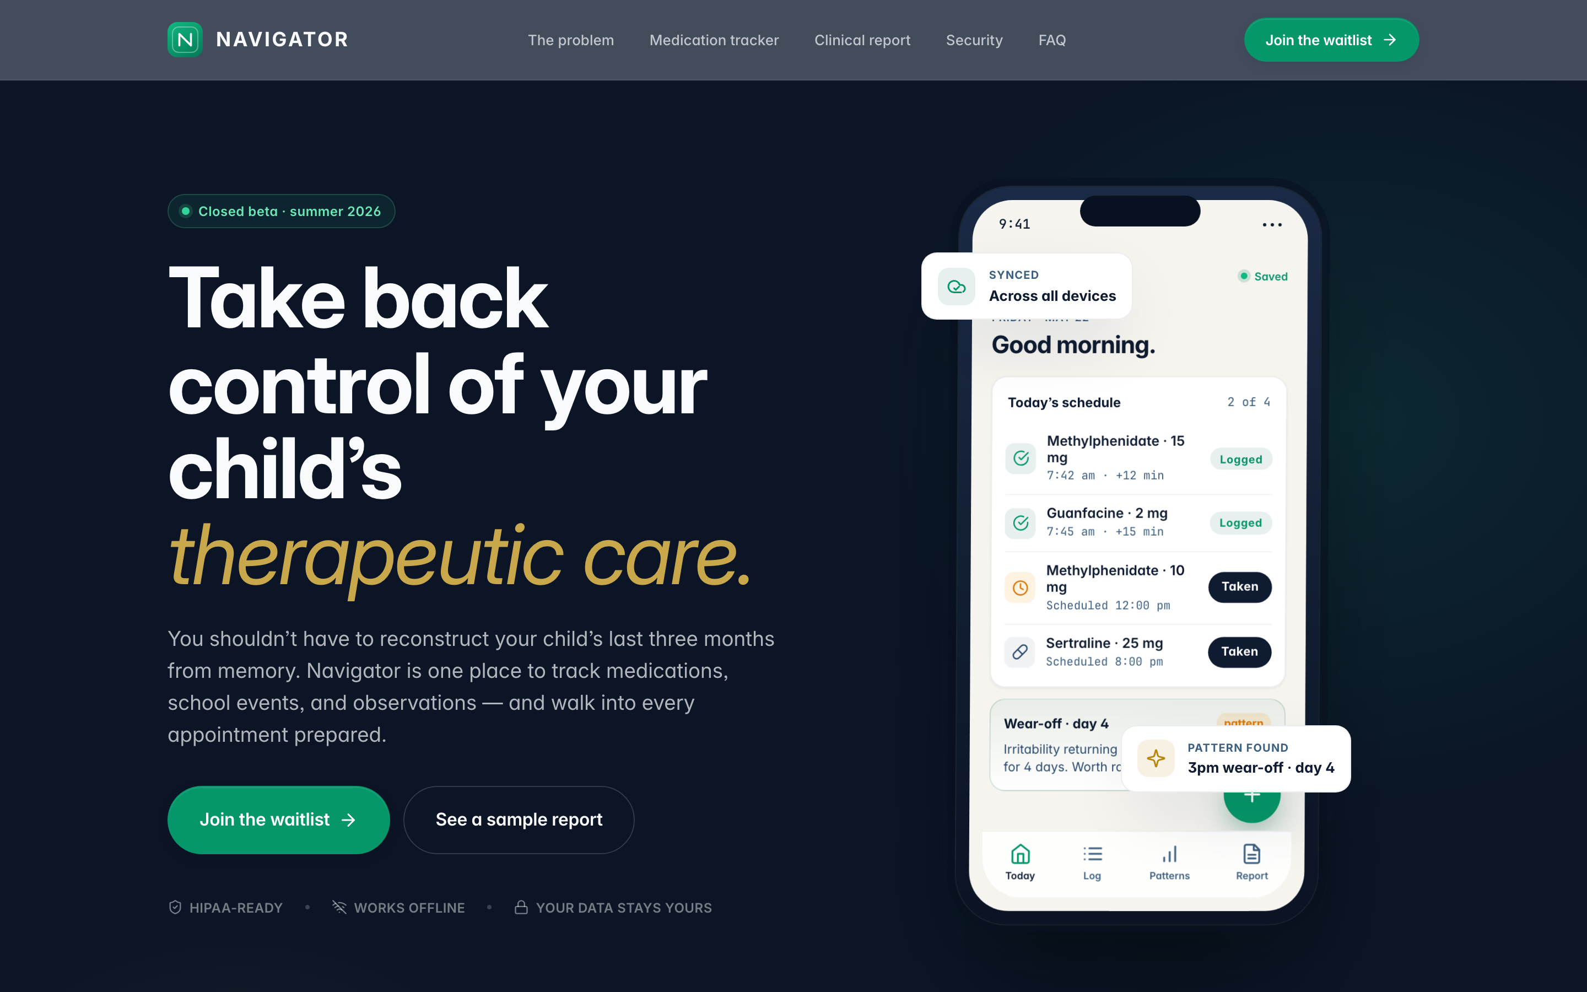
Navigator landing surface — the product’s promise in one screen.

2. The problem & who it serves
Nobody tells a parent they are about to become the case manager for their own child. The child’s story — what changed, when, and what it correlated with — ends up scattered across a pill organizer, a calendar, teacher emails, a notes app, and the parent’s memory.
- 15-minute appointments. Ninety days of life compressed into a vague verbal summary recalled from twelve sticky notes.
- 30–90 day gaps. A lot happens — and is forgotten — between visits.
- ~70% of patterns missed. Wear-off windows, trigger clusters, and sleep–mood links go unseen without a system to surface them.
Who it serves: the primary caregiver of a child with a complex, evolving psychiatric regimen — under sustained stress, logging in fragments, who needs to arrive at the next appointment prepared.
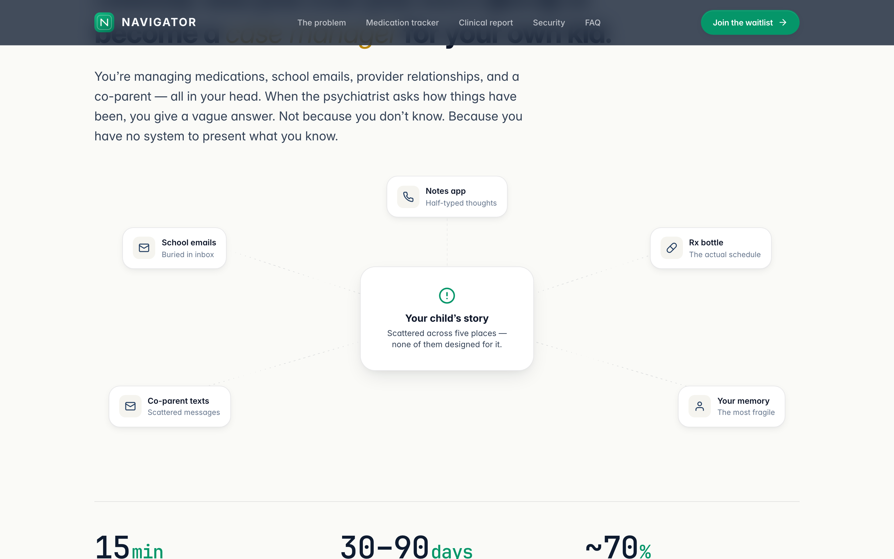
The problem, quantified — the cost of having no system.

3. What we built — the product
Phase 1 (MVP) is shipped and production-hardened. Navigator runs as two surfaces in one codebase: a public marketing site and an installable, auth-gated app shell.

3.1 Medication tracker
Most apps track a single stimulant. Navigator tracks 150+ medications across every major class — stimulants, non-stimulants, mood stabilizers, antipsychotics, SSRIs/SNRIs — and shows how concurrent regimens interact with each other and with daily life. Logging a dose outcome is a single tap and updates the UI in under 50 milliseconds, because every read and write is local.
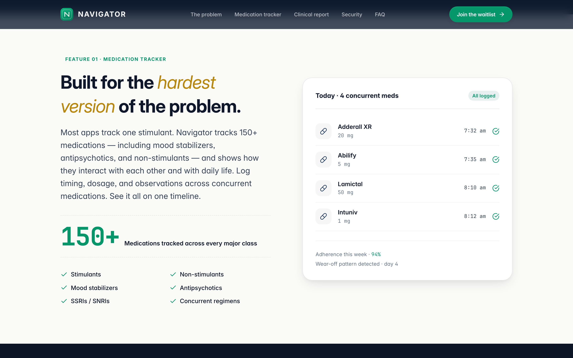
Medication tracker — concurrent regimens on one timeline.

3.2 The clinical report
Before each appointment, one tap generates a clean 90-day clinical summary: medication adherence, behavioral episodes, trigger patterns, school observations, and notable changes — each with a typed headline statistic and an honest “on track” or “review” signal derived directly from the logged data, never invented. It exports to PDF on-device and can be handed straight to a provider.
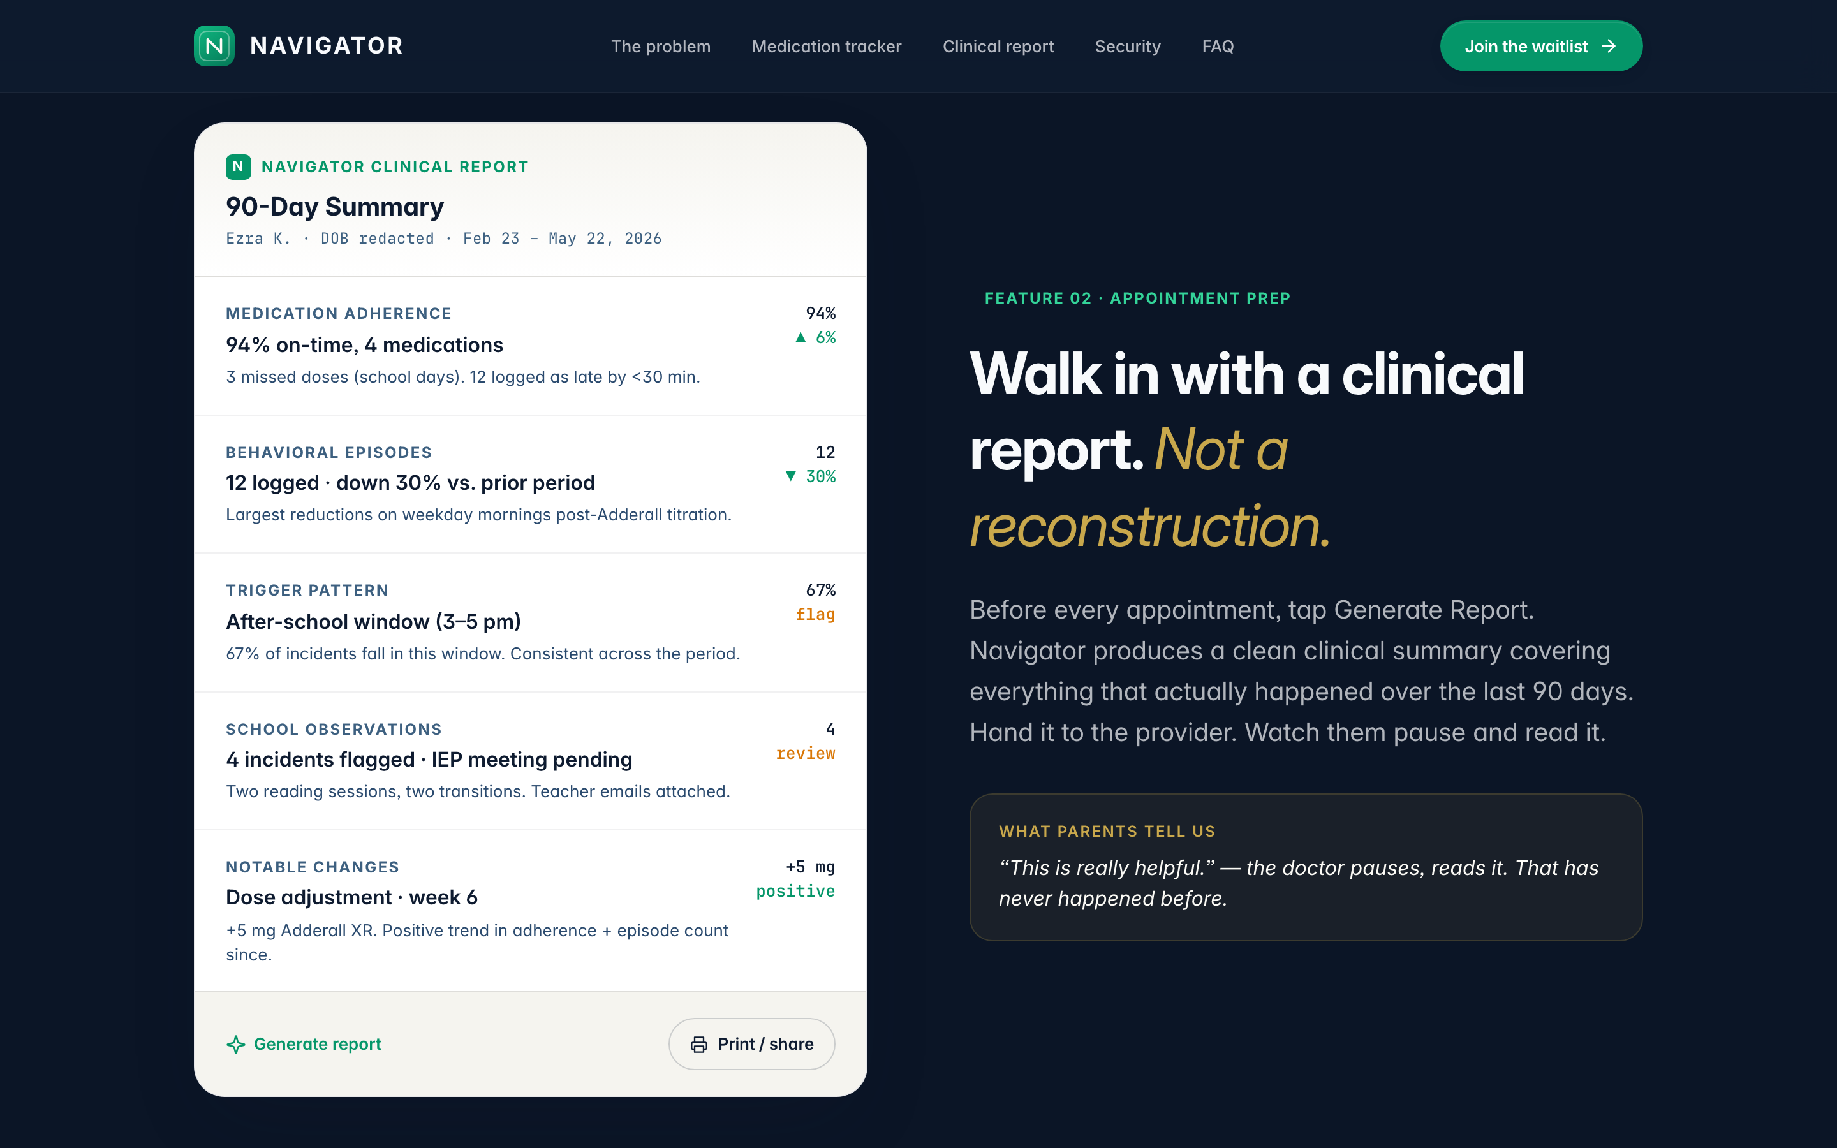
The 90-day clinical report — the product’s core promise.

3.3 Capture, voice & AI narrative
- Fast logging. One-tap dose outcomes (taken / late / missed / refused), tagged observations, and an append-only event log that never loses or overwrites history.
- Voice notes. Speak an observation; it is transcribed by a Whisper-backed function and stored as a structured event.
- AI narrative. A Claude-backed function turns the structured report into a calm, clinician-fluent summary. Both AI features run behind server-side functions so provider keys never touch the device, and both degrade gracefully when unconfigured.

3.4 Works everywhere, offline
Navigator is an installable PWA. The data layer is fully on-device, so the app needs no network to function — a service worker keeps the shell available offline, and an update flow surfaces new versions without disrupting a logging session.

4. Why Navigator is different
Pillar | What it means
Local-first | Every read and write hits an on-device database first. The interface never waits on the network; a dose log is instant. Sync is additive, not a dependency.
Privacy by architecture | The child’s data lives encrypted on the device before it ever leaves it. There is no server round-trip on the critical path, and AI requests are scoped, redacted, and excluded from training.
Clinical, not consumer | The report is the product. It is built to be read by a clinician in under a minute — specific, honest, and never fabricated.
Built for the hardest case | Concurrent multi-drug regimens, corrections without data loss, and a voice and tone designed for a stressed caregiver, not a marketing funnel.

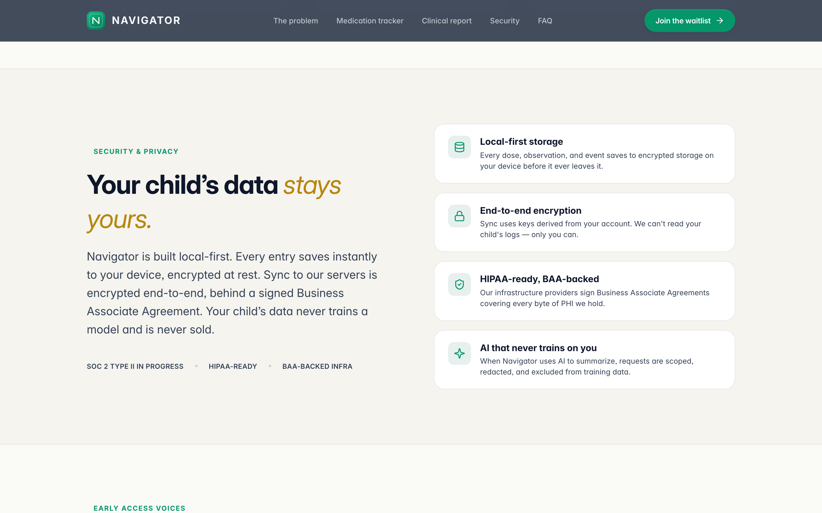
Security & privacy posture, stated plainly for caregivers.

5. Engineering posture
Navigator is built to be trusted with sensitive pediatric health data. The architecture and process enforce that, rather than relying on discipline alone.

5.1 Architecture
Layer | Decision
On-device database | PGlite — a WASM build of Postgres — persisted to the browser’s IndexedDB. Reactive reads keep the UI live.
Event sourcing | The log is append-only. Edits are expressed as correction events; the final state is a projection. Nothing is ever silently overwritten — enforced at the database with hard triggers.
Server boundary | Authentication, cross-device sync, and AI run behind a server boundary with row-level security on every table. Service-role keys never reach the client.
One design system | Every color, type size, and spacing value comes from a single token source, enforced by lint rules — so the product stays visually coherent as it grows.

5.2 Quality & hardening
Beyond the MVP feature set, Navigator went through a structured hardening pass across security, data integrity, accessibility, performance, and responsiveness:
- Security. Content-Security-Policy and standard hardening headers, authorization on server functions, row-level security scoped to the owner, and PII redaction in logging.
- Accessibility. WCAG AA targets: visible focus rings, 44px tap targets, status never communicated by color alone, focus trapping in dialogs, restored pinch-zoom.
- Performance. The primary route’s initial JavaScript was reduced to under the 250 KB budget; the on-device database loads off the critical path with a single calm loading state.
- Responsive. A fluid type scale, codified breakpoints, a reading-width measure, and safe-area handling carry the experience from a 320px phone to a 1920px display.
- Verification. A continuous-integration gate runs typecheck, lint (including design-token and voice rules), unit tests, end-to-end tests, and a production build on every change. The report engine and database migrations are covered by required tests.

5.3 The product on a phone
The same surface adapts intact to mobile — an accessible menu, cleanly stacked actions, and no horizontal overflow at any width.
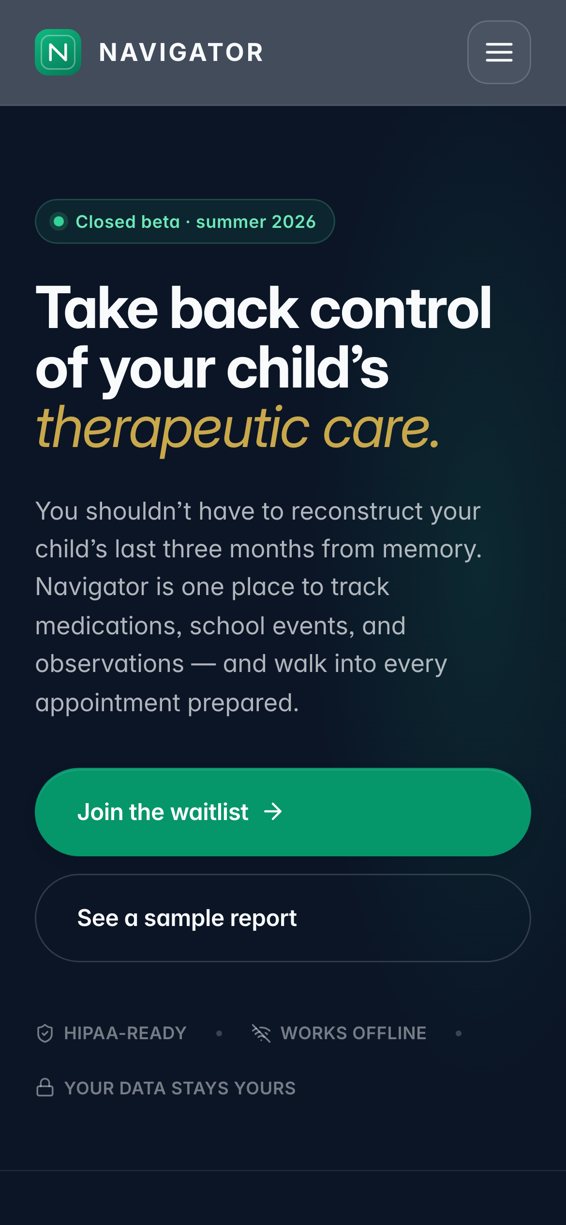
Navigator on a 390px phone — installable, offline-capable, one-handed.

6. Roadmap — built, building, envisioned

Built (Phase 1 — shipped)
- Passwordless auth with graceful local-only mode.
- On-device database, reactive reads, one-tap logging, append-only event log.
- Today, timeline, report, prep, patterns, settings, and a guided onboarding flow.
- Voice notes, AI narrative, PDF export, PWA install, waitlist + sign-in.
- Security, accessibility, performance, and responsive hardening with a full CI gate.

Building (Phase 2 — next)
- Cross-device sync. Wire the already-defined sync interface so a regimen follows the caregiver across devices.
- Co-parent sharing. Invite flow and per-row attribution for who logged what.
- Pattern detection. Surface correlations — ‘this happened around this dose adjustment.’
- Push reminders. Dose reminders at scheduled times.

Envisioned (Phase 3 — beyond the parent)
- Clinician portal. Read-only, time-limited share links for providers.
- Payer-grade exports. Report formatting that matches insurance and IEP paperwork.
- IEP document parsing. Drop in a PDF; extract goals and dates.
- Additional sign-in. Google OAuth alongside the passwordless flow.

7. Summary & next steps
Navigator’s Phase 1 is shipped, hardened, and verified. The product demonstrates that NovaSapien Labs can take a genuinely hard problem — the invisible labor of managing a child’s psychiatric care — and deliver a private, fast, clinical-grade tool that a stressed parent can actually use. The architecture is built so that Phase 2 (sync, co-parent, patterns) and Phase 3 (clinician and payer reach) extend the same foundation rather than rebuild it.
Recommended next steps: open the closed beta to the first cohort of families, wire cross-device sync, and begin clinician discovery for the read-only portal.
Navigator — Powered by NovaSapien Labs.
Navigator does not diagnose, prescribe, or treat. For clinical decisions, always consult your child’s provider.

