Ferdes, Justin Louise R.

BSCS 3A

1. 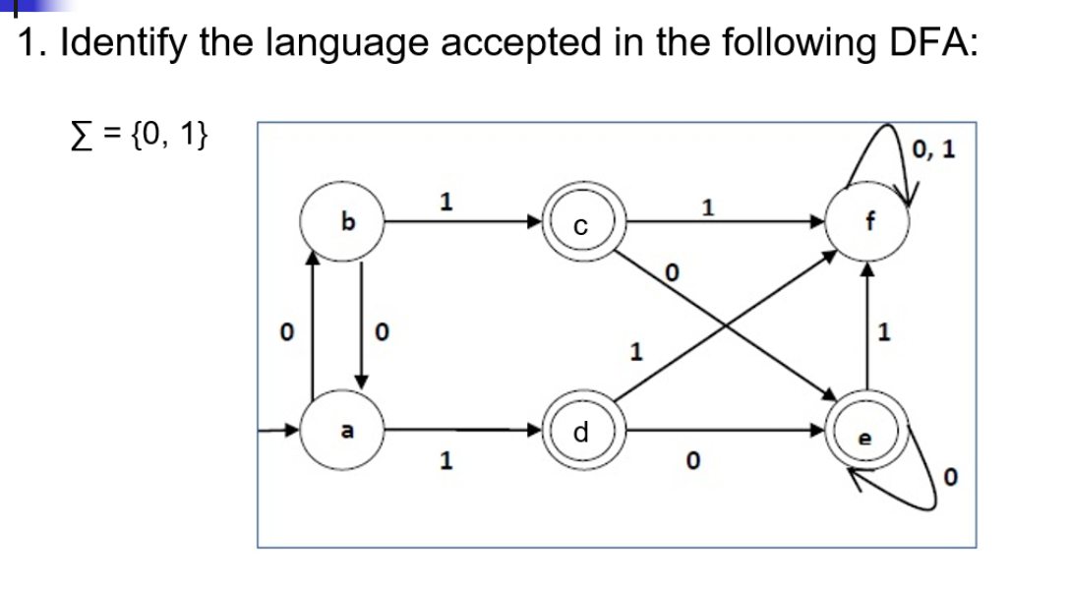

Answer:

Accept string that have single 1.

2.

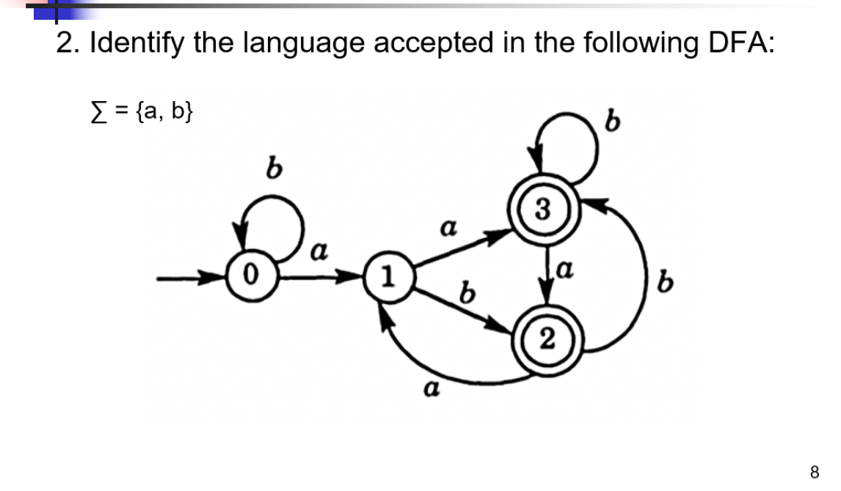

Answer:

Accept string that contain must {a} ends with {b}. Does not accept {aaa},{aba} strings. Accept strings that contain {aa} then ends with either single {b} or multiple {b}.

3.

