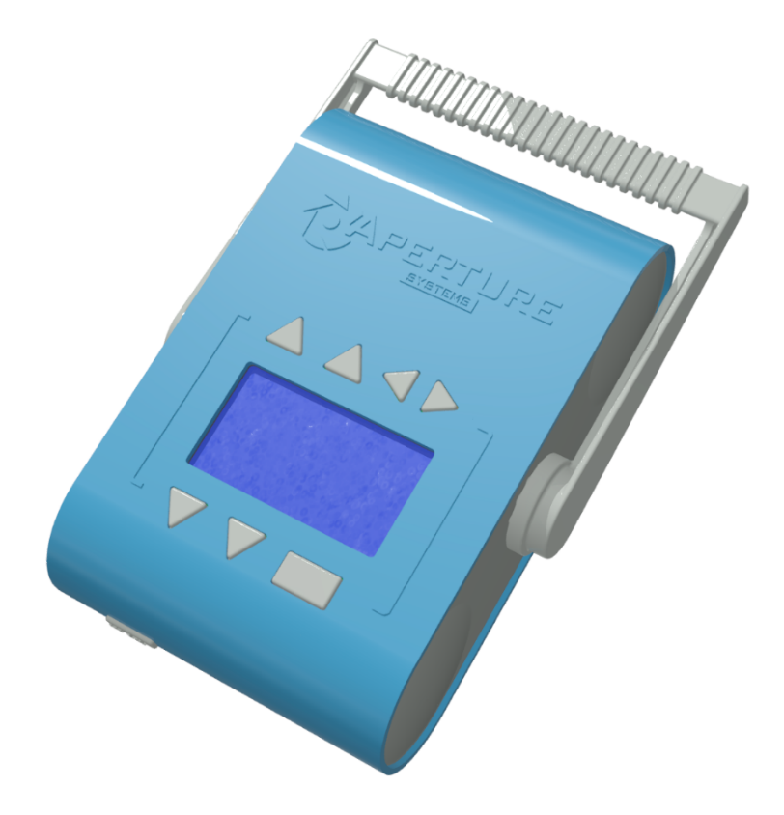

***AX100 Mobile X-ray Source***

PRODUCT TECHNICAL DATA SHEET

**Summary:**

The Aperture AX100 is a self-contained mobile x-ray source. It features a highly focused x-ray tube for superior image quality, as well as an internal lithium ion battery for easy use in the field.

The AX100 is designed to be a simple-to-use source of x-ray illumination for engineers, scientists, designers, artists, and those in other fields who may find use for radio-imaging of small objects.

The unit may be operated stand-alone, or in union with a Bluetooth™ enabled device.

PRELIMINARY

**Applications:**

▪ Inspection of circuit boards, cable harnesses, ball-grid array IC placement and similar electrical fixtures.

▪ Radio-imaging of mechanical connections, buried mating surfaces, threads & blind holes.

▪ Radio-imaging of composite materials and molds.

▪ Non-destructive reverse engineering.

▪ Non-destructive forensic and archeological analysis.

▪ Inspection of packages by security personnel.

▪ Field-imaging of immobile objects and assemblies which cannot be reasonably taken to a lab.

▪ Verification of radiation shielding integrity.

▪ Fine-art radiography.

**Features:**

▪ Self-contained, battery operated unit.

▪ Variable aluminum filter thickness.

▪ Tripod mountable. (1/4-20 UNC thread).

▪ Self-contained operation.

▪ May be charged from any 12V power supply.

▪ Bluetooth 2.0™ remote connectivity.

**Tech Specs:**

Weight: 1.6 kg

Focal spot diameter: 0.25mm

X-ray energy: 40 - 70kVp

Beam current: 1800µA

Battery capacity: 70WH

Target: Tungsten, 12°

Aluminum filtration: 0.5 - 3mm



*AX100 Mobile X-Ray Source*

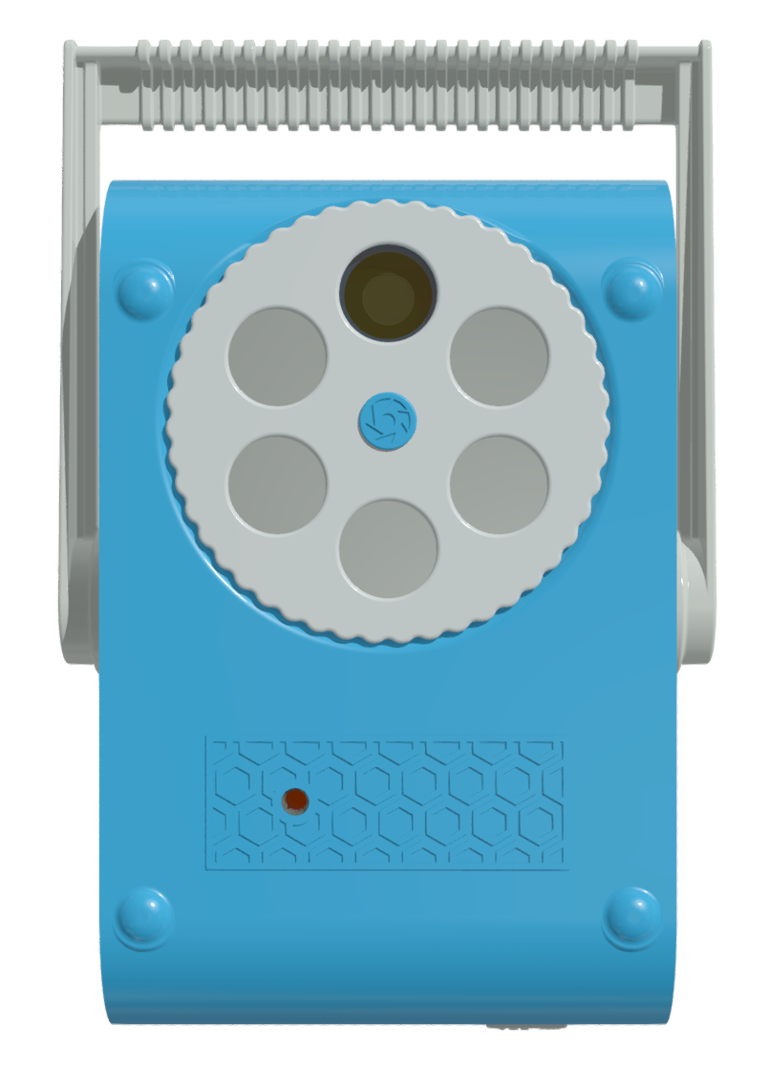

**Detailed Description:**

The Aperture AX100 is the first in our series of low-cost, mobile x-ray sources. It is designed to be an easily-operable source of x-ray illumination for Industrial, analytical and artistic radiography, and has been engineered to provide a finely-focused point source of radiation for crisp, high-resolution x-ray images –up to four times sharper than a typical dentist’s x-ray source.

The source features a variable-thickness high-pass filter for selectively attenuating lower energy x-rays which contribute little to the final exposure and could otherwise damage sensitive electronic assemblies. For ease of positioning, the AX100 features a standard tripod mount and weighs no more than a typical consumer DSLR camera.

The AX100 may be operated as a stand-alone unit through its inbuilt LCD interface, or remotely though any Bluetooth enabled device that can run its associated application. Further, this Bluetooth API has been openly-published to allow integration with custom, end-user developed applications.

It is powered from an internal, maintenance-free lithium ion battery pack, which may be charged from any 12V source including but not limited to, solar panels and automobile power outlets. A wall adapter is included with the source.

**Operation:**

The AX100 has been designed with simplicity in mind. An easily-navigable LCD display allows the user to quickly modify the x-ray beam’s photometric parameters, as well as check upon the status of the battery and overall system. A programmable countdown timer allows the operator time to leave the area before an exposure, if so chosen.

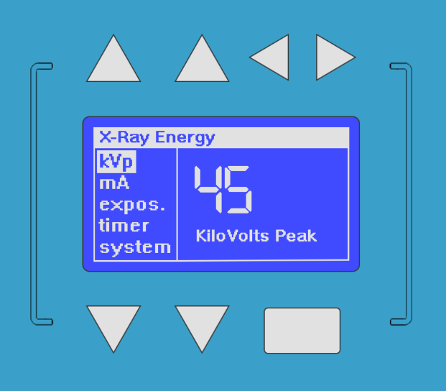

This button functions as “on”, “enter”, and when held, initiates the x-ray exposure sequence.

These buttons change the page on the current menu selection (if applicable).

These buttons scroll through the main menu, which allows the user to adjust various settings relevant to the x-ray beam.

These buttons modify the displayed variable on the current menu page.



*AX100 Mobile X-Ray Source*

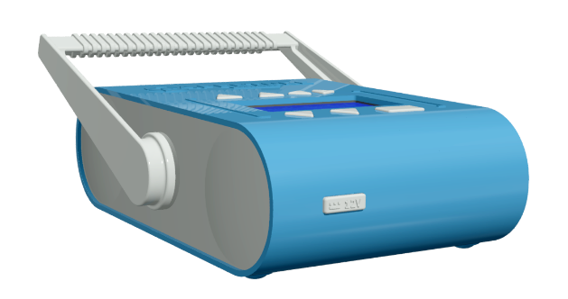

**12VDC**

**Operation (continued):**

To conserve battery life, the LCD display auto-darkens if no button activity is detected. The unit automatically powers off if left idle for 5 minutes, but is quickly rebooted by holding down the “on” button. Inserting the 12V adapter automatically boots the unit and begins the lithium-ion charge cycle.

The unit’s handle may be repositioned by gently flexing both hubs outward and rotating the fixture.

**Sample Radiographs:**

The following radiographs were taken using the AX100 x-ray source, and a GE GXS-700 x-ray sensor. They are provided to demonstrate the extraordinary detail which may be resolved with this x-ray unit.

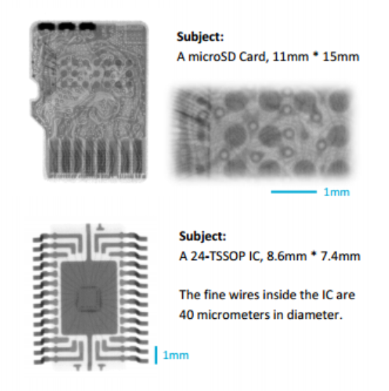

**Subject:**

A MicroSD card, 11mm * 5mm

**Detailed Tech Specs:**

|  |  |  |
| --- | --- | --- |
| X-Ray Energy | 40 - 70 | keV |
| X-Ray Current | 1800 | µA |
| Target Material | Tungsten | - |
| Target Angle | 12 | ° (deg) |
| Focal Spot Diameter | 0.25 | mm |
| Aluminum Filtration | 0.5 – 3 | mm |
| Anode Thermal Mass | 7 | kJ |
| Maximum Duty Cycle | 1 : 5 | - |
| Bluetooth™ System | v2.0, Class 2 | - |
| Bluetooth™ Name | “Aperture AX100” | - |
| Tripod Mount | 1/4-20 UNC / ISO 1222:2010 | in |
| Battery Capacity | 70 | WH |
| Battery Type | Panasonic Lithium Ion | - |
| Input Voltage | 12 | V |
| Input Current | 3.5 | A |
| Power Receptacle | 5.5 x 2.5 mm Barrel, Pin + | - |
| Weight | 1.6 | kg |
| Bounding Box | 24 x 4.5 x 9.5 | cm |
| Shell Material | ABS Plastic | - |
| ROHS | Exempt | - |
|  |  |  |
|  |  |  |

**Subject:**

A 24-TSSOP IC, 8.6mm * 7.4mm

The fine wires inside the IC are 40 micrometers in diameter.

**Further Reading:**

Aperture 1214.2 – AX100 Getting Started Guide