Superball

Design Document

Written by Josuel Corporan Vargas (J.C.V)

What is the game about?

Superball is a breakout style game with a very unusual plot (Yes, this puzzle game has . In the very, very, and I should note, VERY, far future, where the Internet has become what Mark Zuckerberg wishes it would be; Kids, adults, and senior citizens alike have become addicted to the internet. Living life outside, and making meaningful interactions with real people is antiquated, out of style, and, as the kids like to call it, boomer shit. Instead, people use specialized headsets that connect them to an entirely digital universe, mixed with planets that contain mountains, towns, cities, states, and countries very similar to ours, except it’s not real...at all. The headsets use implants to manipulate your body to act as though you are actually there, but not. If you get injured on the Internet, you cannot get injured in real life, but viruses are a different story. Unlike in our world, viruses are made with the intention of harming not only the virtual world, but the real human body behind it as well. On this occasion, a vicious hacker, known simply by the name, OMEN, has unleashed a mysterious virus that has put all of the internet users in a real-life coma. There is no-one other person who can stop it, other than the netmaster, who maintains the entire internet. The only way to destroy the virus is to beat OMEN’s game. The game is a breakout/pong style game where you control 4 paddles, and control a ball, trying to break bricks located in the middle, and also avoid the ball crossing lasers on each side. The game starts with this gamemode, with bricks getting larger and larger, eventually going to you controlling a ball bomb, and the bricks adding more time to prevent it blowing up, and finally controlling more than 1 ball.

Disregard everything disowned in the above paragraph, THAT shit is gay as fuck. I also wouldn’t even have the time to get voice actors. I’m gonna have to settle for a simple, but challenging pong/breakout game. The game will consist of 18 levels. The first six levels will be a pong style game where you destroy blocks of squares in the middle, as they increase in size, and the ball gets faster and faster. Eventually, you switch to another game mode, where you control a ball as a bomb, and prevent it from exploding by destroy bricks that give you more time. Eventually, the final levels, have you controlling multiple balls at once, if even 1 hits the lasers, you lose.

This is a high score game, and honestly, there doesn’t need to be a story for this. Although, considering that this may be a paid game, having a story may make it more worthy for people to actually buy. Maybe I’m wrong, who knows.

Game Outline
- Begin with J.C.V logo
- Show SuperBall logo on screen with ominous sound
- Go to Main Menu (Three Options: Start|Special Features|)
- Start: We have two options (three for the mobile port: Arcade | Custom | Multiplayer (Mobile))
- Arcade: Basically the entire game as listed above.
- It will have levels, custom mode will be endless:
---------- Standard Mode ---------
- Level 1 – 6: We break a block of bricks, starting with 24 x 24, up to 64 x 64.
---------- Bombermode ----------
- Level 7 – 12: Keep bomb from exploding, each level goes 1 minute longer
---------- Babysitter Mode -------
- Level 12 – 18: You have a massive amount of bricks, with
but this time with more than one ball, we start with two, and
as levels increase, so does the amount of balls on the screen.
- There should be a final level, but maybe not. That will have
to be decided.
- Custom: Unlocked after completing first six levels.
- Once unlocked, there are sever more options for the custom mode,
such as picking a constant speed, unlocking new backgrounds, custom pong balls, picking which music is in rotation, and being able to create your own sounds with the DS microphone. These sounds will be used for the explosion, collision, and the laser sound effects. Any
score gotten on the custom mode will be the new global high score.
- Special Features: (Audio Devlogs, audio commentaries detailing the development of the games | Music player where you can play music used throughout the game.)
- The audio devlogs will have photos on the left side of the screen, of the game while it was in development.
- We have a music player to play music that was chosen to be played randomly throughout the game, regardless of whether it appeared or not. It will be called MusicTime.

Game Modes

Standard Mode:

The standard game play mode will consist of four paddles, and a block of bricks located in the middle of the screen. You control a ball that will destroy blocks in the middle. Use the paddles to block the ball from going to the border of the screen, which has lasers. Colliding with the lasers leads to an instant game over.

Bombermode:

The bomber game play mode will consist of four paddles, and a brick that keeps appearing time after time. The ball is a bomb in this mode, and each time you hit a brick, it increase the time left til detonation until by 5 seconds. You must keep the ball alive for a certain time period, if you do, you beat the level, and the time to keep alive increases by a minute.

Babysitter Mode:

Could you believe this was originally called the no condom mode? Anyways, the babysitter mode is similar to the standard mode, except for two differences. One, you always have a constant amount of bricks in the middle (It will always be 64 x 64, rather than randomly changing). And, each level adds a new ball to the mix, eventually, by the final level, you will have a bunch of new balls bouncing around. The catch is that the new added balls do not destroy bricks, so this is really a test of seeing how well the player can control the game.

Music

Mock-Ups
Nintendo DS:
Menu:
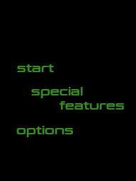


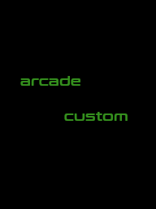
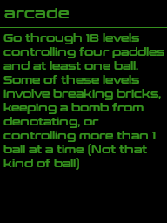

Arcade Mode:
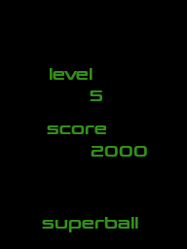
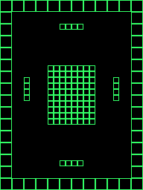

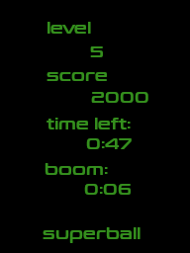
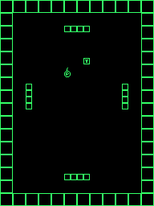

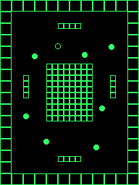
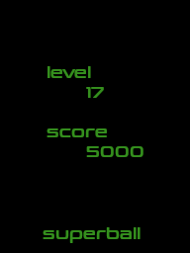

Custom Mode:
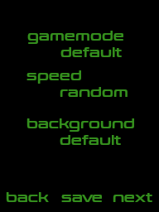

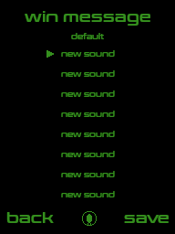
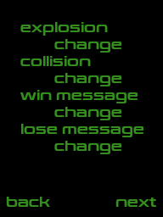

Special Features:
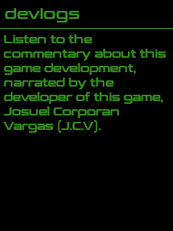
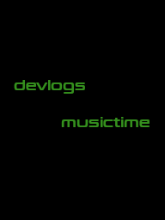

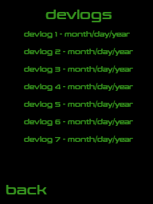

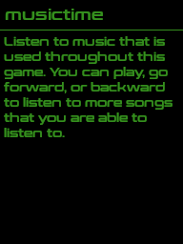
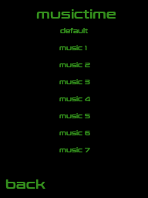

Game Boy:
Menu:
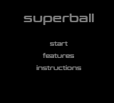
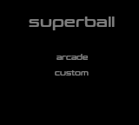

Distribution

The game will be available on three platforms: Game Boy, Nintendo DS, Game Boy Advance, and iOS. The base version is the Nintendo DS version, and the goal is to try and keep as much as features as possible from the DS version. This may be relatively simple for the iOS version, but not so simple for the Game Boy Advance, and Game Boy version of the game.

As far as the non-iOS verisons are concerned, those will be homebrew games, but they will be paid games. Gotta find some way to make some money anyways. If I had to guess, it will either be $1.99 or $2.99. This is the reason there are special features and added content in the game. If I just sold the game with no bells and peppers for that price, no matter how low, I’d be shot dead by the homebrew community. Can’t have that.

