REQUEST FOR PROPOSAL
Commercial Drug Substance and Drug Product Manufacturing
PFZ-SYN-MAB-11 — humanized IgG1 monoclonal antibody
RFP reference | PFZ-RFP-2026-04
Document number | PFZ-ES-RFP-0042, Rev. 1.0
Issued by | External Manufacturing Sourcing, Pfizar Biopharma
Issue date | 2026-10-26
Proposal due | 2026-12-11, 17:00 KST
Classification | Confidential

CONFIDENTIAL — This RFP is disclosed under Confidentiality Agreement No. PFZ-CDA-2026-118 (executed 2026-09-14). It may be used only to prepare a proposal to Pfizar Biopharma and must not be shared outside the bidder's proposal team.
Revision history
Rev. | Date | Description of change | Author
0.1 | 2026-10-05 | Draft for internal review | A. Carter
0.2 | 2026-10-16 | Technical and quality sections added | R. Moore
1.0 | 2026-10-26 | Issued to invited CDMOs | A. Carter
Approval
Role | Name / title | Signature | Date
Prepared by | Alex Carter, Associate Director, External Manufacturing Sourcing | Electronically signed | 2026-10-23
Reviewed by | Dr. Rachel Moore, CMC Lead, PFZ-SYN-MAB-11 | Electronically signed | 2026-10-23
Quality review | Sven Lindqvist, Director, External Quality | Electronically signed | 2026-10-24
Approved by | Laura Bennett, VP, Global Supply Chain | Electronically signed | 2026-10-26

1. Introduction and Purpose
Pfizar Biopharma invites selected contract development and manufacturing organizations (CDMOs) to submit a proposal for the technology transfer, process performance qualification (PPQ) and commercial manufacture of PFZ-SYN-MAB-11 drug substance (DS) and drug product (DP). This RFP describes the scope, quality expectations, commercial terms and the information we need to compare proposals on an equal basis.
Proposals must follow the structure in Section 9 and the timeline in Section 10. Bidders confirm their intent to bid by 2026-11-04.

2. Abbreviations
Abbreviation | Definition
ADA | Anti-drug antibody
AEX / CEX | Anion / cation exchange chromatography
CCI | Container closure integrity
CDA | Confidentiality agreement
CE-SDS | Capillary electrophoresis, sodium dodecyl sulfate
DP | Drug product
DS | Drug substance
HCP | Host cell protein
icIEF | Imaged capillary isoelectric focusing
IPC | In-process control
PPQ | Process performance qualification
QA / QC | Quality assurance / quality control
SEC | Size-exclusion chromatography
SUB | Single-use bioreactor
TT | Technology transfer
UF/DF | Ultrafiltration / diafiltration
VI / VF | Viral inactivation / viral filtration
WFI | Water for injection

3. Program Overview
PFZ-SYN-MAB-11 is a humanized IgG1 monoclonal antibody for a chronic autoimmune indication. The Phase 3 program reads out in 2027; the marketing applications (KR, US) are planned for Q4 2028 and the first commercial launch for 2029. The clinical process runs at 500 L in a single-use train with a fed-batch titer of 4.6 g/L; the drug product is a lyophilized powder, 150 mg/vial, reconstituted with 1.2 mL WFI.
The current clinical manufacturer will support the transfer. Process and analytical documents are listed in Section 4.1; documents are shared in a virtual data room after the CDA is in place.

4. Scope of Services
The table below defines the requested scope by site. Korea is the primary site for both DS and DP; a US backup quote is requested for DS only.
Activity | Drug Substance (DS) |  | Drug Product (DP)
Activity | Primary site (Korea) | Backup site (US) | Primary site (Korea) | Backup site
Technology transfer | Required | Quote requested | Required | Not required
Engineering run | Required (1 run) | Not required | Not required | Not required
PPQ | Required (3 batches) | Not required | Required (3 lots) | Not required
Commercial supply | Required | Quote requested | Required | Not required
Release and stability testing | Required | Quote requested | Required | Not required
Table 1 — Requested scope by activity and site

4.1 Technology Transfer Package
Pfizar Biopharma will provide the following documents at kickoff (Rev. as current):
- Process description and process flow (Figure 1) with step parameters and IPC limits
- Executed clinical batch records (last three 500 L batches) and deviation summaries
- Master and working cell bank certificates of analysis (MCB/WCB) and cell bank storage plan
- Raw material list with specifications and approved suppliers
- Analytical methods, method validation reports and reference standard qualification
- Process characterization reports and the control strategy (criticality assessment)
- Stability data (DS and DP) and the current stability protocol
- Viral clearance study reports and the CMC sections of the IND

4.2 Process Description
Seed train: a vial of WCB is expanded in shake flasks and a perfusion N-1 bioreactor, then the production bioreactor is inoculated at 0.5×10⁶ cells/mL. Targets: pH 7.0 ± 0.2, DO ≥ 30%, 36.5 °C with a shift to 33.0 °C on day 5, CO₂ ≤ 15%; the run lasts 14 days.
Harvest criteria: viable cell density ≥ 1.8×10⁷ cells/mL or viability < 70%; dissolved CO₂ kept below 15%. The viral clearance claim across steps 5 and 8 is ≥ 12 log₁₀ for retroviruses.
Figure 1 shows the process from the seed train to the drug product. Steps 1–10 run at the DS site, step 11 at the DP site; dashed lines are in-process samples sent to QC.
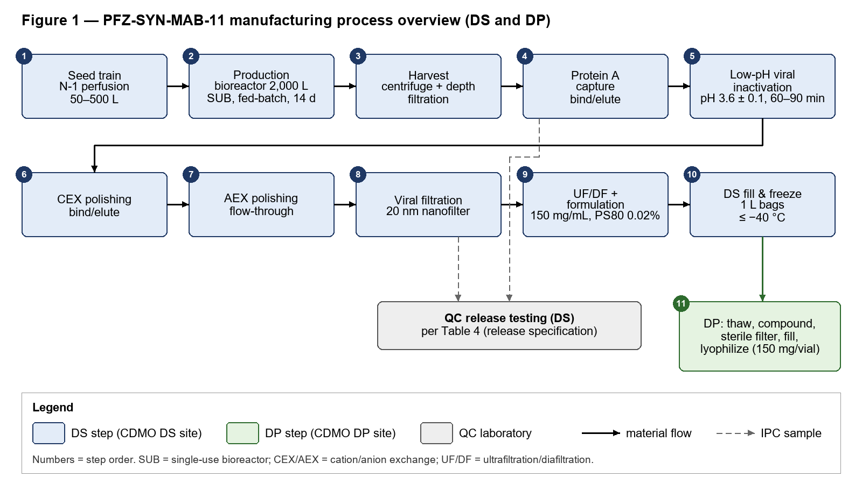

Figure 1 — Process overview, PFZ-SYN-MAB-11 (copy controlled by Pfizar Biopharma)

4.3 Engineering Run and PPQ Batches
One engineering run at commercial scale is followed by three consecutive DS PPQ batches and three DP PPQ lots. Target starts are given below; the bidder proposes firm slots.
Batch | Type | Scale | Target start | Site | Purpose
ENG-01 | Engineering run (non-GMP) | 2,000 L | 2027-11 | DS, Korea | Confirm transfer at scale
PPQ-01 | DS PPQ | 2,000 L | 2028-01 | DS, Korea | Process performance qualification
PPQ-02 | DS PPQ | 2,000 L | 2028-02 | DS, Korea | Process performance qualification
PPQ-03 | DS PPQ | 2,000 L | 2028-03 | DS, Korea | Process performance qualification
DP-PPQ-01 | DP PPQ lot | ≈ 40,000 vials | 2028-04 | DP, Korea | Fill/lyo qualification
DP-PPQ-02 | DP PPQ lot | ≈ 40,000 vials | 2028-05 | DP, Korea | Fill/lyo qualification
DP-PPQ-03 | DP PPQ lot | ≈ 40,000 vials | 2028-06 | DP, Korea | Fill/lyo qualification
Table 2 — Engineering and PPQ batch plan

5. Commercial Supply Forecast
Annual demand after launch (KR and US markets combined). Batch numbers assume about 6 kg DS per 2,000 L batch; bidders state their own yield assumption in the pricing sheet.
Item | 2029 | 2030 | 2031 | 2032 | 2033 | Total 2029–2033
DS demand (kg) | 30 | 60 | 90 | 120 | 120 | 420
Estimated DS batches (2,000 L, ≈ 6 kg/batch) | 5 | 10 | 15 | 20 | 20 | 70
DP demand (vials, 150 mg) | 180,000 | 360,000 | 540,000 | 720,000 | 720,000 | 2,520,000
Table 3 — Annual demand forecast 2029–2033 (last column = total)
Bidders confirm the number of 2,000 L batches they can reserve for this program per year from 2029 and the lead time to add capacity if the forecast increases by 50%.

6. Quality and Regulatory Requirements
- Manufacture under current GMP (MFDS, FDA 21 CFR 210/211) and ICH Q7 for any intermediate steps; the pharmaceutical quality system follows ICH Q10 and quality risk management ICH Q9(R1).
- Specifications and characterization follow ICH Q6B; viral safety follows ICH Q5A(R2).
- A quality agreement (CDMO template acceptable as a basis) is signed before the engineering run; it defines batch disposition, deviation and change control, and audit rights.
- Batch records are reviewed and the certificate of analysis issued within 30 calendar days after the end of manufacture.
- Pfizar Biopharma audits the selected sites before PPQ and every two years afterwards.

6.1 Analytical Methods and Release Specification
Table 4 lists the current release tests and acceptance criteria. All methods are transferred; compendial methods are verified at the CDMO.
Category | Test | Method | Acceptance criteria
Category | Test | Method | DS | DP
Identity | Peptide map | LC-MS peptide mapping | Conforms to reference standard
Identity | Charge profile | icIEF | Profile comparable to reference standard
Quantity | Protein content | UV A280 | 150 ± 15 mg/mL | 150 mg/vial ± 10% (reconstituted)
Purity | Monomer | SEC-HPLC | ≥ 97.0%
Purity | High molecular weight species | SEC-HPLC | ≤ 2.0%
Purity | Purity, non-reduced | CE-SDS (NR) | Main peak ≥ 95.0%
Purity | Purity, reduced | CE-SDS (R) | HC + LC ≥ 97.0%
Purity | Charge variants | icIEF | Main 55–75%; acidic ≤ 30%; basic ≤ 15%
Potency | Biological activity | Cell-based reporter assay | 70–130% of reference standard
Potency | Target binding | ELISA | 80–125% of reference standard
Process impurities | Host cell protein | HCP ELISA | ≤ 100 ng/mg | Not tested
Process impurities | Residual host cell DNA | qPCR | ≤ 10 pg/mg | Not tested
Process impurities | Leached Protein A | ELISA | ≤ 10 ng/mg | Not tested
Safety | Bacterial endotoxins | LAL kinetic chromogenic (USP <85>) | ≤ 0.5 EU/mg | ≤ 0.3 EU/mg
Safety | Bioburden | Membrane filtration (USP <61>) | ≤ 10 CFU/10 mL | N/A
Safety | Sterility | Membrane filtration (USP <71>) | N/A | Sterile
Safety | Mycoplasma (unprocessed bulk) | qPCR (Ph. Eur. 2.6.7) | Not detected | N/A
General | Appearance | Visual | Clear to slightly opalescent, colourless to slightly yellow | White to off-white lyophilized cake
General | pH | Potentiometry (USP <791>) | 6.0 ± 0.3
General | Osmolality | Freezing-point depression | 270–330 mOsm/kg
General | Polysorbate 80 | HPLC-CAD | 0.01–0.03% (w/v)
DP only | Water content | Karl Fischer (coulometric) | N/A | ≤ 2.0%
DP only | Reconstitution time | Visual, 1.2 mL WFI | N/A | ≤ 5 min
DP only | Visible particles | Visual inspection (USP <790>) | N/A | Practically free from particles
DP only | Subvisible particles | Light obscuration (USP <788>) | N/A | ≥ 10 µm: ≤ 6,000/container; ≥ 25 µm: ≤ 600/container
DP only | Container closure integrity | Helium leak / HVLD | N/A | Pass
Table 4 — DS/DP release specification (header rows repeat on each page)

6.2 Stability
The CDMO places the three PPQ batches (DS and DP) on ICH stability: DS at −40 °C and 5 ± 3 °C; DP at 5 ± 3 °C and 25 °C/60% RH, for 36 months. Pull points and tests follow the current protocol.

7. Labeling and Packaging
The DP is labeled and packed at the DP site (single vial per carton, KR and US presentations). The current vial label is shown below for reference only.
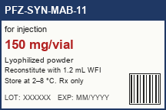
Reference only — final artwork supplied at technology transfer
Figure 2 — Current vial label (low-resolution reference copy)

8. Commercial Terms
Proposals state the bidder's position on each term below; deviations are listed in the proposal.
- Slot reservation: slots are confirmed 12 months ahead; a reservation fee of up to 20% of the batch price may be charged and is credited against the batch invoice.
- Batch failure: if a batch fails for reasons attributable to the CDMO, the CDMO re-manufactures at its own cost or credits the batch price, and replaces client-supplied materials up to an agreed cap.
- Payment milestones: 30% at slot confirmation, 70% at batch disposition (QA release); TT and PPQ activities are invoiced per milestone in the project plan.
- Cancellation: ≥ 12 months before start — no fee; 6–12 months — 50% of the batch price; < 6 months — 100% of the batch price, less materials that can be reused.
- Intellectual property: Pfizar Biopharma owns the product and process IP and all improvements to its process; the CDMO keeps its platform know-how.
- Liability and insurance: product liability insurance of at least USD 10 million per occurrence.

9. Proposal Content and Pricing Sheet
The proposal has a technical part (capabilities, site and equipment, project plan, team, quality system, inspection history) and a commercial part. Prices are entered in Attachment C (PFZ-RFP-2026-04_Pricing.xlsx) with DS, DP, analytics and stability kept separate, as below.
Category | Item | Unit | Price (USD)
DS | Technology transfer (fixed fee) | lot
DS | Engineering run (2,000 L) | batch
DS | PPQ batch (2,000 L) | batch
DS | Commercial batch, per volume tier | batch
DP | PPQ lot (fill, lyophilization, inspection) | lot
DP | Commercial lot, per volume tier | lot / vial
Analytics | Method transfer / verification | method
Analytics | Release testing (DS and DP) | batch
Stability | ICH stability, per condition and time point | pull
Other | Raw materials and consumables (pass-through) | % handling fee
Table 5 — Pricing sheet structure (enter prices in Attachment C)

10. RFP Timeline and Communication
Milestone | Date
RFP issued | 2026-10-26
Intent-to-bid confirmation (e-mail) | 2026-11-04
Deadline for written questions | 2026-11-13
Q&A responses sent to all bidders | 2026-11-20
Proposal due | 2026-12-11, 17:00 KST
Shortlist notification | 2027-01-08
Site audits (shortlisted bidders) | 2027-01-18 to 2027-02-05
Award decision | 2027-02-26
Technology transfer kickoff | 2027-03
Table 6 — RFP milestones
All questions and submissions go to the procurement contact only: Alex Carter, Associate Director, External Manufacturing Sourcing, alex.carter@pfizar-bio.example, +1 555 0100 0142. Questions received after 2026-11-13 may not be answered.

11. Evaluation Criteria
Proposals are scored on (1) technical fit and transfer risk, (2) schedule and capacity for the PPQ and 2029–2033 volumes, (3) total cost over five years (DS, DP, analytics and stability), (4) quality and inspection history, and (5) acceptance of the commercial terms in Section 8.

Data room access is granted per bidder under PFZ-CDA-2026-118; two named users per bidder.
Viral safety evaluation follows ICH Q5A(R2); the CDMO repeats the small-scale VF study with its own filter lot if the filter type differs.
The forecast is non-binding and provided for capacity planning only; binding quantities are agreed in the commercial supply agreement 18 months before each calendar year.
Acceptance criteria are the current clinical specifications and may be tightened after PPQ.

