LXT-204 Process Development and Risk Report
Hanbit BioSolutions | HBS-TEST-2026-010 | 2026-10-29
Fictional material for internal retrieval tests

01 Executive summary
This fictional process development and risk report describes a proposed program for Luminexis Therapeutics and candidate LXT-204. Hanbit BioSolutions presents the scope, review process and decision points; Taekyung Yoon is the document owner. The scenario is intended for retrieval testing.
The baseline duration is 8 months after authorization and the illustrative budget is KRW 0.9 billion, excluding VAT. Until a contract and start date are agreed, both figures remain proposals rather than commitments.
The reader should review the objectives, exclusions and acceptance process together. No value or result in this document represents an actual experiment or manufacturing operation.
The review includes the status of client information and the list of records expected from each stage. The figures provide a starting point for discussion and may be revised in the final agreement. The owner checks delivery timing, review responsibility and the decision path.
Process and risk management review prerequisites and impacts together and record the approval status of each response.

02 Background and objectives
Luminexis Therapeutics is evaluating the characteristics and development potential of LXT-204. Hanbit will check the completeness of client-provided information before proposing the next set of activities.
The objective is to assemble process and analytical knowledge that supports a future decision. The plan does not guarantee entry into a clinical study or regulatory acceptance.
At initiation the client provides candidate information and evidence of relevant rights. Missing items should be recorded and their schedule impact assessed jointly.
The immediate question is whether available information is sufficient to plan the next activity. Missing information does not itself mean the candidate has failed; the team first determines what evidence and decision criteria are needed.
Process and risk management review prerequisites and impacts together and record the approval status of each response.

03 Scope and exclusions
The baseline covers information review, study planning, result review, reporting and preparation for the next stage. The approved statement of work determines the actual experimental activities.
Drug product filling, clinical trial execution, regulatory submission services and commercial manufacturing are excluded. Additional work requires a separate scope and commercial review.
The owner records proposed changes and assesses effects on scope, schedule, budget and quality. A named potential provider is not an appointed contractor.
Each deliverable passes through preparation, internal review, client review and any agreed revision. External services and extra tasks outside the approved scope must be assessed before they begin and handled through change control.
Process and risk management review prerequisites and impacts together and record the approval status of each response.

04 Sample and information receipt
On receipt, the team records the sample identifier, quantity, condition and date and compares them with the client inventory. If identity is unclear, use is paused until the discrepancy is resolved.
The record distinguishes the person providing material from the person receiving it. When shipping records are available, storage conditions and any excursions are reviewed without inventing missing information.
The location of originals and copies and their revision history must be retained. Release for analysis or manufacturing depends on the applicable approval.
The recipient compares the containers with the accompanying inventory and separates any item whose identity cannot be confirmed. Receipt confirmation does not guarantee material suitability or the accuracy of later test results.
Process and risk management review prerequisites and impacts together and record the approval status of each response.

05 Development strategy
The proposed sequence is information assessment, analytical or process review, confirmation of results, reporting and preparation for handover. Overlap depends on the availability of prerequisite material.
When a result does not meet an agreed expectation, the team investigates the cause and assesses whether additional work is needed. A repeat experiment is not automatically approved or included in the budget.
Taekyung Yoon records open issues and accountable owners at review meetings. The parties decide whether to proceed only after checking the relevant decision criteria.
Entry and exit criteria refer to test conditions and review records as well as the numerical table. Where appropriate, the parties assess a revised schedule, an alternative approach or a reduced scope before proceeding.
Process and risk management review prerequisites and impacts together and record the approval status of each response.

06 Illustrative results and merged table
The following table is fictional and tests the relationship between sample, condition and result. A merged sample cell applies to both time points shown beneath it.
Purity and recovery are different measurements, so their headers and units must be retained. Time-point comparisons must not attach one sample result to another.
These values are retrieval test fixtures; they are not valid certificates of analysis or quality decisions.
The initial and week-four values for a sample are recorded in separate rows. A text conversion must preserve the merged sample label and the multirow column headings so that results remain associated with the correct conditions.
Process and risk management review prerequisites and impacts together and record the approval status of each response.
Sample | Condition | Results |  | Review
 |  | Purity % | Recovery % | Status
A | Initial | 98.4 | 74.2 | Reviewed
A | Week 4 | 97.8 | 72.8 | Recheck
B | Initial | 97.9 | 71.5 | Recheck
B | Week 4 | 97.3 | 69.1 | Recheck

07 Analytical methods and calculations
An analytical plan identifies the sample, procedure, calculation, review and record retention. Suitability criteria for each activity are agreed before the relevant work starts.
In the fictional example, a measured concentration of 0.15 mg/mL multiplied by a dilution factor of 10 gives 1.50 mg/mL. Omitting the unit or decimal place changes the meaning.
Example thresholds are purity >= 98.0% and impurity <= 0.25%. They are not actual specifications and their approval status must be checked separately.
A result package should retain the measured value, unit, dilution factor and rounding convention. If an analytical procedure changes, the team should assess whether earlier results remain directly comparable.
Process and risk management review prerequisites and impacts together and record the approval status of each response.

08 Stability information and trends
The following figure shows fictional residual activity for two storage conditions over elapsed months. The axis, legend and line positions must be read together.
At month 3, condition A is set to 94% and condition B to 89%. These numbers are synthetic and do not support an actual storage recommendation.
Additional time points and acceptance criteria require client review. Values extracted from the chart should be checked against the underlying data.
The fictional data alone cannot determine whether a change reflects measurement error or a storage condition. An actual assessment would also consider method suitability, repeat measurements and sample history.
Process and risk management review prerequisites and impacts together and record the approval status of each response.
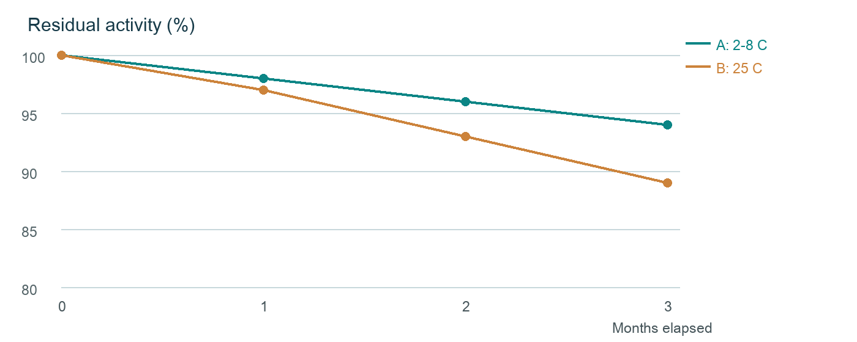

09 Workflow and decision points
The proposed workflow moves from information receipt through quality and client review to preparation of the next stage. Arrows show the direction of the process.
If quality review finds missing information, the owner returns the package for rework. Even after client review, a prerequisite such as receiving-site designation must be confirmed separately.
The diagram is a fictional procedure. Losing node connections or branch conditions can change the interpreted sequence.
Information still under review should not be treated as a final handover deliverable. The owner records requests and responses and checks the receiving organization readiness even after a review is completed.
Process and risk management review prerequisites and impacts together and record the approval status of each response.
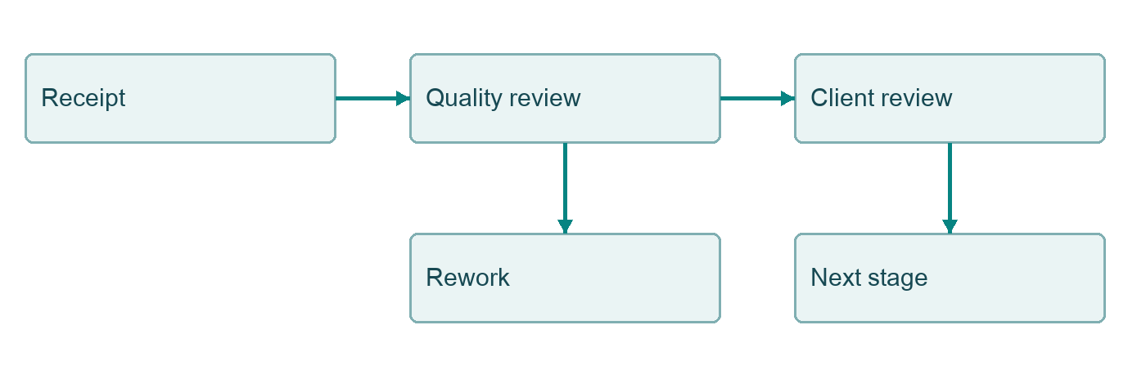

10 Schedule and dependencies
The baseline schedule is measured from an authorized start. Because the start date is not set, this document does not infer a calendar completion date.
Client information, materials, decisions and deliverable reviews are prerequisites for downstream work. The owner documents the effects of a delay and possible alternatives.
Overlapping activities still depend on their individual prerequisites. The schedule is a fictional planning scenario rather than a commitment.
Material schedule changes are recorded together with their effects on milestones and dependent activities. Client review periods are agreed separately based on the complexity and volume of deliverables.
Process and risk management review prerequisites and impacts together and record the approval status of each response.
Phase | Elapsed | Prerequisite
Assessment | Month 1 | Information received
Development | Months 2-5 | Plan approved
Interim review | Month 6 | Data reviewed
Final report | End of period | Review complete

11 Budget and payment assumptions
The illustrative baseline is KRW 0.9 billion, excluding VAT. It supports discussion of scope and is not a confirmed quotation.
External testing, transport, repeat studies and unapproved change work may require separate agreement. The final contract determines which costs are included.
Payment triggers and acceptance criteria remain subject to negotiation. The allocations below illustrate the baseline budget and are not actual invoices.
The work-package allocation is shown so its sum can be compared with the baseline. Discussing an invoice trigger does not automatically remove the client right to assess the agreed deliverable and scope.
Process and risk management review prerequisites and impacts together and record the approval status of each response.
Work package | KRW million
Assessment | 90
Development | 315
Analytical review | 270
Reporting and management | 225
Total | 900

12 Quality review and approval form
The quality reviewer checks sample identity, calculations, table values and revision history. Client approval is a separate process from internal review.
A checked item is marked complete only within this fictional record. An unchecked item should remain searchable as incomplete rather than being treated as an omission.
Where no approval record exists, acceptance is not assumed. Final signature authority is established by the actual agreement or procedure.
The reviewer records completed checks separately from outstanding approvals. Even when the same person is involved, internal review and client approval are distinct actions with separate evidence and dates.
Process and risk management review prerequisites and impacts together and record the approval status of each response.
☒ Sample identity verified
☒ Calculation reviewed
☐ Final client approval
☐ Additional testing approved

13 Risks and proposed responses
Key risks include missing data, ambiguous sample identity, variable results and an undesignated receiving site. Likelihood and impact are qualitative planning estimates.
Each risk has an owner, a proposed response and a status. A proposed response must not be interpreted as already approved or completed.
For material issues the team reviews investigation, client notification and whether a scope change is needed. This document does not assert that an actual quality deviation occurred.
Likelihood and impact are reassessed when new information becomes available. High-priority risks need an owner and review cadence, with the prior and updated status retained for subsequent meetings.
Process and risk management review prerequisites and impacts together and record the approval status of each response.
Risk | Impact | Response | Status
Missing data | High | Client confirmation | In progress
Material delay | Medium | Assess schedule | Planned
Site not designated | Medium | Discuss with client | Open

14 Scanned receipt and handover record
The embedded image is a fictional sample receipt. Its contents are stored as an image rather than native document text, so image analysis is required to read it.
Verify the sample identifier, quantity, date and recipient shown in the image. Slight rotation and blur are intentional for document parsing tests.
The displayed receipt status is illustrative and does not prove that transport or receipt took place.
The body does not repeat every field displayed in the image, so native text extraction alone cannot recover all details. The image location and document version should be retained alongside any extraction result.
Process and risk management review prerequisites and impacts together and record the approval status of each response.
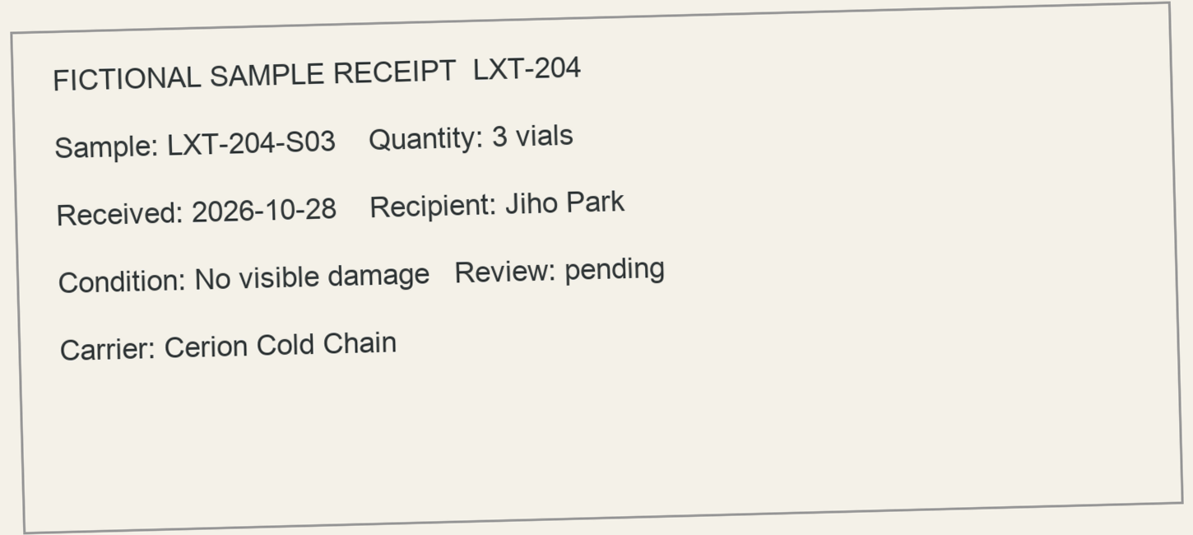

15 Conclusion and next steps
The next step for LXT-204 is to agree a detailed scope after receiving the client information. The present document remains a proposal or plan.
Taekyung Yoon will consolidate open questions and required decisions with Luminexis Therapeutics. A potential receiving site or outside laboratory remains unappointed until separately confirmed.
Final decisions require the approved scope, current document version and actual study results. Do not use the synthetic data for real operational decisions.
The next review should prioritize open questions concerning scope, information delivery, cost and schedule. If an approved plan changes, the reason for the change and its effects should be documented.
Process and risk management review prerequisites and impacts together and record the approval status of each response.

