Request for Proposal
Clinical Drug Product Manufacturing (Phase 2)
ANB-SYN-VAC-03 — adjuvanted recombinant protein vaccine | RFP ANB-RFP-2026-03 | issued 2026-10-19 | proposals due 2026-11-27

1. Purpose
AstraNova Bio seeks a CDMO for the drug product (DP) of ANB-SYN-VAC-03 for its Phase 2 study: formulation with adjuvant, aseptic filling, inspection, clinical labeling and release. The antigen drug substance (DS) is manufactured and released by AstraNova and supplied free of charge; DS manufacturing is not part of this RFP.

2. Contacts
Procurement contact | Name | Ella Novak
Procurement contact | E-mail | ella.novak@astranova-bio.example
Procurement contact | Role | Senior Buyer, Clinical Supply
Technical contact | Name | Dr. Tomas Varga
Technical contact | E-mail | tomas.varga@astranova-bio.example
Technical contact | Role | Head of Vaccine CMC
Questions go to the procurement contact by e-mail only; the technical contact joins the clarification call on request.

3. Product Information
ANB-SYN-VAC-03 is a recombinant protein antigen adsorbed to aluminium hydroxide. One dose (0.5 mL) contains 25 µg antigen and 0.5 mg Al³⁺ in histidine-buffered saline, pH 6.5.
The DP is a single-dose 2R glass vial with a nominal fill of 0.6 mL to deliver 0.5 mL. Store at 2–8 °C; do not freeze. The shelf-life target for clinical use is 24 months.
Phase 1 (180 participants) was completed in 2026 with the clinical lot made at the Phase 1 manufacturer. Phase 2 enrols about 1,200 participants in Korea and the EU; first patient in is planned for October 2027.
The aluminium hydroxide adjuvant is procured by the CDMO from an approved supplier against AstraNova's specification. Antigen DS is shipped frozen (≤ −60 °C) in 1 L bags; 1 bag makes about 20,000 vials.
Release for clinical use in the EU is by AstraNova's Qualified Person after the CDMO's QA certificate.

4. Scope of Work
Scope by site. The primary site is Korea; an EU backup quote is requested for filling only.
Activity | Clinical DP supply — site
 | Korea (primary) | EU (backup)
Formulation (adsorption) | Required | Quote requested
Aseptic fill and finish | Required | Quote requested
Clinical labeling and packaging | Required | Not required
Release and stability testing | Required | Not required
Table 1 — Scope by site (DP only; antigen DS supplied by AstraNova)

4.1 Batches
One technical batch and three GMP clinical batches are planned; no PPQ is required at this stage.
Batch | Type | Size | Target month | Use
TB-01 | Technical batch (non-GMP) | 20,000 vials | 2027-05 | Fill and process verification
CB-01 | GMP clinical batch | 20,000 vials | 2027-06 | Phase 2 supply
CB-02 | GMP clinical batch | 20,000 vials | 2027-07 | Phase 2 supply
CB-03 | GMP clinical batch | 20,000 vials | 2027-08 | Phase 2 supply and stability reserve
Table 2 — Clinical batch plan

4.2 Process and Responsibilities
Figure 1 shows the process steps and who performs them. Numbers give the order of the steps.
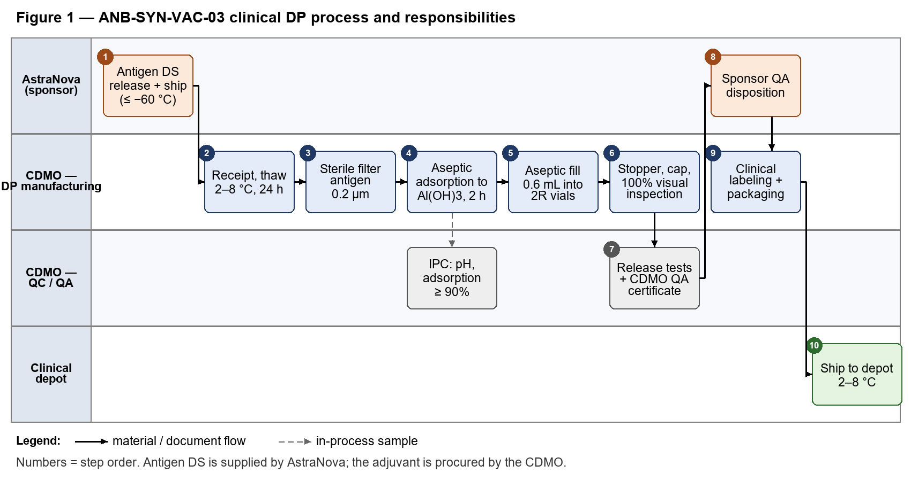

5. Quality Requirements
- GMP for investigational medicinal products (MFDS, EU GMP Part I and Annex 1 for sterile manufacture, Annex 13 expectations); pharmaceutical quality system per ICH Q10.
- A quality agreement is signed before technology transfer; AstraNova audits the site before CB-01.
- Aseptic process simulation (media fill) for the 2R format must be current before CB-01.
- Release tests: appearance, pH, identity, adsorption (≥ 90%), potency (in vitro), sterility, endotoxin, extractable volume, CCI. Methods are transferred from AstraNova.

5.1 Stability Pull Schedule
All three GMP batches are placed on stability. The table below is the pull schedule the CDMO executes.
Lot | Condition | Time point | Tests
CB-01 | 5 ± 3 °C | Initial | Appearance, pH, adsorption, potency (in vitro)
CB-01 | 5 ± 3 °C | 1 month | Appearance, pH, adsorption, potency (in vitro)
CB-01 | 5 ± 3 °C | 3 months | Appearance, pH, adsorption, potency (in vitro)
CB-01 | 5 ± 3 °C | 6 months | Appearance, pH, adsorption, potency (in vitro)
CB-01 | 5 ± 3 °C | 9 months | Appearance, pH, adsorption, potency (in vitro)
CB-01 | 5 ± 3 °C | 12 months | Full release panel incl. sterility, CCI
CB-01 | 5 ± 3 °C | 18 months | Appearance, pH, adsorption, potency (in vitro)
CB-01 | 5 ± 3 °C | 24 months | Full release panel incl. sterility, CCI
CB-01 | 25 ± 2 °C / 60 ± 5% RH | 1 month | Appearance, pH, adsorption, potency (in vitro)
CB-01 | 25 ± 2 °C / 60 ± 5% RH | 3 months | Appearance, pH, adsorption, potency (in vitro)
CB-01 | 25 ± 2 °C / 60 ± 5% RH | 6 months | Appearance, pH, adsorption, potency (in vitro)
CB-01 | 40 ± 2 °C / 75 ± 5% RH | 0.5 month | Appearance, pH, adsorption, potency (in vitro)
CB-01 | 40 ± 2 °C / 75 ± 5% RH | 1 month | Appearance, pH, adsorption, potency (in vitro)
CB-01 | 40 ± 2 °C / 75 ± 5% RH | 3 months | Appearance, pH, adsorption, potency (in vitro)
CB-02 | 5 ± 3 °C | Initial | Appearance, pH, adsorption, potency (in vitro)
CB-02 | 5 ± 3 °C | 1 month | Appearance, pH, adsorption, potency (in vitro)
CB-02 | 5 ± 3 °C | 3 months | Appearance, pH, adsorption, potency (in vitro)
CB-02 | 5 ± 3 °C | 6 months | Appearance, pH, adsorption, potency (in vitro)
CB-02 | 5 ± 3 °C | 9 months | Appearance, pH, adsorption, potency (in vitro)
CB-02 | 5 ± 3 °C | 12 months | Full release panel incl. sterility, CCI
CB-02 | 5 ± 3 °C | 18 months | Appearance, pH, adsorption, potency (in vitro)
CB-02 | 5 ± 3 °C | 24 months | Full release panel incl. sterility, CCI
CB-02 | 25 ± 2 °C / 60 ± 5% RH | 1 month | Appearance, pH, adsorption, potency (in vitro)
CB-02 | 25 ± 2 °C / 60 ± 5% RH | 3 months | Appearance, pH, adsorption, potency (in vitro)
CB-02 | 25 ± 2 °C / 60 ± 5% RH | 6 months | Appearance, pH, adsorption, potency (in vitro)
CB-02 | 40 ± 2 °C / 75 ± 5% RH | 0.5 month | Appearance, pH, adsorption, potency (in vitro)
CB-02 | 40 ± 2 °C / 75 ± 5% RH | 1 month | Appearance, pH, adsorption, potency (in vitro)
CB-02 | 40 ± 2 °C / 75 ± 5% RH | 3 months | Appearance, pH, adsorption, potency (in vitro)
CB-03 | 5 ± 3 °C | Initial | Appearance, pH, adsorption, potency (in vitro)
CB-03 | 5 ± 3 °C | 1 month | Appearance, pH, adsorption, potency (in vitro)
CB-03 | 5 ± 3 °C | 3 months | Appearance, pH, adsorption, potency (in vitro)
CB-03 | 5 ± 3 °C | 6 months | Appearance, pH, adsorption, potency (in vitro)
CB-03 | 5 ± 3 °C | 9 months | Appearance, pH, adsorption, potency (in vitro)
CB-03 | 5 ± 3 °C | 12 months | Full release panel incl. sterility, CCI
CB-03 | 5 ± 3 °C | 18 months | Appearance, pH, adsorption, potency (in vitro)
CB-03 | 5 ± 3 °C | 24 months | Full release panel incl. sterility, CCI
CB-03 | 25 ± 2 °C / 60 ± 5% RH | 1 month | Appearance, pH, adsorption, potency (in vitro)
CB-03 | 25 ± 2 °C / 60 ± 5% RH | 3 months | Appearance, pH, adsorption, potency (in vitro)
CB-03 | 25 ± 2 °C / 60 ± 5% RH | 6 months | Appearance, pH, adsorption, potency (in vitro)
CB-03 | 40 ± 2 °C / 75 ± 5% RH | 0.5 month | Appearance, pH, adsorption, potency (in vitro)
CB-03 | 40 ± 2 °C / 75 ± 5% RH | 1 month | Appearance, pH, adsorption, potency (in vitro)
CB-03 | 40 ± 2 °C / 75 ± 5% RH | 3 months | Appearance, pH, adsorption, potency (in vitro)
Table 3 — Stability pull schedule (CB-01 to CB-03)

5.2 Primary Container
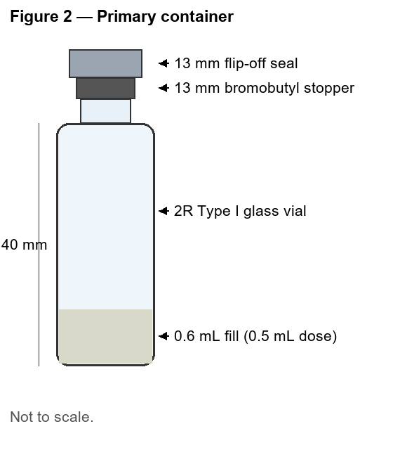 | Vial: 2R, Type I borosilicate glass, ISO 8362-1; supplied ready-to-use by the CDMO.  Stopper: 13 mm bromobutyl, coated; seal: 13 mm aluminium flip-off.  The suspension must be kept homogeneous during filling (continuous stirring of the bulk); state your mixing set-up and the line speed you would use.

6. Timeline
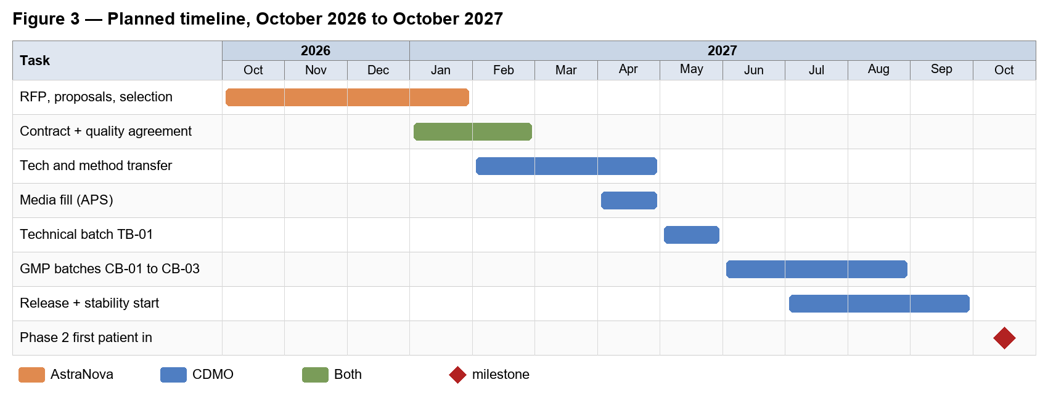
Milestone | Date
RFP issued | 2026-10-19
Intent to bid | 2026-10-28
Deadline for questions | 2026-11-06
Proposal due | 2026-11-27
Shortlist | 2026-12-11
Award | 2027-01-15
Table 4 — RFP milestones

7. Pricing and Commercial Terms
Quote in USD, valid for 180 days: (a) technology and method transfer, (b) media fill, (c) price per batch for TB-01 and each CB batch, (d) release testing per batch, (e) stability per pull point, (f) adjuvant and components at cost plus handling fee. Payment: 30% at slot reservation, 70% at QA certificate. Cancellation less than 3 months before fill: 50% of the batch price.

8. Confidentiality
This RFP is shared under CDA ANB-CDA-2025-031. Do not share it outside the proposal team.

