GigaDB schema

Author: WANG Senhong

Date: 26/2/2012

Table of contents

1. User Requirement
2. ER Diagram
3. The description of tables
4. How to search
5. User Requirement

The GigaDB schema is based on “GigaDBfields” and “GigaDB search specifications”.

1. ER Diagram

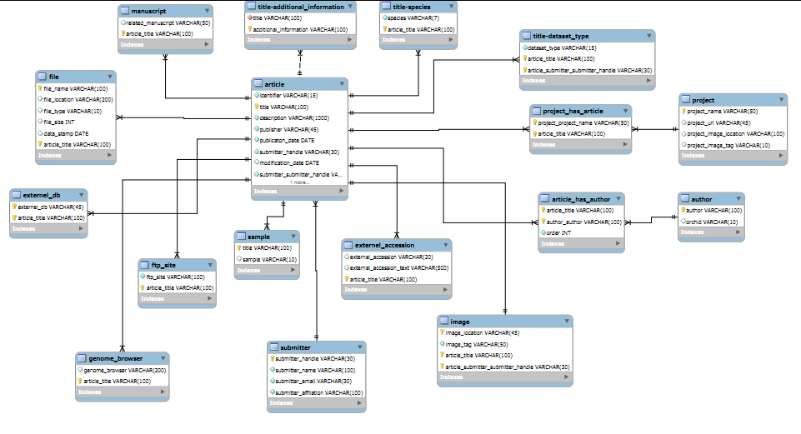

Fig. 1

The diagram above is the ER(Entity-Relation) diagram. It is produced by MySQL Workbench. A rectangle represents an entity, in other words, a table. The blue part of a rectangle is the name of the table and the items below it are the attributes of it. The line between entities shows their relationship. There are two relationships in the diagram: the 1:1 relationship and the 1:n . I will use two examples to illustrate them.

Example 1: The relationship between article and file

The relationship between article and file is a 1:n relationship, which means for one article, there will be multiple files corresponding to it. The webpage directed by the following url shows this relationship.

<http://gigadb.org/sweet-and-grain-sorghums/>

Example2: The relationship between article and image

For each article, there will be an image corresponding to it. It may relate to the topic of the article or so.

Maybe you are confused that why there is not m:n relationships in the diagram. In fact, it has. The relationship of ‘article’ to ‘project’ and ‘article’ to ‘author’ is m:n. However, it has translated it into two 1:n relationships. The following example illustrates this.

Example 3: The relationship between article and author

The relationship between article and author is m:n relationship. In other words, there may be multiple authors for an article and an author can write multiple articles. To implement m:n relationship in a database, a new table should be created. As you can see in the diagram, there is an entity named ‘article_has_author’ between entity ‘article’ and entity ‘author’. The relationship between ‘article’ and ‘article_has_author’ is 1:n, as well as the relationship between ‘author’ and ‘article_has_author’.

1. The description of Tables

The ER diagram has described each table clearly, including all its attributes, its primary key and foreign keys. A primary key can be identified by the yellow symbol ( shape of a key). A foreign key can be found by the red symbol.

1. How to search

The data stored in database can be retrieved through SQL statement. For instance, if you

want to know the articles written by Ramachandran, you can execute the query statement

“ select * from article_has_author where author=’ Ramachandran’ ”. Of course, when the

Website is deployed, you can search what you want though the webpage.