# Creating an EC2 Instance - Step-by-Step Guide

Step 1: Accessing the EC2 Console

* Open the AWS Management Console.
* Use the search box on the left side of the console.
* Type "EC2" and select the "EC2 virtual server in the cloud" option.

Step 2: Launching an Instance

* Within the EC2 Dashboard, click on the "Launch Instance" button.

Step 3: Naming and Tagging

* In the "Names and Tags" section:
* Enter a meaningful name for your instance.

Step 4: Selecting the Operating System

* Under "Amazon Machine Image (AMI)":
* Choose the desired operating system for your instance.

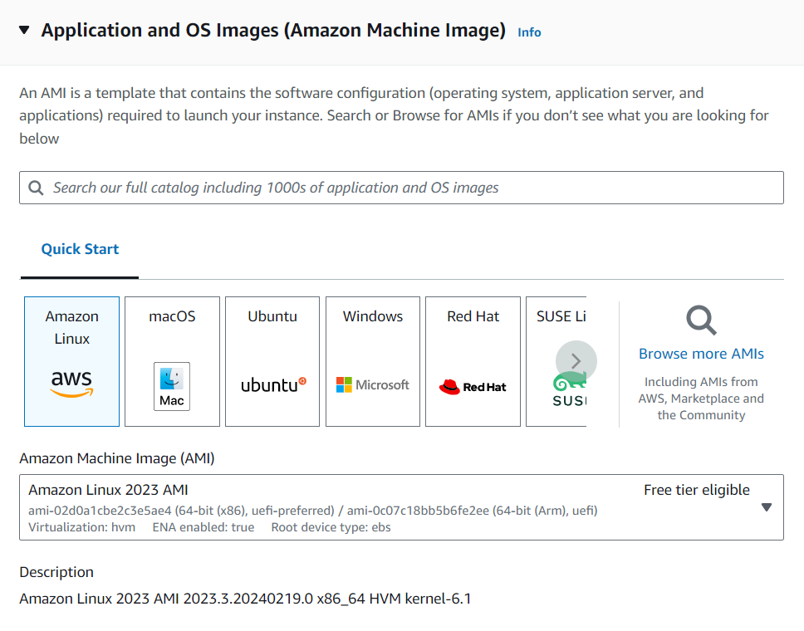

Step 5: Choosing Instance Type

* In the "Instance Type" section:
* Select the instance type. For example, t3.micro.

Step 6: Configuring Key Pair for Login

* In the "Key Pair" section:
* Click on "Create a new key pair."
* A file containing an encrypted key will be downloaded.
* Choose the name you entered earlier while creating the key pair from the dropdown.

Step 7: Configure Storage and Network Settings

* Continue through the configuration steps for:
* Storage: Keep the default settings or adjust based on your requirements.
* Network: Use default settings or modify as needed.

Step 8: Review and Launch

* Review all the configurations made.
* Click on "Launch" to initiate the instance creation.

Conclusion

* Following these steps will guide you through the process of creating an EC2 instance on AWS.
* Ensure that you review each step carefully and customize the settings.

based on your specific needs and preferences. Once the instance is launched, you can access it using the key pair you created and start using the virtual server in the cloud.

* Remember to manage your instances responsibly, considering security best practices and cost optimization strategies. For more detailed information or troubleshooting, refer to the AWS documentation or reach out to AWS support.

Congratulations! You have successfully created an EC2 instance on AWS.