Name: ____James Tate_____

Netid: _____jct322______

- Correct Design part 1 (40 pts, simulation screen shot 10 pts)
- Correct Design part 2 (15 pts, FPGA editor screenshot 10 pts)

FILL IN THIS TABLE
Design | #number of LUTs | %utilization | Longest Path delay | Start pin | End pin
Part 1 (LUT-based multipliers) | 465 | 24% | 20.294 ns | x2[1] | y[7]
Part 2 (hardmacro multipliers) | 22 | 1% | 15. 756ns | X1[9] | y[7]

Simulation Screenshot for Part 1:
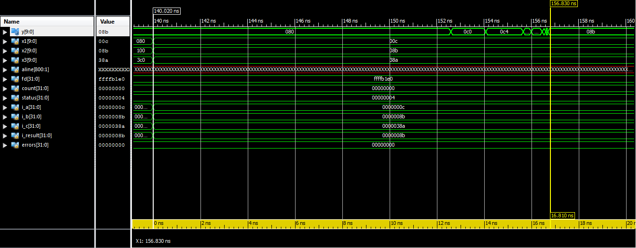

FPGA Editor Screenshot for Part 2:
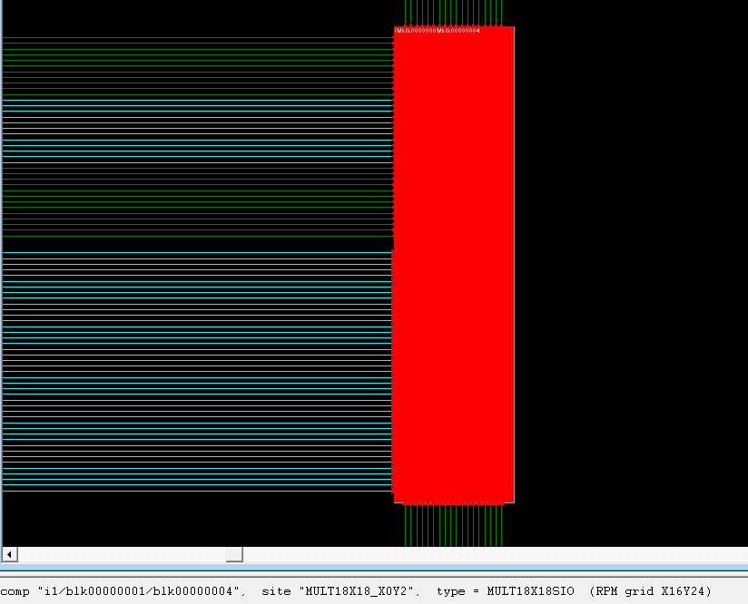
- Question (5 pts): From the data gathered from these two designs, give two reasons why FPGA vendors include hardmacros on their FPGA substrates.
The design will use less LUT's.
The design with hardmacros will be faster.

- Question (10 pts)
For the following multiplication, write the hex values for the two operands encoded as 1.7 signed numbers, and for the result as a 2.14 number.

-0.7421875 x 0.8671875 = -0.64361572265625

Answer:

0xA1 x 0x6F = 0xD6CF

- Question (10 pts)
What is the decimal result of the following multiplication if these hex numbers are signed 2.6 numbers?

0xA4 x 0x70 =

Answer:

2.6 + 2.6 = 5.2

0xA4 = -92 → -92/2^6 = -1.4375

0x70 = 112 → 112/2^6 = 1.75

-1.4375 x 1.75 = -2.5156

