Name: _____James Tate_____

Netid: _____jct322______

- Correct Design part 1 (25 pts with simulation screenshot, table data)
- Correct Design part 2 (25 pts, with simulation screenshot, table data)
- Correct Design part 3 (25 pts, with simulation screenshot, table data)

FYI: Clock Frequency is 1/period
Design | Latency | #number of LUTs (% util) | # of Dffs (%util) | Period (%logic, % route) | Clock Freq (MHz ) | Clock to Out
Part 1 (no pipestages) | 2 | 52 (2%) | 30 (1%) | 1.004 ns (72.3% logic, 26.3% route) | 996 MHz | 19.93 ns
Part 2 (one internal stage) | 3 | 52(2%) | 66(3%) | 7.644 ns (67.5% logic, 32.5% route) | 130 MHz | 11.94 ns
Part 3 (three internal stages) | 5 | 54 (2%) | 54(2%) | 4.165 ns (56.3% logic, 23.6% route) | 240 MHz | 10.04 ns

Simulation Screenshot verifying latency of 2:
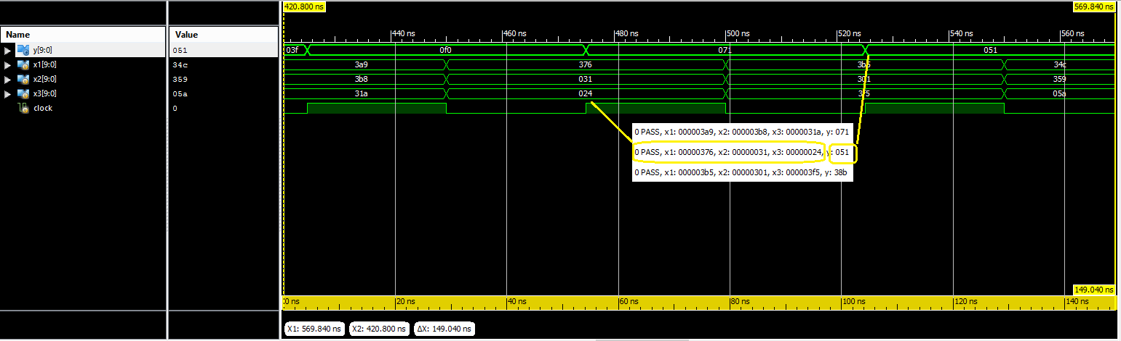
Simulation Screenshot verifying latency of 3:

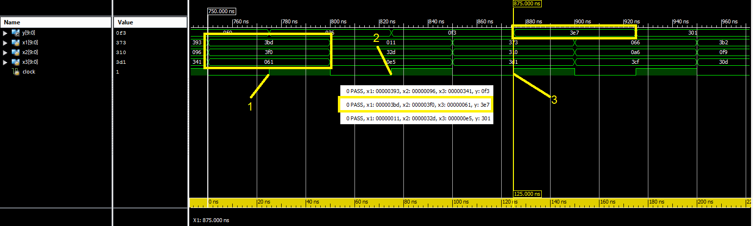
Simulation Screenshot verifying latency of 5:
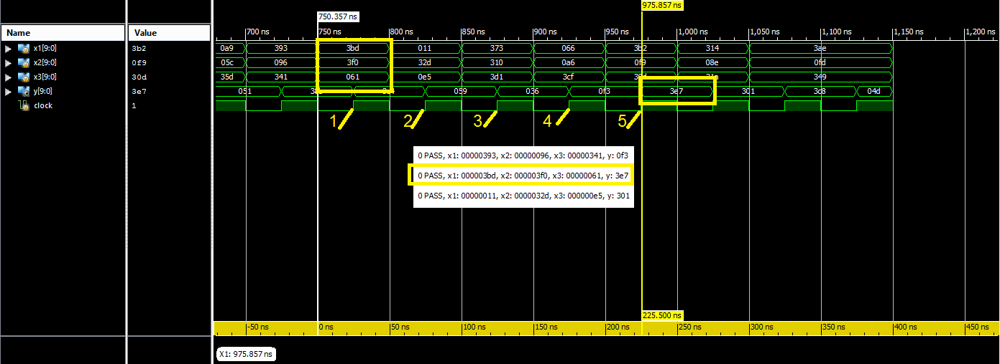

- Question (5 pts): For the design with latency = 3, is the longest path in the multiplier logic or in the adder logic? Include information from the detailed timing analysis to support your answer.
According to the timing analysis the longest path is from the dff output on q2 pin 7 to a pin on the corresponding multiplier. The detailed timing report shows this data path delay to be 7.644ns and it has one level of logic to go through. This would indicate that the longest path would be on the multiplier logic.

- Question (5 pts): For the design with latency = 5, what section of logic (A, B, C or D) is the longest path in? Include information from the detailed timing analysis to support your answer.
The longest path is from a pin on the output of the hardmacro multiplier number 2 to pin 11 on
one of the DFF of before the adder. This means the longest path will be in section C of the datapath. The timing report indicates this has a 4.163 ns data path delay, and there are 6 levels of logic.

- Question (10 pts): From the data gathered from these designs, show computations verifying that the reported number of 'slice DFFs' is what is expected. (HINT: for the third design that uses a hardmacro multiplier with two pipeline stages, these DFFs no longer use slice DFFs as these DFFs are buried inside of the hardmacro multiplier in order to optimally break up the delay paths).
First Design
adder 11bits x 2wide x 2 = 44, 3DFF 9bits x 3wide = 18, 44 + 18 = 62 LUTS
Second Design
adder 11bits x 2wide x 2 = 44, 3DFF 9bits x 3wide = 18, 44 + 18 = 62 LUTS
“Same number of DFF as first, extra pipeline was added to Multiplier.”
Third Design
adder 11bits x 2wide x 2 = 44, 5DFF 9bits x 3 wide = 27, 44+27 = 71 LUTS

- Question (5pts) Comment on what you will think will happen to the delay as you add more and more pipeline stages – justify your answer. You must use complete sentences and correct spelling – this is graded for grammar as well as correctness!
Adding more pipelines will further the delay from input to output. The reason it would do this is every pipeline will use one clock cycle. So for every pipeline stage that you add the delay will increase by one clock cycle.

