EDA / Profiling Agent Layer
  - Architecture: Ingestion-to-Graph Data Quality Gate
2026-08-28
Table of Contents
Executive Summary 3
1. Ingestion Flow Map 5
2. Agent Responsibilities 8
3. Standardized Agent Output Contract 9
4. Build XML Support 10
5. Build Unstructured-Data Analysis 11
6. Agent Orchestration Layer 12
7. Agent Independence 13
8. Persistence and Observability 13
9. Testing 13
10. Initial Deliverable 14

Status | Design baseline, grounded in current code
Prepared | 2026-08-28
Scope | New profiling-agent layer between entity resolution and the FalkorDB graph write
Audience | Executive Summary — business stakeholders. Sections 1–10 — engineering team.
Codebase references | src/aryx/pipeline/orchestrate.py, src/aryx/connectors/*, src/aryx/pipeline/{profile,doc_discovery,clean_text,pii}.py, src/aryx/ontology/extract.py, src/aryx/profiler/, src/aryx/graph_profiler/

Executive Summary
What this is. A new automated checkpoint for data quality, placed right before information is written into the company’s knowledge graph. Today, structured data (spreadsheets, database tables, JSON) gets basic bookkeeping on the way in, but nothing actually stops broken, duplicated, or low-confidence data from reaching the graph. Documents and XML files have even less coverage — XML uploads are currently rejected outright, and the parser behind them has a known security gap.
Why it matters. The knowledge graph is the shared source of truth downstream reporting, entity resolution, and analytics all depend on. Without a quality gate, bad data silently propagates into that shared layer, and the cost of finding and fixing it later is much higher than catching it at the door. This project closes that gap without adding new infrastructure — no new services, no new operational overhead — by adding a small set of automated checks to the pipeline that already exists.
What’s being built. Six small, independent “agents,” each responsible for one concern:
Agent | What it checks
Structured Data Profiling | Spreadsheets, database tables, JSON — reuses analytics already built
XML Profiling | Structure, nesting, repeated/missing elements, data types — new capability
Unstructured Data Profiling | Documents and text — type, language, length, entities, quality
Data Quality | Nulls, duplicates, malformed records, encoding issues, anomalies
Metadata Extraction | Source, file type, size, structure, timestamps, identifiers
Data Type Detector (optional) | Identifies incoming data and routes it to the right agent above
Each agent produces the same simple report format, so results are consistent and easy to review regardless of what kind of data came in. If a serious problem is found (a required field is missing, sensitive data is detected, or the file is malformed), the run stops before anything reaches the graph — an ordinary quality warning does not.
Status. This document is the architecture baseline: what will be built, in what order, and how it will be tested. It has not yet been implemented. Section 10 lays out a minimal first version and its build order.
How to read this document. This summary is written for a non-technical audience. Engineering should continue to Section 1, which maps the design onto the actual codebase file-by-file.

1. Ingestion Flow Map

1.1 Where data enters today
There is no single “ingestion” entry point — there are two public APIs and, under them, per-type connectors:
Path | Entry API | Dispatch | Connector(s)
Structured (CSV, JSON, SQL table, Postgres table, REST) | POST /admin/ingest/file (file_ingest_api.py), POST /admin/docs/read (doc_discover_api.py) | .json/.csv routed directly; sql_source/postgres/rest_api connectors are constructed programmatically, not via file upload | CsvConnector, JsonConnector, SqlConnector, PostgresConnector, RestApiConnector, RecordsConnector (src/aryx/connectors/*.py)
XML (.xml, .html, .htm) | Not reachable through either public API today | doc_router.py::_EXT_MAP already maps these extensions to MarkupConnector, but neither doc_discovery.py::DOC_EXTS/DATA_EXTS nor file_ingest_api.py::_DATA_EXTS/_DOC_EXTS include them, so an uploaded .xml file is rejected with HTTP 400 before it ever reaches the router | MarkupConnector (src/aryx/connectors/markup.py) — exists, wired at the router level, unreachable at the API level
Unstructured documents (PDF, DOCX, PPTX, images) | Both APIs | DocumentRouterConnector dispatches by suffix via _EXT_MAP | PdfConnector, DocxConnector, PptxConnector, ImageConnector
All paths converge on RawRecords: structured connectors emit one RawRecord per row/object; document connectors go through a different sub-path (chunk_pages() → screen_chunks() (PII) → extract_mentions()) before also producing RawRecords. Both kinds are then handed to discover() → run_spine() (src/aryx/pipeline/run.py), which cleans, profiles (ProfileAccumulator), and lands them as CleanRecords.

1.2 The point before data reaches the graph
run_pipeline (src/aryx/pipeline/orchestrate.py) chains: discover → resolve_cluster → relate (optional) → fk_link (optional) → project. project is the only stage that calls project_graph() (src/aryx/project.py), which does graph.clear() then writes nodes/edges to FalkorDB — the sole write path into the graph.
There is a second, easy-to-miss call site: link_entities() (orchestrate.py, ~line 242) invokes the same project_graph() a second time when FK links are resolved after the fact. A gate placed only in run_pipeline is not watertight — it must wrap both call sites, or a re-projection triggered by link_entities() can bypass it.
Separately, src/aryx/profiler/ (dataset-level quality profiling, C03) and src/aryx/graph_profiler/ (graph-shape profiling, C06) already exist and already compute much of what’s being asked for here (type inference, quality flags, roles, stats) — but both are invoked from src/aryx/pipeline/downstream.py::run_downstream(), which wraps every call in try/except Exception: log.warning(...). Today, nothing profiling-related can block a graph write — everything runs best-effort, and only after project has already fired. This is the core gap: the analytics mostly exist; the gate does not.

1.3 Where the EDA/profiling agents should trigger
Two trigger points, not one, because they answer different questions:
- Per-artifact, at ingestion time (inside DocumentRouterConnector.extract() for documents, or immediately after a structured connector’s extract()/clean() pass) — this is where type detection, XML structural profiling, unstructured document profiling, and metadata extraction naturally run, because they need the raw file/chunk, not the resolved entity graph. Output attaches to the run as artifact-level metadata.
- Once, as a blocking gate, immediately before each project_graph() call (orchestrate.py line ~206 and inside link_entities()) — this is where the Data Quality Agent’s aggregate verdict is evaluated and a block-severity result halts the run before any FalkorDB write, exactly as the existing resolve_cluster/relate/fk_link stages already halt on failure via runner.stage(...).
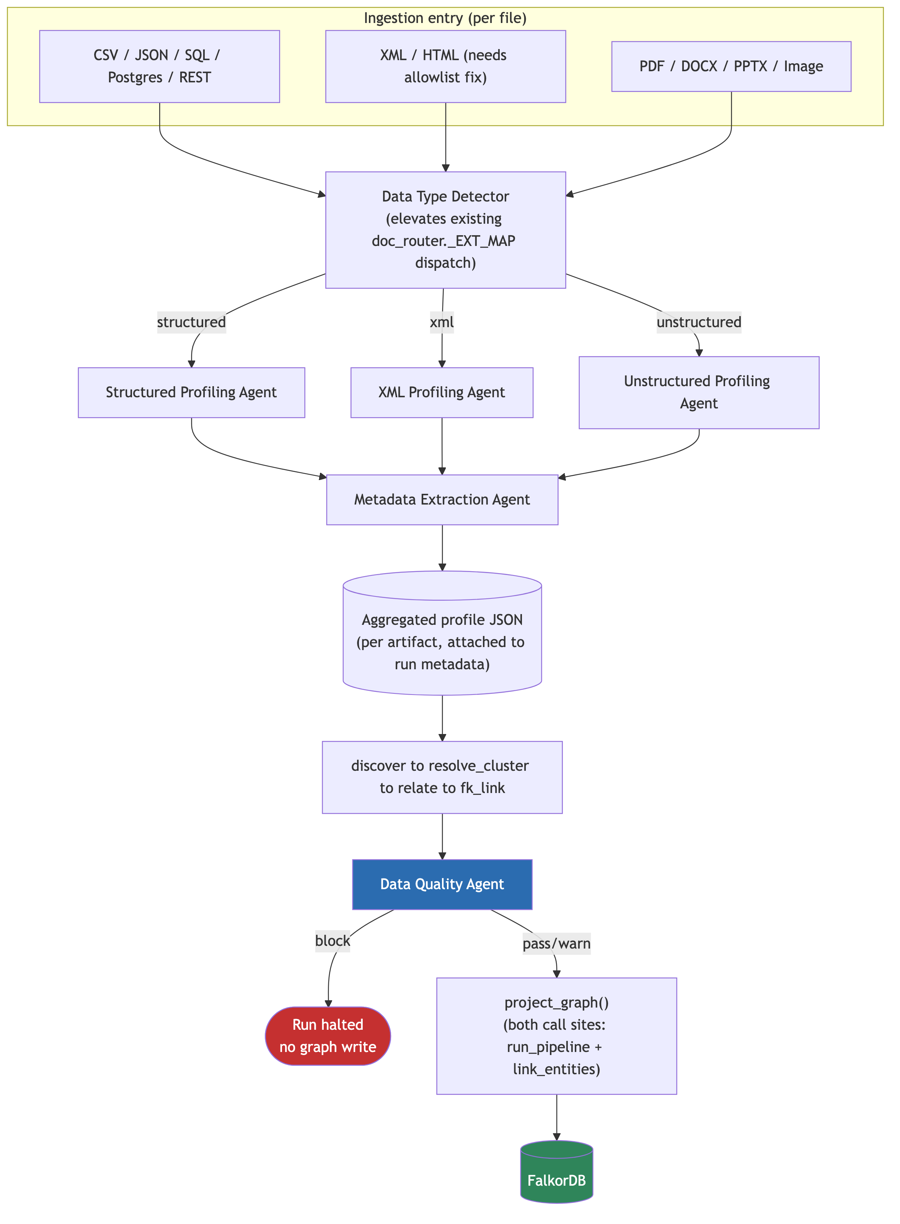
Ingestion flow: per-file entry, through the Data Type Detector and profiling agents, to the Data Quality Agent gate before either FalkorDB call site.

2. Agent Responsibilities
All agents share one interface (Section 3) and are independently callable/testable modules — never inline logic buried in a connector or in orchestrate.py (Section 7).

2.1 Structured Data Profiling Agent
Reuses, does not rebuild. src/aryx/pipeline/profile.py::ProfileAccumulator already computes non-null/distinct/sample stats inline during run_spine(); src/aryx/profiler/profile.py::profile_dataset already computes the richer layer this agent needs — canonical type inference, analytical role (identifier/measure/dimension/time/status/attribute), and quality flags (missing_values, constant, high_cardinality, mixed_types, outliers). Today profile_dataset runs post-hoc and non-blocking via run_downstream().
- Inputs: landed CleanRecords for the run (same input ProfileAccumulator already sees), or a dataset snapshot (same input profile_dataset already takes).
- Change required: expose profile_dataset’s output synchronously to the new gate, and add a severity mapping (e.g. constant/mixed_types on a required field → block; high_cardinality/outliers → warn) — the profiling logic itself does not need to be rewritten.
- Output: standardized JSON (Section 3), source.type = "structured".

2.2 XML Profiling Agent
New — the current XML path (markup.py::_extract_xml) discards structure entirely; it flattens every element into "tag: text" lines before anything downstream sees it. See Section 4 for the build plan.
- Inputs: raw XML bytes/parsed tree, prior to (or alongside) the existing flattening pass.
- Output: schema/tag-path map, nesting depth, repeated-element counts, optional/missing-node flags, inferred per-path data types, malformed-XML flags. Standardized JSON, source.type = "xml".

2.3 Unstructured Data Profiling Agent
New — operates on DocumentChunks (src/aryx/pipeline/clean_text.py::chunk_pages() output), after PII screening (pii.py::screen_chunks), before or alongside ontology/extract.py::extract_mentions.
- Inputs: list[DocumentChunk] for one document, plus the format the connector already determined (PdfConnector/DocxConnector/PptxConnector/ImageConnector/MarkupConnector).
- Output: document/file type, text length stats, language, lightweight entity/keyword signal (reuse the spaCy model already loaded for Presidio in pii.py::_engines() for cheap NER rather than invoking extract_mentions’s LLM call twice), document section/structure hints (from page/slide boundaries already present in DocumentChunk.page_slide), near-duplicate detection across chunks (simhash/minhash over chunk text), missing/corrupted-content flags (e.g. all-OCR-noise, zero extracted text). Standardized JSON, source.type = "unstructured".

2.4 Data Quality Agent
The aggregate gate-facing agent — the one whose verdict actually blocks a project_graph() call (Section 1.3, trigger point 2).
- Inputs: the aggregated per-artifact outputs from 2.1–2.3 for the run, plus a direct pass over landed CleanRecords for record-level checks the per-field profilers don’t already cover: null-rate thresholds, duplicate-record detection (hash of normalized payload), malformed-record detection (schema/required-field violations), encoding issues (mojibake/invalid-UTF-8 detection on raw text fields), and anomaly flags carried up from 2.1–2.3.
- Output: standardized JSON with recommended_next_action ∈ {proceed, warn, block} — this is the value the orchestration layer (Section 6) reads to decide whether to call project_graph().

2.5 Metadata Extraction Agent
Runs alongside 2.1–2.3 for every artifact — cheap, always-on, never blocks.
- Inputs: file path/bytes, SourceRef (already attached to every RawRecord/DocumentChunk), dataset registration info (register_dataset in file_ingest_api.py).
- Output: source system/dataset, file type, byte size, schema/structure summary (column list for structured; tag-path summary for XML; section list for documents), timestamps (file mtime, ingestion time), identifiers (doc_id sha256 for documents — already computed in doc_router.py::ingest_document; a stable content hash for structured files, computed the same way).

2.6 Data Type Detector (optional, first in the chain)
Not a new algorithm — an explicit, testable elevation of dispatch logic that already exists split across two places (doc_router.py::_EXT_MAP, doc_discovery.py::DOC_EXTS/DATA_EXTS). Consolidating it into one component makes it independently unit-testable and gives the orchestration layer one place to ask “what kind of thing is this?” instead of re-deriving the answer from allowlist membership at each call site.
- Inputs: file path/extension, optionally a content sniff (magic bytes) for mislabeled extensions.
- Output: DataKind ∈ {structured, xml, unstructured, unknown}, routed to the matching agent from 2.1–2.3.

3. Standardized Agent Output Contract
Every agent (2.1–2.6) returns the same JSON shape, regardless of what it profiles. This is what makes the orchestration layer’s aggregation step (Section 6) generic instead of per-agent-type logic.
{
"agent": "xml_profiling",
"agent_version": "1.0",
"run_id": "…",
"source": {
"type": "structured | xml | unstructured",
"system": "…",
"dataset": "…",
"identifier": "sha256:…",
"path": "…"
},
"schema_info": {
"fields_or_paths": ["…"],
"nesting_depth": 0,
"repeated_elements": {},
"inferred_types": {}
},
"statistics": {
"record_or_chunk_count": 0,
"field_or_path_stats": {}
},
"quality_issues": [
{ "code": "missing_required_field", "severity": "block", "location": "…", "detail": "…" }
],
"extracted_metadata": {
"file_type": "…",
"byte_size": 0,
"timestamps": { "file_modified": "…", "ingested_at": "…" },
"identifiers": ["…"]
},
"anomalies": [
{ "code": "…", "detail": "…" }
],
"warnings": [
{ "code": "…", "detail": "…" }
],
"recommended_next_action": "proceed | warn | block"
}
quality_issues[].severity follows the same {block, warn} vocabulary already established for Track A/B checks in the prior gate design — a block at the agent level rolls up into recommended_next_action: "block" at the Data Quality Agent’s aggregate level. agent_version exists so a later change to one agent’s logic doesn’t silently invalidate stored history for baseline-relative checks (e.g. drift, extraction-confidence).

4. Build XML Support
The current gap, concretely:
- Allowlist fix. Add .xml, .html, .htm to doc_discovery.py::DOC_EXTS and file_ingest_api.py::_DOC_EXTS — MarkupConnector and doc_router.py::_EXT_MAP already handle the dispatch, they’re just unreachable.
- Parser hardening — must ship in the same change as (1), never after. markup.py::_extract_xml uses stdlib xml.etree.ElementTree, which has no entity-expansion or XXE protection. Swap to defusedxml.ElementTree (near-identical API; _extract_xml’s flattening logic needs no other change). Add a regression fixture: billion-laughs payload and an external-entity payload, both must be rejected, not silently truncated.
- Structure-preserving pass, alongside the existing flattener. Today _extract_xml walks the tree once and only emits flattened "tag: text" lines — the tree shape is thrown away before anything downstream sees it. Add a second pass over the same parsed tree (no second parse) that builds:
  - a tag-path map: {tag_path: {count, attrs: [...], sample_values: [...]}}, one entry per distinct path from root;
  - nesting depth per path;
  - repeated-element detection: a tag path appearing more than once under the same parent, at the same level (e.g. <Invoice><LineItem> × N);
  - optional/missing-node detection: compare tag-path sets across a sample of documents sharing a document_type classification — a path present in most samples but absent in one is flagged, not treated as an error (XML has no schema by default; absence is a signal, not a violation, unless an XSD is supplied);
  - type inference per path: same scalar-type inference approach as the structured Type-Consistency check (numeric/text/boolean/date-like), applied to leaf text and attribute values;
  - malformed/inconsistent flags: parse failure (post-hardening) is warn, not block — the existing regex fallback still applies; a path whose values fail type-consistency below threshold is warn.
- Flattener output stays byte-identical. The structure-preserving pass is additive — clean_text.py and everything downstream of the flattened text must observe no change.

5. Build Unstructured-Data Analysis
For DocumentChunks produced by clean_text.py::chunk_pages():
Extract | Source of truth | Notes
Document/file type | Connector already used (PdfConnector/DocxConnector/PptxConnector/ImageConnector/MarkupConnector) | No new detection — read from the router’s existing dispatch.
Text length + basic stats | DocumentChunk.text, char_start/char_end | Character count, word count, chunk count per document.
Language | Bounded sample of chunk text | Lightweight detection (e.g. langdetect/fasttext); failure → "unknown", not an error.
Entities/keywords | The spaCy model already loaded by pii.py::_engines() for Presidio | Reuse the loaded model for cheap generic NER/noun-phrase extraction; do not call ontology/extract.py::extract_mentions’s LLM path a second time just for profiling — that path is for grounded entity-mention extraction into the graph, not for cheap document profiling.
Document sections/structure | DocumentChunk.page_slide, chunk ordering | Page/slide boundaries are already tracked; a “structure” summary is just an aggregation of what’s already on each chunk.
Duplicate/near-duplicate content | Chunk text | Simhash or minhash signature per chunk; compare within a document (repeated boilerplate) and, optionally, across a run (near-duplicate documents).
Missing/corrupted content | Chunk text | Zero non-whitespace chunks, or a chunk that is >X% non-printable/OCR-noise characters, flags content_missing/content_corrupted.
Metadata/identifiers | SourceRef, doc_id (sha256, already computed in doc_router.py::ingest_document) | Same identifier already used to key chunk storage — reuse, don’t recompute differently.
All of the above run after screen_chunks() (PII screening) — the profiling agent never sees unscreened text, consistent with the existing fail-closed PII boundary.

6. Agent Orchestration Layer
A single coordinator, not a message bus or service mesh — consistent with the codebase’s current scale and with the existing StageRunner pattern (in-process, checkpointed, no new infrastructure class).
Responsibilities:
- Receive the incoming file/dataset (same point DocumentRouterConnector.extract() or a structured connector’s extract()/clean() already receives it).
- Call the Data Type Detector (2.6) to get a DataKind.
- Invoke the matching profiling agent (2.1/2.2/2.3) and the Metadata Extraction Agent (2.5) concurrently — they’re read-only and independent, no ordering constraint between them.
- Aggregate their standardized JSON outputs into one per-artifact record; persist it (Section 8).
- Once all artifacts for the run have landed, invoke the Data Quality Agent (2.4) once against the aggregate — this is the call whose recommended_next_action gates project_graph().
- On block: halt via the same runner.stage(...) exception mechanism resolve_cluster/relate/fk_link already use — the run’s checkpoint records failed, and both project_graph() call sites (run_pipeline and link_entities) must consult this same verdict.
- On warn/proceed: pass the aggregated JSON through as run metadata (same detail dict convention used elsewhere) and allow project_graph() to run.
Failure isolation: one agent failing (timeout, exception, malformed input) must not fail the artifact or the run — it degrades that agent’s contribution to status: "skipped" in the aggregate, exactly as a timed-out check degrades to skipped rather than a hang in the existing Track A/B design. Only the Data Quality Agent’s own explicit block verdict halts the run; an agent failure is never itself a block.

7. Agent Independence
Each agent (2.1–2.6) is a separate, independently callable/testable module with a fixed input/output contract (Section 3) — not branches inside one large profiling function. This is a hard design constraint, not a style preference: an agent must be addable, removable, or replaceable without touching any other agent’s code, and must be unit-testable in isolation against a fixture, with no dependency on the orchestration layer being present. Concretely, this means each agent lives in its own module (e.g. structured.py, xml.py, unstructured.py, quality.py, metadata.py, classifier.py) behind one shared ProfileAgent protocol (name, applies_to(kind), run(input) -> AgentResult), the same shape as the existing ProfileCheck interface used by the tabular gate design. “Independent” means independently pluggable in-process modules, not distributed services — there is no scale justification in this codebase for agent-per-process deployment, and it would add deployment/IPC/partial-failure surface with no offsetting benefit (the same rejected-alternative reasoning that already applies to the tabular/XML gate design).

8. Persistence and Observability
Every agent run must be inspectable after the fact, independent of whether the run proceeded to the graph.
- Storage: persist each agent’s standardized JSON output (Section 3), keyed by run_id + artifact identifier, in the same store family already used for run metadata (tracker.finish(run_id, name, detail) pattern) — no new storage technology.
- Logging, per agent invocation:
  - which agent ran, and its agent_version
  - execution status (pass/warn/block/skipped/error)
  - failure detail, if any (exception type/message, never a raw stack trace exposed to run metadata)
  - the full profiling result (or a pointer to it, if large)
  - processing time (wall-clock, to catch a slow agent before it needs a timeout bump)
  - input identifier (doc_id/content hash) and agent_version, so a later reprocessing run can be diffed against a prior one
- Retrievability: the aggregated per-run JSON must be queryable by run_id before deciding whether to investigate a warn/block — this is what lets someone answer “why did this run stop” without re-running the pipeline.

9. Testing

9.1 Representative fixtures
Category | Fixture examples
Structured | Well-formed CSV/JSON; a file with a missing required column; a file with mixed-type values in one column
Simple XML | Shallow, well-formed XML with a handful of repeated sibling elements
Deeply nested XML | Multi-level nesting (e.g. Invoice > LineItems > LineItem > Tax), to exercise tag-path/nesting-depth logic
Malformed XML | Unclosed tags, invalid encoding declarations, a billion-laughs payload, an external-entity payload
Plain text | Short and long plain-text documents, including a near-empty one (sparse-but-legitimate case)
Large documents | Multi-hundred-page PDFs/DOCX, to exercise chunking and timeout behavior
Mixed-quality/unstructured | Scanned/OCR-noisy documents, documents with embedded images, documents with partially corrupted encoding

9.2 Validation criteria
- Every fixture produces output matching the standardized JSON contract (Section 3) — schema validation, not just “it ran.”
- A fixture that should block (missing required field, malformed-beyond-fallback XML, detected PII) halts before the graph write; the halt is demonstrated in an integration test against both project_graph() call sites (run_pipeline, link_entities).
- A fixture that should warn/proceed (cardinality anomaly, sparse-but-legitimate document, first-run cold start) does not halt anything, and the warning is present in the aggregated JSON.
- One agent failing does not block the graph flow for artifacts that other agents handled successfully — simulate a forced exception/timeout in one agent and confirm the run still reaches project_graph() if no other agent returned block.
- Repeated runs against identical input produce identical verdicts (idempotency), matching the existing Track A/B idempotency bar.

10. Initial Deliverable
A minimal first version, in dependency order:
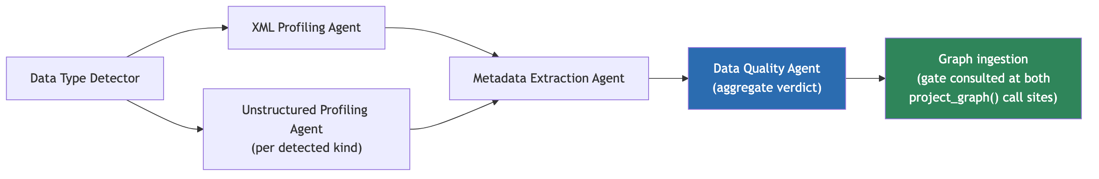
Initial deliverable: Data Type Detector routes to the XML or Unstructured Profiling Agent, both feed the Metadata Extraction Agent, then the Data Quality Agent’s aggregate verdict gates graph ingestion.
Scope for v1:
- Data Type Detector — consolidate existing _EXT_MAP/DOC_EXTS/DATA_EXTS dispatch into one testable component.
- XML Profiling Agent (Section 4) + the two prerequisite fixes (allowlist + defusedxml), shipped together.
- Unstructured Profiling Agent (Section 5), reusing the already-loaded spaCy model for cheap NER rather than the LLM extraction path.
- Data Quality Agent (Section 2.4), initially reusing aryx.profiler.profile_dataset’s existing quality flags made synchronous, plus the record-level checks it doesn’t already cover (duplicates, encoding).
- Metadata Extraction Agent (Section 2.5) — cheap, always-on, ships alongside the others since it has no gating logic to get wrong.
- Wire the aggregate verdict into both project_graph() call sites (orchestrate.py::run_pipeline and orchestrate.py::link_entities) as a new checkpointed StageRunner stage.
- Persistence + logging (Section 8) ships with v1, not as a follow-up — without it, a block is unactionable noise.
Deferred to v2: Structured Data Profiling Agent’s richer role-inference reuse from graph_profiler/ (graph-shape profiling is a separate concern from pre-graph gating and can stay async/best-effort for now); cross-run near-duplicate detection across documents; XML schema (XSD)-aware validation beyond sample-based optional/missing-node inference.

