Vivianna Weaver and Gianna Claros

Drs. Richard Schugart and Mustafa Atici

April 27, 2023

CPS 371

CPS Project: Exercise: Made for You

Table of Contents:

i. Introduction and Our Approach

ii. Main Goals

iii. Overcoming Obstacles and Challenges

iv. Our Functions and Writing the Code

v. Future Work

vi. Problems Not Overcome

vii. How to Run

viii. References

i.

Our project was to create a program that produces a personalized fitness plan based on a user’s primary fitness goals and areas of focus. Our program was entirely completed over the designated time frame. The end product creates an optimized schedule based on a user’s input from a selection of options, which was precisely our goal. We wanted to help more people explore and enjoy fitness and help them overcome any barriers that prevented them from doing so. We combined these goals by making a fitness plan that encourages safety and specificity to the user’s goals.

ii.

The main goal of our programming was to create a personalized fitness plan based on a user’s inputted goals. We aimed to give each user a unique schedule based on their end goals and starting point. One of the primary aims of our code was to make our interface extremely user-friendly. We accomplished this by providing the user with multiple options at each step. We also added descriptions to our project, both visual and written. For example, each muscle group has a corresponding image that displays the muscle group from an easy-use drop-down menu. When the schedule appears for the user, each exercise is a button, which, when pressed, displays a written how-to on safely performing the exercise. This addition makes the program simple for the user while accomplishing one of the primary goals of our programming: safety.

iii.

One of the main obstacles we had to overcome was the addition of pictures to our project. We considered images that informed the users of primary muscle groups essential to the goals of our project. It was difficult, however, to add the pictures to the file so that the images could appear. We overcame this by placing the code and all picture files in a folder in the MATLAB pathway. When opening the app, the code will read the picture files, then, depending on user input, display the corresponding muscle group picture.

Another obstacle we encountered was modifying sets, reps, and weights depending on a user’s goals. This was overcome by adding separate boxes to display these measurements in a clear format for the user. This made our program more user-friendly while removing the possibility of these measurements interfering with the description of the displayed exercise. The sets, reps, and weight text boxes can change based on the selected exercise by modifying each if-else statement to change their and the description box’s value property.

One challenge of the programming was creating a schedule that made both of our contributions to the project equal. We decided Vivianna would code the sets/reps/description functions and the initial interface while researching and writing exercise lists. She also wrote a significant portion of the project reports and presentations. Gianna would handle the implementation of Vivianna’s research and write the code that reads in the user’s muscle group input and exercise type input, use Vivianna’s code to adjust the app’s output, and research ways to implement photos and UI objects for the code’s purpose to be fulfilled. This design resulted in both partners contributing equal time and effort to our project.

Developing functions that accomplished all the goals of our program was a significant challenge. We wanted to be sure our code was as comprehensible and efficient as possible, creating ease for others reading our code and for those that wish to use it for a personalized fitness plan.

iv.

We developed many different functions for this project. We wrote the NeedMoreInfoButtonDropDown function, which uses the user’s drop-down selection to display the corresponding muscle-group photo. We wrote the CreateMyScheduleButtonPushed function, which creates a UI figure and uses the exercise list made earlier in the program to make an interactive, user-friendly workout schedule. We created the UIFigureButtonDown function, which uses the display created in CreateMyScheduleButtonPushed and gives use to the buttons and text boxes of the made UI figure. Subdividing our code into these many functions created a more efficient and practical program.

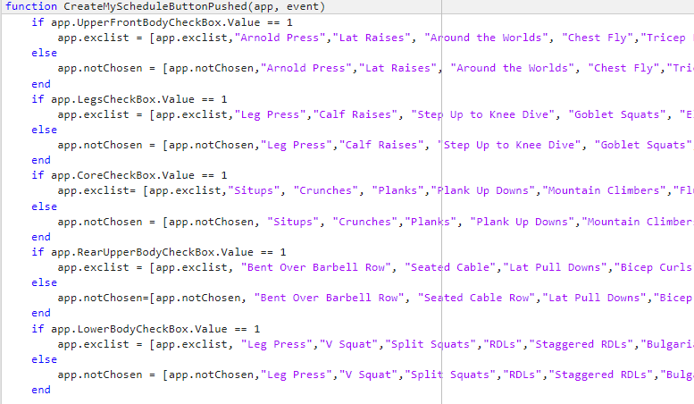

The code above is a portion of the CreateScheduleButtonPushed function. This specific part of the function creates contents of the app.exclist array by adding exercises based on the user’s selected muscle group(s). In addition, the function determines the contents for the app.notChosen array, which holds the exercises not chosen by the user to be used later to create the schedule. We chose to subdivide it in this way as we prioritized a focus on the muscle group, but wanted a schedule that would still work the whole body. In correspondence with one of our primary goals (safety), we wanted to encourage the ideology that it is important to exercise the whole body, not just focus groups. This is because full body focus increases critical aspects like bone strength, which is essential to preventing injury in a fitness schedule.

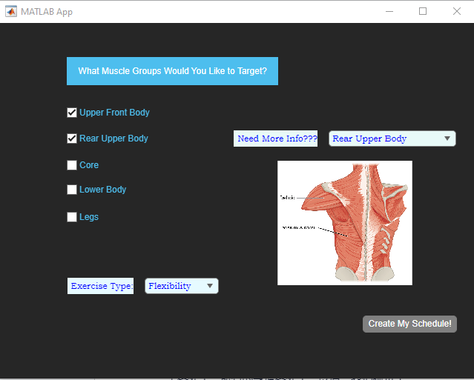

The first thing we coded was the initial interface, which is shown above. It was created to be visually appealing and highly efficient for the user. We created a drop-down menu using the app feature available in Matlab. The drop-down contains a list of the primary muscle groups that the user could choose. They are the upper rear body, upper front body, core, legs, and lower body. When a user selects a muscle group from the drop-down, a picture demonstrating the focus group on a human body will be just below the drop-down. This enables the user to determine which area they want to focus on, as some users may not know the specific names of the muscles they wish to focus on. The second function on the initial interface is a series of checkboxes. Each box corresponds to one of the focus groups previously listed: the upper rear body, upper front body, core, legs, and lower body. The user can select as many or few as they wish. Once they choose the set of boxes they wish, they continue to the final function, another drop-down. This drop-down asks the user to pick a primary focus for exercising from a list of four options. This allows the user to be given a plan that corresponds to their actual goals. The options listed are muscle recovery, muscle tone, beginner, and flexibility. This broad range of goals allows for a broad range of users to employ and enjoy this app. Once the user has selected one choice from this list of options, they can click a button that says “Create My Schedule!”. This button will open a second pop-up, which is the personalized schedule.

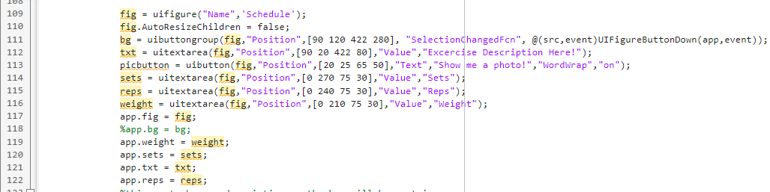

The schedule, shown above, was created using very efficient code. The schedule has seven columns, each corresponding to one day of the week. They are each labeled, and Sunday is always a rest day, highlighting one of the main goals of our program: safety. Active rest is a critical component of any exercise plan. Users should give their bodies time to rest and relax while advancing their fitness. Under every other day is a series of buttons, each labeled with a different exercise. Below the schedule is a large box used for exercise descriptions. This box is another critical element of our programming. One priority was that our program was accessible to many different types of users since many beginners in the gym may not know what a specific exercise is, having never performed it before. Our program gives a detailed description of every exercise that pops up when the user clicks on the box with the exercise written. We recognize that people having a large range of experience in the gym may wish to use a scheduling program, so we accounted for that as well, by modifying the amount of work the user has to do. To do this, we created three boxes to the left of the schedule. The first two display the amount of sets and repetitions to be done for each exercise. The third box shows the amount of weight the exercise should be performed with. If the exercise is done exclusively with body weight, “N/A” appears in the weight box. Each of these three amounts gets modified by both the users' goals and the specific exercise that they chose. This was difficult to code, but we considered the user specificity a must of our program. The schedule that the user is shown appears below!

To accumulate these descriptions, we spent a significant amount of time creating a document (linked under sources) that contains a description we wrote for each specific exercise and a specific amount of repetitions, sets, and weights for each user goal. While writing all of the descriptions, we made sure to emphasize form and safe repetitions.

To the left of the description box is a button that reads, “Show me a photo!” This button, when clicked, will display a photo demonstrating the exercise in question. This will help users understand the movement entirely since they will be shown a written and visual description.

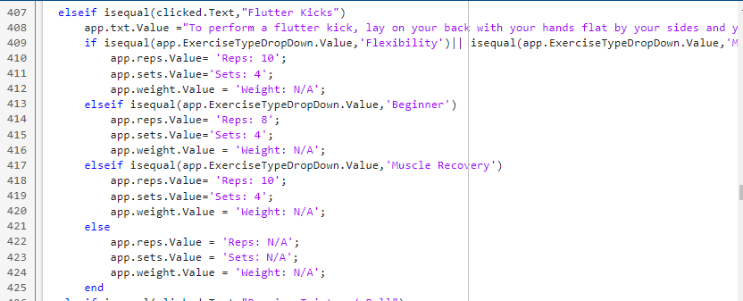

The above image depicts the section of the program that controls and changes the text value for the reps, sets, weight, and description box upon user input. Each text box corresponds to an exercise with repetition, set, and weight amounts based on the exercise type chosen. The description box allows for a more user-friendly experience as the user does not need previous knowledge of the exercises to perform them.

v.

As for future work, several small upgrades could be made to the programming that could improve it in the future. For example, we could add more exercises to our selection for more diversity for the user. As of now, we have added 36 exercises. We stuck to the more basic movements to remove complexity for the user, but as the user progressed, a greater array of options could be helpful for their exercise goals. We would also like to add videos that demonstrate the exercises to users. We feel like the pictures included should make it accessible for most users, but we hope an additional visual addition could increase usability for the user, especially if they are a beginner. One final upgrade that could be made is increased accessibility. The program is currently accessible to many, but widening the horizon of this program could make it even more so. We could do this by expanding the list of options for the users’ primary goals, potentially to other common restraints on exercise, such as limited mobility.

vi.

There was only one significant problem not accomplished during the span of our project. We would have liked to incorporate videos that demonstrated the exercises to users, but we were unable to. This is due to the many new files that would’ve had to be incorporated into our code. As it stands now, this would’ve been a problem due to a corresponding slower run time. We believe it could be done through the incorporation of a table to organize videos by exercise, allowing the computer to directly access the video file rather than having the code search through files trying to match names. This would allow us to add videos to our program while barely slowing run time. Given several more weeks, we believe it would have been accomplished, but in this time frame, we were unable to.

vii.

To run the code, simply download the zipped file that contains the code and images into a Matlab folder. Click run, and the program will begin!

The above information on running the code is also present in the attached README file!

viii.

**REFERENCES:**

<https://quiz.betterme.world/checkout-personalized-generated?order=5ef31986-4c6b-4a29-900d-78af6f391b24>

<https://www.nerdfitness.com/blog/how-to-determine-your-perfect-workout-plan/>

<https://www.helpguide.org/harvard/whats-the-best-exercise-plan-for-me.htm>

<https://www.shape.com/fitness/tips/how-order-exercises-gym-workouts>

<https://www.youtube.com/watch?v=iicwWgSqgSI&list=PLbCKIccGqrGqpO8F9vWSymX8vAlax1Ew9&index=2&pp=gAQBiAQB>

<https://docs.google.com/document/d/1WK73oPuMRMTZ4J3QItiRP1XZX9z4JYjkqjO1Rec0isI/edit>

[https://youtu.be/43NWZnVNA](https://youtu.be/43NWZnVNAvc)

<https://youtu.be/43NWZnVNAvc>

<https://youtu.be/dFeX4l13wh0>

<https://youtu.be/43NWZnVNAvc>

<https://youtu.be/X_zuWITrq88>

<https://youtu.be/Ww7PPdH7Ulg>

<https://youtu.be/gqrv3uBgcGM>

<https://youtu.be/LstV8oveFJ0>

<https://youtu.be/ximZfmqh2hI>

<https://youtu.be/LstV8oveFJ0>