HTTP (Hypertext Transfer Protocol) is an application protocol used for transmitting hypermedia documents, such as HTML files, over the World Wide Web. It's the foundation of data communication for the World Wide Web and defines how messages are formatted and transmitted, and how web servers and browsers should respond to various commands.

Here's an extensive overview of HTTP:

**1. Client-Server Model:** HTTP operates in a client-server model, where a client sends a request to a server, and the server responds with the requested resource. The client is typically a web browser, and the server is a web server such as Apache or Nginx.

**2. Stateless Protocol:** HTTP is stateless, meaning each request from a client to the server is treated independently. The server doesn't retain any information about previous requests from the same client.

**3. HTTP Methods:** HTTP defines several methods (also known as verbs) that indicate the desired action to be performed on a resource. Some common HTTP methods include:

- GET: Requests a representation of the specified resource. GET requests should only retrieve data and should not have any other effect.

- POST: Submits data to be processed to the server. Commonly used for submitting form data or uploading files.

- PUT: Uploads a representation of the specified resource. It replaces the current representation of the target resource with the uploaded content.

- DELETE: Deletes the specified resource.

- PATCH: Applies partial modifications to a resource.

**4. HTTP Status Codes:** HTTP responses include status codes that indicate the success, failure, or other state of the request. Some common status codes include:

- 200 OK: The request was successful.

- 404 Not Found: The requested resource could not be found.

- 500 Internal Server Error: Indicates a server-side error occurred while processing the request.

**5. HTTP Headers:** HTTP headers provide additional information about the request or response, such as the content type, **caching directives, and authentication credentials.**

**6**. URL Structure: URLs (Uniform Resource Locators) are used to specify the location of resources on the web. They consist of a protocol (such as HTTP), domain name, path, and optional query parameters.

**Example of a simple HTTP request:**



**Example of a simple HTTP response:**

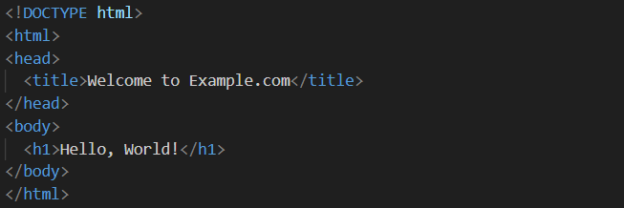

**In this example:**

- The client (browser) sends a GET request to retrieve the `index.html` file from `www.example.com`.

- The server responds with a status code of 200 OK, indicating that the request was successful, along with the HTML content of the `index.html` file.

Overall, HTTP is a crucial protocol for web communication, facilitating the exchange of information between clients and servers on the World Wide Web.