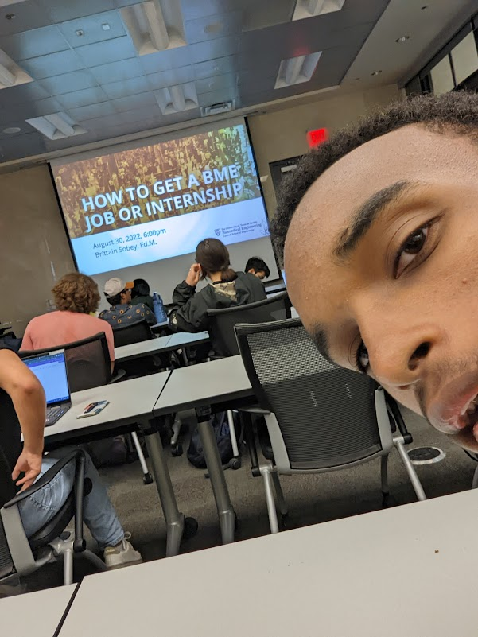

I attended the BME JOB/INTERNSHIP WORKSHOP on 8/30/22

This experience really opened my eyes on the versatility of the BME degree in the job sphere. Before, I already knew that having a BME degree didn’t mean that I would have to become a Biomedical Engineer by title, but I didn’t realize the extent of that. I was expected just jobs as other related engineering fields, but it looks like I neglected the legal sector (patent law), many of the more interpersonal jobs like marketing, and other professions like consultations. It really freed my mind from the pigeon-holed “engineering degree = engineering job” mindset.