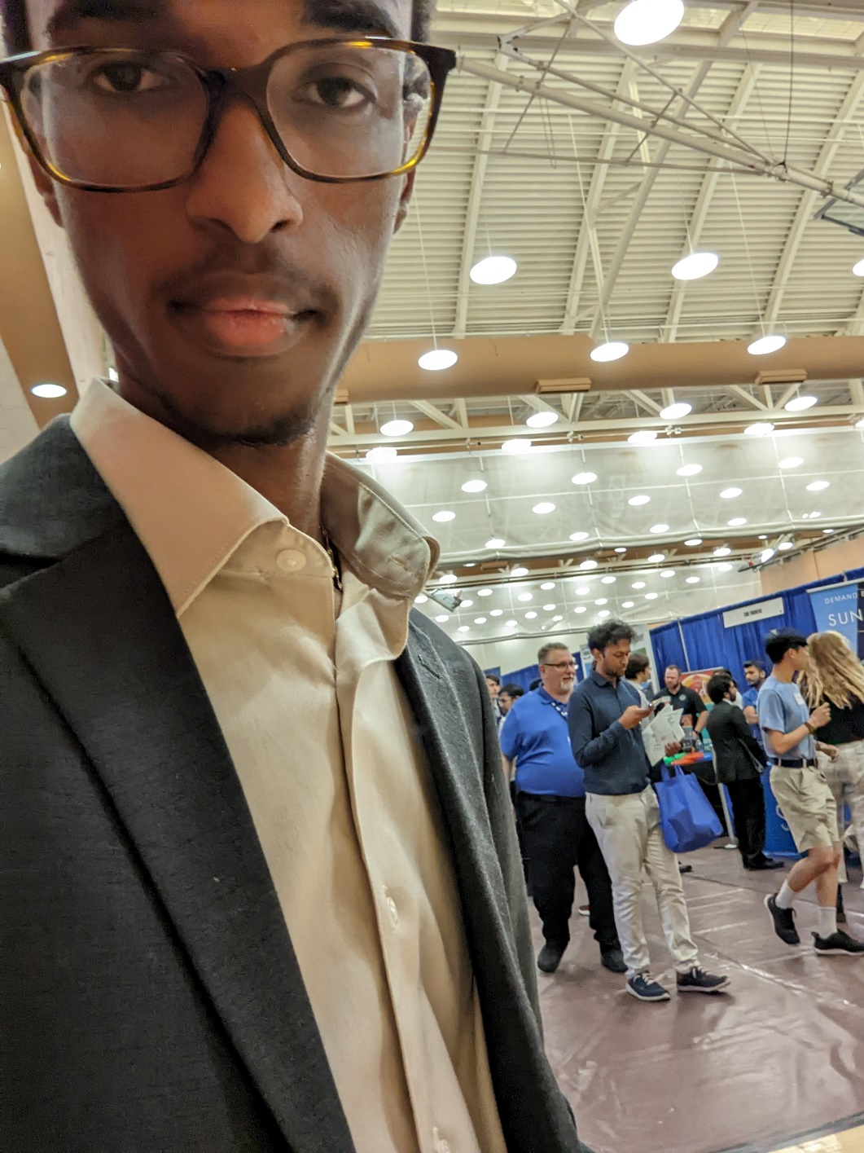

I attended the ENGINEERING EXPO on 9/8/22

This experience really helped boost my understanding of the industry. By coming to EXPO, I gained insight into what companies are really seeking in the engineering field; I had mostly research experience and by going to EXPO I was able to see what parts of my experience fill the roles that companies like TI or EPIC are seeking. I also got to work on my resume and marketing myself in preparation for EXPO, making it more viable for me to get into the industry. This experience also helped me get out of the idea of looking for a “BME” job and start considering adjacent fields like ECE jobs. Overall, EXPO gave me the “hands-on” experience that (although rough at times) was critical in providing me with a foothold into industry.