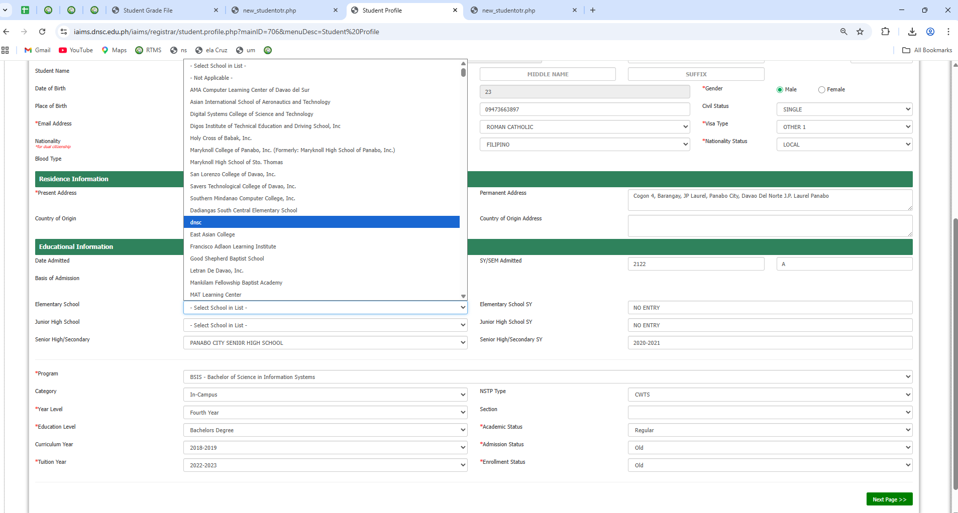
- Add “NO ENTRY” for Elementary in the Student Profile

- Add “NO ENTRY” for JHS in the Student Profile
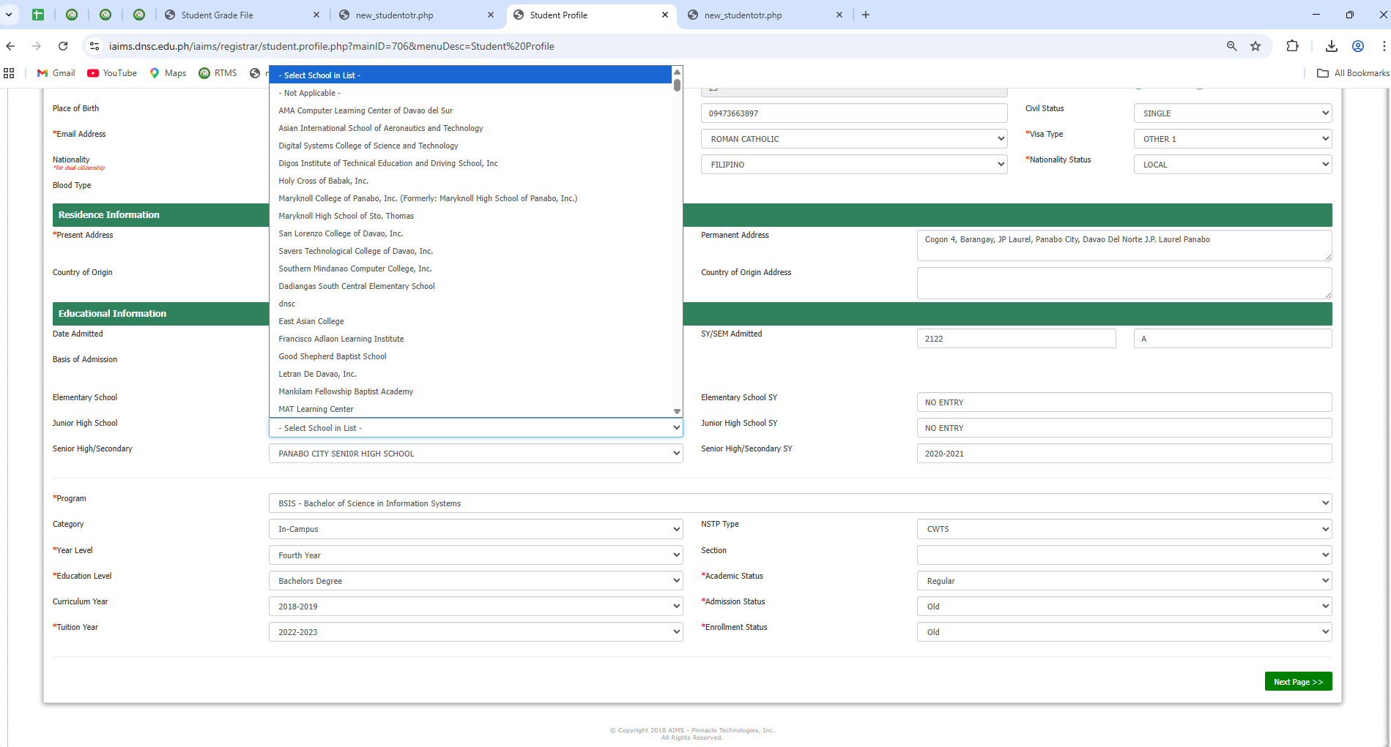

- Add “NO ENTRY” for SHS in the Student Profile
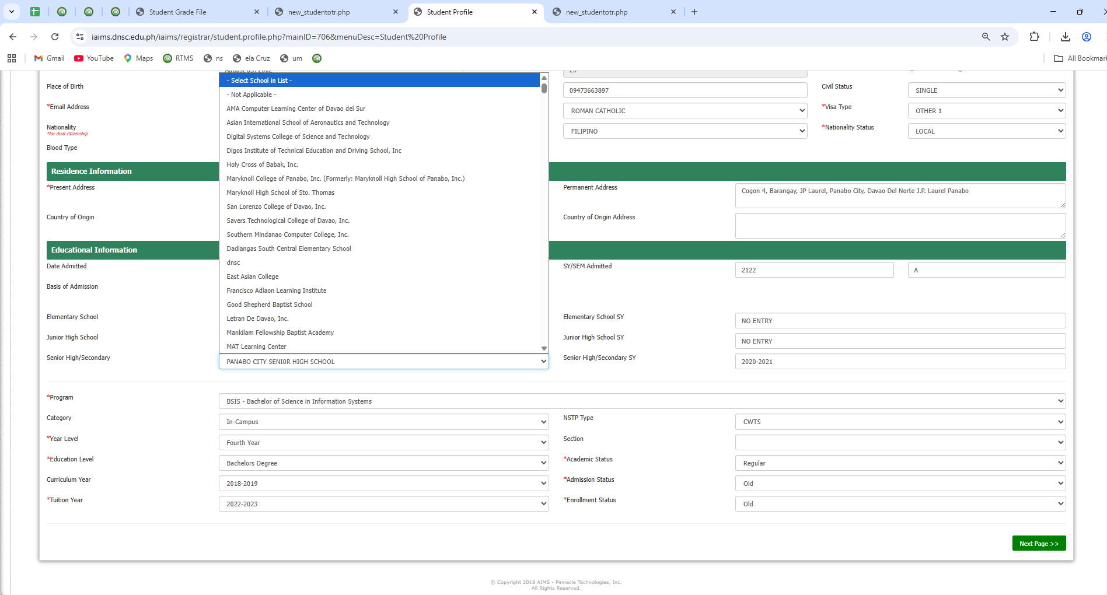

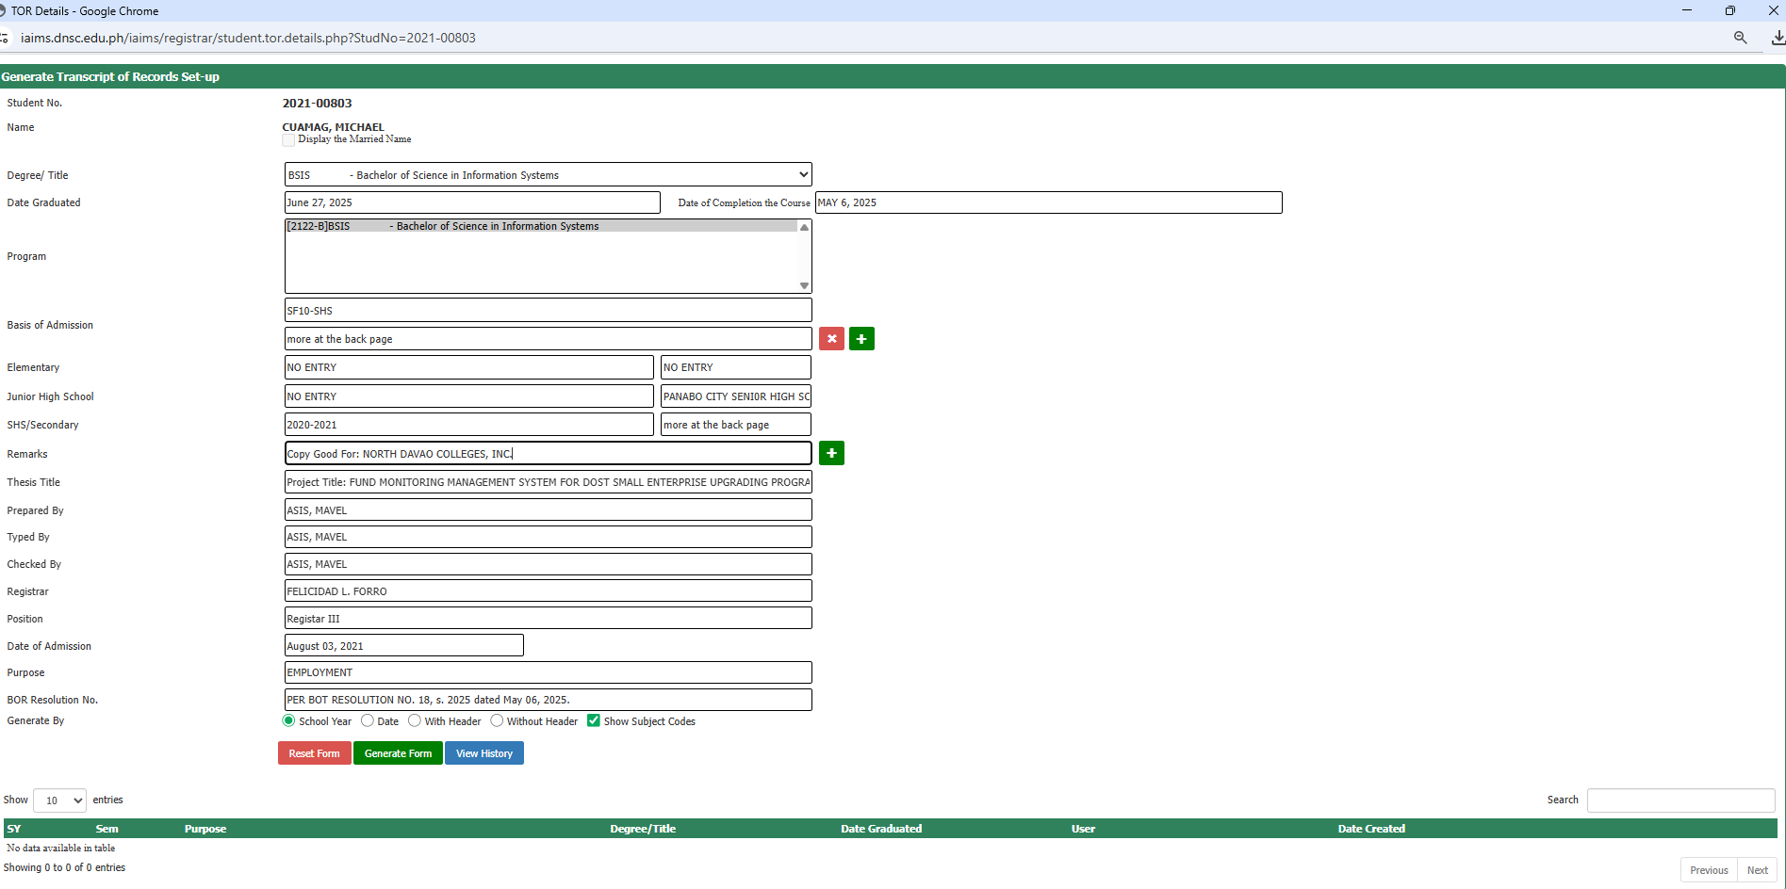

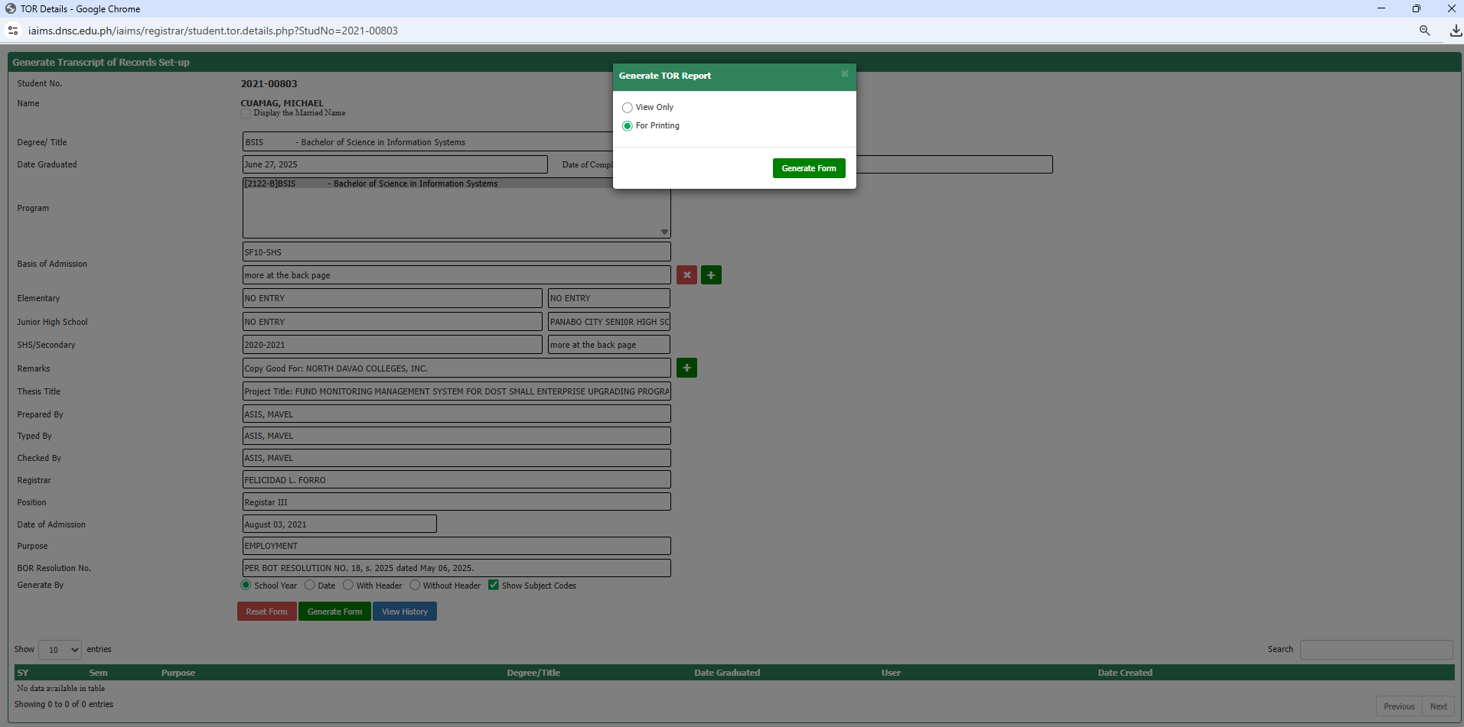

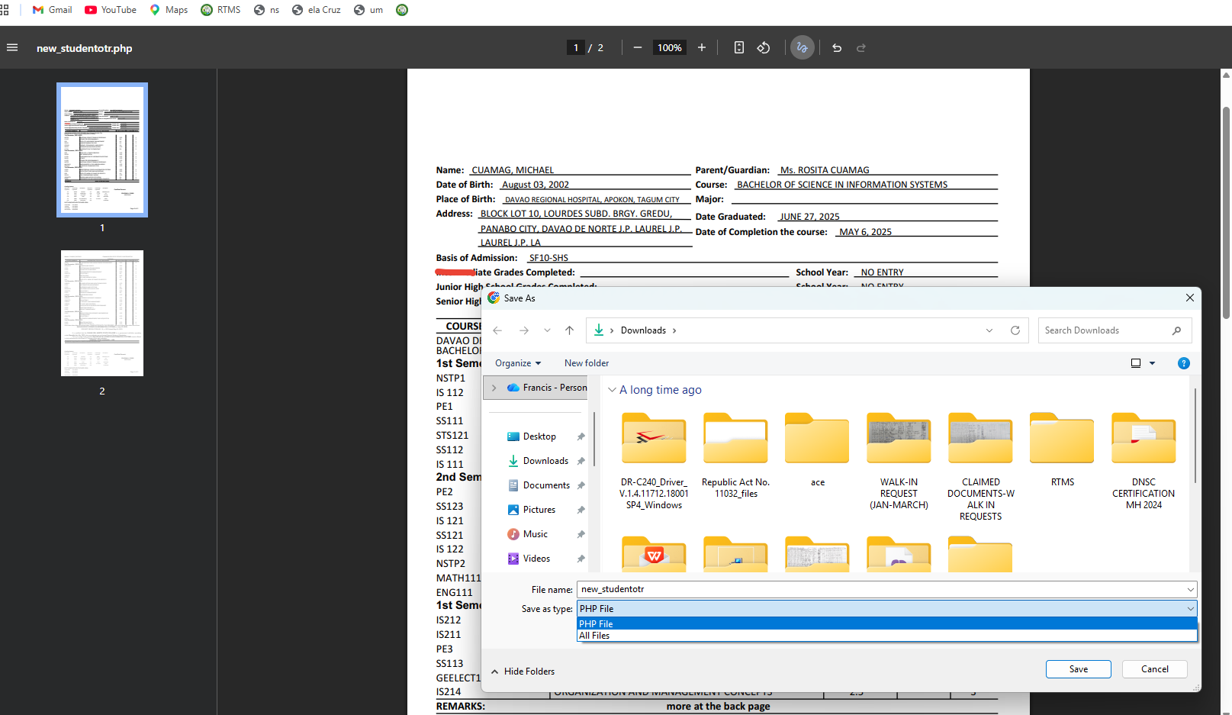
- Add “Word Document, PDF, and Excel” for Save as Type

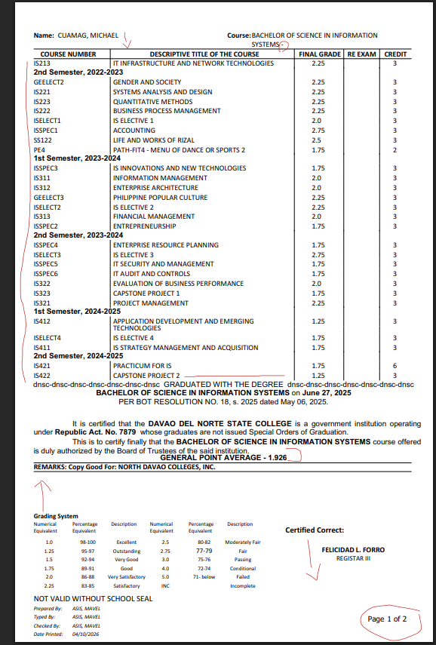
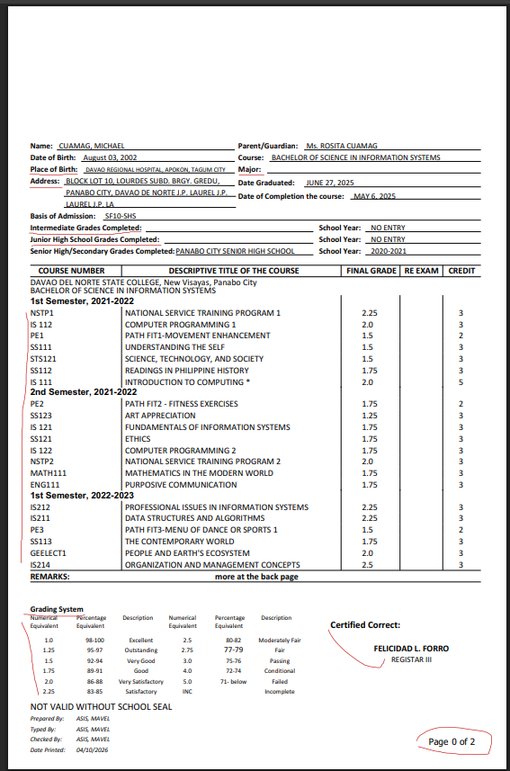
- PLACE OF BIRTH and ADDRESS should be in Sentence Case
- Major can be filtered
- Course number should be in alphabetical order
- Spacing for Grading System and Name of the College Registrar
- PAGE NUMBER should start in 1
- Thesis title should reflect
- Spacing in the Name and Course at the back page of TOR
- Spacing before GPA

- Sample of TOR manually encoded
