PLONN

White Paper

Executive Summary

PLONN is the first of its kind, integrated investment firm, delivering high Return on Investments (ROI) through two complementary strategies: a sophisticated sports-investment ensemble and a diversified equity/dividend portfolio. Utilizing proprietary machine learning models, applied data analytics, and disciplined risk management via the Kelly criterion, we generate consistent, high-ROI outcomes. In June 2025, PLONN’s Major League Baseball (MLB) strategy delivered +320% ROI; in July, PLONN’s MLB model achieved a 71%+ win rate on total-run predictions using a complex encoded rolling window neural network. For the 2025 National Basketball Association (NBA) season we invested over $2,330 ($10/day) and our models returned 32,943%

Market Opportunity

• Equities & Income: Global public markets exceed $100 trillion, offering dividend yields of 2–5% and long-term growth of 6–8% annually.  
• Sports Betting: A $200 billion annual handle forecast to grow 8% p.a., with NFL, NBA, and MLB markets presenting algorithmic inefficiencies.  
• Institutional Access: We democratize professional-grade analytics to accredited investors via subscription and AUM services.

Strategy Overview

1. Equity & Dividend Portfolio (e.g. 95% of Capital)
   * LLM-Powered Equity Models: NLP on news, earnings transcripts, and social signals identifies 3–12-month trends.
   * Dividend-Growth Selection: Screens for companies with 5+ years of dividend increases, stable cash flows, and low payout ratios.
   * ETF & Sector Rotation: Tactical shifts based on macroeconomic indicators and volatility targeting.
   * Risk Controls: Dynamic rebalancing, drawdown limits (max 8%), and sector diversification maintain portfolio stability.
2. Sport-Investing Portfolio (e.g. 5% of Capital)
   * MLB Model: Ensemble of gradient-boosted trees and neural networks, betting line moves, and applied statistics layers; Kelly-based sizing delivers +320% ROI in June.
   * NBA Model: A twin-vector multi-layer perceptron (MLP) predicts total points scored by both teams. One input vector encodes team-level features (pace, efficiency, home/away, injuries); the second encodes game-specific signals (recent form, back-to-back status, travel distance). The MLP merges these and outputs a probability distribution over total-points.
   * Kelly-Based Sizing: Tiered allocations (¼, ½, full Kelly) allow clients to choose low, moderate, or aggressive growth profiles, applying uniform risk controls across leagues.
   * Profit Reinvestment: Monthly sports profits can compound in the sport ensembles or flow back to equity capital, optimizing cross-asset growth. Equity and dividends can be reallocated into the sport ensembles

Performance Track Record

* **June 2025** (MLB):
  + Flipped top-Total_Run strategy
    - 21/28 wins → +320% ROI (full Kelly).
    - $2,000→$7,500 (Peaked at $9,900)
* **July 2025** (MLB):
  + Early 5/7 correct → 71% win rate
  + Projected ¼-Kelly growth of 300% $≥$
* **NBA 2025**:
  + Total winnings 2025 NBA season $≈\$773,000$
    - January 25th $25→$765,000 14-leg parlay predicted correct
    - 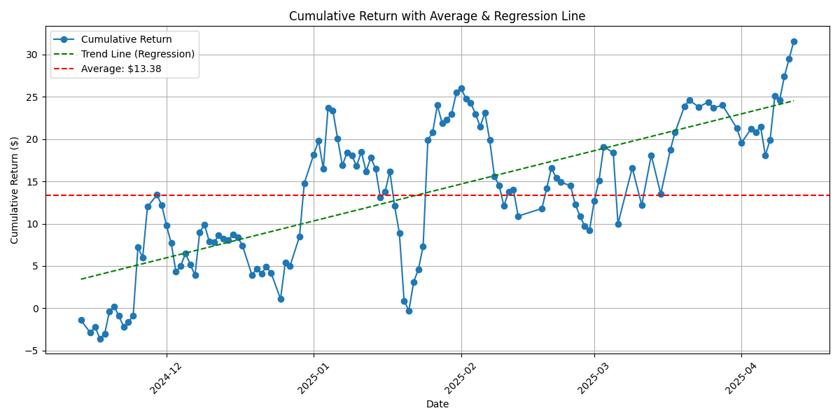**A graph with orange lines

      AI-generated content may be incorrect.**4 9-leg parlays $10→$3,300

Figure 1-MLB top-Total_Run Strategy: the yellow line shows the actual Half-Kelly allocation to the wins in June and the Bankroll each day in June (b) the Orange line is the projected Bankroll Growth for July using the Half-Kelly Criterion

Figure 2-NBA Cumulative return over the entire 2025 NBA season (a) Dotted Green line shows the linear increase in returns (b) The average return is about 133.8% over the season.

Risk Management & Position Sizing

We employ the Kelly criterion to optimize geometric growth while controlling risk:

| Profile | Kelly Fraction | Target Monthly ROI | Typical Drawdown |
| --- | --- | --- | --- |
| Low-Risk | ¼ Kelly (~10%) | 5–10% | ≤5% |
| Moderate-Risk | ½ Kelly (~20%) | 10–20% | ≤10% |
| Growth-Aggro | Full Kelly | 20–40% | ≤20% |

Fee & Profit Sharing

* Subscription: $39.99/month for daily bets and buy/sell signals across models.
* AUM Fees: 1% management + 30% performance on net profits.
  + 94% to data science and engineering teams.
  + 6% to CPA/Accounting, scaling to 10–15% based on thresholds.

Governance & Reporting

* Daily P&L statements, monthly performance reports, and daily discord updates ensure transparency.

Roadmap

* Q3 2026: Launch interactive investor dashboard; integrate dynamic portfolio allocation tools
* Q4 2026: Introduce NFL and international soccer models; deploy dividend reinvestment automation.
* Q1 2027: Enhance LLM-driven equity signals with alternative data (satellite, credit-card spending) and expand sports analytics into college leagues.

Conclusion

By combining a robust equity/dividend framework with high-conviction MLB and NBA models under strict risk management, we offer a diversified, repeatable path to success. Our transparent fee model, professional governance, and proven track record invite accredited investors to partner in this innovative, data-driven investment approach.