HW2 Submission: https://github.com/gih6/Docker

1. Github:
2. URL for Docker Image: <https://hub.docker.com/repository/docker/gih6/hwtwo> & Screenshots of creation:

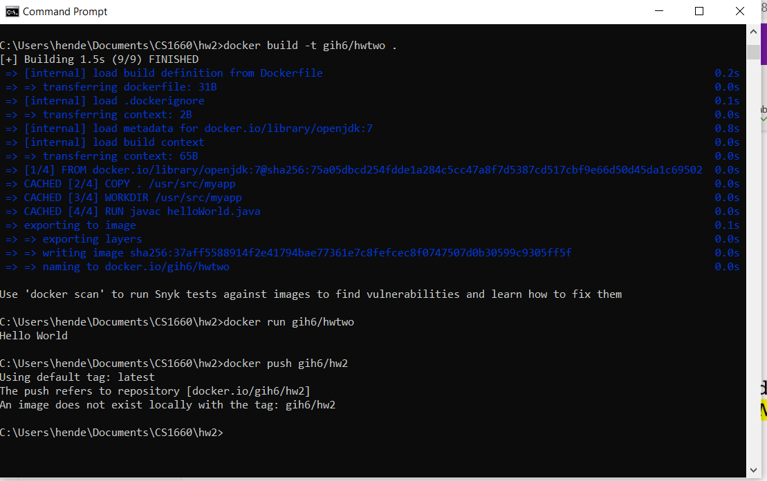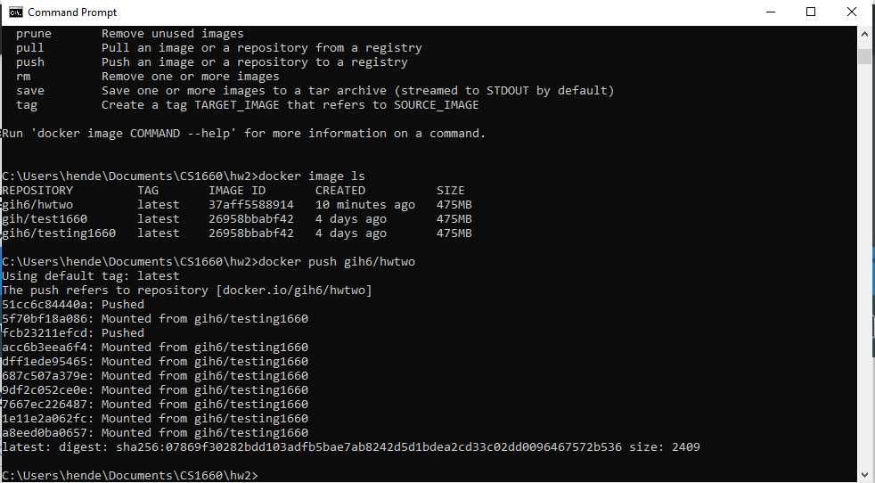

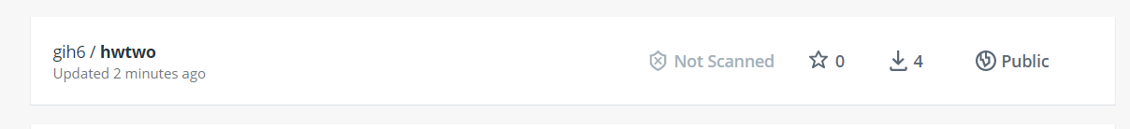

1. Screenshot of execution of docker on GCP showing “Hello World” message on console. Show command used to run container on GCP and the output and the cluster name

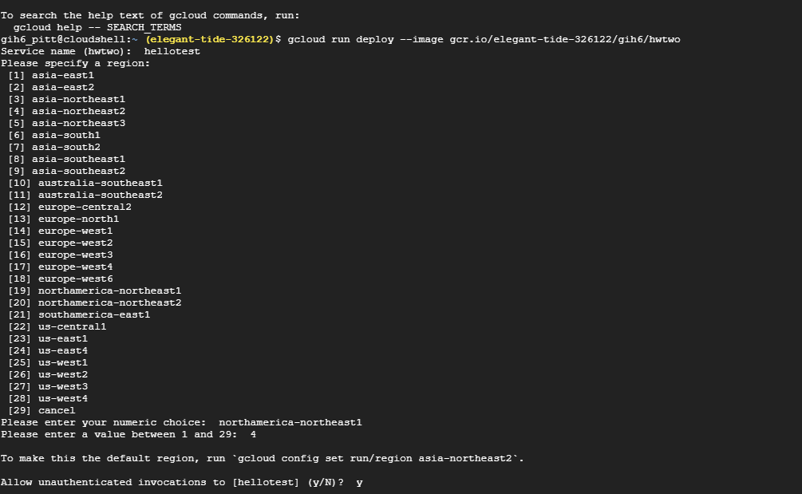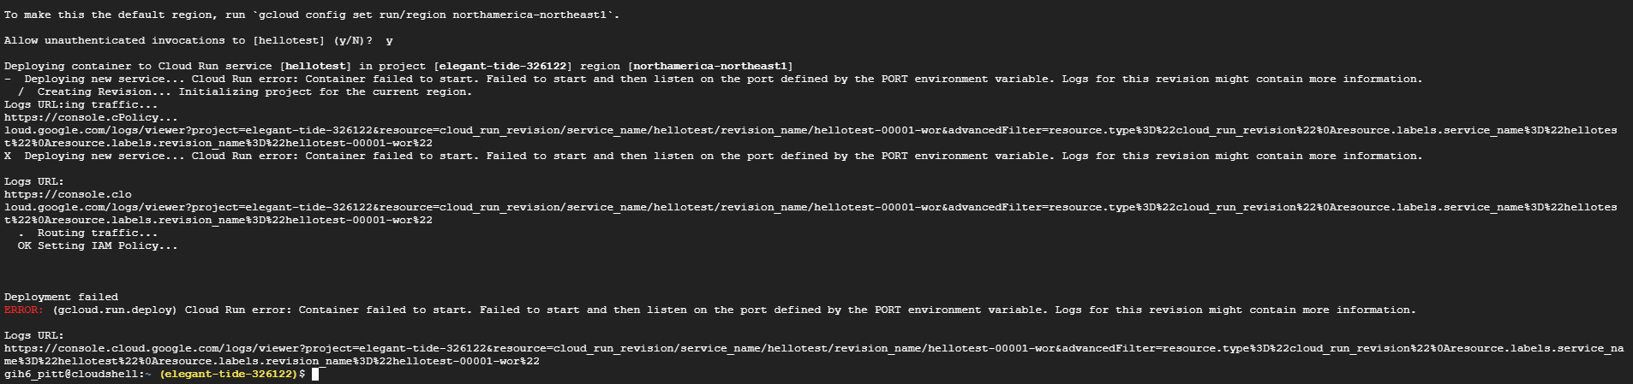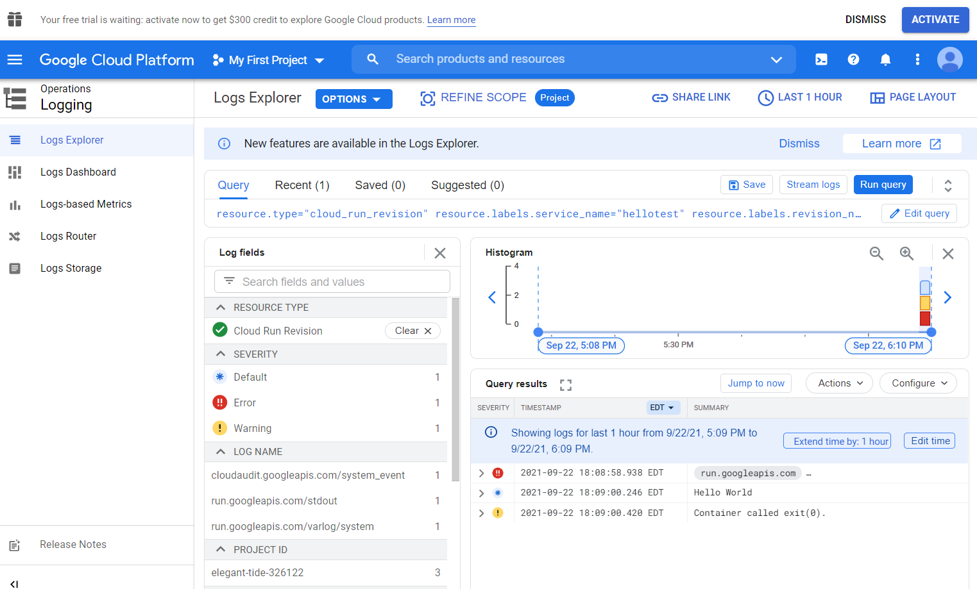

1. Docker File Contents:

1. Source Code Contents:

Part 2: Downloading and running Jupityr Notebook:

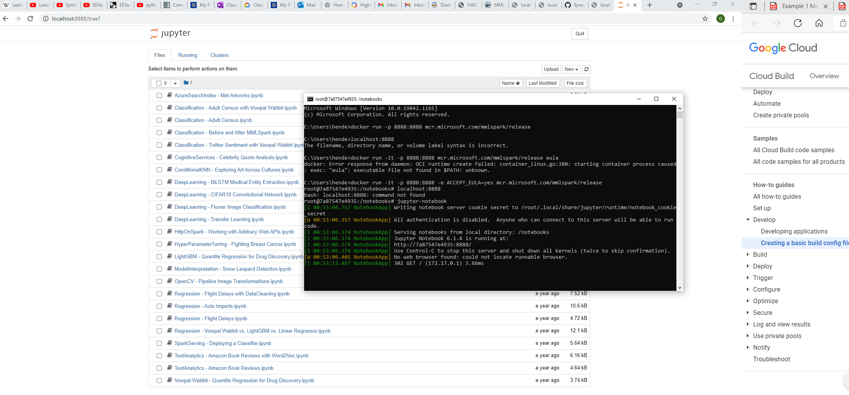

Extra Credit:

