EE387 – LAB 01

G. C. JAYATILAKA
E/14/158
SEMESTER 06
13-11-2018

PART 1: Basic Signal Representation in MATLAB

1. Write a Matlab program and necessary functions to generate the following signal:
y(t) = r(t+3) – 2r(t+1) +3r(t) – u(t-3)

ramp.m
function y = ramp( t, m, ad )
% t : length of time
% m : slope of the ramp function
% ad: advance (positive), delay (negative) factor
y = max(t+ad,0);
y = y*m;

end

ustep.m
function y = ustep( t,ad)
% ad: advance (positive), delay (negative) factor
y = (t+ad) >= 0 ;

end

Part1.m

clear all;
close all;
clc;

Ts=0.01; %Sampling time
t=-5:Ts:5; %Time vector

y1=ramp(t,3,3);
y2=ramp(t,-6,1);
y3=ramp(t,3,0);
y4=ustep(t,-3);

y=y1 - 2*y2 + 3*y3 - y4;

plot(t,y,'k');
axis([-5,5,-1,7]);
grid;
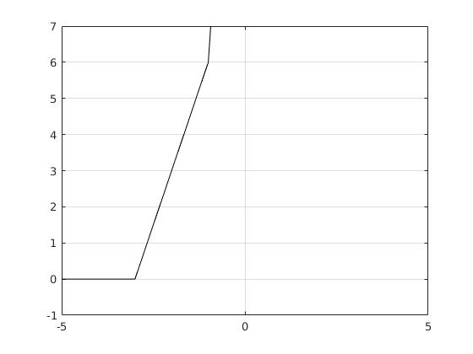

Elementary signal operations

DampedSignal.m
clear all;
close all;
clc;

Ts=0.01; %Sampling time
t=-5:Ts:5; %Time vector

x= 3 * exp(-1*t) .* cos(4*pi*t);
envelope= 3 * exp(-1*t);

figure;
hold on;
plot(t,x);
plot(t, envelope);
plot(t, -1*envelope);
title('A damped signal');
xlabel('t');
ylabel('x(t)');
grid

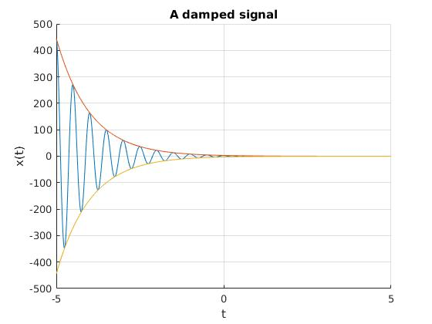

PART 2: Time-Domain Convolution and elementary signal operations

Q: Are there any disadvantages if a high sampling frequency is used?
Yes. The disadvantages are.
1. More computation power will be required for processing
2. Higher sampling frequencies require hardware (sensors, ADC units etc:) that can work with higher clocks. These units are usually expensive.

rect.m
function x = rect( t )
x = abs(t) <= 0.5 ;
end

Part2.m
clear all;
close all;
clc;

Ts=0.01; %Sampling time
t=-5:Ts:5; %Time vector

x1=rect(t);
x2 = rect(t-1);
x3 = rect(t/2);
x4 = rect(t) + (1/2)*rect(t-1);
x5 = rect(-t) + (1/2)*rect(-t-1);
x6 = rect(1-t)+ (1/2)*rect(-t);

subplot(3,2,1);
plot(t,x1) ;
axis( [-2 2 -1 2]);
xlabel( 'time (sec)' );
ylabel('x_1(t) = rect(t)');

subplot(3,2,2);
plot(t,x2);
axis( [-2 2 -1 2]);
xlabel( 'time (sec)' );
ylabel('x_2(t) = x_1(t-1)');

subplot(3,2,3);
plot(t,x3);
axis( [-2 2 -1 2]);
xlabel( 'time (sec)' );
ylabel('x_3(t) = x_1(t/2)');

subplot(3,2,4);
plot(t,x4);
axis( [-2 2 -1 2]);
xlabel( 'time (sec)' );
ylabel('x_4(t) = x_1(t) + 0.5*x_1(t-1) ');

subplot(3,2,5);
plot(t,x5);
axis( [-2 2 -1 2]);
xlabel( 'time (sec)' );
ylabel('x_5(t) = x_4(-t)');

subplot(3,2,6);
plot(t,x6);
axis( [-2 2 -1 2]);
xlabel( 'time (sec)' );
ylabel('x_5(t) = x_4(-t)');
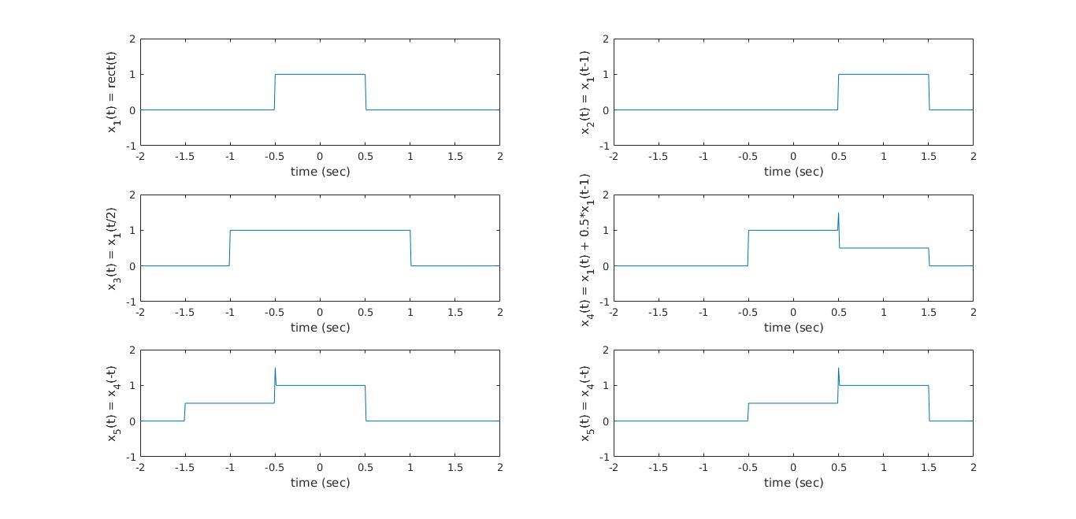

Convolution
ConvolutionExample.m
clear all;
close all;
clc;

Ts=0.01; %Sampling time
t=-5:Ts:5; %Time vector

x1=rect(t);
y=conv(x1,x1);

try
plot(t,y)
catch
disp('The dimensions do not match for t and y');
end

t_y=-10:Ts:10;

%plot(t_y,y);

y1 = Ts* conv(x1,x1);
plot(t_y, y1);
axis( [-2 2 -1 2] ) ;
xlabel( 'time (sec)');
ylabel('y_1(t)');
title('Figure : y_1(t) = x_1(t)*x_1(t)');
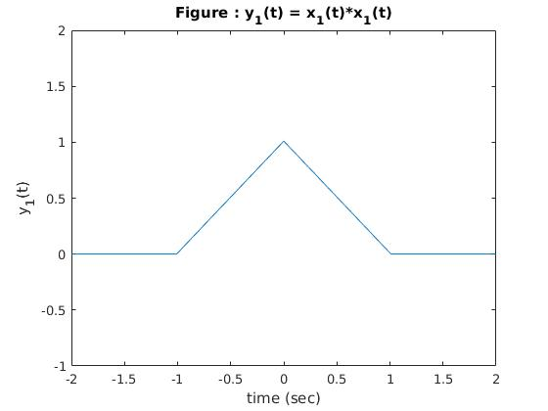

Exercise 01
Ex01.m
clear all;
close all;
clc;

x1=[1,2,4];
h1=[1,1,1,1,1];
y1=conv(x1,h1);

x2=1:5;
h2=1;
y2=conv(x2,h2);

x3=[1,2,0,2,1];
h3=x3;
y3=conv(x3,h3);

%>>>>>>>> Plot the set (1) of graphs
subplot(3,3,1)
stem(x1)
title('x_1(n)');
grid

subplot(3,3,4)
stem(h1)
title('h_1(n)');
grid

subplot(3,3,7)
stem(y1)
title('y_1(n) = x_1(n)*h_1(n)');
grid

%>>>>>>>> Plot the set (2) of graphs
subplot(3,3,2)
stem(x2)
title('x_2(n)');
grid

subplot(3,3,5)
stem(h2)
title('h_2(n)');
grid

subplot(3,3,8)
stem(y2)
title('y_2(n) = x_2(n)*h_2(n)');
grid

%>>>>>>>> Plot the set (3) of graphs
subplot(3,3,3)
stem(x3)
title('x_3(n)');
grid

subplot(3,3,6)
stem(h3)
title('h_3(n)');
grid

subplot(3,3,9)
stem(y3)
title('y_3(n) = x_3(n)*h_3(n)');
grid

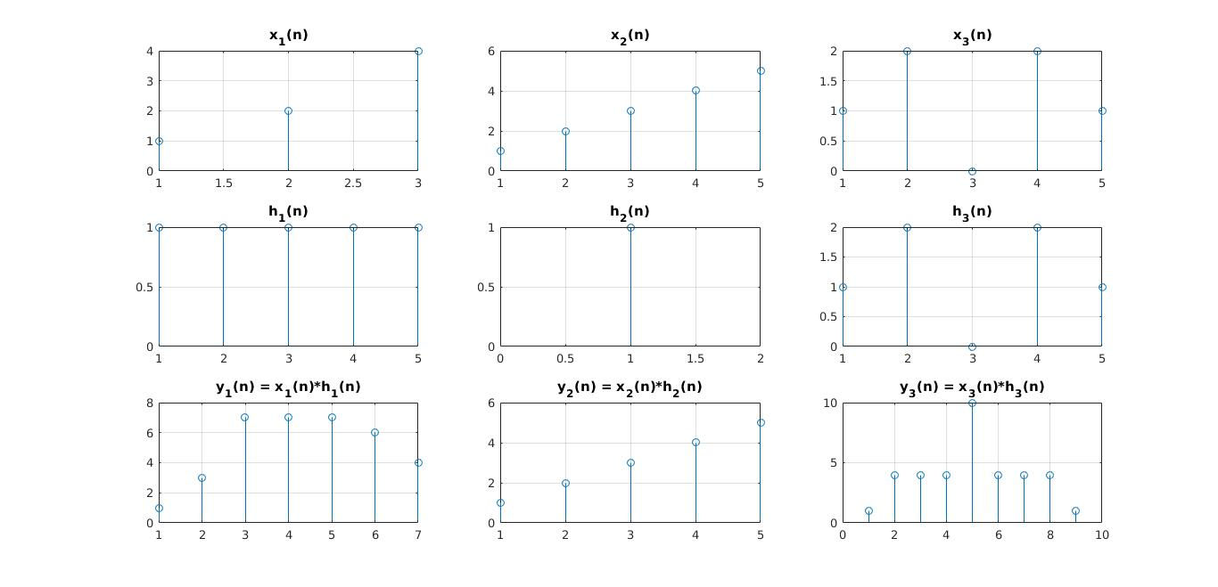

Exercise 02
Ex02.m
clear all;
close all;
clc;
% [Q,R] = deconv(B,A)
% B = conv(A,Q) + R.

n=0:3;
h=0.5.^n;

y=[1, 2, 2.5, 3, 3, 3, 2, 1, 0, 0, 0, 0, 0, 0, 0, 0 ];

[x,R]=deconv(y,h);

figure

subplot(3,1,1);
stem(h);
title('Impulse response');
xlabel('n');
ylabel('h(n)');

subplot(3,1,2);
stem(y);
title('Output');
xlabel('n');
ylabel('y(n)');

subplot(3,1,3);
stem(x);
title('Input');
xlabel('n');
ylabel('x(n)');
