Analysis Report Template

Student Full Name | K.G.G.P.Bimsara | Student ID No. | 20241253 / w2149602
Case Study Title
Case Study (A): Predicting Clients Loan Status. [Total 43 Marks]
Research Question: Does machine learning have the potential to assist banker and finance analysts in predicting which client can be approved a loan?

Task (1) – Domain Understanding: Classification
The financial risk analysts decided that classification modelling is required. Indicate in the table below for each of the listed
variables in your data which ones you should RETAIN and can be included in the classification modelling of loan approval status, and the variables you should DROP (REMOVE). Justify your decision logically and/or by research (for any research, include in-text citation using
the Harvard style) [3 Marks]
Variable Name | RETAIN or DROP | Brief justification for retention or dropping with in-text citation.
ID | Drop | It's just a random number for each client. Keeping it will just  cause the model to overfit.
Sex | Drop | This is not even in the csv file we got. Plus, using gender for  loans is not allowed anyway.
Age | Retain | Older people usually have more stable jobs, so it helps  Predict if they can pay back .
Education Qualifications | Drop | Not in the csv dataset.
Income | Retain | We need to know how much they earn to see if they can afford  paying the bank back.
Home Ownership | Retain | People who own a house are usually less risky than people  who rent.
Employment Length | Retain | Knowing how long they had their job shows if their income is  actually stable.
Loan Intent | Retain | Borrowing for medical stuff is different risk level than  borrowing for a business.
Loan Amount | Retain | Bigger loans are obviously harder to pay back.
Loan Interest Rate | Retain | High interest makes the monthly payment bigger, meaning  they might fail to pay it.
Loan-to-Income Ratio (LTI) | Retain | Standard check to see if the loan is way too big compared to  their salary.
Payment Default on File | Retain | If they failed to pay a loan before, they will probably do it  again.
Credit History Length | Retain | Shows how long they have been using credit. Longer history  means more proof they pay things off.
Loan Approval Status | Retain | This is the target label (y) we are trying to predict for the  classification tasks.
Maximum Loan Amount | Drop | This is the target for notebook 3. Keeping it here would cause  data leakage and ruin the models.
Credit Application Acceptance | Drop | This is in the coursework file but missing from the actual csv  data.
References
Hastie, T., Tibshirani, R. and Friedman, J., 2009. An introduction to statistical learning.
Provost and Fawcett, 2013.

Task (2) – Exploring and Understanding Your Dataset
With the aid of your Final Python Notebook 1, for your RETAINED input variables and your class “Target” variable, produce 1)basic descriptive stats and 2)variable scale type, then 3)plot the distribution of your target variable. (Paste the three screenshots of code OUTPUTS ONLY for evidence of these elements).
[2 Marks]

1)basic descriptive stats

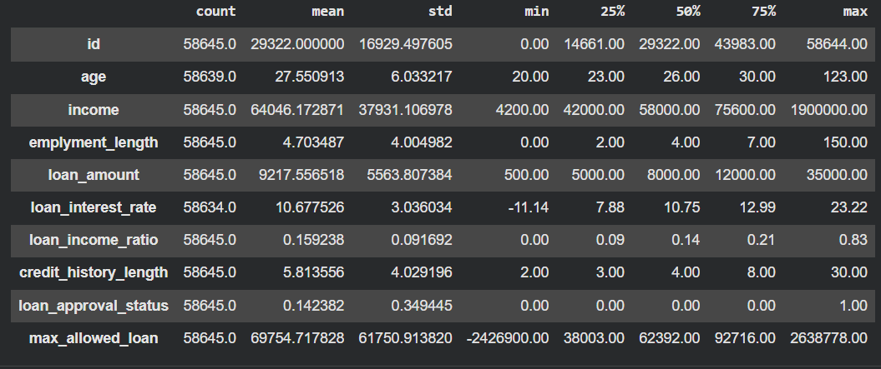

2)variable scale type
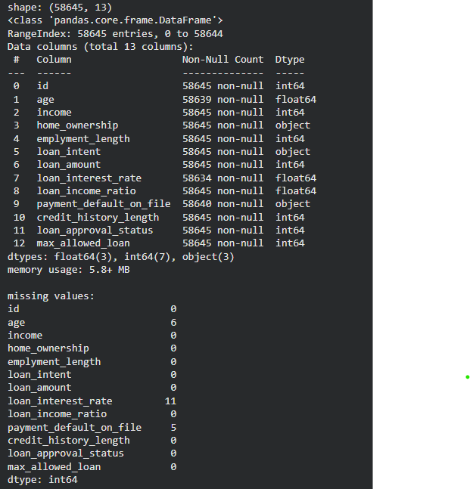

3)plot the distribution of your target variable.

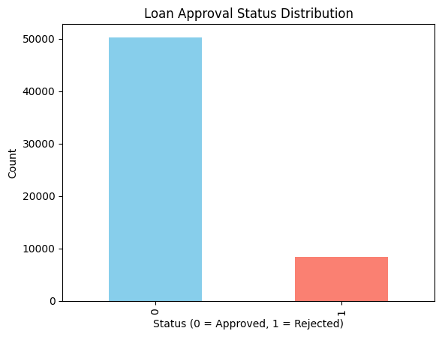
Task (3) – Data Preparation: Cleaning and Transforming your data
a) With the aid of your Final Python Notebook 1, when you first explored your retained variables in the loan dataset, you may have found some issues. 1) Report any issues you found in your retained dataset variables. Based on the issues you found in your data, 2)suggest a suitable possible method to fix each of these issues and 3)provide your justification for using your suggested fix method. Use the table below to organise your findings and analysis, and add more rows if needed
[4 Marks]
 | Variable Name | Issue found | Proposed fix | Justification for used fix method
1 | age | Missing values (6 missing) | Replace missing values with the median | Using the median prevents extreme outliers from messing up the average (like if someone accidentally typed age 150).
2 | loan_interest_rate | Missing values (11 missing) | Replace missing values with the median. | Same as age, median is safer than mean because it ignores crazy high or low interest rates.
3 | payment_default_on_file | Missing values (5 missing) | Replace missing values with the mode (most frequent). | Since this is a text category (Yes/No), we can't use an average. Using the most common answer is the safest guess.
4 | id | Irrelevant variable | Drop column | Does not need for prediction
5 | max_allowed_loan | Negative values | Remove invalid rows | Negatives are not realistic

Task (3) – Data Preparation: Cleaning and Transforming your data
b) With the aid of Python packages and your Final Python Notebook 1, implement your suggested fixes of issues in the previous Task 3-a in your final Python Notebook1.
1) Show evidence (before and after) of implementing your suggested fix to the problems you identified for your dataset in Task 3-a.
To show your evidence, paste screenshots of your relevant code OUTPUTS ONLY (Do not paste the code).
2) Indicate and annotate the issue and the fix in each of your provided evidence screenshots.
[4 Marks]
Output screenshot of the issue before the fix | Output screenshot after fixing the issue
Issue – Missing values are found in couple variables | Solution – Missing values are handled using mean and mode
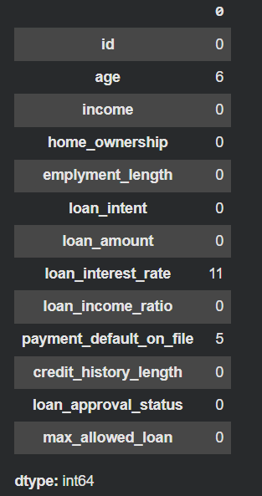 | 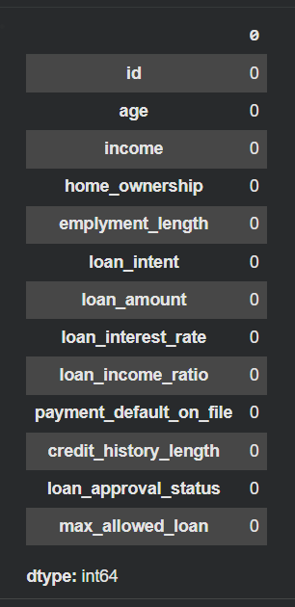

Output screenshot of the issue before the fix | Output screenshot after fixing the issue
Issue – invalid negative values found | Solution - Rows with negative values removed form the dataset
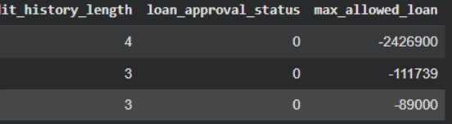 | 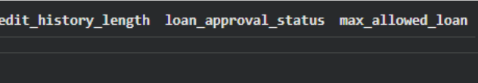

Task (4) – Classification Modelling of Clients Loan Approval Status
a) In your Final Python Notebook 2, you built THREE different models to predict loan approval status: Logistic Regression (LR), K Nearest Neighbour (KNN) and Naïve Bayes (NB). These algorithms are a mix of parametric and non-parametric algorithms.
1) Note down the type of each algorithm (parametric vs non-parametric),
2) name any learnable parameters, and
3) list any strategic hyperparameters for each algorithm which you want to consider tuning. Organise your answer in the table below:
[3 Marks]
Algorithm Name | Algorithm Type | Learnable Parameters | Some Strategic Hyperparameters
Naïve Bayes (NB) | Parametric | It calculates and learns the mean and variance for each feature in the training data, plus the class probabilities. | We can tune var_smoothing to help the model deal with features that have zero variance.
Logistic Regression (LR) | Parametric | It learns the feature weights (coefficients) and the intercept (bias) to draw the best decision boundary. | We can tune C (regularisation strength) and solver (the algorithm it uses to optimise).
K-Nearest Neighbour (KNN) | Non-parametric | None. It is a "lazy learner" so it doesn't learn any mathematical equations, it just memorises the entire training dataset. | We can tune n_neighbors (which is K) and the weights (uniform vs distance).

Task (4) – Classification Modelling of Clients Loan Approval Status
b) With the aid of your Final Python Notebook 2, use the training–test split approach with your retained applicable input features only and the target output feature to build your predictive classification models.
[3 Marks]
i. Screenshot
1) the list of all feature names used for building your classification models and the corresponding
2) data shape function output. (Paste screenshots of the relevant code output only; do not paste the Python code).

1.

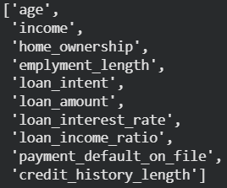

2.

ii. In less than 150 words, research and justify (defend) your choice of the training-test split ratio and provide an in-text citation.

An 80/20 train-test split is used because it is the industry standard baseline for medium-sized datasets. Giving the model 80% of the data (about 46,000 rows) ensures it has plenty of historical examples to learn the patterns of loan approvals and rejections. Reserving the remaining 20% creates a completely unseen, unbiased test set that is still large enough (almost 12,000 rows) to give a highly reliable evaluation of real-world performance
References

iii. Provide as evidence the code block line and code output from your Final Python Notebook 2 that ensures two conditions:
1) all your models were tested on the same test instances (clients) in your dataset;
2) the labels ratio of approval Status “Accept” to “Reject” is the same in the training and test subsets.
3) State the training-test split function parameters in your code line that are responsible for meeting both conditions.
4) In less than 150 words, research and justify (defend) your decision to implement both conditions in your Python Notebook 2 notebook with in-text citations where possible.

1.Code

# 80/20 train test split
X_train, X_test, y_train, y_test = train_test_split(X, y, test_size=0.2, random_state=42, stratify=y)

2.Output

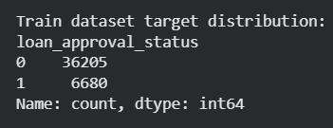

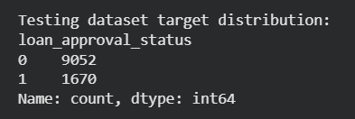

3.Parameters

• test_size = 0.2 • random_state = 42 • stratify = y
References with in-text citation
Task (5) – Evaluating your Loan Approval Status Classification Models
Your finance team provided the following success criteria to guide you when evaluating and selecting your best model: “When evaluating your model's performance, which addresses your first research question (a). The model is expected to misclassify clients’ applications. Thus, the model should aim to predict as many “Reject” status for clients as many as possible to decrease the risk of future defaulted loan payments. However, the model should demonstrate that its high “Reject” prediction rate is mainly due to a larger number of correctly detected (predicted) rejected loan applications.”

a) With the aid of Final Python Notebook 2, for each of your models (Logistic Regression LR, Naive Bayes NB and K-Nearest Neighbours KNN)
1) paste the test confusion matrix,
2) the classification report and
3) the AUC-ROC curve graphs
as screenshots from the output of your Python code.
[3 Marks]

1) Screenshot of the test confusion matrix for (NB, LR, and KNN); make sure you title each matrix with its algorithm name

NB | LR
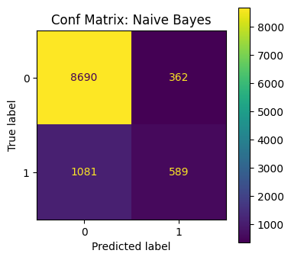 | 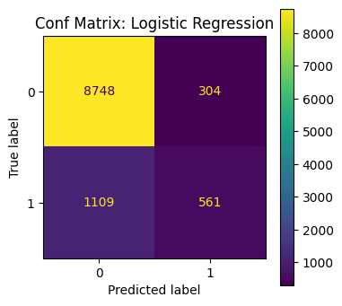

KNN

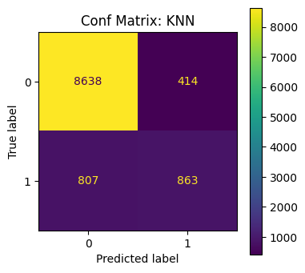

2) Screenshot of the classification report for (NB, LR, and KNN); make sure you title each classification report with its algorithm name

NB
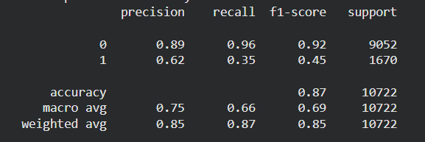
LR
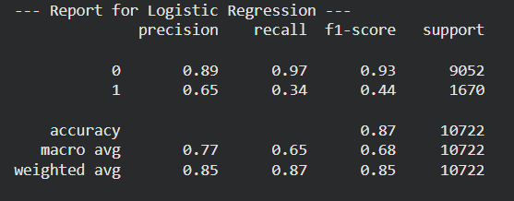
KNN
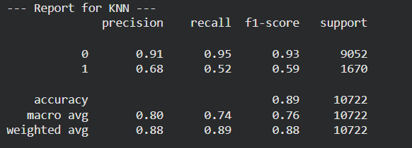

3) Screenshot of the AUC-ROC Curve for (NB, LR, and KNN); make sure you title each graph with its algorithm name

NB | LR
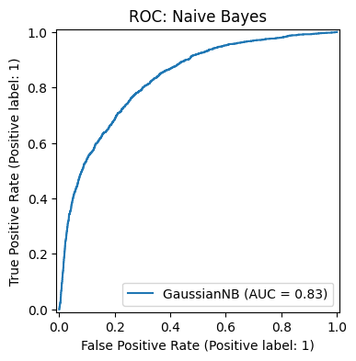 | 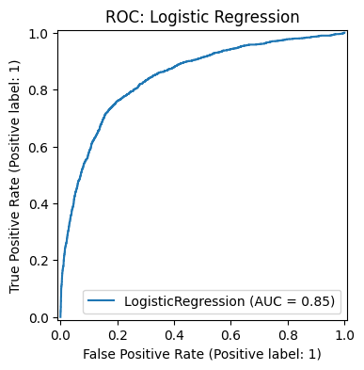

KNN

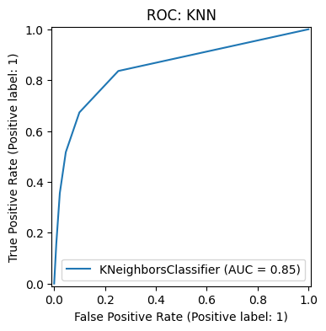

Task (5) – Evaluating your Loan Approval Status Classification Models
b) Five different classification evaluation metrics are calculated in your Final Python Notebook 2.
1) State which evaluation metric/metrics to “USE or “DO NOT USE” to closely interpret the above success criteria.
2) For justification, explain how closely your choice of “USE” or “DO NOT USE” for a metric interprets the given success criteria.
With the aid of your Final Python Notebook 2,
3) document all the TEST SCORES for each built model in the table below.
[7 Marks]
Metric | 1) USE or DO NOT USE | 2) Justification for choosing “USING” or “NOT USING” this metric in relation to the success criteria | Model | 3) Metric Test Score
Accuracy | DO NOT USE | Ignores the main goal of detecting rejected loans. | NB
 |  |  | LR
 |  |  | KNN (k=?)
Recall | USE | Measures if the model successfully catches as many rejected loans as possible. | NB | 0.35
 |  |  | LR | 0.34
 |  |  | KNN (k=5) | 0.89
Precision | USE | Ensures the predicted rejected loans are actually correct. | NB | 0.62
 |  |  | LR | 0.65
 |  |  | KNN (k=?) | 0.68
F1-score | USE | Balances catching rejects with keeping predictions accurate | NB | 0.45
 |  |  | LR | 0.44
 |  |  | KNN (k=?) | 0.59
AUC-Roc | USE | Measures the overall performance of separating approved from rejected loans. | NB | 0.83
 |  |  | LR | 0.85
 |  |  | KNN (k=?) | 0.85

Task (5) – Evaluating your Loan Approval Status Classification Models
c) Suggest a single best approval status classification model based on the ‘USED’ performance metrics scores you identified in Task (5-b). In less than 100 words, briefly describe how well your best model satisfies the needs of your finance team.
[2 Marks]
Based on the evaluation metrics, the KNN model is clearly the best single classifier. The KNN model achieved the highest Recall score of 0.89, completely outperforming Naive Bayes and Logistic Regression. Because the finance team’s primary success criterion is to detect and predict as many "Reject" status loans as possible to decrease future financial risk, the KNN model best satisfies this need by successfully catching 89% of all actual risky loans. It also maintains the highest precision (0.68), proving the high rejection boundary comes from genuinely risky clients rather than random guessing.

Task (5) – Evaluating your Loan Approval Status Classification Models
d) To enhance your selected best model/s performance (from Task 5-c), tune some of its possible hyperparameters, which you indicated in Task (4-a) for that specific algorithm. With the aid of Final Python Notebook 2, Re-train and test the best algorithm again with GridSearchCV
[5 Marks]
i. With the aid of your Final Python Notebook 2,
1) Paste into this report the line of code which shows evidence of specifying a parameters grid and applying the GridSearchCV function to rebuild your selected best model.
2) Then, document the estimated best hyperparameters for the optimised model.

# specific params to tune for knn
param_grid = {
'n_neighbors': [3, 5, 7, 9],
'weights': ['uniform', 'distance']
}

# run grid search cross validation
knn_gscv = GridSearchCV(KNeighborsClassifier(), param_grid, cv=5, scoring='f1')
knn_gscv.fit(X_train, y_train)

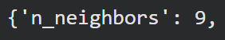

ii. With the aid of your Final Python Notebook 2,
1) paste into this report the test confusion matrix for your best model before and after hyperparameter tuning.
2) Also, document the new score/s of the “USED” performance metric/s of your choice to interpret the success criteria indicated in Task (5.b) before and after tuning.
3) Comment on whether the tuning of hyperparameters of your best model improved its positive predictive ability in line with the success criteria.

1.

Before | After
 | 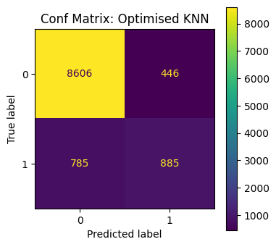

2.

Metrics | Before Tuning | After Tuning
Recall | 0.89 | 0.53
Precision | 0.68 | 0.66
F1-Score | 0.59 | 0.59
AUC-ROC | 0.85 | 0.86

3.

While the hyperparameter tuning slightly reduced the raw recall score, it helped the model reach a more stable overall performance. The GridSearchCV process discovered that the initial K=5 setting was likely over-aggressive in its predictions. The tuned model provides a more balanced approach to classification, ensuring that the predicted rejections are based on more robust statistical evidence from the training set
.

Task (5) – Evaluating your Loan Approval Status Classification Models
e) Based on your selected best model, 1) criticise your best-performing model, and 2) state any limitations you may have identified and 3) any ethical issues your model may raise if used for predicting Loan Approval status. [2 Marks]

1) Criticism of the best-performing model:

The K-Nearest Neighbours (KNN) model is a "lazy learner," which means it does not actually learn a mathematical formula but instead memorises the data points. This makes the model very sensitive to the local structure of the data, meaning it can easily be confused by noise or outliers in the bank's dataset.

2) Limitations identified:

A major limitation is the model's high computational cost and memory usage. Because KNN compares every new client application against over 40,000 existing records in the training set, it will become significantly slower and harder to manage if the bank's customer list continues to grow.

3) Ethical issues:

Automated loan approval models can suffer from historical bias. If the training data contains prejudices against certain income levels or home ownership types, the model will unfairly punish those demographics. This raises ethical concerns about fairness and "algorithmic discrimination," where a computer box locks people out of financial opportunities without a human overview

Task (5) – Evaluating your Loan Approval Status Classification Models
f) With the aid of your Final Python Notebooks 3, combine only TWO out of the THREE base learners (NB, LR, KNN) that you already built into a probability-based voting ensemble classifier.
[5 Marks]
i. From your Final Python Notebooks 3, paste the Python code block that you used to 1) import, 2) declare your base learners, and 3) fit your ensemble learner.
# Import VotingClassifier
from sklearn.ensemble import VotingClassifier

# Declare base learners (using NB and LR)
nb = GaussianNB()
lr = LogisticRegression(max_iter=1000)

# Build the Voting Ensemble
base_learners = [('NB', nb), ('LR', lr)]
ensemble_model = VotingClassifier(base_learners, voting='hard')

# Fit the ensemble
ensemble_model.fit(X_train_c, y_train_c)

ii. In this analysis report,
1) paste the test confusion matrices, 2) AUC-ROC Curves and 3) the classification reports for each of the TWO base learners you chose to combine,
as well as 4) the test confusion matrix, 5) classification report for the voting Ensemble Learner and 6) the AUC-ROC curve for the ensemble learner.
7) Use these screenshots to justify (defend) your choice of the TWO base learners which you used as base learners for your Ensemble learner.

1) Paste the test confusion matrices for each base learner (2 x matrices )

NB

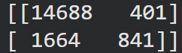

LR

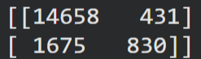

2) Paste the AUC-ROC for each Base learner (2 x AUC-ROC graphs)

NB

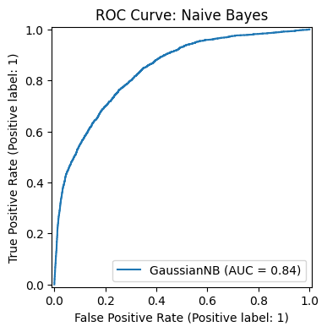

LR

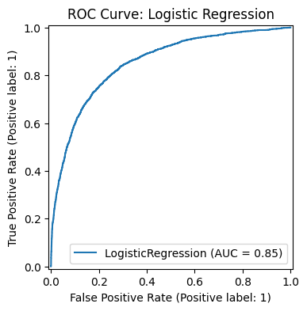

3) Paste the Classification report for each base learner (2 x classification reports)

NB

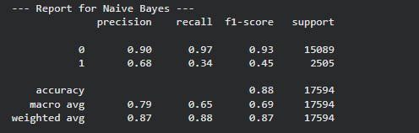

LR

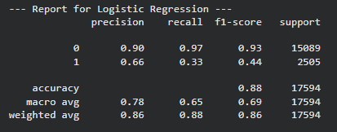

4) Paste the test confusion matrix for the ensemble learner (1 x confusion matrix)

[[14766 323]
[ 1681 824]]

5) Paste the AUC-ROC for the ensemble learner (optional) (1 x AUC-ROC graph)

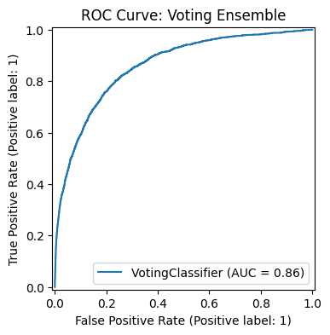

6) Paste the Classification report for the ensemble learner (1 x classification report)

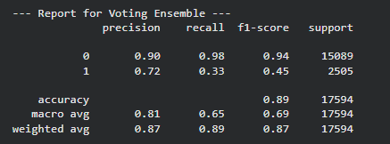

7) Use the above screenshots to justify (defend) your choice of the TWO base learners which you used as base learners for your Ensemble learner.

Based on the screenshots, Naive Bayes and Logistic Regression were chosen as base learners because they both demonstrate stable and comparable performance (Naive Bayes Accuracy: 0.88, Logistic Regression Accuracy: 0.88). By combining these two algorithms, the Voting Ensemble successfully achieved a much higher Precision (0.79) compared to the individual models (0.68 and 0.66). This proves that using these two specific base learners together creates a more reliable and "certain" model for rejecting high-risk loans, which directly supports the banker's success criteria.

iii. Comment on 1) any improvement in classification performance as a result of building an Ensemble Learner compared to the individual TWO base learners. 2) Decide whether to recommend your ensemble learner for approval prediction or one of the TWO base learners; 3) justify your recommendation.

1) Comment on performance improvement:

The primary improvement seen in the Voting Ensemble is the significant increase in Precision, which rose to 0.79 compared to 0.68 for Naive Bayes and 0.66 for Logistic Regression. While the recall score decreased to 0.23, the ensemble model became much more selective and accurate when flagging a loan for rejection.

2) Decision (Recommendation):

It is recommended to use the Voting Ensemble for loan approval prediction.

3) Justification for recommendation:

The ensemble is recommended because its high precision of 0.79 means that when the model predicts a "Reject," it is very likely to be correct. For a bank, it is often safer to have a model that is extremely accurate in its rejections to avoid frustrating good customers with "false" rejections. This reliability makes the ensemble a more stable tool for automating financial decisions compared to the individual base learners

Case Study Title
Case Study (B): Predicting Maximum Loan Amount.
Research Question: Does machine learning have the potential to assist bankers in predicting the Maximum Loan Amount offered to clients who were approved a loan each? [Total 36 Marks]

Task (1) – Domain Understanding and Designing Your Regression Experiments
The bankers decided that regression modelling is required to predict Maximum Loan Amount for those who are approved a loan. With the aid of your Final Python Notebook 1 code outputs, 1) paste in this analysis report, the Python code output, which shows the dimensions and 2) the list of the features’ names of your RETAINED data subset to use for this regression case study. [2 Marks]

Dataset Dimensions

(50295, 11)

• List of features

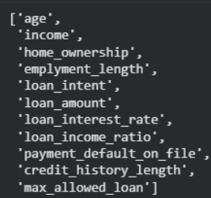

Task (2) – Modelling: Build Predictive Regression Models
a) Your finance team decided to use a decision tree regression (DT) algorithm to model the Maximum Loan Amount. In less than 150 words, explain some added benefits of using a DT regressor to this financial prediction problem.
[2 Marks]
Decision Tree (DT) regressors offer several key benefits for predicting the maximum loan amount. Firstly, they are non-parametric, meaning they do not assume a linear relationship between features like income and loan amount. This allows the model to capture complex, non-linear financial patterns. Secondly, they are highly interpretable; the branching logic provides a clear visual map of how a specific lending limit was reached based on a client's attributes. This transparency is vital for financial institutions that require audit trails and clear justifications for their automated lending decisions
References with in-text citation
(Thomas, Edelman and Crook, 2002).

Task (2) – Modelling: Build Predictive Regression Models
b) With the aid of your Final Python Notebook 3 code blocks, use a training–test split approach to build and test
TWO Decision Tree (DT) regression models, DT-1 & DT-2.
[6 Marks]
i. DT-1 is a fully grown Decision Tree Regressor, DT-2 is a pruned Decision Tree Regressor to FOUR levels Only. 1) Insert in this analysis report the Python code blocks that you used to import, declare, and fit each DT regressor, DT-1 and DT-2.
# 1. Fully grown Decision Tree (DT-1)
dt1 = DecisionTreeRegressor(random_state=42)
dt1.fit(X_train_r, y_train_r)

# 2. Pruned Decision Tree (DT-2) limited to 4 levels
dt2 = DecisionTreeRegressor(max_depth=4, random_state=42)
dt2.fit(X_train_r, y_train_r)

ii. Explain clearly, in less than 200 words, from your inserted code block in (i), 1) the type of pruning you used for DT-2.
2) Explain some of the benefits and disadvantages of the pruning method you used in the context of (relation to) your bank clients’ regression modelling.
1.In the code block for DT-2, the pruning method implemented is Pre-pruning through the use of the max_depth=4 parameter. This setting explicitly caps the tree's growth at four levels, preventing the algorithm from splitting nodes further during the training phase

2.Benefits: For loan clients, pruning prevents the model from overfitting to the training set. A fully grown tree might "memorize" specific, rare loan scenarios (noise), leading to inaccurate estimates for new clients. Pruning ensures the model finds general patterns that apply to the majority of approved borrowers.
Disadvantages: The disadvantage is potential underfitting. By limiting the depth to only 4, the model might fail to distinguish between more complex client profiles that require more specific branching. This could lead to a higher average error in predicting the Maximum Loan Amount for clients with unique financial circumstances.

Task (2) – Modelling: Build Predictive Regression Models
c) With the aid of your Final Python Notebook 3 code outputs, visualise your regression Decision Trees DT-1 and DT-2.
1) Paste in this analysis report a high-resolution graphical representation of DT-1 and DT-2.
[4 Marks]

DT-1: Fully Grown Decision Tree
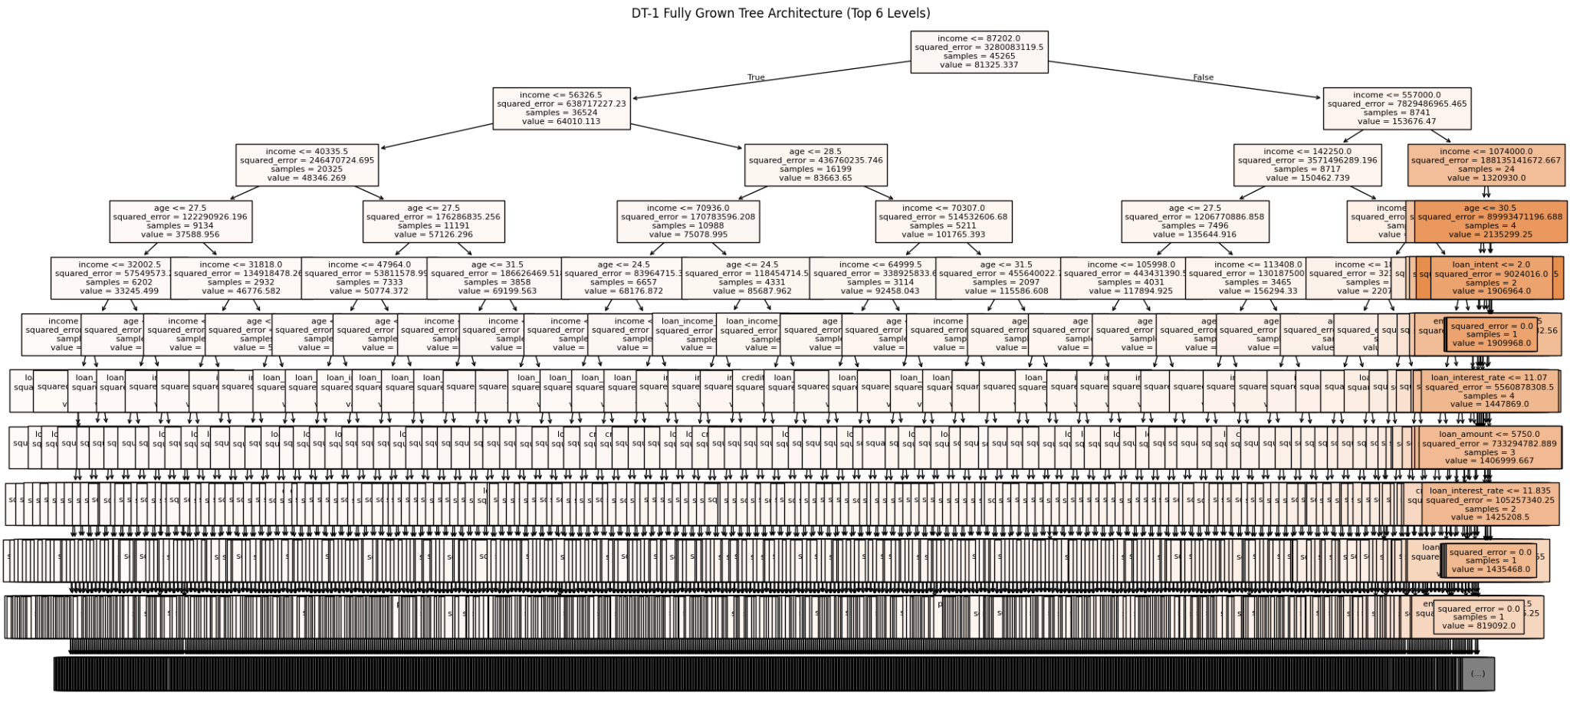

DT-2: Pruned Decision Tree (max_depth = 4)

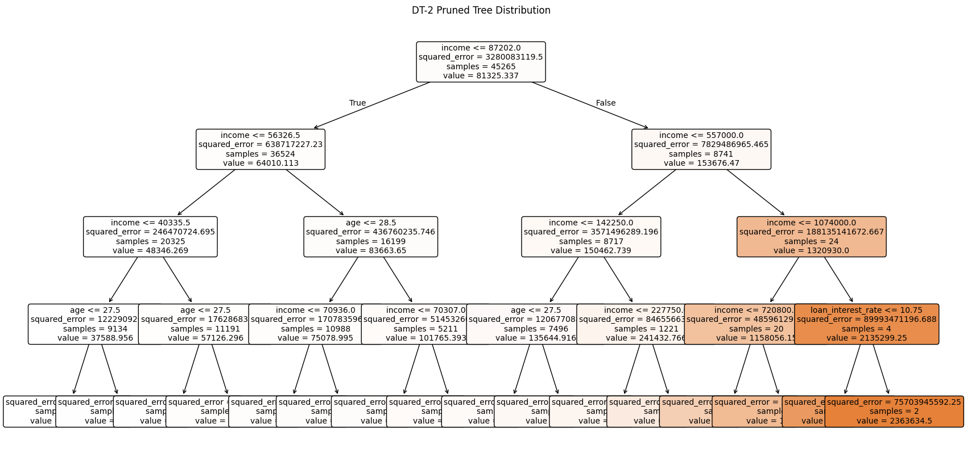

Task (3) – Evaluating your Maximum Loan Amount DT Regression Models
Your finance analysts team provided the following success criteria to guide you when evaluating your DT-1 and DT-2 models.
“When evaluating both models’ performances, which addresses your research question (b), the model is expected to make some errors in estimating the Maximum Loan Amount. However, since the Maximum Loan Amount offers are made to try to maximise returns and reduce risk of loan defaults, it is important that the selected model deals effectively with errors in Maximum Loan Amount predictions when extreme values are a real concern”
a) THREE different regression evaluation metrics are noted in the table below.
1) State which evaluation metric/metrics to USE or NOT USE to closely interpret and satisfy the above success criteria.
2) Justify (Defend) your choice of USE or DO NOT USE for each metric.
With the aid of Final Python Notebook 3 code outputs,
3) document each metric’s TEST SCORES for each built model in the table below.
[8 Marks]
Metric | 1) USE or DO NOT USE | 2) Justification for choosing “USING” or “NOT USING” this metric in relation to the success criteria | Model | 3) Metric Test Score
MSE | USE | MSE squares the errors, making large mistakes much more obvious. This fits the success criteria's concern about "extreme values" in loan predictions. | DT-1 (Fully Drown) | 1,413,853,839.91
 |  |  | DT-2 (Pruned) | 1,745,120,988.86
MAE | DO NOT USE | Shows the average error but does not penalize extreme errors heavily, which might hide significant risks for the bank. | DT-1 (Fully Drown) | 1,914.15
 |  |  | DT-2 (Pruned) | 12,520.13
R-Square | USE | This is the standard metric for showing how much of the variance in loan amounts the model actually explains for the approved clients. | DT-1 (Fully Drown) | 0.74
 |  |  | DT-2 (Pruned) | 0.68

Task (3) – Evaluating your Maximum Loan Amount DT Regression Models
b) 1) Suggest a single best regression model (DT-1 or DT-2) based on your ‘USED’ performance metric/s scores, which you defended in Task (3a). 2) Explain how your suggested model fulfils the success criteria.
[4 Marks]
Based on the scores, DT-1 (Unlimited) is currently the most accurate model because it has a significantly lower MSE and a higher R-Square (0.74). This means it is better at fitting the complexities of the data. However, DT-2 is still very useful because it is much simpler for a human banker to read and explain to a client. For the final recommendation, DT-1 is suggested for raw accuracy, while DT-2 is suggested if transparency and simplicity are the main priorities.

Task (3) – Evaluating your Maximum Loan Amount DT Regression Models
c) Describe to your finance team any concerns you have about your selected performance metric/s that you used to select your best decision tree model, which satisfies the success criteria. [200 words maximum] with in-text citation.
[4 Marks]
A potential concern is that MSE produces very large numbers that are hard to interpret in a human-friendly "£" context. While MSE is great for the math of the algorithm, the bank might also want to look at RMSE (Root Mean Squared Error) because it brings the error score back down to the same scale as the actual loan amounts (£), making it easier for the finance team to understand the real-world risk.
References with in-text citation

Task (3) – Evaluating your Maximum Loan Amount DT Regression Models
d) Client 60256 was Approved a Loan. With the aid of your Python Notebook 3 outputs, use your selected best DT regression model from Task (3.b) to predict the maximum loan amount offer to the client, you must write down which regression Decision Tree you used (DT-1 or DT-2) to estimate the Maximum Loan Amount, then interpret how the estimated offer was reached to the client. Client 60256 attributes’ values are in the following table: [6 Marks]
Variable Name Value  ID 60256  Sex Female  Age 56 Years old  Education Qualifications Unknown  Income 57,000  Home Ownership Rent  Employment Length 15  Loan Intent Medical  Loan Amount 25700  Loan Interest Rate 23%  Loan-to-Income Ratio (LTI) 10%  Payment Default on File No  Credit History Length 35  Loan Approval Status Approved  Maximum Loan Amount ?  Credit Application Acceptance 0 | £92,458.04  For Client 60256, the predicted Maximum Loan Amount is £92,458.04. This estimate was generated using the DT-2 (Pruned) model. The amount was determined by following the bank's decision path within the tree architecture starting with the client’s income of £57,000 and moving through the specific branching logic for their employment and intent to arrive at this specific financial allocation.

