**Flappy Bird**

**Group Members**

1. **IM/2019/086 Gauri Wathsala**
2. **IM/2019/101 Hiruni Hathnagoda**
3. **IM/2019/073 Nimesh Heshan**
4. **IM/2019/081 Janith Lahiru**

**Basic Documentation**

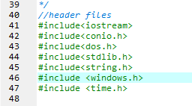

**Header files we used**

1. Windows header file contains declarations for all of the functions in the Windows API.
2. conio.h is a C header file used mostly by MS-DOS compilers to provide console input/output.
3. dos.h library has functions that are used for handling interrupts, producing sound, date and time functions.

**#Define**

1. **Define the screen height ,width and set the menu screen.**

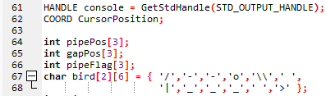

1. **COORD is a structure.**
2. **COORD specifies the new cursor position in characters. The coordinates are the column and row of a screen buffer character cell.**

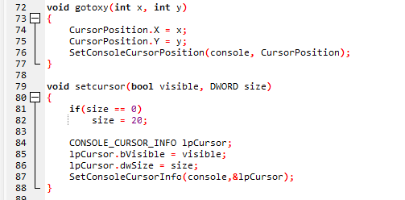

**gotoxy function helps to place cursor at a desired location on screen. The user can change cursor position using this function.**

**Declaration 🡪 void gotoxy (int x, int y); where (x, y) is the position where the user wants to place the cursor.**

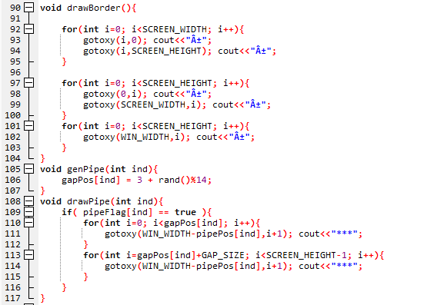

**We used drawBorder function to draw the border of the screen**

**We used genPipe function to set the gap between two pipes.**

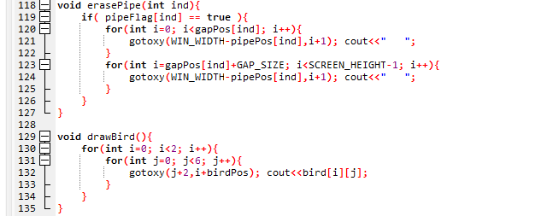

**erasePipe Function 🡪 To create gaps to display as two seperate columns.**

**drawBird Function 🡪 To create the bird.**

**collision function 🡪 To stop the bird's movement when it hits the pipe.**

**Gameover function 🡪 Display “Game Over” message on console once the bird gets collided.**

**updateScore Function 🡪 To update the scores.**

**Instructions Function 🡪 To display the instruction.**

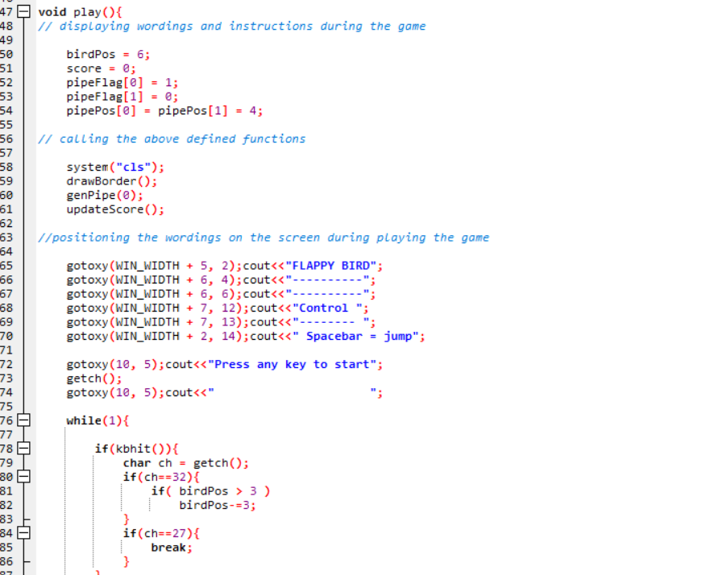

**Play function 🡪 This can be considered as the most important part of our code because most of the functions that are required to run this game are included here.**

**Main Function 🡪 This is used to get a user input and to call the “play” function as user instructs.**

**Instructions to play**

1. **Firstly you need to run the flappybird.exe file.**
2. **Press,**

1 🡪 to start

2 🡪 to view instructions

3 🡪 to quit game.

* **If you enter 1 , the game starts.**

Press spacebar to make bird fly.

If you hit a pipe or the ground, the game ends.

**Problems we faced**

1. Due to covid 19 we couldn’t meet each other so that we used github platform to do our codings. It helped us to complete this project as a group.

1. We didn’t have any idea about how games are programmed and the logic behind a game.

We watched several you tube tutorials related to game development and gained some basic idea .(This is one of the link for game development that we used to get an idea. Here , the instructor teaches the theory behind the game development clearly but the problem is, in this video they use Python and Pygame modules. )

Ref: <https://youtu.be/FfWpgLFMI7w>

1. We had to use new header files. But we didn’t have any idea about those files and their inbuilt functions ,so we used internet to find neccassary details.

**What we have Done Different**

To build this game we didn’t use any game engine. Instead of using a game engine we tried to bring the same functions to our game that are in game engines. (Through header files like dos.h , conio.h, windows.h & time.h.)