**Profiling report**

Design & Testing 2 - GI-5

**User Story 1** **1**

**User Story 14** **4**

**User Story 21** **8**

For this project we have had to do profiling manually, interacting directly with the deployed application because some queries executed during performance tests were not shown in the profiling tools.

# User Story 1

The positive case of the user story has been executed and the response time graph and the calls to queries have been filtered at the time it took to execute, this is how the test was developed:

* On the welcome page select login and I login as the Admin1.
* Back on the welcome page I select “tournaments”.
* I select “add new tournament”.
* I complete the form and save it.

The average time that all the transactions have taken has been 41,3ms, being the transaction to create a tournament taking the longest with 270ms.

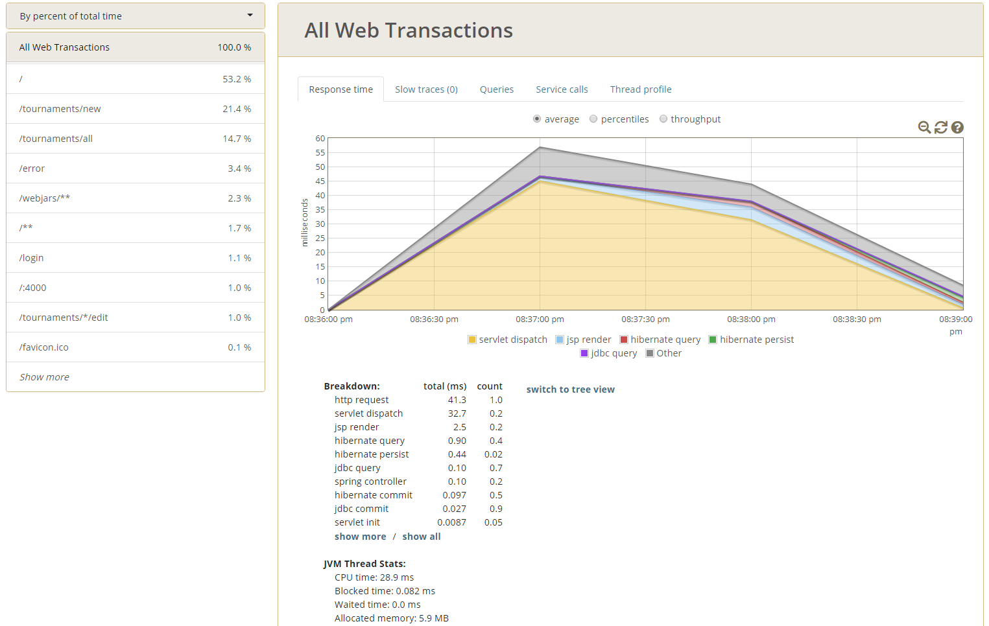

# 

During the development of the test there were no slow traces. The queries that have been executed during the test are the following:

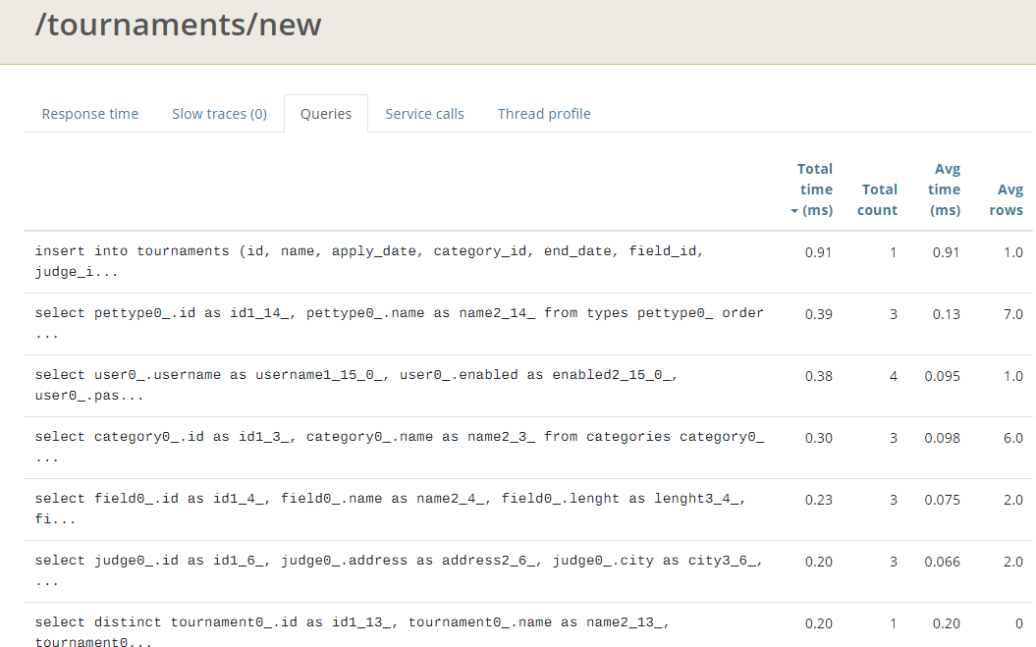

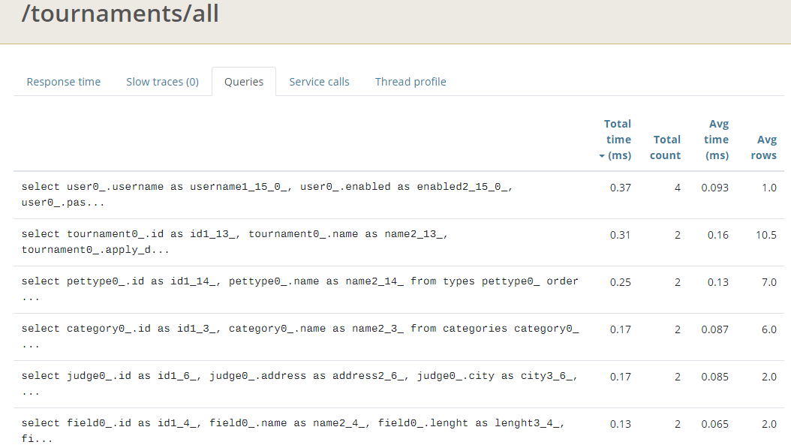

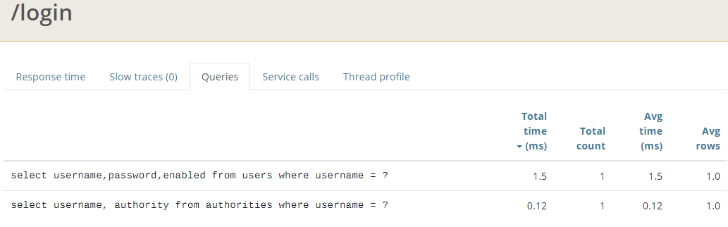

It can be seen that the queries that have taken the longest to execute are: The login, the one that creates the tournament and the one that selects all the tournaments for the list.

# User Story 14

The positive case of the user story has been executed and the response time graph and the calls to queries have been filtered at the time it took to execute, this is how the test was developed:

* On the welcome page select login and I login as the Owner5.
* Back on the welcome page I select the my profile link.
* I select to edit one of the Owner's pets.
* In the form to edit pet, in the drop-down list I select an available Guide and click Update Pet.

The average time that all the transactions have taken has been 30ms, being the transaction to edit pet and showing the owner's data the ones that have taken the longest with 60ms, another point to observe is that the transaction in the welcome view has also It took a long time compared to the login transaction.

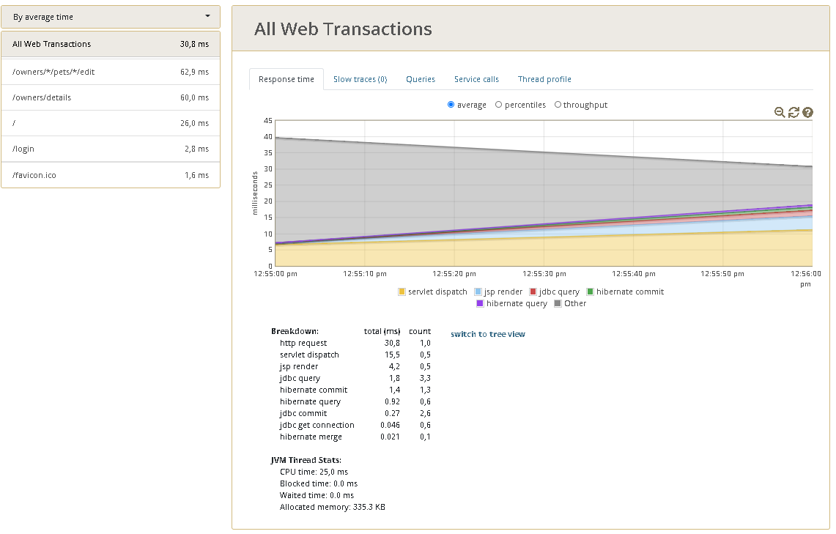

During the development of the test there were no slow traces. The queries that have been executed during the test are the following:

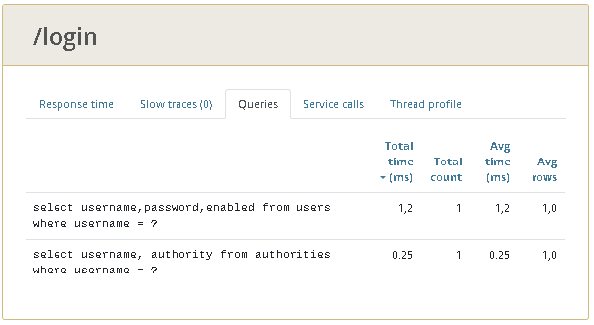

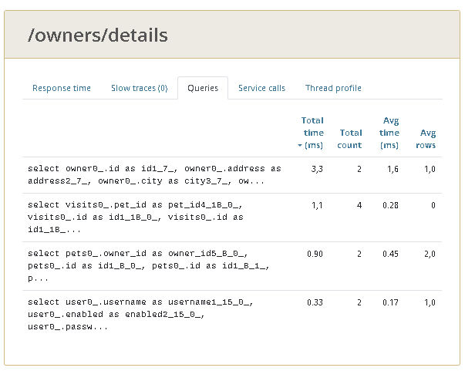

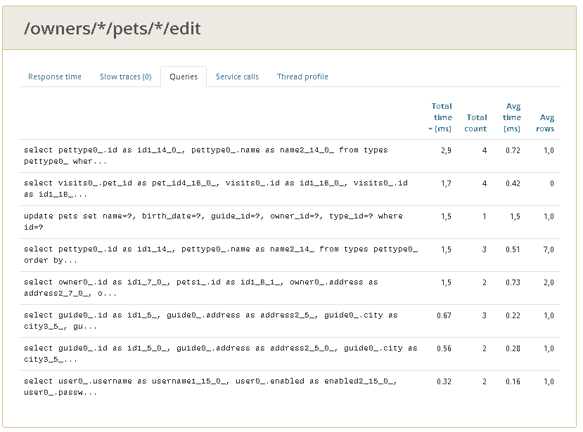

It can be seen that the queries that have taken the longest to execute are: The one that brings the data of the Owner authenticated in the transaction /owners/details, the query with the petTypes during the edit pet view and the third query that selects the visits that each pet of the owner has

An interesting point is that it takes much less time to select the guides than the petTypes, that will probably be that there is only one guide in the database.The other transactions do not execute queries.

In the second attempt an additional workload was added to the job and 2 slow traces arose during the test run, specifically during the pet edit.

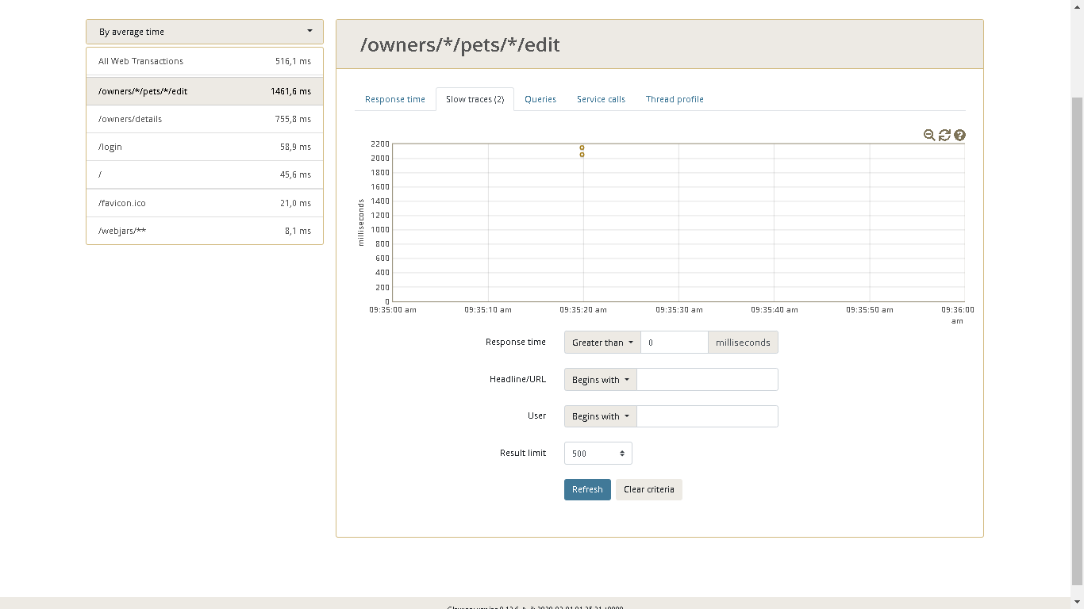

It can also be seen that transactions take much longer than with a clean execution.

# User Story 21

The positive case of the user story has been executed and the response time graph and the calls to queries have been filtered at the time it took to execute, this is how the test was developed:

* On the welcome page select login and I login as the Guide1.
* Back on the welcome page I select “Edit my profil”.
* I select “my reports”.

The average time that all the transactions have taken has been 73,7ms, being the transaction to show reports taking the longest with 331ms.

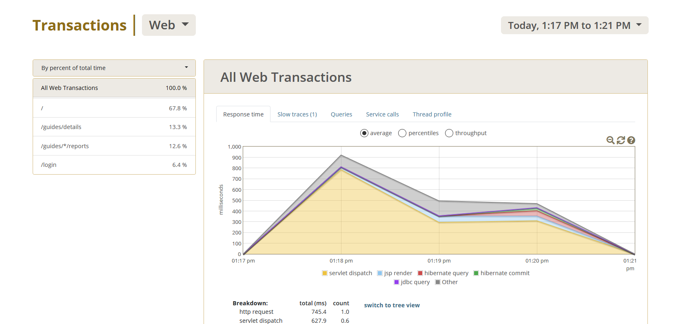

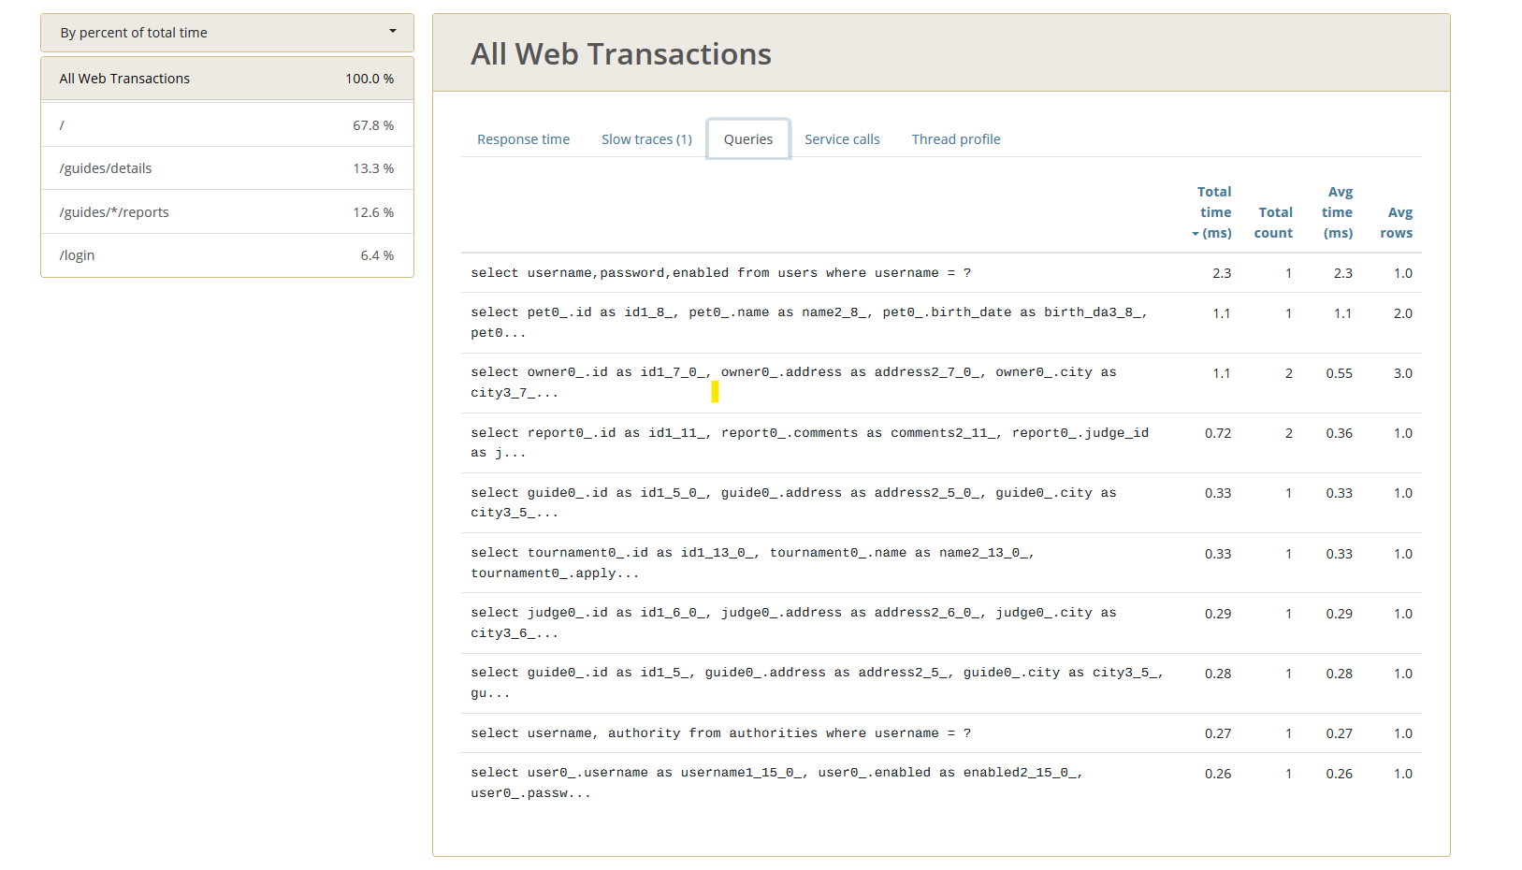

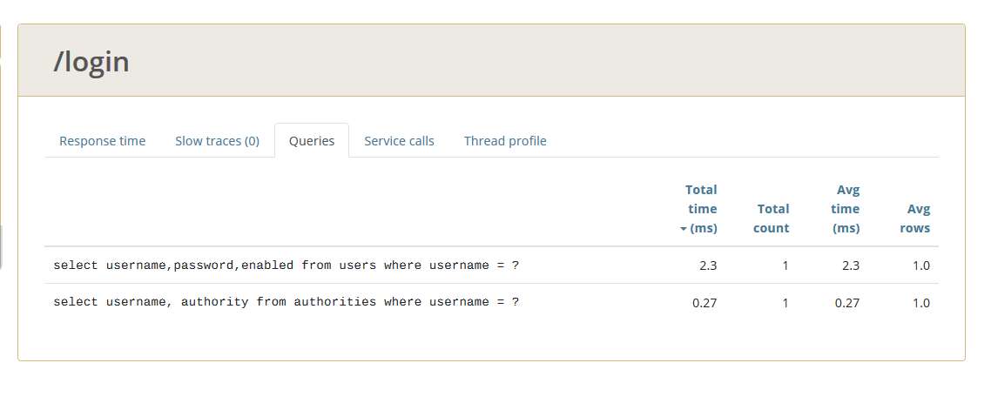

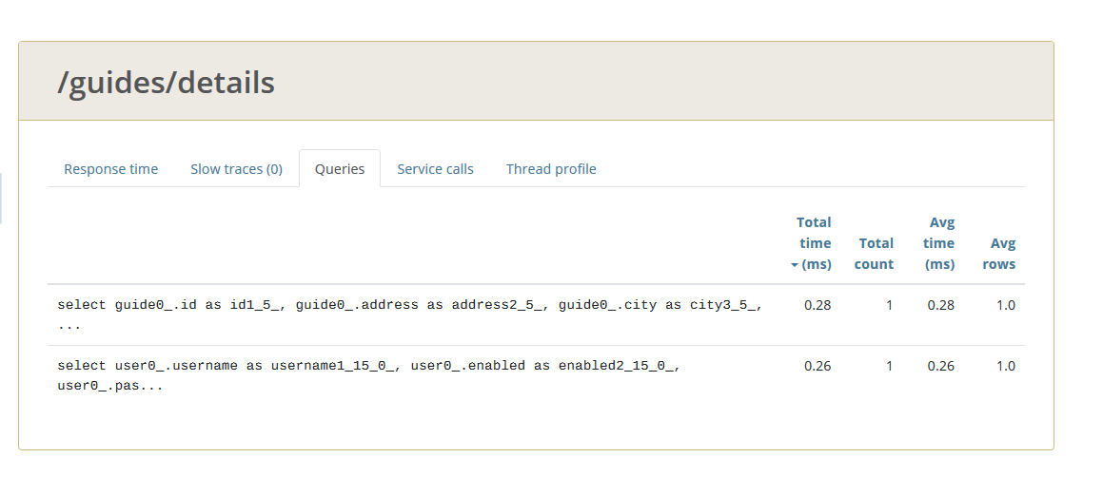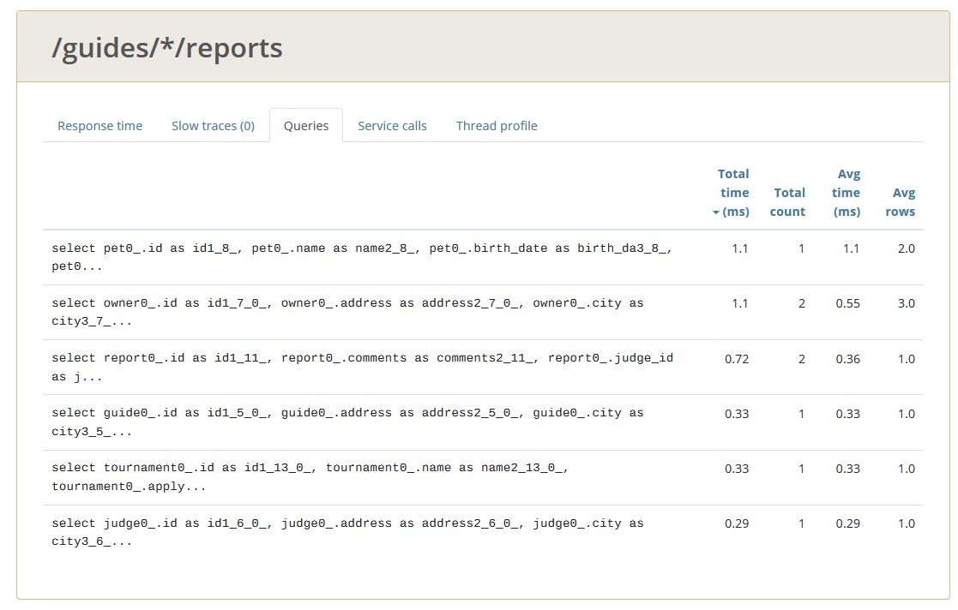

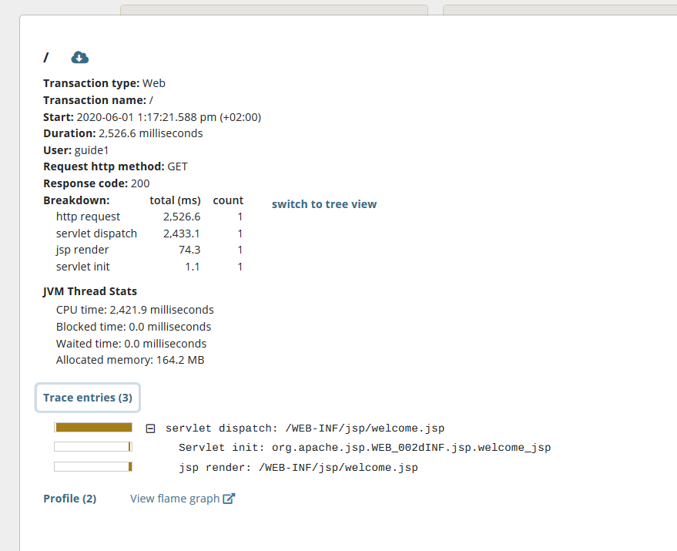

It can be seen that the queries that have taken the longest to execute are: The one that brings the data of the just logged user, the query that searches the Pet and his owner of each that guide has assigned.

An interesting point is that it calls the tournament query.