**Refactoring report**

*Design & Testing 2 - GI-5*

**Joaquín González refactorings** **1**

Refactoring 1 1

**Juan Manuel Varela refactorings** **2**

Ranking Service [Smell: Bloater] 3

Tournament Controller [Smells: Dispensables and Bloaters] 3

Ranking Controller [Smell: Dispensable] 4

Owner Controller [Smell: Dispensable] 4

ApplicationValidator [Smell: Dispensable] 5

JSPs [Smell: Dispensable] 5

**Manuel Alés refactoring** **5**

# Joaquín González refactorings

## Refactoring 1

PetService and TournamentService do the same check when they save.

It is proposed to create a superclass that does the same if, so just call the method of the superclass to do that check. The number of lines is reduced by 40%.

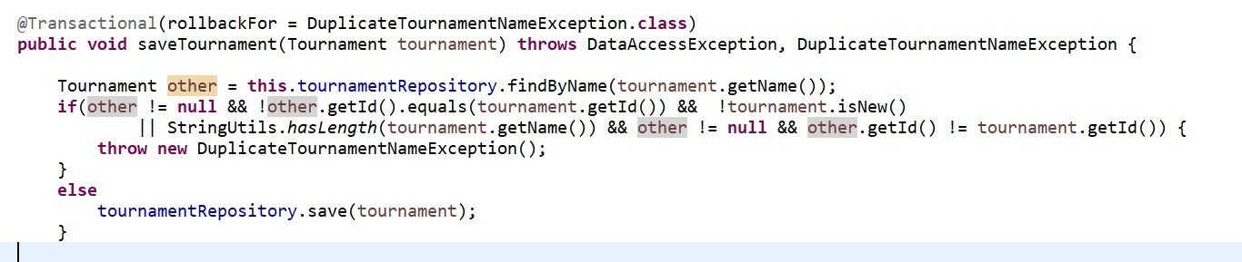

*TournamentService: method save*

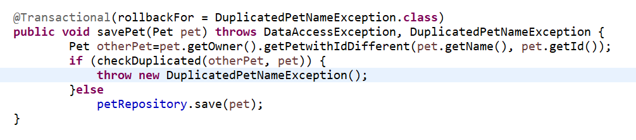

*PetService: method save*

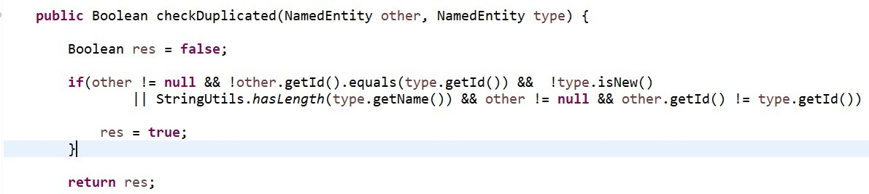

*Utils: duplicate name check method*

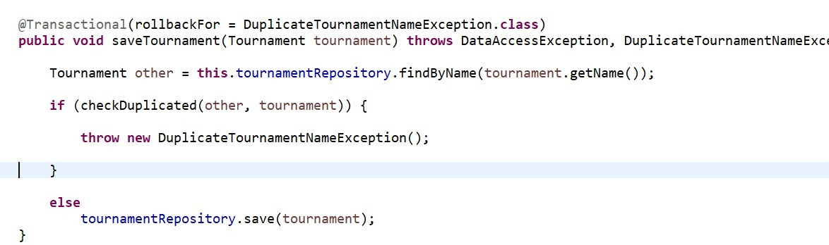

*TournamentService: save method after refactoring*

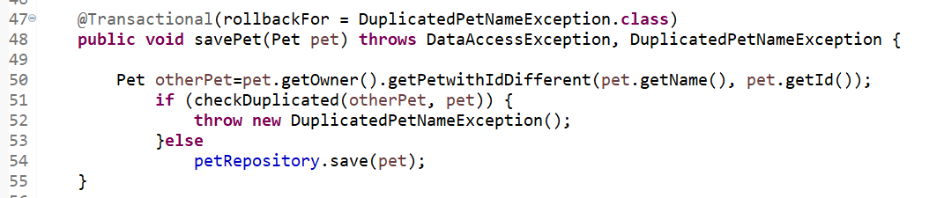

*PetService: save method after refactoring*

# Juan Manuel Varela refactorings

Updated unused imports of several classes.

## Ranking Service [Smell: Bloater]

* Separated the MakeRanking() method, doing a private method so it's not that long.

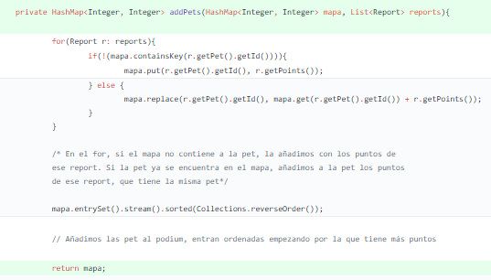

## Tournament Controller [Smells: Dispensables and Bloaters]

* Removed unused Services.

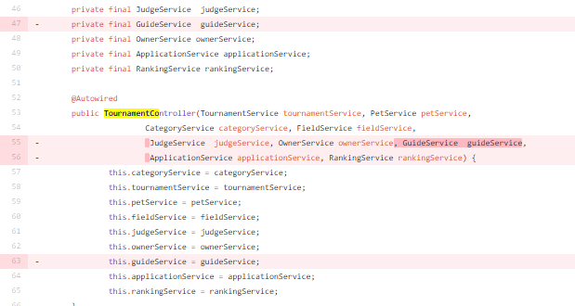

* Separated the initShowTournament(...) method, doing a private method so it's not that long.

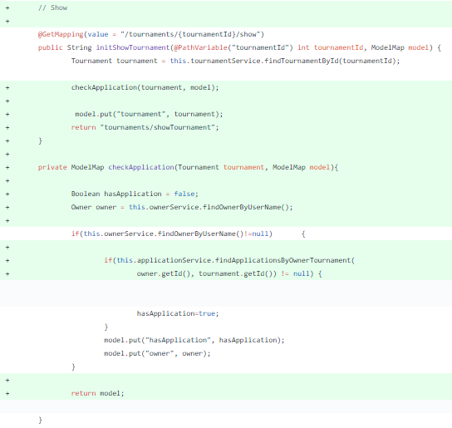

## Ranking Controller [Smell: Dispensable]

* Removed, as it’s never user.

## Owner Controller [Smell: Dispensable]

* Removed unused Services.

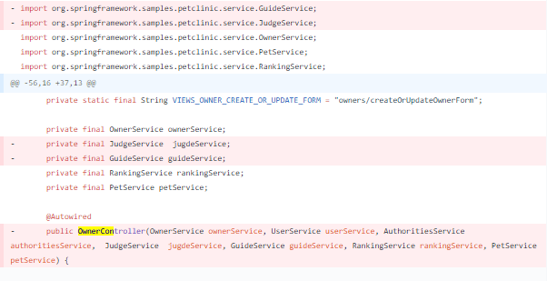

## ApplicationValidator [Smell: Dispensable]

* Removed unused attribute.



## JSPs [Smell: Dispensable]

Removed unused Ranking’s create.jsp

# Manuel Alés refactoring

Branch: Hot_Fix_Refactoring_Manu.

Focused in “main/test”.

These code smells are of type **Dispensables** due to the abuse of copy & paste.

**ApplicationControllerIntegrationTests:**

Removed some unused imports.

An unused attribute deleted.

Unused services deleted.

**ApplicationControllerTests**

Removed some unused imports.

An unused attribute deleted.

**ApplicationRepositoryTests**

Removed some unused imports.

**ApplicationServiceTests**

Removed some unused imports

**CategoryControllerTests**

Unused services deleted.

**CategoryControllerIntegrationTests**

Removed some unused imports

Unused services deleted

Unused variables deleted

**FieldControllerIntegrationTests**

Removed some unused imports

Unused services deleted

**FieldControllerTests**

Unused services deleted

**GuideControllerE2ETests**

Removed some unused imports

**GuideUITests**

Removed some unused imports

**GuideServiceTests**

Removed some unused imports

**GuideControllerIntegrationTests**

Removed some unused imports

Unused services deleted

**JudgeControllerE2ETests**

Removed some unused imports

**JudgeControllerIntegrationTests**

Removed some unused imports

Unused services deleted

**JudgeControllerTest**

Unused services deleted

**OwnerControllerE2ETest**

Removed some unused imports

**OwnerControllerTests**

Unused services deleted

**PetControllerE2ETest**

Removed some unused imports

**PetTypeFormatterTests**

Removed some unused imports

**PetRepositoryTests**

Removed some unused imports

**PetControllerTests**

Unused services deleted

**RankingControllerE2ETests**

Removed some unused imports

**ReportControllerIntegrationTests**

Removed some unused imports

Unused services deleted

**ReportControllerTests**

Removed some unused imports

Unused services deleted

**TournamentServiceTest**

Removed some unused imports

**TournamentControllerIntegrationTests**

Removed some unused imports

Unused services deleted

**TournamentControllerTests**

Unused services deleted

**TournamentRepositoryTests**

Removed some unused imports

**VetControllerTests**

Removed some unused imports

Unused services deleted

**VisitControllerTests**

Unused services deleted