# GP34 Group Workspace

## Tasks

1. Create a plan.
2. Delegate the task.
3. Schedule meetings.
4. Execute the plan.

## Plan

| **Task** | **Who is responsible** | **Start** | **Deadline** | **Status** |
| --- | --- | --- | --- | --- |
| **Phase 1: Structure and Foundations** | | | | |
| Conduct a meeting and Project Briefing | Adriel — Group Lead | 11.15.2022 | 11.15.2022 | Completed |
| Explore the data and answer the main questions | Ivan | 11.15.2022 | 11.15.2022 | Completed |
| Further investigate the data | All group members | 11.16.2022 | 11.19.2022 | Completed |
| Conduct 2nd meeting:  Presentation of group structure, timeline, and task delegation | Adriel - Leader | 11.19.2022 | 11.19.2022 | Completed |
| Presentation of findings | All group members | 11.19.2022 | 11.19.2022 | Completed |
| **Phase 2: Project Creation** | | | | |
| Consolidation of findings, conclusions, and recommendations.  (Excel and Sql file) | Adriel - Leader  Ivan | 11.20.2022 | 11.21.2022 | Completed |
| Create Technical Paper | Kristine, Ian, Gina | 11.20.2022 | 11.23.2022 | Completed |
| Create Ppt | Barry | 11.20.2022 | 11.22.2022 | Completed |
| Create Report script | Ivan | 11.20.2022 | 11.22.2022 | Completed |
| Create Video presentation | Mhy | 11.20.2022 | 11.23.2022 | Completed |
| **Phase 3: Project Evaluation and Improvements** | | | | |
| Conduct 3rd meeting | Adriel - Leader | 11.23.2022 | 11.23.2022 | Completed |
| Project Presentation | All group members | 11.23.2022 | 11.23.2022 | Completed |
| Evaluation and Recommendations | Adriel - Leader | 11.23.2022 | 11.23.2022 | Completed |
| Apply revisions and improvements | All group members | 11.24.2022 | 11.30.2022 | Completed |
| Attend Q&A with mentor | All group members | 11.26.2022 | 11.26.2022 | Completed |
| 4th meeting for add’l findings | All group members | 11.27.2022 | 11.27.2022 | Completed |
| **Phase 4: Final Refinements** | | | | |
| Apply revisions and improvements | All group members | 11.30.2022 | 12.3.2022 | Completed |
| 5th meeting for ptt improvement | All group members | 12.1.2022 | 12.1.2022 | Completed |
| 6th meeting for video improvement | All group members | 12.2.2022 | 12.2.2022 | Completed |
| Presentation of Final Revisions | All group members | 12.3.2022 | 12.3.2022 | Completed |
| Passing of Group Project | All group members | 12.4.2022 | 12.4.2022 | Completed |

## 

## 

## Project Timeline

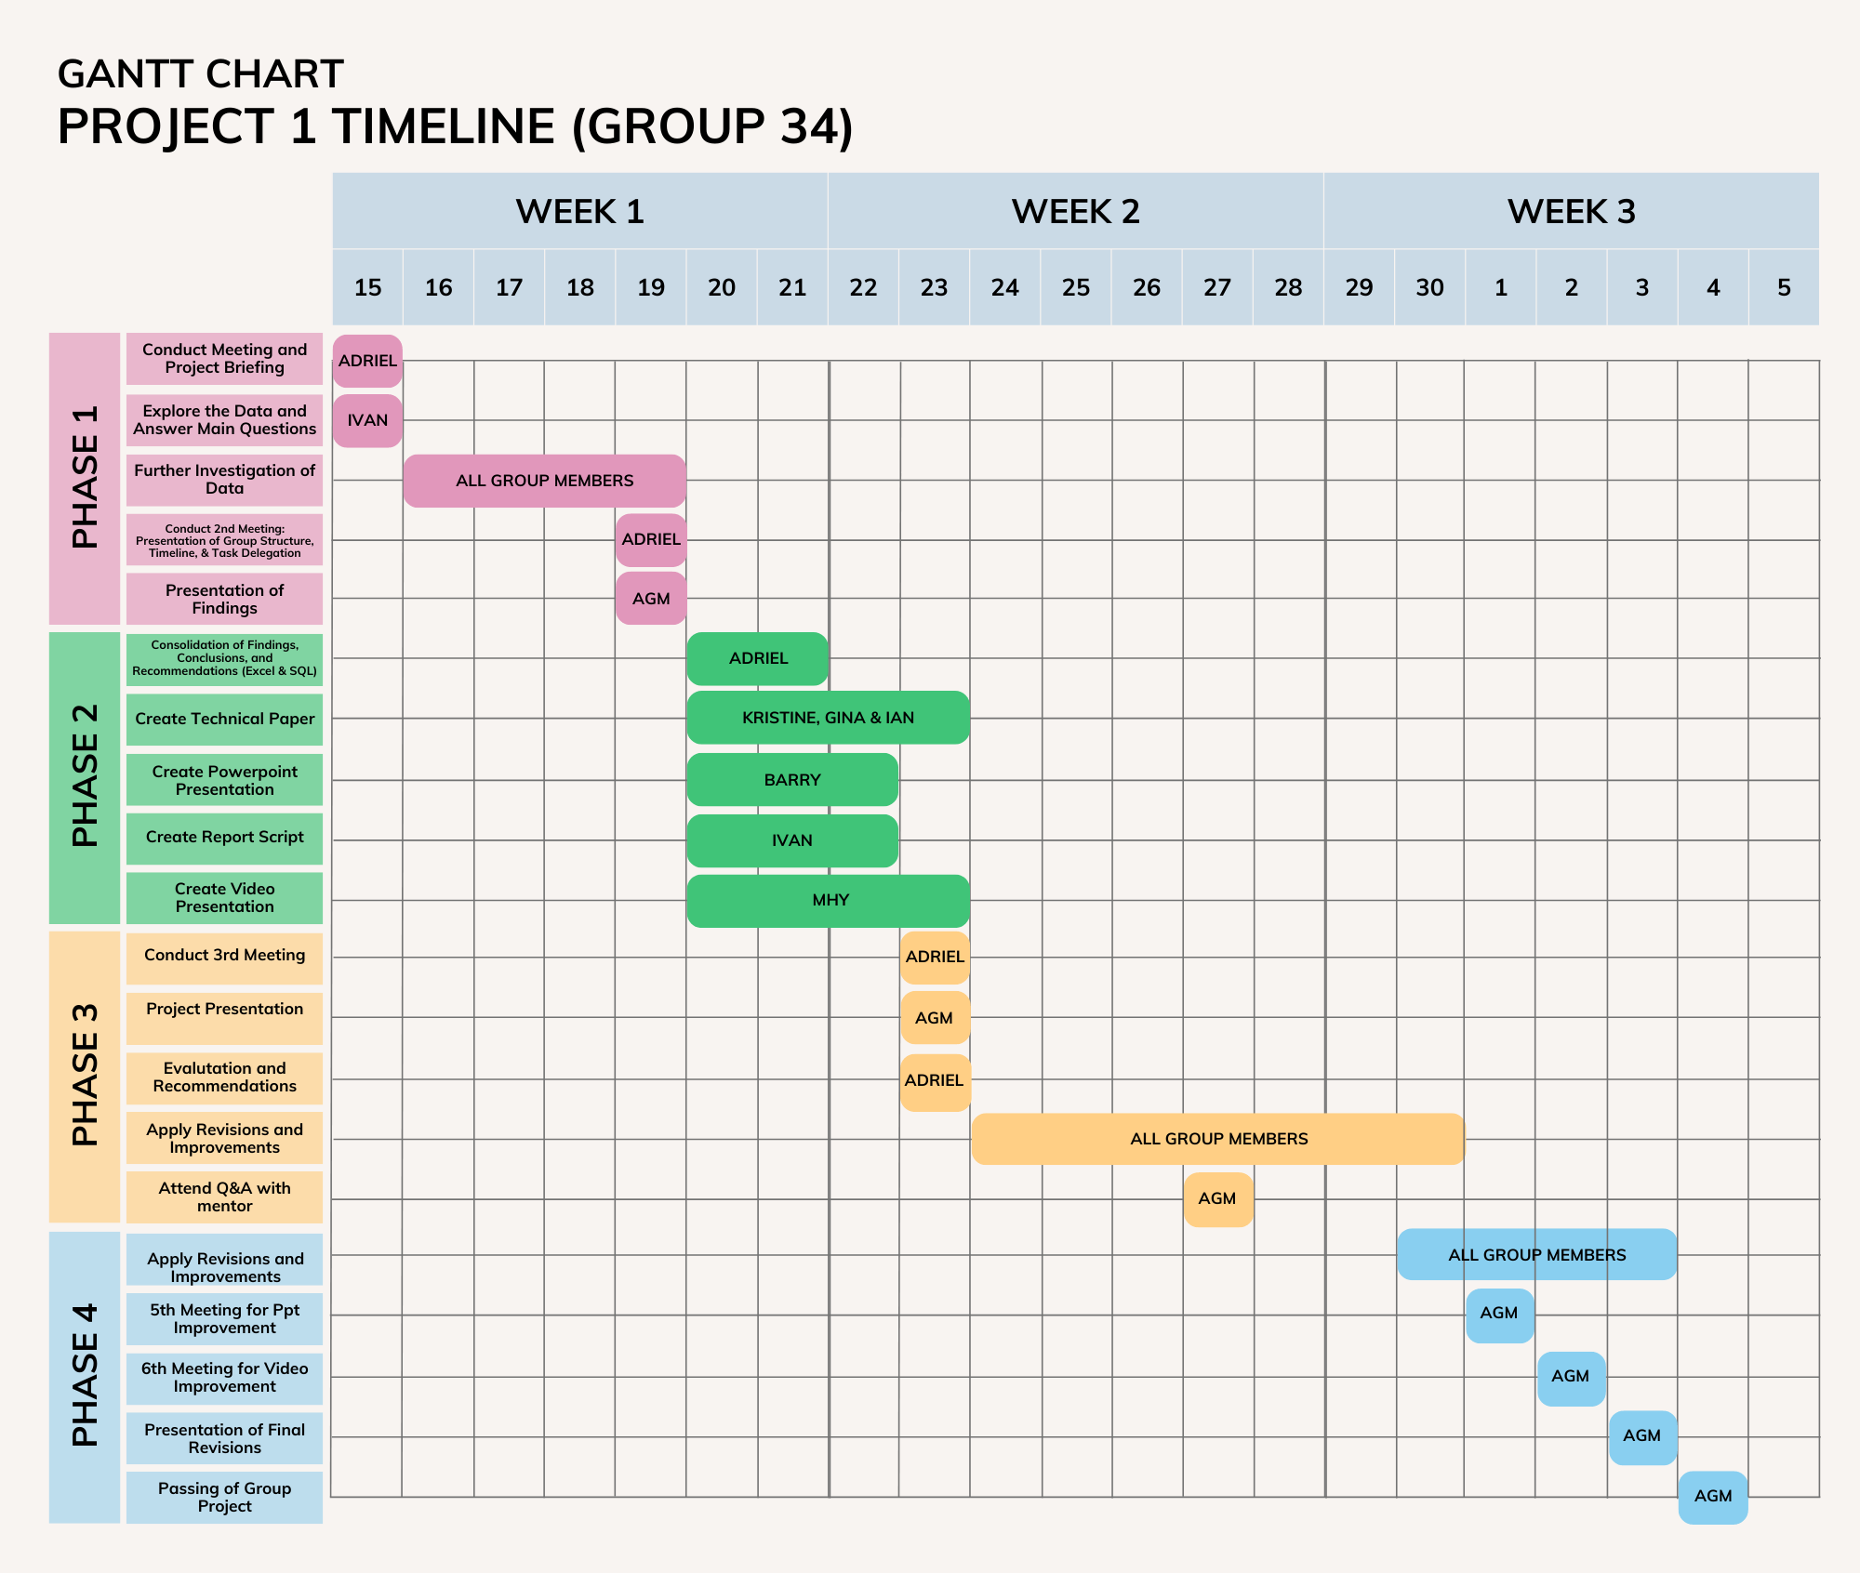

## Notes

### Meeting #1

Date: 11.15.2022

Who attended the meeting: Adriel Lachica, Barry Dela Cruz, Lester Nollora, Kristine Grace Sampelo, Ian Geoffrey Montemayor, Mayla Agabin, Gina Cabatic

What we discussed:

* Getting to know each other
* Project briefing
* Proposed timeline for the project
* Answered the 5 main questions with post SQL query

Next steps: Further investigate and study the data. Presentation of Initial Findings

### Meeting #2

Date: 11.20.2022

Who attended the meeting: Adriel Lachica, Barry Dela Cruz, Kristine Grace Sampelo, Ian Geoffrey Montemayor, Mayla Agabin

What we discussed:

* Team structure (Team Goal)
* Team Leader expectation to the team
* Timeline for group project in 3 weeks
* Recap from last meeting (questions and clarifications of the 5 questions)
* Each members of the team presented the initial findings
* Initial Task deligation
  + Excel and SQL (Gina)
  + Technical Report (Kristine and Ian)
  + Power Point Presentaion (Barry)
  + Report Script (Ivan)
  + Video Presentation (Mhy)
* Guidelines
  + Proper use of graph

Next steps: Presentation of task given to each member. More initial findings if any. Questions and clarification. Revisions of task designated.

### Meeting #3

Date: 11.23.2022

Who attended the meeting: Adriel Lachica, Barry Dela Cruz, Lester Nollora, Kristine Grace Sampelo, Ian Geoffrey Montemayor, Mayla Agabin, Gina Cabatic

What we discussed:

* Work Flow and process
  + Decided to combine the two recommended work flow.
  + Findings (all members) -> SQL and EXCEL (Adriel and Ivan) -> Technical report (Kristine,Ian,Gina) and Presentation (Barry, Mhy, Gina) -> New ideas, findings, revision
* Team Process
  + Plan -> Execute -> Evaluate -> New Findings -> Evaluate ->Plan -> Execute
* Project presentation and improvement
* Presented the tasks given to each member
  + Excel (Adriel)
  + Draft of technical report (Kristine)
  + Power Point Presentation (Barry)
  + Presented additional initial finding (Ian)
  + SQL (Ivan)
  + Questions and clarifications regarding to the task given to each members.

- Tips

- Finish the tasks within 2-3 days

Next steps: Attend the live session of Q&A. Possible Emergency meeting. Next team meeting November 27, 2022 (Sunday) 7pm.

### Meeting #4

Date: 11.27.2022

Who attended the meeting: Adriel Lachica, Barry Dela Cruz, Lester Nollora, Ian Geoffrey Montemayor, Mayla Agabin, Gina Cabatic

What we discussed:

* Presented the additional finding (Ian and Ivan)
* Discussed the recommended recommendations (Ivan)
* Initial Video Presentation (Mayla)
* Suggestion on how to improve the video presentation

Next steps: Next meeting December 02, 2022. Presentation of revisions

### Meeting #5

Date: 12.02.2022

Who attended the meeting: Adriel Lachica, Barry Dela Cruz, Lester Nollora, Kristine Grace Sampelo, Ian Geoffrey Montemayor, Mayla Agabin, Gina Cabatic

What we discussed:

* Presented the video presentation (Mayla)
* Comments, Suggestions and recommendation on how to improve the video presentation
* The team tried the suggested approach in recording the video presentation
* Edited the power point presentation and script to syncronize

Next steps: Next meeting December 03, 2022. Dry run of video presentation. Final revisions

### Meeting #6

Date: 12.03.2022

Who attended the meeting: Adriel Lachica, Barry Dela Cruz, Lester Nollora, Kristine Grace Sampelo, Ian Geoffrey Montemayor, Mayla Agabin, Gina Cabatic

What we discussed:

* Review the assessment criteria
* Minor revisions on SQL, Tech paper and power point presentation.
* Practice the deliberation of script and power point presentaion for video presentation

Next steps: Next meeting December 04, 2022, Dry run of video presentation, Submission of group project 1

### Meeting #7

Date: 12.04.2022

Who attended the meeting: Adriel Lachica, Lester Nollora, Kristine Grace Sampelo, Ian Geoffrey Montemayor, Mayla Agabin, Gina Cabatic

What we discussed:

* Recording of the video presentation.
* Submission of the group project 1