Azure Databricks Credit Risk Lakehouse Project

Silver Standardization Layer Technical Documentation
Technical schema standardization, DQ validation, rejected records, and standardized Delta outputs

Document attribute | Value
Project | Azure Databricks Credit Risk Lakehouse Project
Layer | Silver Standardization Layer
Author | Gijo Baby
Document status | Initial draft
Version | 1.0

Contents
1. Document Purpose 3
2. Layer Objective 3
3. Scope 3
3.1 In Scope 3
3.2 Out of Scope 3
4. Workflow Diagram 4
5. Runtime Parameters 5
6. Component Inventory 5
7. Silver Standardization Metadata and Tables 5
8. Technical Standardization Logic 6
9. Production Troubleshooting Model 6
Rejection Enhancement 6
10. Detailed Engineering Design 6
Design principles 6
Unity Catalog organization 7
ADF and Databricks responsibility split 7
Rerun and recovery matrix 7
11. Audit, Error Handling, and Observability 7
Retry Philosophy 7
12. Production Operations and Support Model 8
Monitoring entry points 8
Common support queries 8
Production readiness checklist 8
13. Silver Standardization Detailed Technical Appendix 8
Column configuration example 8
Validation sequence 9
Production-grade rejection diagnostics 9
Support SQL for all-record rejection scenario 9
Phase 2 - DQ threshold recommendation 9

1. Document Purpose
This document provides a detailed technical description of the Silver Standardization layer in the Azure Databricks Credit Risk Lakehouse project. It is written in a corporate engineering style and is intended to support portfolio review, technical interviews, implementation handover, and production-readiness assessment.
The document explains the layer objective, processing responsibilities, notebooks, Python modules, metadata tables, runtime parameters, execution sequence, audit/error handling, rerun behavior, operational monitoring, and Phase 2 improvements.

2. Layer Objective
The Silver Standardization layer converts raw Bronze data into technically standardized Delta tables. It standardizes column names, applies configured data types using try_cast, validates required and cast-sensitive columns, executes business DQ rules, writes rejected records, deduplicates valid data, and publishes standardized Silver tables.

3. Scope

3.1 In Scope
- Metadata-driven source-to-target column mapping.
- Source column existence validation against Bronze.
- try_cast-based data type standardization.
- Required-field and cast-failure validation.
- Business DQ rule execution from dq.data_quality_rules.
- Rejected-record persistence and DQ result summaries.
- Deduplication using configured keys.
- Audit/error logging and ADF-ready parameterization.

3.2 Out of Scope
- Cross-entity conformance and business entity modeling.
- SCD Type 2 customer history management.
- Dimensional/fact table creation.
- Power BI semantic layer and KPI reporting.

4. Workflow Diagram
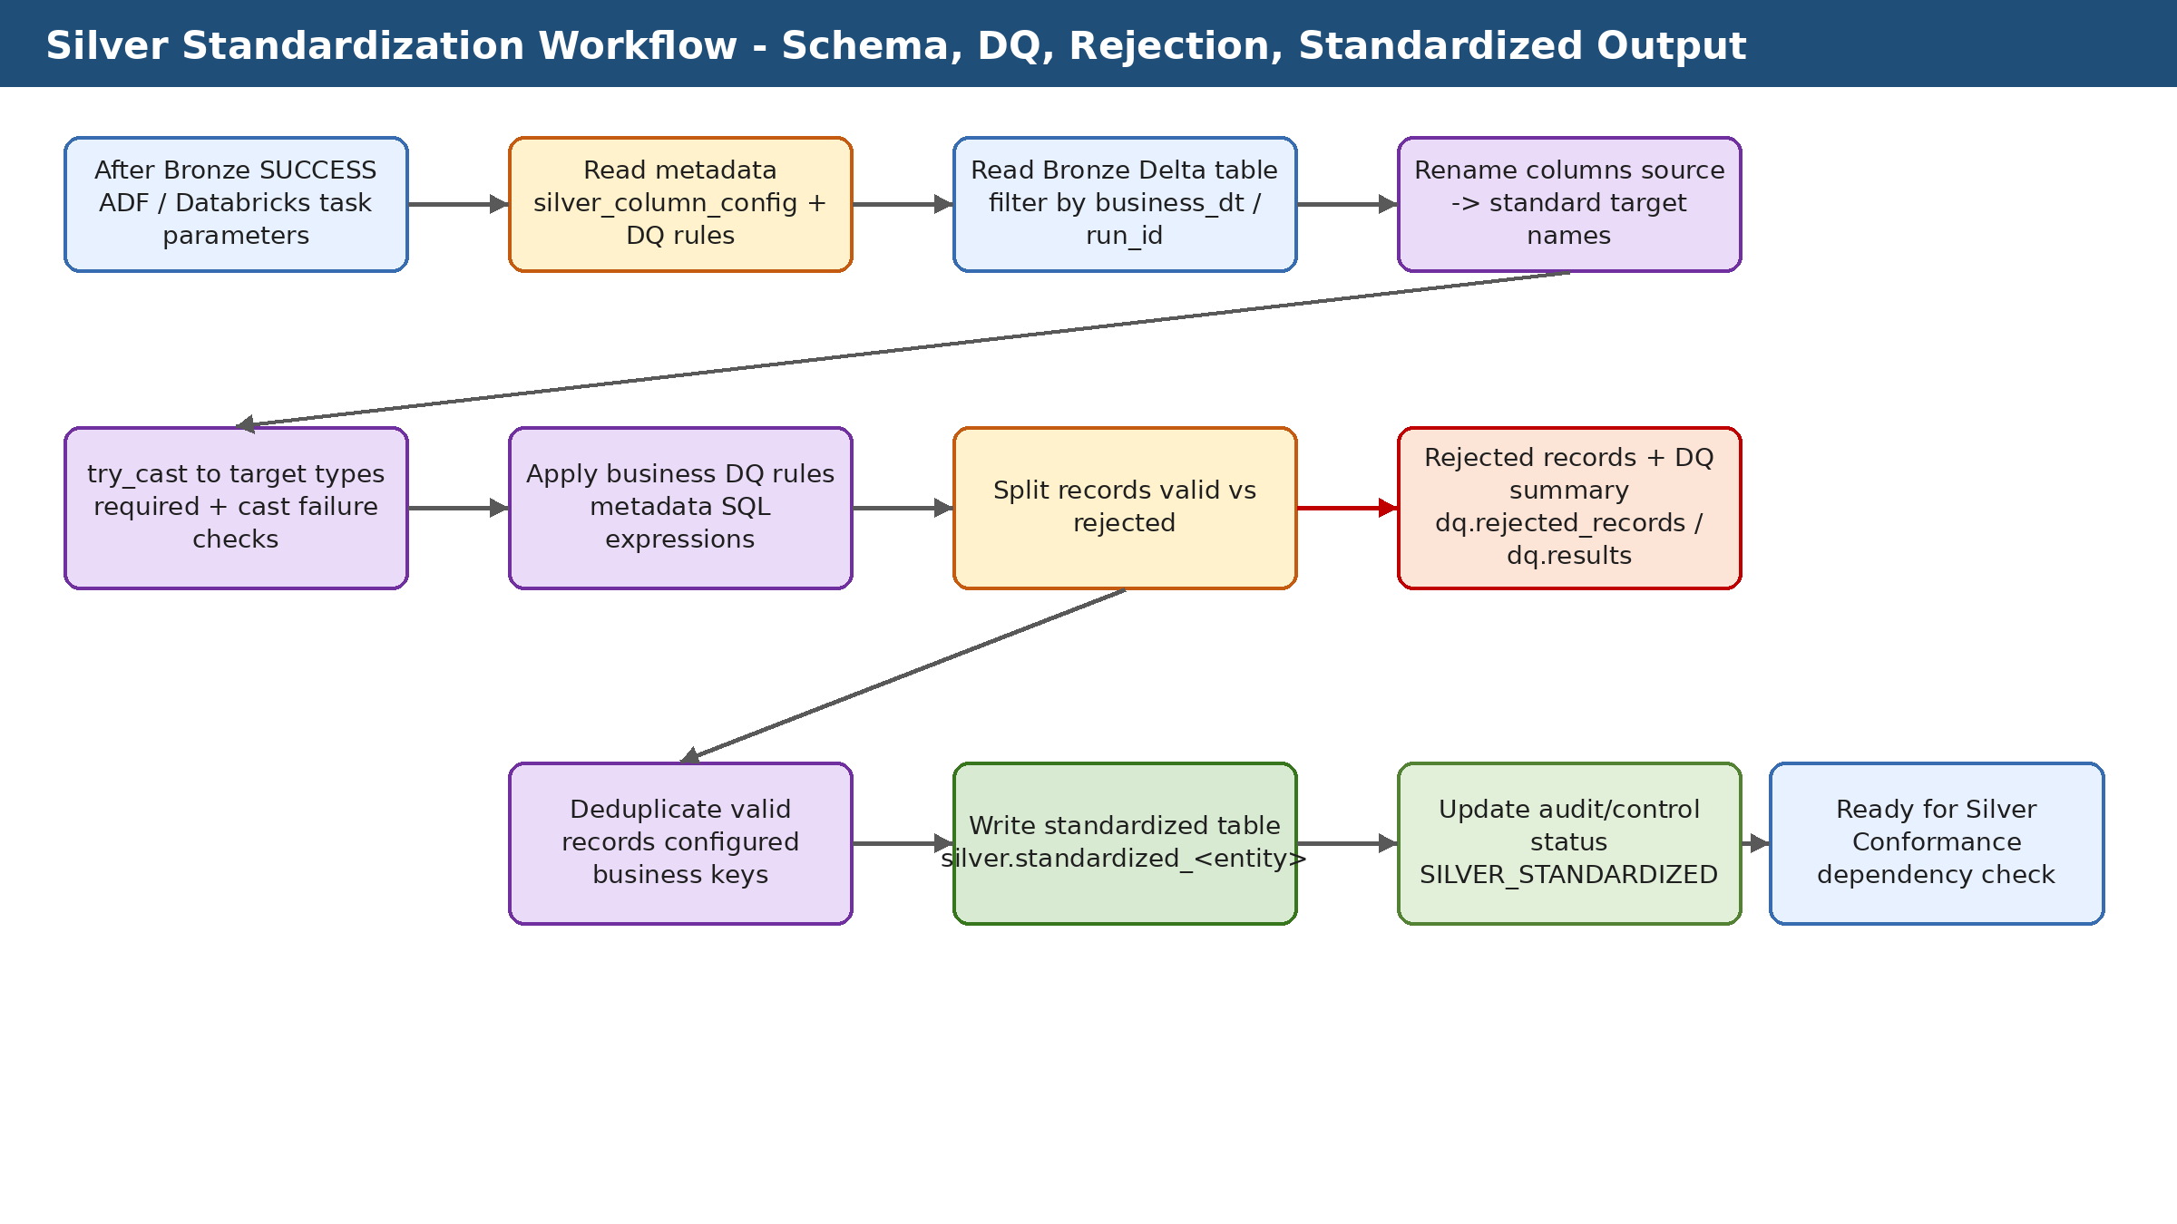

5. Runtime Parameters
Runtime parameters allow the same notebooks and modules to be reused across entities, environments, Databricks Jobs, ADF pipelines, and future Databricks Asset Bundle deployments. In production, ADF should own business-date and SLA orchestration, while Databricks Jobs own task execution and notebooks own layer-specific processing logic.
Parameter | Required | Example | Purpose
catalog_name | Yes | credit_risk_dev | Unity Catalog environment.
entity_name | Yes | bureau_balance | Entity to standardize.
business_dt | yes | 2026-06-02 | Processing scope and partition/rerun control.
pipeline_run_id | Yes | ADF run id | Run lineage and audit correlation.
write_mode | Yes | overwrite / append | Controls Silver target write behavior; recommend replaceWhere by business_dt for production.
debug_mode | Optional | false | Controls additional diagnostic logging when enabled.

6. Component Inventory
The following table lists the primary notebooks, Python modules, SQL scripts, tests, and documentation files used by this layer. Each component has a single responsibility to keep the framework modular, testable, and reusable.
Component | Type | Purpose
notebooks/02_silver/01_generic_silver_standardizer.py | Notebook | Generic standardization notebook for all entities. Orchestrates config read, Bronze read, validation, DQ, rejected records, write, audit, and error handling.
src/silver/silver_config_reader.py | Python module | Reads silver_column_config and resolves Bronze source and standardized target table names.
src/silver/silver_standardizer.py | Python module | Implements core standardization: source validation, raw-column preservation, try_cast, technical rejection split, deduplication.
src/silver/dq_rule_reader.py | Python module | Reads active DQ rules for the standardized target table from dq.data_quality_rules.
src/silver/dq_rule_validator.py | Python module | Applies metadata-driven business DQ expressions and separates valid and rejected records.
src/silver/dq_writer.py | Python module | Writes dq.rejected_records and dq.data_quality_results.
sql/01_metadata/08_update_silver_column_config_cast_policy_dev.sql | SQL script | Adds reject_on_cast_failure policy column to Silver column config.
sql/01_metadata/09_create_dq_rules_table_dev.sql | SQL script | Creates metadata table for business data quality rules.
sql/01_metadata/10_insert_sample_dq_rules_application_train_dev.sql | SQL script | Inserts example business DQ rules for application_train.

7. Silver Standardization Metadata and Tables
Metadata-driven design reduces hardcoding and allows new entities or business rules to be added with configuration changes instead of notebook rewrites. The metadata tables should be governed in Unity Catalog and updated through controlled deployment scripts.
Table / object | Purpose | Key columns or notes
config.silver_column_config | Column-level mapping and validation policy. | entity_name, source_column_name, target_column_name, target_data_type, is_required, is_dedup_key, reject_on_cast_failure, column_sequence, is_active.
dq.data_quality_rules | Business DQ metadata table. | rule_id, rule_name, rule_type, target_catalog/schema/table/column, rule_sql_expression, severity, is_active.
silver.standardized_<entity> | Standardized valid Delta output. | Typed standardized columns plus technical columns such as business_dt, pipeline_run_id, standardization_run_id, standardization_timestamp.
dq.rejected_records | Dead-letter/rejection table. | rejection_id, pipeline_run_id, source/target table, rule_id, rejection_reason, rejected_record_json, source_file_path, created_timestamp.
dq.data_quality_results | DQ summary table. | rule_id, table_name, failed/passed counts, failed percentage, status, severity, checked timestamp.

8. Technical Standardization Logic
- Validate every configured source column exists in the Bronze DataFrame.
- Create temporary _bronze_<source_column> fields to preserve raw values for cast-failure diagnostics.
- Apply try_cast to target_data_type so invalid values become NULL instead of failing the entire job.
- Reject a record when a required target column is NULL.
- Reject a record when raw value is non-null/non-blank, casted value is NULL, and reject_on_cast_failure is true.
- Remove temporary _bronze_* columns before writing valid standardized output.
CAST FAILURE RULE:
raw Bronze value is not NULL/blank
AND try_cast result is NULL
AND reject_on_cast_failure = true
=> record is rejected into dq.rejected_records

9. Production Troubleshooting Model
Production support should not depend on displaying intermediate DataFrames. The framework should persist diagnostics so failures can be investigated through SQL.
Diagnostic need | persisted evidence | Example
Which rule failed? | dq.data_quality_results | rule_id, failed_record_count, failed_percentage
Which records failed? | dq.rejected_records | rejected_record_json by pipeline_run_id
Which column failed? | enhancement: failed_column_name, source_value, target_data_type | months_balance / CAST_FAILED
Was it technical or business DQ? | rule_type and rule_id | SILVER_SCHEMA_CAST_VALIDATION vs business rule
Was threshold breached? | DQ summary threshold status | FAILED if rejected percentage exceeds limit

Rejection Enhancement
- Add failed_column_name to rejected records.
- Add source_value and casted_value for failed casts.
- Add failure_type values such as REQUIRED_NULL and CAST_FAILED.
- Add DQ threshold handling so 100% rejection fails the notebook.
- Write one DQ summary row per rule and column.

10. Detailed Engineering Design

Design principles
- Used metadata to control behavior instead of hardcoding entity-specific logic in notebooks.
- Kept notebooks thin and reusable; place reusable logic in Python modules under src/.
- Separate orchestration control from technical execution audit.
- Used business_dt and pipeline_run_id as cross-layer traceability keys.
- Fail fast for missing metadata or target-table contract violations.
- Persist support diagnostics in Delta tables rather than relying on notebook display output.
- Make reruns deterministic and idempotent before enabling automatic retries.

Unity Catalog organization
Schema | Responsibility | Example objects
config | Static or slowly changing processing metadata | bronze_ingestion_config, silver_column_config, silver_conformance_entity_config
bronze | Raw persisted source data | application_train, bureau, bureau_balance
silver | Standardized and conformed curated data | standardized_bureau_balance, conformed_customer_scd2
gold | Business-ready dimensional and fact marts | dim_customer, fact_credit_application, fact_customer_risk_snapshot
dq | Rejected records and DQ results | rejected_records, data_quality_results
audit | Technical execution logs | pipeline_run_log, table_load_log, error_log
orchestration | ADF control and dependency state | file_arrival_status, layer_processing_status, pipeline_run_control

ADF and Databricks responsibility split
Responsibility | Owner | Reason
Business date calculation and SLA polling | ADF | ADF is better suited for external orchestration, time windows, waiting, and branching.
Layer transformation execution | Databricks Jobs | Databricks is the processing engine for Spark/Delta workloads.
Reusable transformation logic | Python modules and SQL scripts | Version-controlled code is easier to test and deploy.
Technical run details | Audit and DQ Delta tables | Persistent evidence supports production troubleshooting and audit.
Manual repair of failed task | Databricks Jobs repair run | Only failed tasks should be rerun when downstream dependencies allow.

Rerun and recovery matrix
Failure point | recovery | Duplicate-risk control
Before any table write | Rerun task normally | No data written.
After data write but before audit success | Retry/repair audit update only if possible; otherwise verify data then repair carefully | business_dt partition check and table history.
DQ/rejection failure | Fix metadata/rule and rerun affected entity only | pipeline_run_id and rejected-record summary.
Downstream dependency not ready | Hold downstream layer and continue polling/status check | layer_processing_status.
Gold fact failed after dimensions completed | Repair only failed Gold task and dependent snapshot | idempotent replace/merge by business_dt.

11. Audit, Error Handling, and Observability
The layer follows a production-style observability pattern: technical execution state is written to audit tables, technical failures are written to an error log, and detailed DQ or rejection details are persisted in Delta tables where applicable. Databricks notebook output is useful for development, but Delta audit tables should be treated as the authoritative operational record.
Object | Responsibility | Typical usage
audit.pipeline_run_log | Tracks pipeline-level STARTED, SUCCESS, and FAILED status. | Used by ADF and support teams to check overall run outcome.
audit.table_load_log | Tracks entity/table-level processing with records read, written, rejected, and duration. | Used for table-level troubleshooting and layer completion checks.
audit.error_log | Stores technical exception details, stack trace, source table/path, and severity. | Used for production support and failed-run analysis.
orchestration.layer_processing_status | control table for ADF dependency checks across Bronze, Silver, Conformance, and Gold. | Used to decide whether downstream layer can start.

Retry Philosophy
- Retry only small audit/error SQL updates for Delta concurrency conflicts.
- Do not blindly retry the full Databricks task after data has already loaded successfully unless the notebook is idempotent by business_dt.
- Use Databricks repair runs to rerun only failed tasks in multi-task jobs.
- Use business_dt partition replacement or MERGE strategies to protect against duplicate results.

12. Production Operations and Support Model

Monitoring entry points
- Databricks Job Run UI and task graph.
- audit.pipeline_run_log and audit.table_load_log.
- audit.error_log for technical exceptions.
- DQ/rejected-record tables where applicable.
- DESCRIBE HISTORY and DESCRIBE DETAIL for Delta operational analysis.
- ADF pipeline run output and orchestration control tables.

Common support queries
SELECT *
FROM credit_risk_dev.audit.table_load_log
WHERE pipeline_run_id = '<pipeline_run_id>'
ORDER BY start_timestamp;
SELECT *
FROM credit_risk_dev.audit.error_log
WHERE pipeline_run_id = '<pipeline_run_id>'
ORDER BY created_timestamp DESC;
DESCRIBE HISTORY credit_risk_dev.<schema>.<table_name>;
DESCRIBE DETAIL credit_risk_dev.<schema>.<table_name>;

Production readiness checklist
- All tables and configuration rows are deployed through version-controlled scripts.
- Runtime parameters are documented and passed consistently by ADF/Databricks Jobs.
- Audit and error logging are tested for success and failure paths.
- Rerun behavior is tested for the same business_dt.
- Layer-level status is persisted for downstream dependency checks.
- Access is governed through Unity Catalog grants and service-principal identities.
- Rejected and error records are protected if they contain sensitive data.

13. Silver Standardization Detailed Technical Appendix

Column configuration example
Config column | Example | Business meaning
source_column_name | MONTHS_BALANCE | Column as received from Bronze/source.
target_column_name | months_balance | Standardized lowercase business column.
target_data_type | INT | Target technical type.
is_required | true | Record is rejected if result is NULL.
reject_on_cast_failure | true | Non-blank raw value must cast successfully.
is_dedup_key | true/false | Controls deduplication key selection.
column_sequence | 20 | Controls transformation order.

Validation sequence
- Load active column mapping for the entity from config.silver_column_config.
- Validate all configured Bronze source columns exist.
- Create _bronze_<column> copies for diagnostic use.
- Apply try_cast into target_data_type for each configured target column.
- Build failed conditions for required-null and configured cast failure.
- Split valid and rejected rows.
- Apply business DQ rules on technically valid rows.
- Persist rejected records and DQ summaries.
- Deduplicate valid records by configured keys.
- Write standardized output and update audit status.

Production-grade rejection diagnostics
field | Purpose | Example
failed_column_name | Identifies which column caused rejection. | months_balance
source_value | Shows raw value before cast. | ABC
target_data_type | Shows expected datatype. | INT
casted_value | Shows result after try_cast. | NULL
failure_type | Groups technical failure. | CAST_FAILED or REQUIRED_NULL
rule_id | Links to technical/business rule. | SILVER_SCHEMA_CAST_VALIDATION

Support SQL for all-record rejection scenario
SELECT rule_id, rejection_reason, COUNT(*) AS rejected_count
FROM credit_risk_dev.dq.rejected_records
WHERE pipeline_run_id = '<pipeline_run_id>'
AND target_table_name = 'credit_risk_dev.silver.standardized_bureau_balance'
GROUP BY rule_id, rejection_reason
ORDER BY rejected_count DESC;
SELECT rejected_record_json
FROM credit_risk_dev.dq.rejected_records
WHERE pipeline_run_id = '<pipeline_run_id>'
LIMIT 20;

Phase 2 - DQ threshold recommendation
- Fail the notebook when 100% of records are rejected.
- Fail or alert when rejection percentage exceeds entity-level threshold.
- Treat CRITICAL DQ rules as pipeline-blocking if failed count is greater than zero.
- Write threshold status to dq.data_quality_results and orchestration.layer_processing_status.

