Azure Databricks Credit Risk Lakehouse Project

Silver Conformance Layer Technical Documentation
Business entity conformance, Customer SCD2, derived columns, and conformed Delta outputs

Document attribute | Value
Project | Azure Databricks Credit Risk Lakehouse Project
Layer | Silver Conformance Layer
Author | Gijo Baby
Document status | Initial draft
Version | 1.0

Contents
1. Document Purpose 3
2. Layer Objective 3
3. Scope 3
3.1 In Scope 3
3.2 Out of Scope 3
4. Workflow Diagram 4
5. Runtime Parameters 5
6. Component Inventory 5
7. Silver Conformance Metadata and Tables 5
8. Customer SCD Type 2 Design 6
9. Generic Conformance Design 6
10. Detailed Engineering Design Considerations 6
Design principles 6
Unity Catalog organization 6
ADF and Databricks responsibility split 7
Rerun and recovery matrix 7
11. Audit, Error Handling, and Observability 7
Retry Philosophy 7
12. Production Operations and Support Model 7
Monitoring entry points 7
Common support queries 8
Production readiness checklist 8
12. Silver Conformance Detailed Technical Appendix 8
Entity configuration contract 8
SCD2 operational contract 8
Generic conformance write strategies 8
Conformance validation queries 9

1. Document Purpose
This document provides a detailed technical description of the Silver Conformance layer in the Azure Databricks Credit Risk Lakehouse project. It is written in a corporate engineering style and is intended to support portfolio review, technical interviews, implementation handover, and production-readiness assessment.
The document explains the layer objective, processing responsibilities, notebooks, Python modules, metadata tables, runtime parameters, execution sequence, audit/error handling, rerun behavior, operational monitoring, and Phase 2 improvements.

2. Layer Objective
The Silver Conformance layer converts technically standardized tables into reusable conformed business entities. It aligns entities using business keys, applies derived columns, validates conformed outputs, implements Customer SCD Type 2 processing, and writes curated Silver tables for Gold layer consumption.

3. Scope

3.1 In Scope
- Read standardized Silver tables after dependency completion.
- Process Customer SCD2 through dedicated SCD notebook and utilities.
- Process non-SCD entities through generic metadata-driven conformance notebook.
- Apply source SQL, derived columns, business keys, record hash, and write strategy from metadata.
- Apply conformance-level DQ rules and rejected-record handling.
- Write conformed entities using REPLACE_BUSINESS_DT, MERGE, or controlled overwrite.
- Maintain audit/error logs and business_dt traceability.

3.2 Out of Scope
- Raw file ingestion.
- Technical schema standardization of raw Bronze columns.
- Gold dimensional or fact modeling.
- Power BI semantic model definition.

4. Workflow Diagram
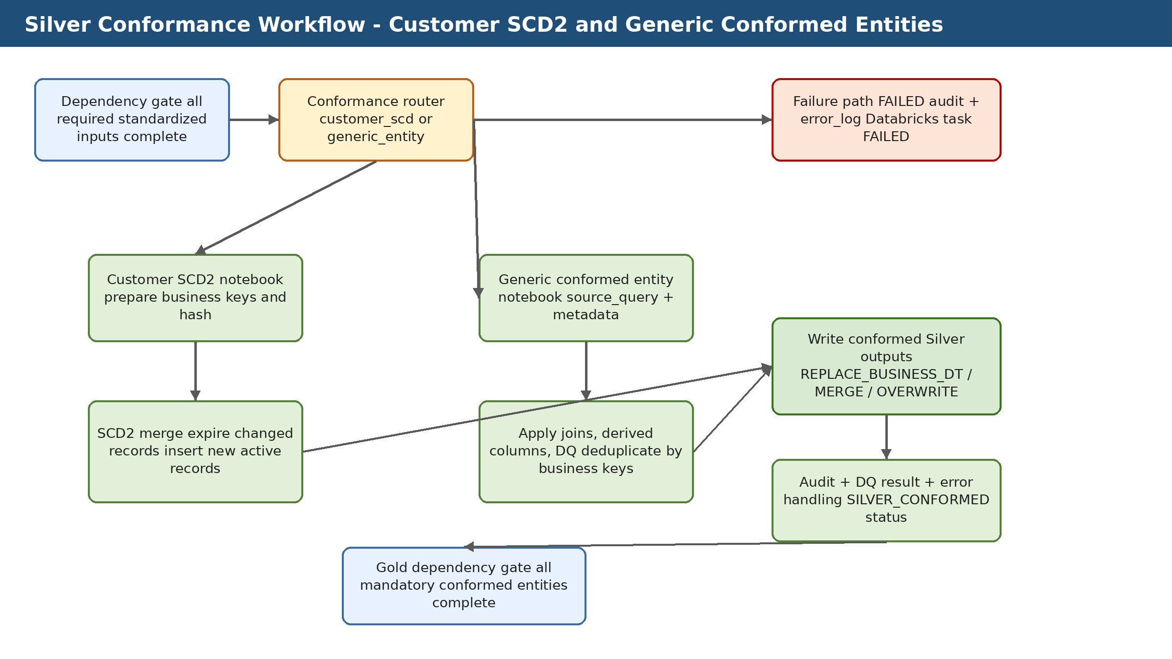

5. Runtime Parameters
Runtime parameters allow the same notebooks and modules to be reused across entities, environments, Databricks Jobs, ADF pipelines, and future Databricks Asset Bundle deployments. In production, ADF should own business-date and SLA orchestration, while Databricks Jobs own task execution and notebooks own layer-specific processing logic.
Parameter | Required | Example | Purpose
catalog_name | Yes | credit_risk_dev | Unity Catalog environment.
business_dt | Yes | 2026-06-02 | Conformance processing snapshot date.
pipeline_run_id | Yes | ADF/Databricks run id | Audit and lineage identifier.
entity_name | Conditional | conformed_bureau_credit | Used by generic entity conformance notebook.

6. Component Inventory
The following table lists the primary notebooks, Python modules, SQL scripts, tests, and documentation files used by this layer. Each component has a single responsibility to keep the framework modular, testable, and reusable.
Component | Type | Purpose
notebooks/03_silver_conformance/01_build_customer_scd2.py | Notebook | Dedicated customer SCD Type 2 processing notebook.
notebooks/03_silver_conformance/02_build_conformed_entity.py | Notebook | Generic metadata-driven notebook for all non-SCD conformed entities.
notebooks/03_silver_conformance/99_run_all_silver_conformance.py | Notebook | Wrapper/orchestration notebook for running conformance tasks in development or controlled testing.
src/conformance/silver_conformance_config_reader.py | Python module | Reads entity and derived-column metadata.
src/conformance/silver_conformance_transformer.py | Python module | Builds source DataFrame from source_query, applies derived columns, adds conformance metadata and record_hash, deduplicates by business keys.
src/conformance/silver_conformance_writer.py | Python module | Implements write strategies: replaceWhere by business_dt, full overwrite, and Delta MERGE.
src/conformance/silver_conformance_dq_validator.py | Python module | Reads and applies conformance DQ rules; aligns output schema for rejected records and DQ summaries.
src/conformance/hash_utils.py | Python module | Builds deterministic hash values for change detection or audit.
src/conformance/scd2_utils.py | Python module | Supports SCD2 logic such as current record identification, hash comparison, expiry and insertion.
01_metadata/07_create_silver_conformance_config_tables.sql | SQL script | Creates conformance entity and derived column metadata tables.
01_metadata/08_insert_silver_conformance_entity_config.py | Python script | Inserts conformance entity metadata using multiline SQL safely, preserving string literals such as train/test.
03_tables/03_create_silver_conformance_lakehouse_tables.sql | SQL script | Creates conformed Silver output tables.
tests/conformance/01_validate_silver_conformance_tables.sql | SQL test | Smoke tests for conformed table row counts and Customer SCD current-record uniqueness.

7. Silver Conformance Metadata and Tables
Metadata-driven design reduces hardcoding and allows new entities or business rules to be added with configuration changes instead of notebook rewrites. The metadata tables should be governed in Unity Catalog and updated through controlled deployment scripts.
Table / object | Purpose | Key columns or notes
config.silver_conformance_entity_config | Entity-level conformance configuration. | entity_name, source_query, target_catalog/schema/table, load_strategy, business_key_columns, hash_columns, active flag.
config.silver_conformance_derived_column_config | Derived-column metadata. | entity_name, derived_column_name, derived_sql_expression, target_data_type, column_sequence.
dq.data_quality_rules | Conformance-level DQ rules. | Rules scoped to conformed target tables; supports business_dt traceability if DQ tables contain business_dt.
silver.conformed_customer_scd2 | SCD2 customer dimension/entity. | customer_id, application_source, hash, is_current, valid_from, valid_to, business_dt.
silver.conformed_<entity> | Generic conformed outputs. | Business-aligned columns, business_dt, source_system, pipeline_run_id, record_hash, created/updated timestamps.

8. Customer SCD Type 2 Design
- Customer SCD2 is implemented separately because it requires historical tracking rather than simple business_dt replacement.
- Incoming standardized customer/application records are prepared with business keys and hash values.
- The framework compares incoming record hash to the current active record.
- If no change is detected, the active record remains unchanged.
- If change is detected, the existing record is expired and a new active record is inserted.
- The design preserves valid_from, valid_to, is_current, pipeline_run_id, and business_dt auditability.

9. Generic Conformance Design
- Generic conformance is metadata-driven through source_query and derived-column rules.
- The transformer applies SQL expressions for derived columns and metadata fields.
- Deduplication is driven by business_key_columns.
- Write behavior is driven by load_strategy: REPLACE_BUSINESS_DT, MERGE, or OVERWRITE.
- REPLACE_BUSINESS_DT is preferred when a run contains the complete business snapshot for one date.
Conformance load strategy:
- Customer SCD2: MERGE with SCD2 expiry/insert logic
- Snapshot-style conformed entities: replaceWhere business_dt = '<business_dt>'
- Slowly changing non-SCD entities: MERGE by business keys where required

10. Detailed Engineering Design Considerations

Design principles
- Use metadata to control behavior instead of hardcoding entity-specific logic in notebooks.
- Keep notebooks thin and reusable; place reusable logic in Python modules under src/.
- Separate orchestration control from technical execution audit.
- Use business_dt and pipeline_run_id as cross-layer traceability keys.
- Fail fast for missing metadata or target-table contract violations.
- Persist support diagnostics in Delta tables rather than relying on notebook display output.
- Make reruns deterministic and idempotent before enabling automatic retries.

Unity Catalog organization
Schema | Responsibility | Example objects
config | Static or slowly changing processing metadata | bronze_ingestion_config, silver_column_config, silver_conformance_entity_config
bronze | Raw persisted source data | application_train, bureau, bureau_balance
silver | Standardized and conformed curated data | standardized_bureau_balance, conformed_customer_scd2
gold | Business-ready dimensional and fact marts | dim_customer, fact_credit_application, fact_customer_risk_snapshot
dq | Rejected records and DQ results | rejected_records, data_quality_results
audit | Technical execution logs | pipeline_run_log, table_load_log, error_log
orchestration | ADF control and dependency state | file_arrival_status, layer_processing_status, pipeline_run_control

ADF and Databricks responsibility split
Responsibility | Owner | Reason
Business date calculation and SLA polling | ADF | ADF is better suited for external orchestration, time windows, waiting, and branching.
Layer transformation execution | Databricks Jobs | Databricks is the processing engine for Spark/Delta workloads.
Reusable transformation logic | Python modules and SQL scripts | Version-controlled code is easier to test and deploy.
Technical run details | Audit and DQ Delta tables | Persistent evidence supports production troubleshooting and audit.
Manual repair of failed task | Databricks Jobs repair run | Only failed tasks should be rerun when downstream dependencies allow.

Rerun and recovery matrix
Failure point | recovery | Duplicate-risk control
Before any table write | Rerun task normally | No data written.
After data write but before audit success | Retry/repair audit update only if possible; otherwise verify data then repair carefully | business_dt partition check and table history.
DQ/rejection failure | Fix metadata/rule and rerun affected entity only | pipeline_run_id and rejected-record summary.
Downstream dependency not ready | Hold downstream layer and continue polling/status check | layer_processing_status.
Gold fact failed after dimensions completed | Repair only failed Gold task and dependent snapshot | idempotent replace/merge by business_dt.

11. Audit, Error Handling, and Observability
The layer follows a production-style observability pattern: technical execution state is written to audit tables, technical failures are written to an error log, and detailed DQ or rejection details are persisted in Delta tables where applicable. Databricks notebook output is useful for development, but Delta audit tables should be treated as the authoritative operational record.
Object | Responsibility | Typical usage
audit.pipeline_run_log | Tracks pipeline-level STARTED, SUCCESS, and FAILED status. | Used by ADF and support teams to check overall run outcome.
audit.table_load_log | Tracks entity/table-level processing with records read, written, rejected, and duration. | Used for table-level troubleshooting and layer completion checks.
audit.error_log | Stores technical exception details, stack trace, source table/path, and severity. | Used for production support and failed-run analysis.
orchestration.layer_processing_status | control table for ADF dependency checks across Bronze, Silver, Conformance, and Gold. | Used to decide whether downstream layer can start.

Retry Philosophy
- Retry only small audit/error SQL updates for Delta concurrency conflicts.
- Do not blindly retry the full Databricks task after data has already loaded successfully unless the notebook is idempotent by business_dt.
- Use Databricks repair runs to rerun only failed tasks in multi-task jobs.
- Use business_dt partition replacement or MERGE strategies to protect against duplicate results.

12. Production Operations and Support Model

Monitoring entry points
- Databricks Job Run UI and task graph.
- audit.pipeline_run_log and audit.table_load_log.
- audit.error_log for technical exceptions.
- DQ/rejected-record tables where applicable.
- DESCRIBE HISTORY and DESCRIBE DETAIL for Delta operational analysis.
- ADF pipeline run output and orchestration control tables.

Common support queries
SELECT *
FROM credit_risk_dev.audit.table_load_log
WHERE pipeline_run_id = '<pipeline_run_id>'
ORDER BY start_timestamp;
SELECT *
FROM credit_risk_dev.audit.error_log
WHERE pipeline_run_id = '<pipeline_run_id>'
ORDER BY created_timestamp DESC;
DESCRIBE HISTORY credit_risk_dev.<schema>.<table_name>;
DESCRIBE DETAIL credit_risk_dev.<schema>.<table_name>;

Production readiness checklist
- All tables and configuration rows are deployed through version-controlled scripts.
- Runtime parameters are documented and passed consistently by ADF/Databricks Jobs.
- Audit and error logging are tested for success and failure paths.
- Rerun behavior is tested for the same business_dt.
- Layer-level status is persisted for downstream dependency checks.
- Access is governed through Unity Catalog grants and service-principal identities.
- Rejected and error records are protected if they contain sensitive data.

12. Silver Conformance Detailed Technical Appendix

Entity configuration contract
Metadata item | Purpose | Example
source_query | SQL used to construct the conformance input DataFrame. | SELECT ... FROM silver.standardized_application_train
target_table_name | Conformed table to write. | conformed_bureau_credit
load_strategy | Controls write behavior. | REPLACE_BUSINESS_DT / MERGE / OVERWRITE
business_key_columns | Business keys used for deduplication or merge. | sk_id_bureau, customer_id
hash_columns | Columns used for record_hash generation. | customer attributes / tracked fields
active_flag | Enables or disables an entity. | true

SCD2 operational contract
- Only one current record should exist per customer/application business key.
- Change detection should be based on stable hash columns, not ingestion timestamps.
- Existing active record is expired when a tracked attribute changes.
- New active record receives valid_from equal to business_dt and open-ended valid_to.
- business_dt and pipeline_run_id must be retained for auditability.

Generic conformance write strategies
Strategy | When to use | Risk/control
REPLACE_BUSINESS_DT | Complete snapshot for one business date. | Safe rerun if replaceWhere filters only that business_dt.
MERGE | Incremental upsert by business keys. | Requires reliable business keys and merge condition.
OVERWRITE | Small development-only controlled cases. | Avoid for production unless full-table rebuild is intentional.

Conformance validation queries
-- Row counts by business date
SELECT 'conformed_customer_scd2' AS table_name, business_dt, COUNT(*) AS row_count
FROM credit_risk_dev.silver.conformed_customer_scd2
GROUP BY business_dt;
-- SCD2 uniqueness check
SELECT customer_id, application_source, COUNT(*) AS current_record_count
FROM credit_risk_dev.silver.conformed_customer_scd2
WHERE is_current = true
GROUP BY customer_id, application_source
HAVING COUNT(*) > 1;

