Azure Databricks Credit Risk Lakehouse Project

Gold Layer Technical Documentation
Credit risk dimensional mart, fact tables, customer risk snapshot, and reporting-ready outputs

Document attribute | Value
Project | Azure Databricks Credit Risk Lakehouse Project
Layer | Gold Layer
Author | Gijo Baby
Document status | Initial draft
Version | 1.0

Contents
1. Document Purpose 3
2. Layer Objective 3
3. Scope 3
3.1 In Scope 3
3.2 Out of Scope 3
4. Workflow Diagram 4
5. Runtime Parameters 5
6. Component Inventory 5
7. Gold Tables and Data Mart Objects 5
8. Gold Design Pattern: Python Wrapper + SQL Transformation 6
9. Gold Task Dependency Model 6
10. Detailed Engineering Design Considerations 6
Design principles 6
Unity Catalog organization 6
ADF and Databricks responsibility split 7
Rerun and recovery matrix 7
11. Audit, Error Handling, and Observability 7
Retry Philosophy 7
12. Production Operations and Support Model 8
Monitoring entry points 8
Common support queries 8
Production readiness checklist 8
13. Gold Layer Detailed Technical Appendix 8
Gold task inventory and dependency position 8
Gold idempotency standard 8
Gold validation queries 9

1. Document Purpose
This document provides a detailed technical description of the Gold layer in the Azure Databricks Credit Risk Lakehouse project. It is written in a corporate engineering style and is intended to support portfolio review, technical interviews, implementation handover, and production-readiness assessment.
The document explains the layer objective, processing responsibilities, notebooks, Python modules, metadata tables, runtime parameters, execution sequence, audit/error handling, rerun behavior, operational monitoring, and Phase 2 improvements.

2. Layer Objective
The Gold layer converts conformed Silver data into business-ready analytical Delta tables. It creates dimensions, facts, exposure metrics, payment behavior views, credit utilization metrics, and a final customer risk snapshot suitable for Power BI, SQL Analytics, and portfolio demonstrations.

3. Scope

3.1 In Scope
- Read conformed Silver entities after dependency checks.
- Build reusable dimensions and facts.
- Apply SQL-based transformation logic wrapped by Python orchestration.
- Write Gold Delta tables with business_dt-aware idempotency.
- Generate the final customer risk snapshot as the primary reporting entry point.
- Maintain audit/error logs and support Databricks repair runs.
- Provide dbt-readiness by keeping transformation SQL isolated from orchestration code.

3.2 Out of Scope
- Raw ingestion and file polling.
- Silver technical validation and rejected-record handling.
- Customer SCD2 conformance creation.
- ADF orchestration metadata management.

4. Workflow Diagram
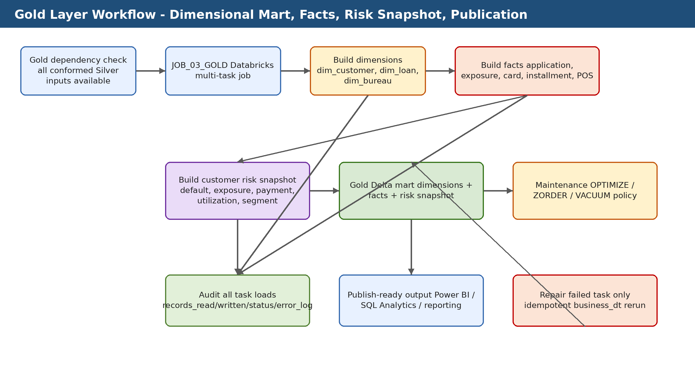

5. Runtime Parameters
Runtime parameters allow the same notebooks and modules to be reused across entities, environments, Databricks Jobs, ADF pipelines, and future Databricks Asset Bundle deployments. In production, ADF should own business-date and SLA orchestration, while Databricks Jobs own task execution and notebooks own layer-specific processing logic.
Parameter | Required | Example | Purpose
catalog_name | Yes | credit_risk_dev | Unity Catalog environment.
business_dt | Yes | 2026-06-02 | Gold processing snapshot date and rerun partition.
pipeline_run_id | Yes | ADF/Databricks run id | Audit and lineage identifier.
environment | Recommended | dev | Environment label for audit and deployment.
write_mode | Recommended | replace_business_dt | Controls idempotent table write behavior.

6. Component Inventory
The following table lists the primary notebooks, Python modules, SQL scripts, tests, and documentation files used by this layer. Each component has a single responsibility to keep the framework modular, testable, and reusable.
Component | Type | Purpose
notebooks/04_gold/01_build_dim_customer.py | Notebook | Builds customer dimension from conformed customer/SCD outputs.
notebooks/04_gold/02_build_dim_loan_application.py | Notebook | Builds loan application dimension.
notebooks/04_gold/03_build_dim_bureau_credit.py | Notebook | Builds bureau credit dimension.
notebooks/04_gold/04_build_fact_credit_application.py | Notebook | Builds credit application fact table.
notebooks/04_gold/05_build_fact_bureau_credit_exposure.py | Notebook | Builds bureau exposure fact table.
notebooks/04_gold/06_build_fact_credit_card_balance_monthly.py | Notebook | Builds monthly credit card balance fact table.
notebooks/04_gold/07_build_fact_installment_payment.py | Notebook | Builds installment payment fact table.
notebooks/04_gold/08_build_fact_pos_cash_balance_monthly.py | Notebook | Builds monthly POS cash balance fact table.
notebooks/04_gold/09_build_fact_customer_risk_snapshot.py | Notebook | Builds final customer risk snapshot for reporting.
notebooks/04_gold/99_run_all_gold.py | Notebook | Development wrapper for running the full Gold sequence.
src/gold/gold_sql_executor.py | Python module | Executes Gold SQL transformations with audit-friendly reusable behavior.
sql/03_tables/04_create_gold_lakehouse_tables.sql | SQL script | Creates Gold Delta dimensions, facts, and risk snapshot tables.
sql/05_maintenance/05_maintain_gold_tables.sql | SQL script | Contains table maintenance operations such as OPTIMIZE and VACUUM.
tests/gold/01_validate_gold_layer.sql | SQL test | Validates row counts, key relationships, and basic Gold table integrity.
dbt_phase2/README_dbt_migration.md | Documentation | Explains how the SQL blocks can be migrated to dbt models later.

7. Gold Tables and Data Mart Objects
Metadata-driven design reduces hardcoding and allows new entities or business rules to be added with configuration changes instead of notebook rewrites. The metadata tables should be governed in Unity Catalog and updated through controlled deployment scripts.
Table / object | Purpose | Key columns or notes
gold.dim_customer | Customer dimension. | Customer-level descriptive attributes and keys sourced from conformed customer data.
gold.dim_loan_application | Loan application dimension. | Loan/application descriptors for reporting and slicing.
gold.dim_bureau_credit | Bureau credit dimension. | Credit bureau relationship and descriptive attributes.
gold.fact_credit_application | Credit application fact. | Application-level measures, default indicators, and credit request metrics.
gold.fact_bureau_credit_exposure | Bureau exposure fact. | External credit exposure metrics.
gold.fact_credit_card_balance_monthly | Credit card balance fact. | Monthly utilization and balance metrics.
gold.fact_installment_payment | Installment payment fact. | Payment behavior and delay indicators.
gold.fact_pos_cash_balance_monthly | POS cash monthly fact. | Monthly POS/cash balance behavior.
gold.fact_customer_risk_snapshot | Primary reporting table. | Customer-level risk snapshot combining default, exposure, utilization, payment behavior, and segmentation.

8. Gold Design Pattern: Python Wrapper + SQL Transformation
The Gold layer intentionally separates orchestration from transformation. Python notebooks are used for widgets, runtime parameters, audit, error handling, and execution control. SQL blocks contain the actual business transformations, which makes the implementation easy to review and ready for a future dbt migration.
Python wrapper responsibilities:
- Read catalog_name, business_dt, pipeline_run_id
- Start audit records
- Execute SQL transformation
- Count records written
- Update audit success/failure
- Raise exception to Databricks Jobs/ADF on failure
SQL responsibilities:
- Join conformed Silver entities
- Select business columns
- Derive metrics and indicators
- Write dimensions, facts, and risk snapshot

9. Gold Task Dependency Model
- Build dimensions first: customer, loan application, and bureau credit.
- Build facts after dimension inputs are available.
- Build customer risk snapshot after all required facts are complete.
- Use one Databricks multi-task Job rather than separate jobs per notebook.
- Use Databricks repair run to rerun only failed Gold tasks.
- Ensure each notebook is idempotent by business_dt before enabling automatic task retry.

10. Detailed Engineering Design Considerations

Design principles
- Use metadata to control behavior instead of hardcoding entity-specific logic in notebooks.
- Keep notebooks thin and reusable; place reusable logic in Python modules under src/.
- Separate orchestration control from technical execution audit.
- Use business_dt and pipeline_run_id as cross-layer traceability keys.
- Fail fast for missing metadata or target-table contract violations.
- Persist support diagnostics in Delta tables rather than relying on notebook display output.
- Make reruns deterministic and idempotent before enabling automatic retries.

Unity Catalog organization
Schema | Responsibility | Example objects
config | Static or slowly changing processing metadata | bronze_ingestion_config, silver_column_config, silver_conformance_entity_config
bronze | Raw persisted source data | application_train, bureau, bureau_balance
silver | Standardized and conformed curated data | standardized_bureau_balance, conformed_customer_scd2
gold | Business-ready dimensional and fact marts | dim_customer, fact_credit_application, fact_customer_risk_snapshot
dq | Rejected records and DQ results | rejected_records, data_quality_results
audit | Technical execution logs | pipeline_run_log, table_load_log, error_log
orchestration | ADF control and dependency state | file_arrival_status, layer_processing_status, pipeline_run_control

ADF and Databricks responsibility split
Responsibility | Owner | Reason
Business date calculation and SLA polling | ADF | ADF is better suited for external orchestration, time windows, waiting, and branching.
Layer transformation execution | Databricks Jobs | Databricks is the processing engine for Spark/Delta workloads.
Reusable transformation logic | Python modules and SQL scripts | Version-controlled code is easier to test and deploy.
Technical run details | Audit and DQ Delta tables | Persistent evidence supports production troubleshooting and audit.
Manual repair of failed task | Databricks Jobs repair run | Only failed tasks should be rerun when downstream dependencies allow.

Rerun and recovery matrix
Failure point | recovery | Duplicate-risk control
Before any table write | Rerun task normally | No data written.
After data write but before audit success | Retry/repair audit update only if possible; otherwise verify data then repair carefully | business_dt partition check and table history.
DQ/rejection failure | Fix metadata/rule and rerun affected entity only | pipeline_run_id and rejected-record summary.
Downstream dependency not ready | Hold downstream layer and continue polling/status check | layer_processing_status.
Gold fact failed after dimensions completed | Repair only failed Gold task and dependent snapshot | idempotent replace/merge by business_dt.

11. Audit, Error Handling, and Observability
The layer follows a production-style observability pattern: technical execution state is written to audit tables, technical failures are written to an error log, and detailed DQ or rejection details are persisted in Delta tables where applicable. Databricks notebook output is useful for development, but Delta audit tables should be treated as the authoritative operational record.
Object | Responsibility | Typical usage
audit.pipeline_run_log | Tracks pipeline-level STARTED, SUCCESS, and FAILED status. | Used by ADF and support teams to check overall run outcome.
audit.table_load_log | Tracks entity/table-level processing with records read, written, rejected, and duration. | Used for table-level troubleshooting and layer completion checks.
audit.error_log | Stores technical exception details, stack trace, source table/path, and severity. | Used for production support and failed-run analysis.
orchestration.layer_processing_status | control table for ADF dependency checks across Bronze, Silver, Conformance, and Gold. | Used to decide whether downstream layer can start.

Retry Philosophy
- Retry only small audit/error SQL updates for Delta concurrency conflicts.
- Do not blindly retry the full Databricks task after data has already loaded successfully unless the notebook is idempotent by business_dt.
- Use Databricks repair runs to rerun only failed tasks in multi-task jobs.
- Use business_dt partition replacement or MERGE strategies to protect against duplicate results.

12. Production Operations and Support Model

Monitoring entry points
- Databricks Job Run UI and task graph.
- audit.pipeline_run_log and audit.table_load_log.
- audit.error_log for technical exceptions.
- DQ/rejected-record tables where applicable.
- DESCRIBE HISTORY and DESCRIBE DETAIL for Delta operational analysis.
- ADF pipeline run output and orchestration control tables.

Common support queries
SELECT *
FROM credit_risk_dev.audit.table_load_log
WHERE pipeline_run_id = '<pipeline_run_id>'
ORDER BY start_timestamp;
SELECT *
FROM credit_risk_dev.audit.error_log
WHERE pipeline_run_id = '<pipeline_run_id>'
ORDER BY created_timestamp DESC;
DESCRIBE HISTORY credit_risk_dev.<schema>.<table_name>;
DESCRIBE DETAIL credit_risk_dev.<schema>.<table_name>;

Production readiness checklist
- All tables and configuration rows are deployed through version-controlled scripts.
- Runtime parameters are documented and passed consistently by ADF/Databricks Jobs.
- Audit and error logging are tested for success and failure paths.
- Rerun behavior is tested for the same business_dt.
- Layer-level status is persisted for downstream dependency checks.
- Access is governed through Unity Catalog grants and service-principal identities.
- Rejected and error records are protected if they contain sensitive data.

13. Gold Layer Detailed Technical Appendix

Gold task inventory and dependency position
Task | Output table | Dependency position
01_build_dim_customer | gold.dim_customer | Dimension task; run before facts and risk snapshot.
02_build_dim_loan_application | gold.dim_loan_application | Dimension task; run before application facts.
03_build_dim_bureau_credit | gold.dim_bureau_credit | Dimension task; run before bureau exposure facts.
04_build_fact_credit_application | gold.fact_credit_application | Fact task after dimensions.
05_build_fact_bureau_credit_exposure | gold.fact_bureau_credit_exposure | Fact task after bureau dimension and conformed bureau data.
06_build_fact_credit_card_balance_monthly | gold.fact_credit_card_balance_monthly | Fact task from conformed card balances.
07_build_fact_installment_payment | gold.fact_installment_payment | Fact task from conformed installment payments.
08_build_fact_pos_cash_balance_monthly | gold.fact_pos_cash_balance_monthly | Fact task from conformed POS/cash balances.
09_build_fact_customer_risk_snapshot | gold.fact_customer_risk_snapshot | Final mart output after all required facts.

Gold idempotency standard
- Each Gold notebook should be safe to rerun for the same business_dt.
- Prefer DELETE + INSERT or replaceWhere by business_dt for snapshot-style tables.
- Use MERGE only when a stable key and update semantics are required.
- Avoid simple append for rerunnable Gold facts unless downstream deduplication is guaranteed.
- Validate record counts and key uniqueness after each task.

Gold validation queries
-- Row count by business date across Gold outputs
SELECT business_dt, COUNT(*) AS row_count
FROM credit_risk_dev.gold.fact_customer_risk_snapshot
GROUP BY business_dt
ORDER BY business_dt DESC;
-- Check customer risk snapshot duplicate keys
SELECT customer_id, business_dt, COUNT(*) AS cnt
FROM credit_risk_dev.gold.fact_customer_risk_snapshot
GROUP BY customer_id, business_dt
HAVING COUNT(*) > 1;
-- Check latest Delta operation history
DESCRIBE HISTORY credit_risk_dev.gold.fact_customer_risk_snapshot;

