1. Implement with different learning rates of ${5*10}^{-7}, {{5*10}^{-9}, and 5*10}^{-11}$ and plot objective function (Loss function) as a function of iteration. The plots are show below.

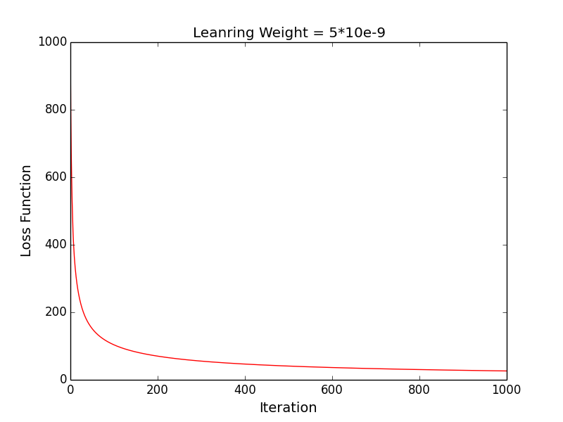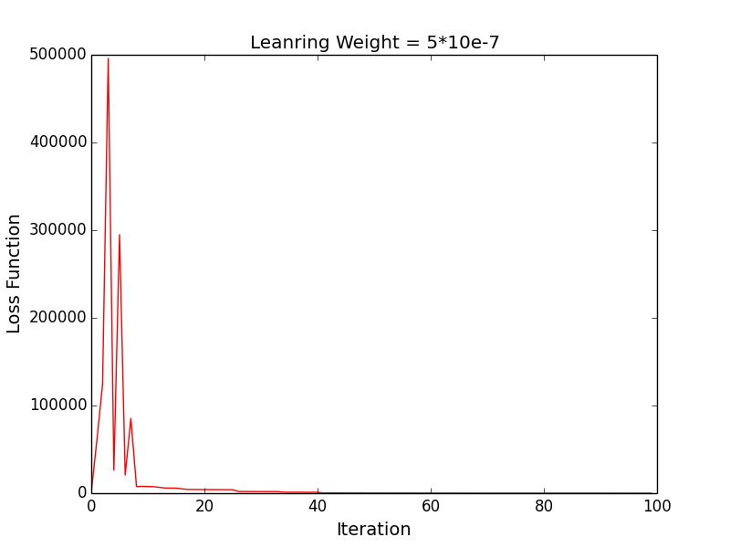

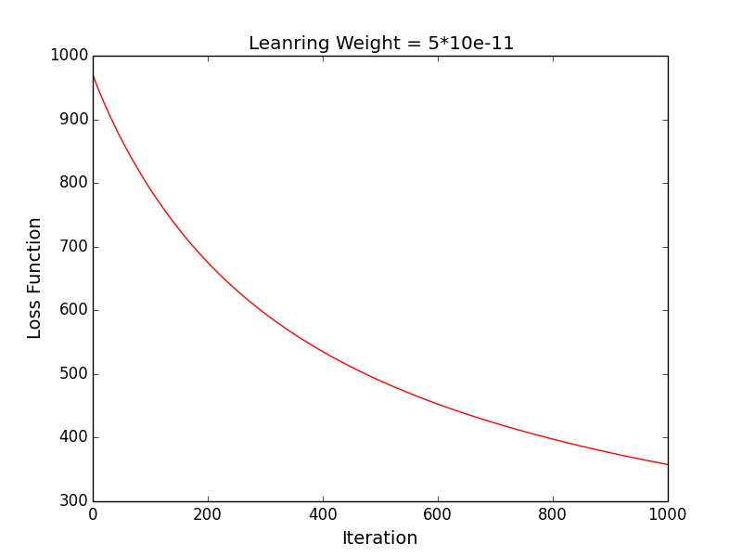

While we set learning rate as ${5e}^{-7}$, we observed that the objective function fluctuated at small iteration; if we set learning rate as ${5e}^{-11}$, we observed the objective function decreases slowly, which means slow convergence during gradient descent. When we set learning rate as ${5e10}^{-9}$, the objective function converged fast and no fluctuation so we choose ${5e10}^{-9}$ as our final learning rate.

1. For each gradient iteration, plot the training accuracy and the test accuracy as a function of the number of gradient descent iterations by using the learning rate as ${5*10}^{-9}$. The plots are shown below.

3.

**Gradient of new objective function:**

d = $\sum_{i=0}^{n}{\left(y^{i}-g\left(w^{T}\right)\right)x^{i}+}w$

**Pseudo Code for modified algorithm:**

Given training example (xi, yi), I = 1, …, N

Let w 🡨 (0,0,0….,0)

Repeat until convergence encountered:

$for i = 1 to N do:$

${\hat{y}}^{i}←\frac{1}{1+e^{-w*x^{i}}}$

$error= y^{i}- {\hat{y}}^{i}$

$d=d+error∙$

$$x^{i}w←w+η(d+λw)$$

4.