Alter-Egos

by Matt Buland, Maria Deslis, and Eric Young

Purpose
The Alter-Egos app is designed to work as an RPG game assistant. Its main goal is to provide tools for any RPG player to maintain their characters and inventories for one or many games.

Usage Flow
The general usage of the Alter-Egos will work like a tree. First, the user selects the game he/she would like to manage. Then, the user is presented with a menu of different views to describe the state of their game. The tree will be single-directional, so pressing the back button on any of the screens will return to the previous node in the state it was before (as opposed to starting a new activity).

Screen Definitions / Descriptions (Illustrations in Appendix A)
- Global Options Menu
  - Roll Die (start DieRollDialog)
- Select Game
  - List View containing the different games
  - When one of these games is selected, the GameCarousel is started, and passed the game_id
- GameCarousel – Display the different views in a rotating carousel (swipe left/right. Looping)
  - If no character has been created for the game, only one fragment will populate the carousel (Figure 2). This fragment states that there is no character for the game, and has a button that will bring up a create-character dialog. (See #5)
  - If there IS a character for the game (including after a character has been created), the following views will be shown
  - StatViewer (Figure 3)– Display the name and description of the character, and their base attributes, skills, and complications
  - InventoryManager (Figure 4) – Display the names of all items in the inventory in a ListView. Provide a button for adding items. Long-pressing will bring a context menu allowing the removal of an item (verified with an OK/Cancel dialog). Regular-clicking on an item will bring-up a read-only Dialog displaying the item (described later).
  - NotesRecorder (Figure 5) – Maintain a set of notes related to the game. Each note's name will be shown in a ListView. Clicking on a note will bring up the edit-note dialog (described later).
- DieRollDialog (Figure 6)– Has a single EditText for die-string input (based on Roll20's die rolling language), and one TextView that shows the progressive result, and sum.
- CreateCharacterDialog (Figure 7)– Adds a new character to the database. Each character needs a name, description, and set of attributes. The attributes will be displayed in a ListView, and have a button to add new attributes via a dialog (See #6). Long-pressing the attribute will bring-up a context menu with a delete option. Active-saving will be implemented: After any change to the character, the information will be created/updated in the database. At the bottom of the screen will be OK and Cancel buttons. Pressing the back button will ask the user if they are sure they'd like to remove all changes. (Synonomous with pressing Cancel).
- NewAttributeDialog (Figure 8) – Adds a dialog to a character. It expects an integer describing the character_id. When the Dialog is created, a row is added into the database. Any changes will be actively saved (like the CreateCharacterDialog). Attributes need a name, a value, an attribute category, and a description.
- InventoryItemViewer (Figure 9)– Read-only viewer for an inventory item. It displays the name and description of the item, and a list of attributes/stats for the item. At the bottom will be a single close button that simply closes the dialog. Those will all be read-only. In the top-right corner will be a pencil-icon. When clicked, it will transform the view into an editing dialog. All changes will be actively saved into the database (like the dialogs before it). The previous close button will become a Cancel button, and an OK button will appear next to it (at the bottom of the screen). Pressing OK will save the object to the database, and return to the InventoryView, while pressing Cancel will revert the changes made, and return to the Inventory View.

Android Life-cycle and Data-flow
When the android system sends the app into a different state, it will be our mission to design the app to have prepared for the onStop/Destroy before it occurs. This mostly applies to editable dialogs, and views that interface with the database. The read-only components will be safe in-memory (stopped-state), or are able to be scrapped (destroy-state). The editable dialogs will go through a verification when being stopped that the database contains the correct information. Though it will be our goal to design our saving system to keep the database very updated, in preparation for these situations.

Incremental Implementation

V 0.1:
By version 0.1, it is expected that the underlying database will be fully implemented, and the basic screens to interact with the database will exist, but maybe not reachable (or testable).

V 1.0:
Version 1.0 will look nice, contain the carousel for fragments, and all views will be reachable, and the program flow will be correct. Testing will have also been done.

Data Flow
Select Game → Game Menu: Int representing Game Identifier
Game Menu → StatViewer: Int: GameID ; String: CharacterName

Database Usage/Implementation:
Table: game
int: game_id text:name

Table: character
int:game_id int:character_id text:name text:description

Table: inventory_item
int:character_id int:inventory_item_id

Table: statistic
int:entity_id int:stat_value text:stat_name text:description/usage/etc int:category_id

Table: category
int:category_id text:category_name

Table: notes
int game_id text:note

Appendix A: Illustrations

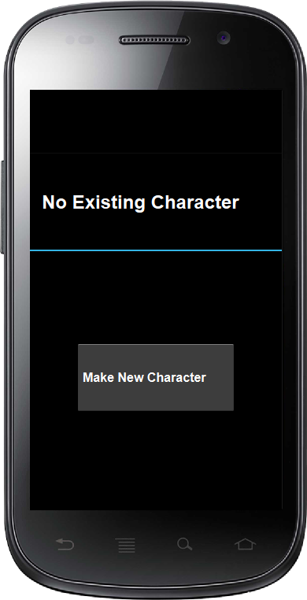Illustration 3: No Character Yet
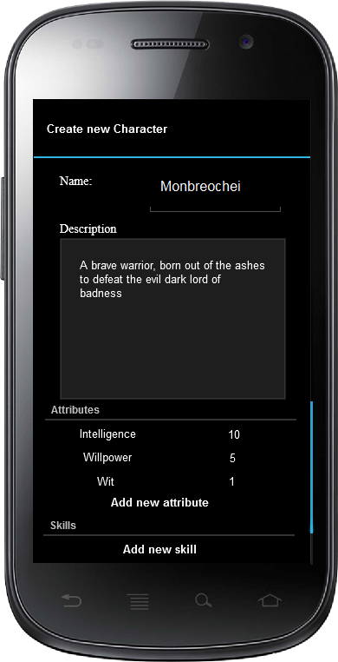Illustration 2: Creating New Character
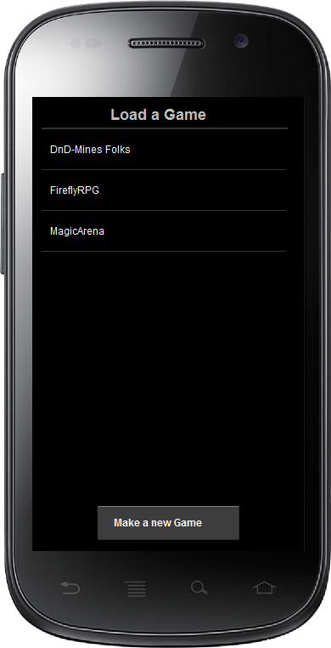Illustration 1: Select Game

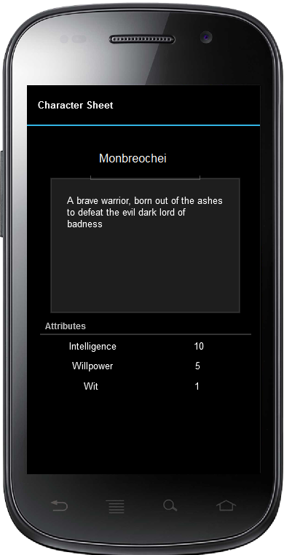Illustration 5: View Character
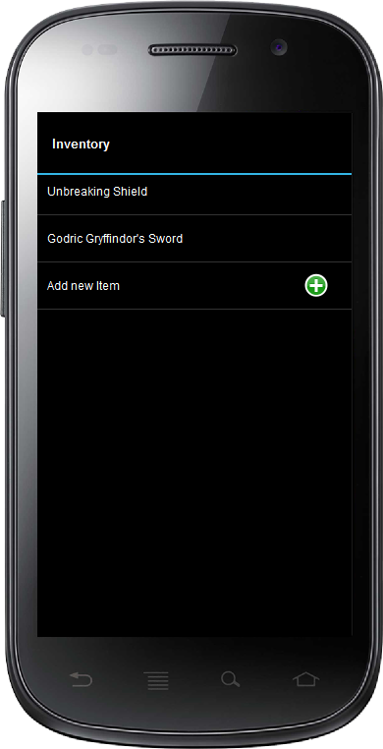Illustration 4: View Inventory
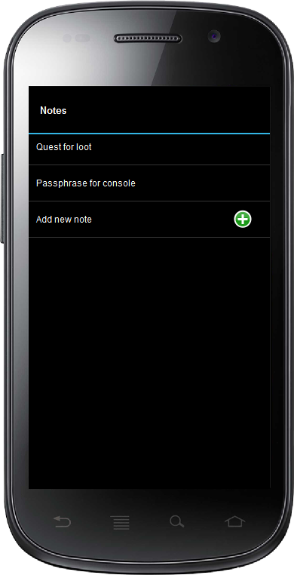Illustration 6: View Notes
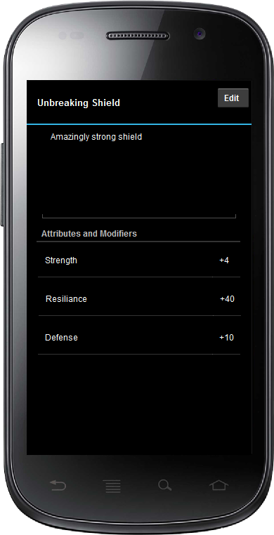Illustration 7: Inspecting an Inventory Item
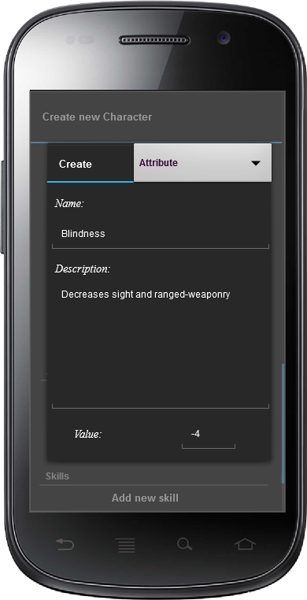Illustration 8: Add Attribute/Skill
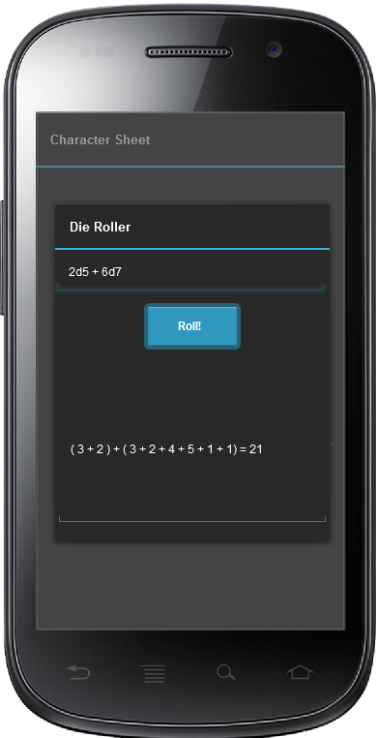Illustration 9: Die Roller Dialog

