Requirements Document for
the Pentaho Batch Publisher
Created By: Matt Buland, Software Engineering Intern

Goal/Project Vision
Creating a publishing utility for pentaho reports will provide an easy way to publish many reports at once. Beyond just publishing, there is a need for a suite of utilities to enhance operations with pentaho prpt files.

Scope
This utility suite could be of use to anyone who uses pentaho reporting. Opensourcing the project would enable the entire pentaho community to more effectively use pentaho reports.

Hard Requirements (prioritized)
- Publish prpt reports and xactions.
- Publish many reports/xactions in one command / action.
- Change the name of the destination report (file name)
- Graphical User Interface

Soft Requirements (unordered)
- Changeable:
  - Name
  - Description
  - Output type
  - Output lock

Unscoped Requirements and Ideas (unordered)
- Extract SQL
- Change JNDI name
- Comparison operations with svn and git integration

Design Highlights
Modularity should be the first concern with design. This project should be usable as a library, with independent components. Each independent component will be contained inside a single ruby file, so each extra file will be its own module. The usage of these components will be driven by either a graphical interface, or a command-line interface, which allow the use of all components.

Design Proposals
Library Access:
Each module must then have a 'handle' method that takes all of the arguments after the module, and executes the command with the options. The CLI driver will reflect the modularity in it's argument usage:
publisher.rb <module> <module-command> [OPTIONS]

Modules:
prpt Will offer report-modification tools (specific to prpts)
publish Publish utilities, and most web calls

GUI Design Ideas
- Similar to Pentaho Report Designer's publishing interface
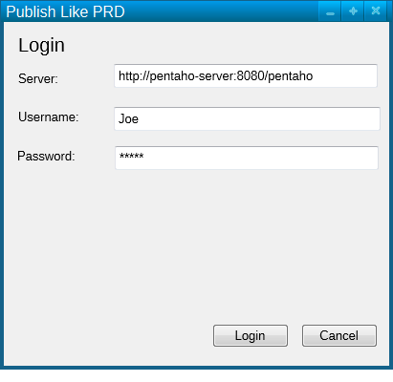Illustration 1: Login First
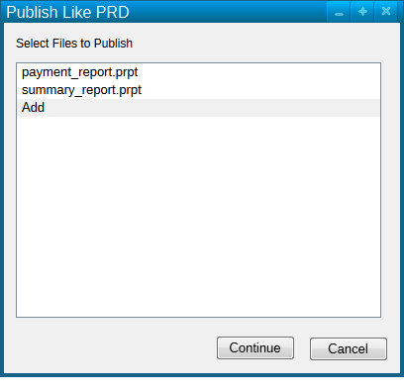Illustration 2: Then Choose some files to Publish
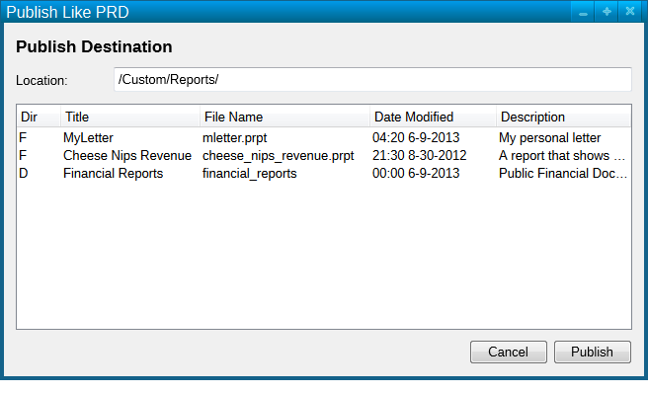Illustration 3: Finally, pick a destination

- Non-linear, unified interface, called Publishing Center.
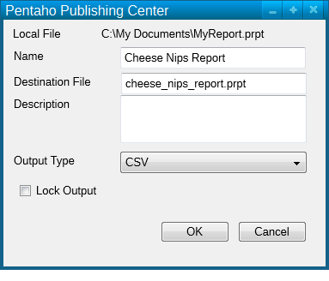Illustration 5: Right click a report to edit its details
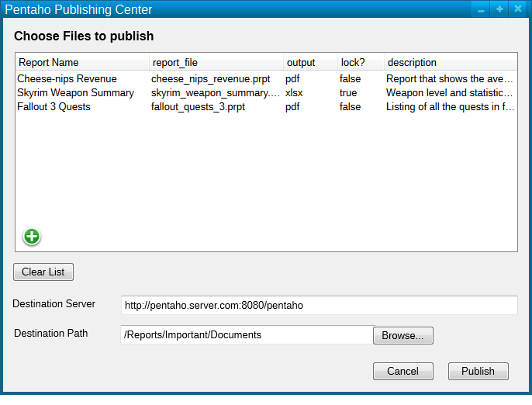Illustration 4: Publishing Center Interface

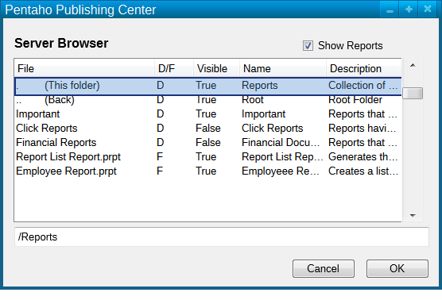Illustration 6: Pick a destination on the server
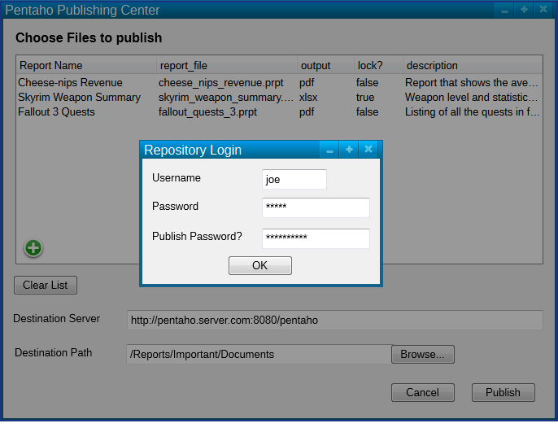Illustration 7: Hit the Publish button, provide credentials, and publish away!
Technologies
Pentaho BI-server offers a suite of web-calls that can be used to communicate with the server via HTTP requests. Appendix A will contain a record of the known web calls and their parameters. The target object of publication will first be a pentaho report (prpt file, generated by the Report Designer), but also an xaction, generated by the pentaho design studio.

Appenices

Appendix A – Pentaho Web Services
POST /repositoryfilepublisher?publishpath=_&publishkey=_&overwrite=_&mkdirs=_
Description:
Publish one or many files onto a BI-server
Parameters:
publishpath: Location in the repository to put the file
publishkey: md5hash of the publish password
and the string: 'P3ntah0Publ1shPa55w0rd'
overwrite: true|false: whether or not an existing file should be replaced on the server
mkdirs: If a folder specified in the publishpath does not exist, should it be created?
“filename” => file_data file to be published to the server. Many of these can be specified
GET /SolutionRepositoryService?component=getSolutionRepositoryDoc
Description:
Retrieve an XML representation of the file-tree on a BI-server
Parameters:
None

