Visual Features and Likes per Recorded Follower on Instagram: A Pre-Registered Mixed-Model Analysis of 583,830 Posts
Galya Aymalieva
Sofia University “St. Kliment Ohridski”, Faculty of Economics and Business Administration, 125 Tsarigradsko Shose Blvd., Block 3, 1113, Sofia, Bulgaria
gikonomova@uni-sofia.bg
Abstract - Do visual properties of a photograph predict how many likes it earns once audience size is taken into account? We analysed 583,830 Instagram photographs from 469,330 public accounts with a pre-registered negative binomial mixed model. The model has an account random intercept and uses the log of the recorded follower count as an offset. A finding counted only if it passed Holm-corrected significance, exceeded a ±3% smallest effect size of interest (with equivalence tests for null claims), and replicated in two disjoint halves of accounts. Higher overall aesthetic quality (+5.7% likes per follower per SD; IRR 1.057, 95% CI [1.055, 1.059]) and the presence of a detected person (IRR 1.239, [1.230, 1.249]) were supported. The aesthetic association held within accounts (IRR 1.042 [1.039, 1.045]), and its between-account component differed only negligibly. Colour vividness, often recommended to creators, had a practically negligible association (IRR 0.977, [0.974, 0.980]). On 94,172 held-out accounts, visual features improved the joint log predictive score by 0.0160 nats per post (95% CI [0.0148, 0.0170]). A freely estimated follower elasticity of 0.629 shows that likes grow sublinearly with audience size. The study demonstrates an auditable CRISP-DM workflow for large-sample social-media inference.
DOI: —–
Corresponding author: Galya Aymalieva, Sofia University “St. Kliment Ohridski”
Email: gikonomova@uni-sofia.bg
Received: —–. Revised: —–. Accepted: —–. Published: —–.
© 2026 Galya Aymalieva. This work is licensed under the Creative Commons Attribution-NonCommercial-NoDerivatives 4.0 International License. The article is published with Open Access at http://csirjournal.com/
Keywords – social media analytics, computational aesthetics, negative binomial mixed model, pre-registration, equivalence testing, CRISP-DM

Introduction
Instagram is the largest image-first social platform, and the number of likes a post receives is its most visible engagement signal. Brands, influencers, and public-sector communicators invest in visual production in the belief that how a picture looks affects how well it performs. A computational literature supports this belief. Computer-vision features have been associated with engagement in influencer marketing [1], food marketing [2], tourism [3, 4], architectural photography [5], and public-health communication [6]. Image content has been shown to matter beyond text in marketing research [7], and photographs containing faces have been reported to attract more likes [8].
Two features of this literature limit what a practitioner can take from it. First, most studies analyse a few hundred to a few tens of thousands of posts from a limited set of accounts [1-6]. Larger studies [18, 26] focus on prediction or profiling rather than on isolating visual associations. In cross-sectional data, account identity, audience size, and visual style are entangled. Accounts with larger audiences may also have larger production budgets, so their photographs are both more polished and more liked. Second, results are typically reported as statistical significance from exploratory modelling. At the sample sizes now common in social-media research, a p-value alone is uninformative [9], and screening many features without a prior protocol invites researcher degrees of freedom [10].
This paper addresses both limitations. We analyse 583,830 photo posts from 469,330 public accounts with a negative binomial generalised linear mixed model (NB-GLMM) in which the log of the recorded follower count enters as an offset. Each coefficient is therefore a multiplicative association with likes relative to the recorded follower count. This is a pragmatic normalisation: follower counts are not impressions, and Section 3.1 discusses how they differ. A random intercept per account captures stable account-level heterogeneity, and a Mundlak decomposition [11, 12] separates within-account from between-account associations. The work follows the CRISP-DM process model [13, 14]. The five confirmatory hypotheses, the smallest effect size of interest (SESOI), the multiplicity correction, and the replication criterion were committed to a version-controlled protocol before any model relating visual features to likes was estimated [10]. One amendment, made before any confirmatory result existed, clarified the decision rules (Section 4.5).
We ask two research questions:
- RQ1. Which visual properties (overall aesthetic quality, colour vividness, presence of a detected person) are associated with likes per recorded follower by an amount that is both statistically significant and larger than a pre-specified practical threshold? Do these associations replicate across disjoint sets of accounts?
- RQ2. Do visual features improve the prediction of likes for accounts the model has not seen, beyond follower count, timing, and caption controls?
In brief, two visual properties pass all criteria: overall aesthetic quality (+5.7% likes per recorded follower per SD) and the presence of a person (about +22%). The aesthetic association holds within accounts. Colour vividness has a practically negligible association. Visual features improve held-out prediction by a small but reliable margin.
The contributions are fourfold. (i) A pre-registered, audience-normalised analysis of visual features at the scale of over half a million posts. It uses a decision rule that combines Holm-corrected significance, a ±3% SESOI with equivalence testing [15], and internal split-half replication, so practically meaningful associations are separated from those that are merely detectable at large n. (ii) A quantification of within-account versus between-account associations, which shows how far visual “drivers” reported in cross-sectional studies may reflect differences between accounts. (iii) A held-out evaluation of predictive value using the joint log predictive score for new accounts [16], reported together with calibration diagnostics [27]. (iv) A fully auditable pipeline: code, decision log, protocol and amendment (as git tags), and aggregate outputs. Figure 1 maps the CRISP-DM phases to the study’s artefacts.
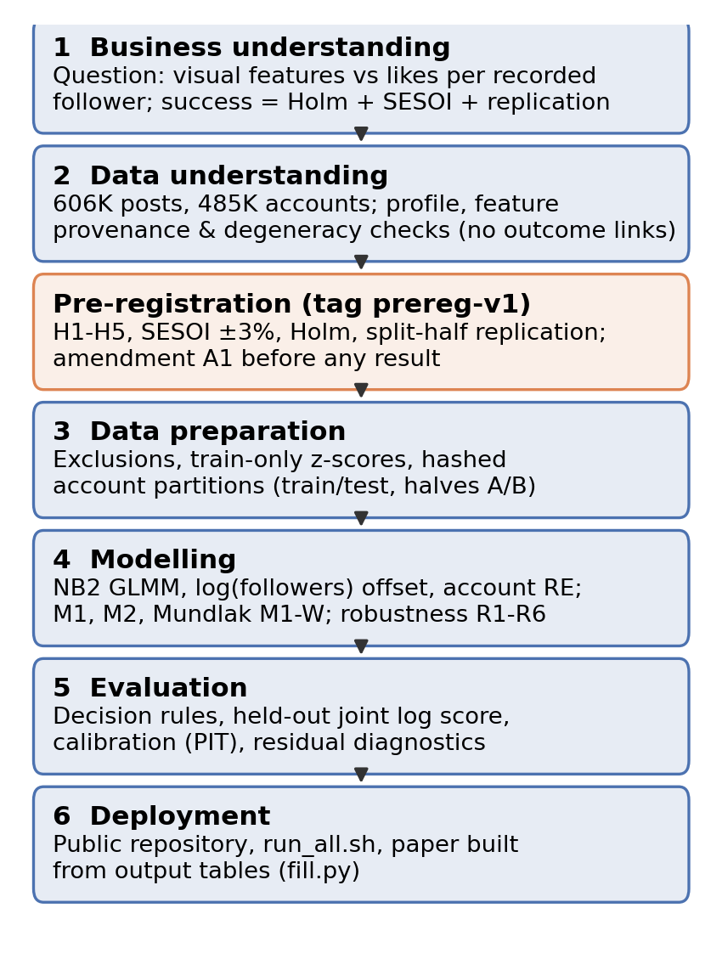
Figure 1. Study design: CRISP-DM phases and the point at which the protocol was registered.
Related Work
Image features and engagement
Early large-scale work on Flickr found that image content predicts view counts, but much less well than social context such as follower counts [17]. On Instagram, photos with faces were reported to receive 38% more likes [8]. Our person indicator comes from a general object detector (the COCO “person” class [22]). It also flags people seen from behind or at a distance, so it is a broader construct than face detection. Li and Xie [7] found that image presence and professional quality are associated with engagement on Twitter and Instagram, with effects that depend on platform and content. Domain studies have used off-the-shelf vision models to code content: colour schemes in tourism photographs [3], food typicality [2], lines and corners in travel-agency posts [4], and image classes in anti-vaping campaigns [6]. In experimental aesthetics, Instagram likes on architectural photographs have been validated as a measure of aesthetic appeal [5]. Popularity-prediction studies combine user, post, and image features [18-20]. They report high rank correlations that are driven largely by user features, and they rarely isolate the visual contribution. Large Instagram corpora have also been used to profile influencers by topic [26] rather than to estimate visual associations with engagement.
Computational aesthetics
The AADB dataset and attribute-adaptive ranking network of Kong et al. [21] defined eleven interpretable photographic attributes alongside an overall aesthetic score: balancing elements, colour harmony, content, depth of field, lighting, motion blur, object emphasis, repetition, rule of thirds, symmetry, and vivid colour. These give a vocabulary for what kind of aesthetic quality matters, which a single score cannot. The dataset used here provides AADB-named attributes, COCO-style object labels, and a shot-scale classification for each image. Their provenance is discussed in Section 3.2.
Methodological gaps
Three gaps motivate the design. (a) Audience normalisation: many studies model raw likes or enter followers as an ordinary covariate. An offset fixes the follower elasticity at one, so coefficients describe likes per recorded follower; we estimate the elasticity explicitly in robustness check R1. (b) Account heterogeneity: a conventional random intercept does not remove confounding when account characteristics correlate with post-level predictors. The Mundlak device [11, 12] recovers within-account associations under stated assumptions. (c) Inference at scale: with hundreds of thousands of observations, significance is nearly guaranteed [9]. A pre-registered [10] effect-size criterion and equivalence test [15] make “no practically meaningful association” a falsifiable, reportable outcome.
Data (CRISP-DM Phases 1-3)
Business understanding and the outcome
The practical question is which visual properties of a photograph, which a creator controls, are associated with more likes, given the size of the creator’s following, which a creator does not control in the short run. The outcome is the like count of each post. Normalisation uses the follower count recorded once per account at data collection. Three caveats follow and are carried through the paper. (1) The recorded count can differ from the audience at posting time, especially for older posts and fast-growing accounts. (2) Followers are not impressions: not every follower sees a post, and non-followers can like it. (3) The interval between posting and collection is unknown. Month-of-posting fixed effects absorb average differences in this interval and platform-wide shifts. They cannot absorb account-specific follower growth or post-specific collection intervals. Robustness check R2 (2019 posts only) shortens the time between posting and the follower snapshot. R1 replaces the offset with an estimated elasticity.
Data understanding
The data are the public Hugging Face dataset vargr/ig_train_dataset [23]: revision cb6e88ac5c817329219a3cf55711844774a130a0, parquet SHA-256 0aa06bbfad98704a8a2b32b89b053a66f9c7032f6ac8822807f04908b38f61d5. It contains 605,868 English-language Instagram posts from 485,125 accounts, posted between February 2012 and August 2019, with 70.7% from 2019. Each post has like and comment counts, the recorded follower count, a business-account flag, a caption-topic label, detected object labels, a 12-level shot-scale label, an 18-level image category, and AADB-named aesthetic scores. Figure 2 shows the heavy-tailed distributions of likes and followers and the concentration of posts in 2019. Figure 3 shows the composition of the analysis sample by image category and shot scale. Fashion, travel, food, and beauty images, and selfies and medium shots, dominate.
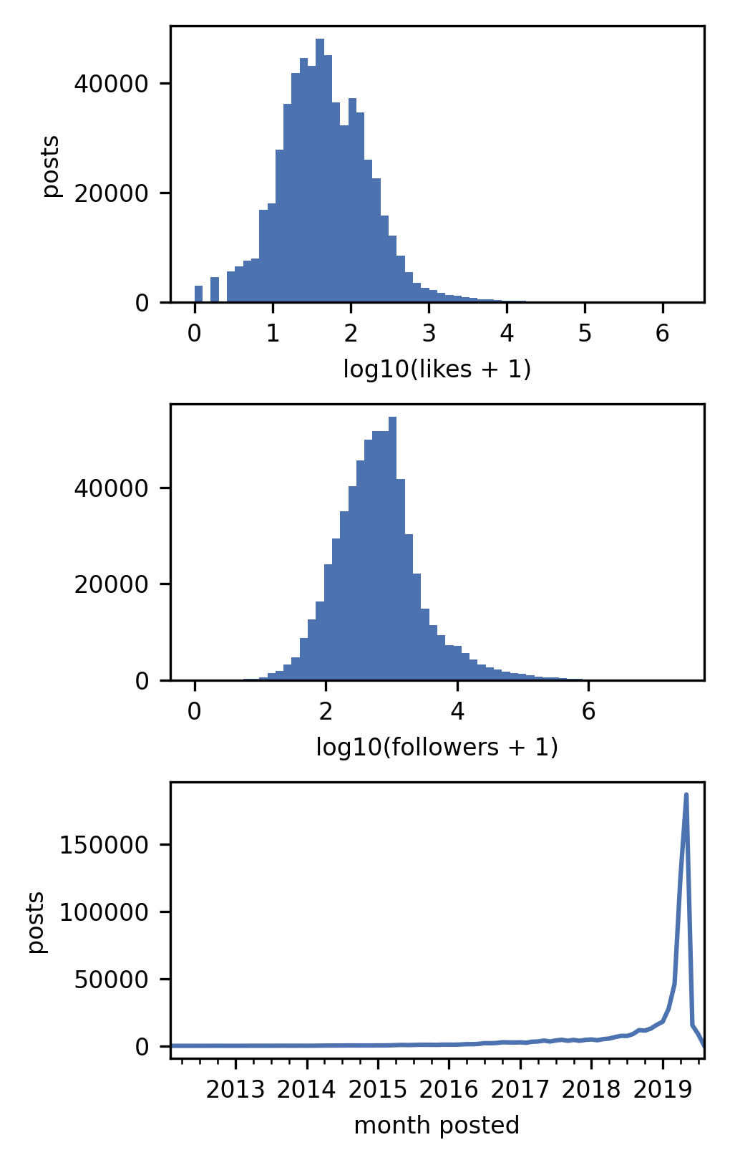
Figure 2. Distributions of likes and recorded followers (log scale) and posts per month.
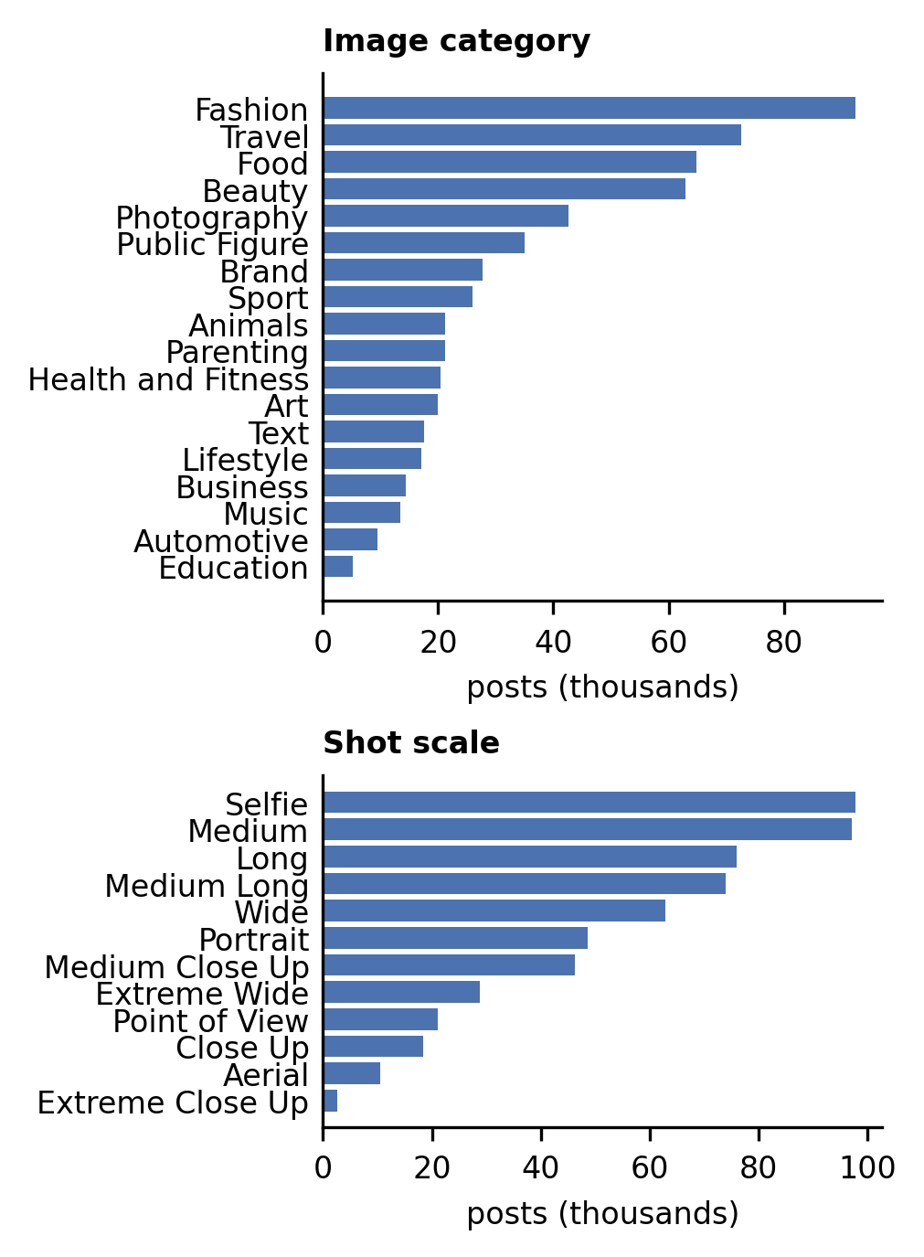
Figure 3. Composition of the analysis sample by image category and shot scale.
Provenance of the visual features. The dataset card has no documentation, licence, or description of the sampling process. A search of the Hugging Face Hub, GitHub, and the literature found no description of the generating pipeline. The attribute names match AADB [21], the object labels match COCO [22], and the shot-scale labels match common cinematographic taxonomies. The generating models, their training data, and any calibration are unknown. We therefore treat all image-derived variables as model-based proxies of the named constructs. We report three checks of internal plausibility instead of a validation against human ratings, which was not feasible because the dataset does not include the images. (i) Two independently produced labels agree (Figure 4): a person is detected in 93.8% of images labelled selfie and 91.2% labelled portrait, but in only 17.4% of aerial shots. (ii) Depth-of-field scores agree only partly with shot scale. They are highest for portrait and close-up shots, which typically have a shallow focus, but extreme close-ups score below average (mean z = -0.06, against 0.02 for extreme wide shots), which optics would not predict (Figure 4). We read this as evidence of substantial measurement noise in the attribute scores.
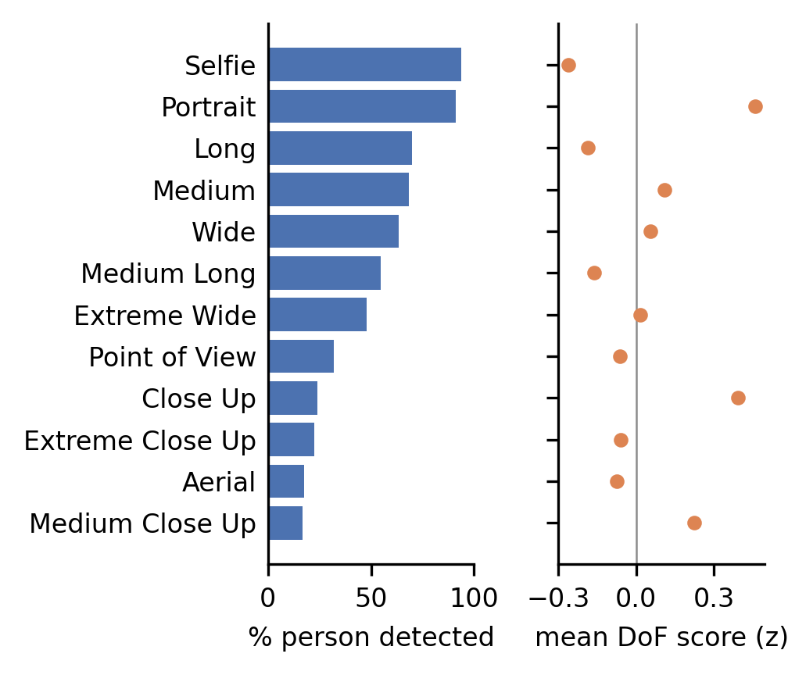 (iii) Three attributes were numerically degenerate and were excluded: motion blur (all |values| < 4·10⁻³³), repetition, and symmetry (constant 0.5). The degenerate attributes show that the feature pipeline was not error-free. Any null or negligible finding below therefore concerns these proxies, not visual aesthetics in general.
The overall aesthetic score correlates 0.61-0.86 with six attributes, so it is a composite and is analysed in a separate model (M1). Among the eight retained attributes, the median absolute pairwise correlation in the training data is 0.49 and the maximum is 0.77 (Figure 5). Coefficients in M2 are therefore conditional associations: the association of one attribute with the outcome, holding the others fixed.
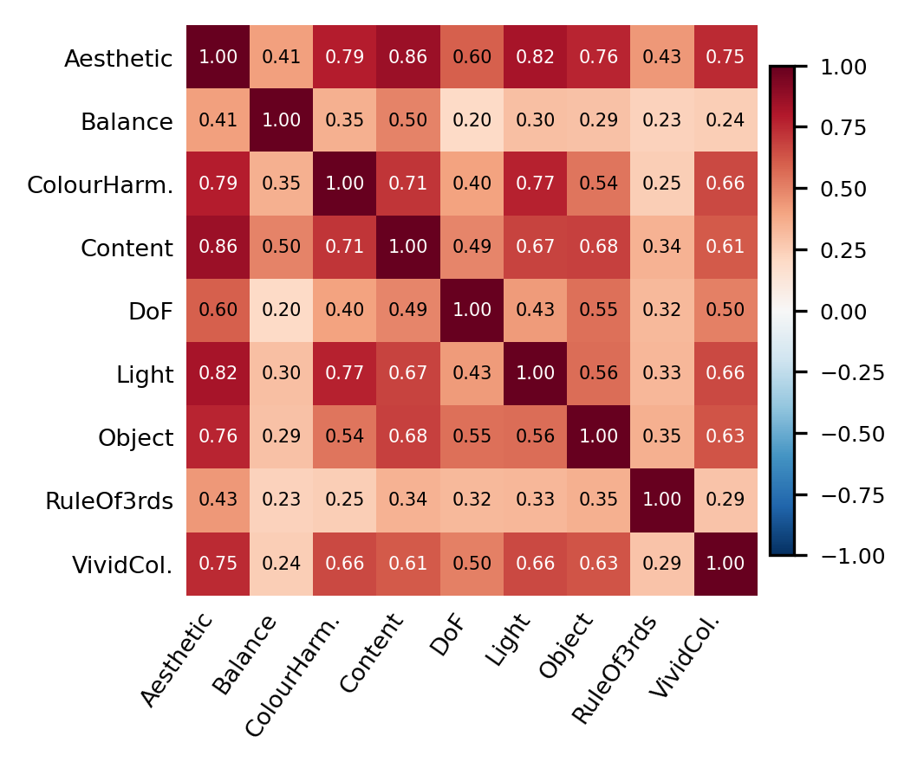
Figure 5. Pairwise correlations of the overall aesthetic score and the eight retained attributes (training accounts).
Data preparation
The sample flow is sequential (Figure 6):
- Start with 605,868 posts.
- Remove 232 posts with zero recorded followers, for which the offset is undefined; one of them is a video. This leaves 605,636 posts.
- Remove 21,806 videos, whose scores describe a single cover frame. This leaves 583,830 photo posts from 469,330 accounts.
No captions are missing. Captions were reduced to three counts and then discarded: caption length, hashtags, and mentions, each transformed as log(1 + x). The person count and the object count are also log(1 + x) and are not standardised. The nine continuous aesthetic scores are z-standardised using the mean and SD of the training accounts only, so each IRR is per one training SD. No usernames, biographies, or captions are stored or published.
Accounts are assigned to partitions by a salted SHA-256 hash of the account identifier. All posts of an account fall in the same partition, and the procedure is reproducible without releasing identifiers.
- Training and test split: 80% of accounts for training and 20% held out for prediction (H5). The test accounts are used only for H5. All preprocessing parameters come from the training accounts.
- Replication halves A and B: formed with an independent salt, so they cut across the training and test split.
- Confirmatory inference (H1-H4) uses all accounts, and the halves are used for internal replication.
- Model selection: none. Every model specification was fixed in the protocol.
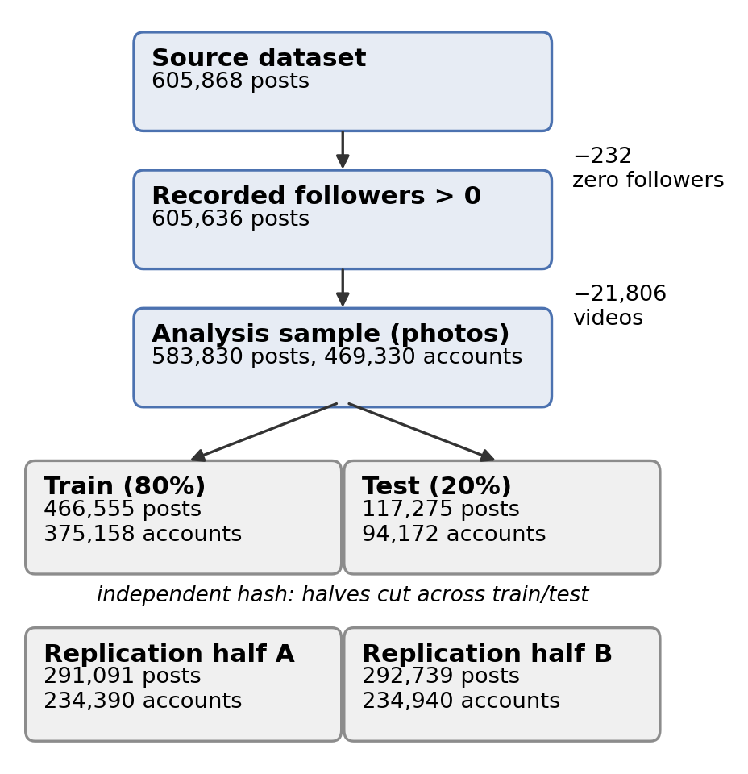
Figure 6. Sequential sample flow and account-level partitions.
Table 1 reports, for each partition, the number of multi-post accounts and the share of each focal predictor’s variance that lies within accounts, which is the information available to within-account estimates.
Table 1. Partitions, multi-post accounts, and the within-account share of predictor variance (sum of squared deviations from account means divided by the total sum of squares).
Partition | Posts | Accounts | Accounts ≥ 2 posts | Posts in them | Within share: aesthetic | vivid colour | person
all | 583,830 | 469,330 | 50,272 | 164,772 | 0.148 | 0.157 | 0.127
train | 466,555 | 375,158 | 40,186 | 131,583 | 0.147 | 0.157 | 0.127
test | 117,275 | 94,172 | 10,086 | 33,189 | 0.149 | 0.158 | 0.128
half_A | 291,091 | 234,390 | 24,916 | 81,617 | 0.147 | 0.157 | 0.126
half_B | 292,739 | 234,940 | 25,356 | 83,155 | 0.148 | 0.157 | 0.127
Methods (CRISP-DM Phase 4)
Model
For post $i$ of account $j$, the like count $y_{ij}$ follows a negative binomial (NB2) distribution with mean $μ_{ij}$ and variance $μ_{ij}+μ_{ij}^{2}/θ$:
$$logμ_{ij}=logF_{j}+x_{ij}^{⊤}β+c_{ij}^{⊤}γ+u_{j}, u_{j}∼N(0,σ_{u}^{2}) (1)$$
Here $F_{j}$ is the recorded follower count (an offset), $x_{ij}$ are visual features, and $c_{ij}$ are controls: month-of-posting fixed effects (months before 2018 pooled), business account, caption topic (19 levels), and the three caption counts. $exp(β_{k})$ is an incidence-rate ratio (IRR) for likes per recorded follower, per training SD of a continuous feature or for a binary switch.
- M1 contains only the overall aesthetic score as its visual term.
- M2 contains the eight AADB attributes, a person-presence indicator, log(1 + number of persons), log(1 + number of objects), shot scale (reference: medium shot), and image category (reference: lifestyle). Person presence and person count are entered together, so each has a conditional interpretation. The overall contrast for “one detected person versus none” is $exp(β_{\text{presence}}+β_{\text{count}}log2)$, which we report with a delta-method CI.
- M1-W adds the account means ${\overset{‾}{x}}_{j}$ of the aesthetic score and of person presence:
$$logμ_{ij}=logF_{j}+β_{W}x_{ij}+δ {\overset{‾}{x}}_{j}+c_{ij}^{⊤}γ+u_{j}, δ=β_{B}−β_{W} (2)$$
Here $β_{W}$ is the within-account association and $β_{B}=β_{W}+δ$ is the between-account association. The decomposition assumes that, given ${\overset{‾}{x}}_{j}$, $u_{j}$ is independent of the post-level covariates and depends on ${\overset{‾}{x}}_{j}$ linearly. $β_{W}$ is identified only from accounts with two or more posts (Table 1). Among those accounts, 42-62% of each predictor’s variance lies within accounts (Figure 7), so within-account estimates rest on substantial variation.
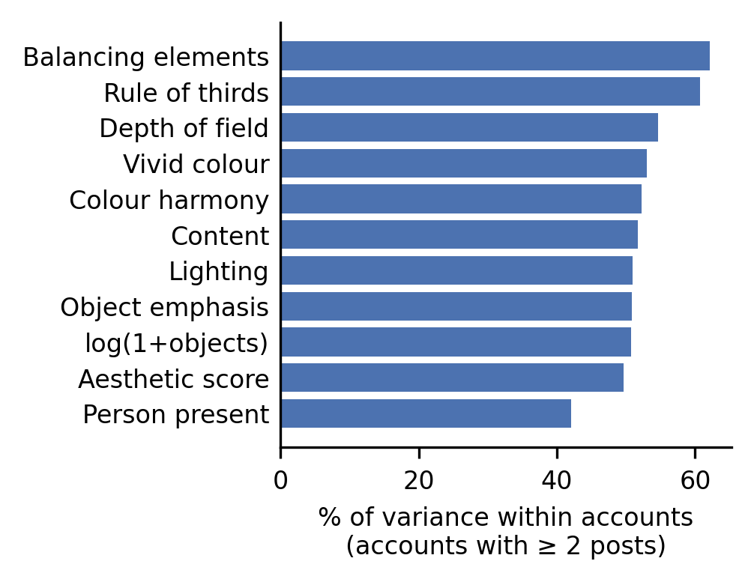 M1-W gives means only to the two focal predictors of H4. The exploratory model R5 adds account means for every post-varying numeric covariate of M2 and so tests whether the other covariates need the same treatment. The categorical shot and category dummies receive no means.
Models were fitted by maximum likelihood with the Laplace approximation in glmmTMB 1.1.9 [24] under R 4.1.2. For every model we record the convergence code and whether the Hessian is positive definite.
Separating account heterogeneity from dispersion
For an account with one post, $u_{j}$ and the NB2 dispersion both inflate the marginal variance. They are distinguishable only through the shape of the marginal distribution, a lognormal mixture of negative binomials, so identification of $σ_{u}$ rests mainly on the 50,272 multi-post accounts (164,772 posts). We therefore report $θ$ and $σ_{u}$ for every model (Table 7). We also refit the main models on multi-post accounts only (R4), where $σ_{u}$ is identified from repeated posts.
Prediction and calibration (H5)
The predictive target is the joint distribution of all posts of a new account. Because the account is unseen, $u_{j}$ is integrated out jointly over its posts:
$$logp(y_{j})=log∫\prod_{i=1}^{n_{j}}{\text{NB2}}​\left(y_{ij}∣exp({\hat{η}}_{ij}+u),\hat{θ}\right)ϕ(u;0,{\hat{σ}}_{u}^{2}) du (3)$$
Here ${\hat{η}}_{ij}$ is the fitted fixed-effect linear predictor including the offset, $n_{j}$ is the number of posts of account $j$, $ϕ$ is the normal density, and the integral is evaluated by Gauss-Hermite quadrature with 30 nodes (checked against 60). The per-post score is j​logp(yj)/j​nj, which weights posts equally; the account-weighted mean is also reported. Models M0 (controls only) and M2 were fitted on training accounts and scored on the 94,172 test accounts (117,275 posts). The 95% CI of the score difference comes from 1,000 paired bootstrap resamples of test accounts, applying the same resample to both models. A strictly proper score rewards the true predictive distribution in expectation [16]. It does not guarantee that the better-scoring model is calibrated, so we report calibration separately: randomised probability integral transform (PIT) histograms [27] and the empirical coverage of central 50% and 90% prediction intervals, computed from each post’s marginal predictive distribution.
Pre-registered hypotheses and decision rules
Table 2 lists the hypotheses. Each was registered with its direction, estimand, model, and test before estimation.
Table 2. Confirmatory hypotheses (registered as tag prereg-v1).
H | Claim (association) | Estimand / model | Test
H1 | Higher overall aesthetic score → more likes per recorded follower | IRR per SD, $β$ of aesthetic score in M1 | One-sided Wald, IRR > 1
H2 | A detected person → more likes per recorded follower | IRR of person presence in M2 | One-sided Wald, IRR > 1
H3 | More vivid colour → more likes per recorded follower | IRR per SD of vivid colour in M2 | One-sided Wald, IRR > 1
H4 | Within- and between-account aesthetic associations differ | $exp(δ)$ in M1-W (eq. 2) | Two-sided Wald, $δ≠0$
H5 | Visual features improve held-out prediction | Δ joint log score per post, M2 − M0 | One-sided paired bootstrap, Δ > 0
The decision rules separate three questions.
(a) Statistical significance against a null of no association. Wald tests (one-sided for H1-H3, two-sided for H4) and the bootstrap test for H5. The five p-values are Holm-adjusted [25].
(b) Practical importance. For H1-H4, the 95% CI of the IRR lies entirely outside the SESOI band [0.97, 1.03]. For H5, which is measured in log-score units, the lower 95% bound of the score difference must be at least 0.01 nats per post. That threshold is a 1% gain in geometric-mean predictive probability ($e^{0.01}=1.010$), the same order as the IRR band.
(c) Internal replication. In each half A and B, the estimate has the same sign as in the full sample and a nominal p < 0.05 with the same sidedness, unadjusted. For H5, the score difference is positive in the test accounts of both halves.
A hypothesis is supported if (a) after Holm adjustment, (b), and (c) all hold. It is negligible if the 90% CI lies inside the band, as pre-registered, and the two one-sided tests (TOST) [15] against 0.97 and 1.03 reject after Holm adjustment across H1-H4. For H5, negligible means the 95% CI lies within ±0.01. Anything else is inconclusive. The ±3% band was fixed in advance as a convention, not estimated. At the median post (42 likes) it corresponds to about 1.3 likes, far below the Poisson-level noise of a single post (SD ≈ 6.5 likes). We report verdicts for ±1% and ±5% as a sensitivity analysis (Table 4), together with all CIs.
Pre-specified robustness checks: - R1: log follower count as a free covariate, which estimates the elasticity; - R2: 2019 posts only; - R3: comments as the outcome; - R4: accounts with two or more posts only.
Two further checks were added in the amendment, before any results: - R5: the full Mundlak model; - R6: without posts above the training 99.9th percentile of likes per recorded follower and without accounts with more than 10⁶ followers.
All are exploratory.
Registration and chronology
The protocol is stored in DECISIONS.md in the project repository. It is marked by git tag prereg-v1 (commit ae91829, 2026-10-08 11:16:07 EEST, pushed to GitHub immediately) and by amendment tag amend-A1 (commit 2b7378c, 11:33:32 EEST). The repository records the complete chronology. Before registration, the only outcome information inspected was the marginal distribution of likes (Figure 2) and the dispersion parameters of two control-only timing fits on random subsamples. These fits contained no visual terms. A first batch of fits was stopped before any model finished, because the amendment changed the preprocessing. All confirmatory fits were run after the amendment. A code check on a 6,000-account subsample followed the amendment and did not alter any specification. Because the registration lives in a repository the author controls, its independence rests on the git and GitHub timestamps. Archiving the tagged release with a DOI service would give an independent timestamp.
Results (CRISP-DM Phase 5)
Confirmatory hypotheses
Table 3 and Figure 8 summarise the five confirmatory tests. Three hypotheses are supported, and two are classified as negligible. No hypothesis is inconclusive.
Table 3. Confirmatory results. IRRs are per training SD (H1, H3), for presence versus absence (H2), or $exp(δ)$ = between/within ratio (H4). H5 is the difference in joint log score per post on held-out accounts. p values are Holm-adjusted across H1-H5 (significance) and across H1-H4 (TOST).
H | Estimate (IRR or Δ) | 95% CI | p (Holm) | p TOST (Holm) | Half A / B | Replicated | Verdict
H1 | 1.057 | [1.055, 1.059] | < 0.001 | 1.000 | 1.056 / 1.057 | yes | Supported
H2 | 1.239 | [1.230, 1.249] | < 0.001 | 1.000 | 1.241 / 1.238 | yes | Supported
H3 | 0.977 | [0.974, 0.980] | 1.000 | < 0.001 | 0.977 / 0.977 | no | Negligible
H4 | 1.017 | [1.013, 1.022] | < 0.001 | < 0.001 | 1.015 / 1.019 | yes | Negligible
H5 | 0.0160 nats | [0.0148, 0.0170] | 0.002 | – | 0.0161 / 0.0159 | yes | Supported
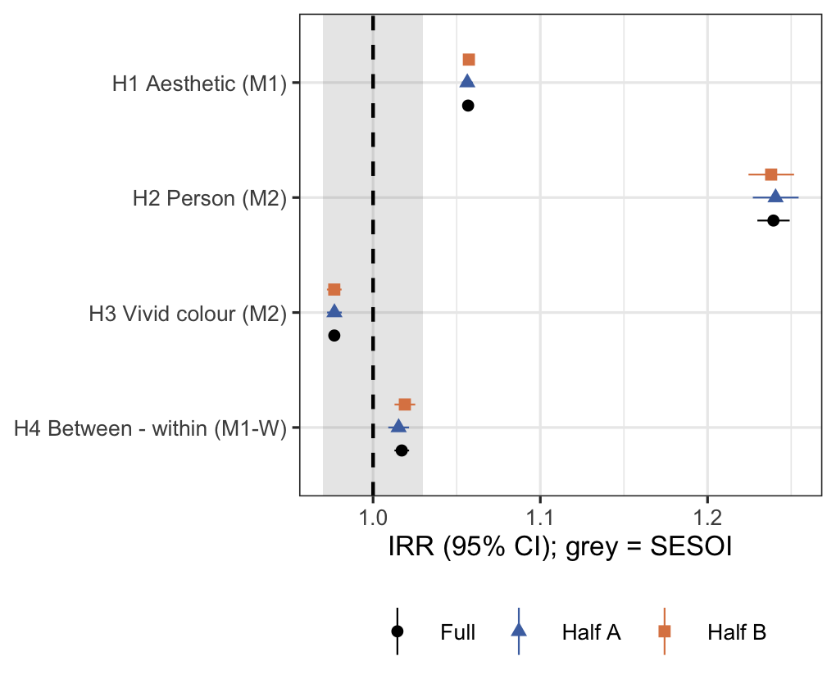
Figure 8. Confirmatory estimates for the full sample and the two replication halves. Grey band: SESOI [0.97, 1.03].
H1 (overall aesthetic score): supported. One training SD higher aesthetic score is associated with 5.7% more likes per recorded follower (IRR 1.057, 95% CI [1.055, 1.059]). The interval lies entirely above the SESOI band, and the estimate is reproduced almost exactly in half A (1.056) and half B (1.057).
H2 (person present): supported. Holding the other visual terms fixed, photographs with a detected person receive 23.9% more likes per recorded follower (IRR 1.239, 95% CI [1.230, 1.249]; halves 1.241 and 1.238). Because person count enters the same model, the overall contrast for exactly one person against none is IRR 1.216 [1.209, 1.224]. Each additional person is associated with slightly fewer likes (IRR for log(1 + persons) 0.973 [0.968, 0.979]).
H3 (vivid colour): negligible, and in the opposite direction. Conditional on the other attributes, vivid colour is associated with fewer likes (IRR 0.977, 95% CI [0.974, 0.980]). The one-sided test for a positive association is not significant (Holm p = 1.000). The 90% CI [0.974, 0.979] lies inside the SESOI band and the Holm-adjusted TOST rejects (p < 0.001), so any association is smaller than ±3% per SD.
H4 (within versus between accounts): negligible difference. Between-account and within-account aesthetic associations differ significantly (ratio 1.017, 95% CI [1.013, 1.022], Holm p < 0.001), but the difference is practically negligible (90% CI [1.013, 1.021]; TOST Holm p < 0.001). The within-account association alone is IRR 1.042 [1.039, 1.045], and the implied between-account association is 1.060. Most of the aesthetic association therefore holds within the same account: an account’s better-scored photographs earn more likes per follower than its own weaker ones.
H5 (prediction): supported. On 94,172 held-out accounts, adding the visual features improves the joint log predictive score by 0.0160 nats per post (95% paired bootstrap CI [0.0148, 0.0170]). That is a 1.61% gain in geometric-mean predictive probability. The lower bound exceeds the pre-specified 0.01 threshold. The gain is the same in the test accounts of both halves (0.0161 and 0.0159), with account weighting (0.0159), and with 60 quadrature nodes (0.0159). The rank correlation between predicted and observed likes per recorded follower rises from 0.172 (controls only) to 0.254.
Verdicts are stable across practical thresholds (Table 4). H1 and H2 exceed even a ±5% band. H3 and H4 are inside the band at ±3% and ±5%, but outside it at ±1%, so they are small rather than exactly zero.
Table 4. SESOI sensitivity: whether the 95% CI lies entirely outside the band / the 90% CI lies entirely inside it.
H | ±1%: outside / inside | ±3% | ±5%
H1 | yes / no | yes / no | yes / no
H2 | yes / no | yes / no | yes / no
H3 | yes / no | no / yes | no / yes
H4 | yes / no | no / yes | no / yes
Exploratory results: attributes, content, and framing
Figure 9 shows all visual terms of M2. Beyond the confirmatory terms, the content attribute (1.036 [1.031, 1.040]) is the only aesthetic attribute whose interval lies above the SESOI band. Lighting (1.021 [1.017, 1.025]) and rule of thirds (1.020 [1.017, 1.022]) are positive but straddle the band. Object emphasis (0.987 [0.984, 0.991]) is slightly negative, and depth of field (1.001 [0.998, 1.003]) is null. The attributes are correlated (Figure 5), so these are conditional associations and should not be read as independent levers.
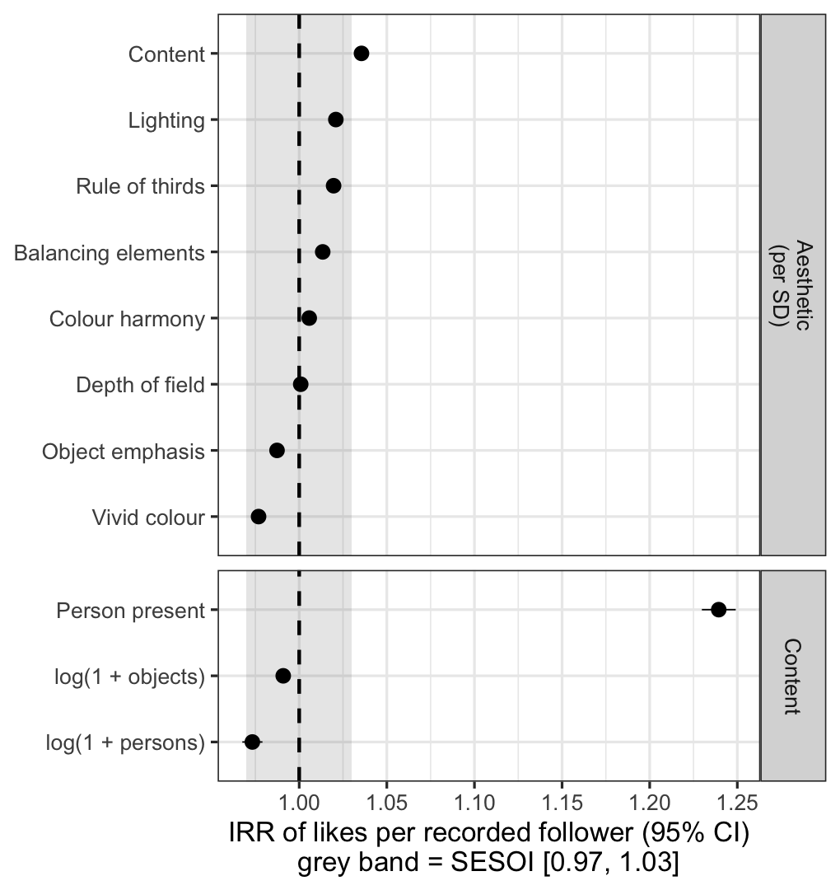
Figure 9. Visual terms of M2 (IRR per training SD for attributes). Grey band: SESOI.
Framing and genre matter more than any single aesthetic attribute (Figure 10). Relative to medium shots, close-ups (0.862 [0.851, 0.872]), point-of-view shots (0.871 [0.860, 0.882]), and aerial shots (0.887 [0.873, 0.900]) receive 11-14% fewer likes per recorded follower. Portraits are the only shot scale above the reference (1.020 [1.011, 1.030]). Among image categories, sport (1.135 [1.115, 1.154]), art (1.124 [1.105, 1.143]), fashion (1.099 [1.084, 1.114]), and animals (1.095 [1.077, 1.114]) are above the lifestyle reference. Text images (0.905 [0.890, 0.921]) and brand imagery (0.916 [0.902, 0.930]) are below it. Among the controls, business accounts receive fewer likes per recorded follower (0.820 [0.815, 0.826]), as do captions with more mentions (0.901 [0.896, 0.906] per log unit).
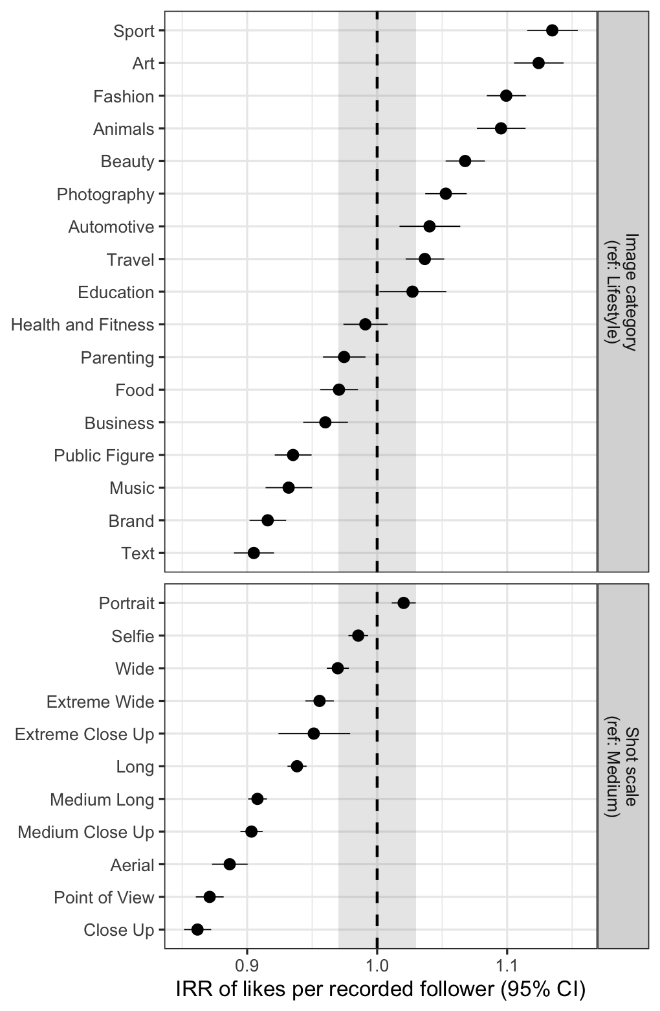
Figure 10. Shot-scale and image-category terms of M2 (IRR against medium shot and lifestyle).
Internal replication extends beyond the confirmatory terms. Across all visual terms of M2, the log-IRRs estimated in half A and half B correlate at 0.98 (Figure 11).
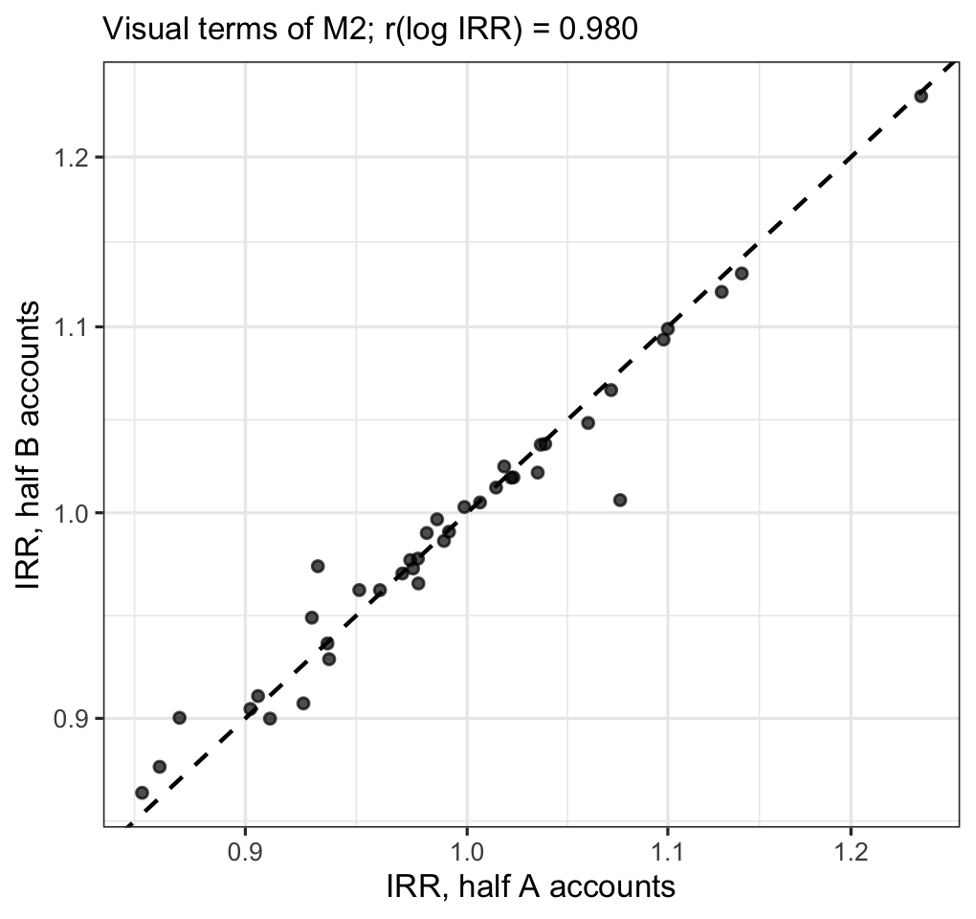
Figure 11. Replication of all M2 visual terms across disjoint halves of accounts.
Robustness
Table 5 and Figure 12 report the focal estimates under each robustness specification. Freeing the follower coefficient (R1) gives an elasticity of 0.629 [0.628, 0.631], well below the value of 1 imposed by the offset. Likes grow less than proportionally with recorded followers. Under R1 the aesthetic association becomes larger (1.086 [1.084, 1.088]), so the offset specification is, if anything, conservative for H1. Restricting to multi-post accounts (R4), where the account effect is identified from repeated posts, gives the same signs and similar magnitudes: aesthetic 1.046 [1.043, 1.049], person 1.137 [1.126, 1.149], vivid colour 0.988 [0.984, 0.992].
Table 5. Focal estimates across robustness specifications (exploratory).
Term | Specification | IRR | 95% CI
Person (H2) | Main | 1.239 | [1.230, 1.249]
Person (H2) | R4 ≥ 2 posts | 1.137 | [1.126, 1.149]
Aesthetic (H1) | Main | 1.057 | [1.055, 1.059]
Aesthetic (H1) | R1 followers free | 1.086 | [1.084, 1.088]
Aesthetic (H1) | R4 ≥ 2 posts | 1.046 | [1.043, 1.049]
Vivid colour (H3) | Main | 0.977 | [0.974, 0.980]
Vivid colour (H3) | R4 ≥ 2 posts | 0.988 | [0.984, 0.992]
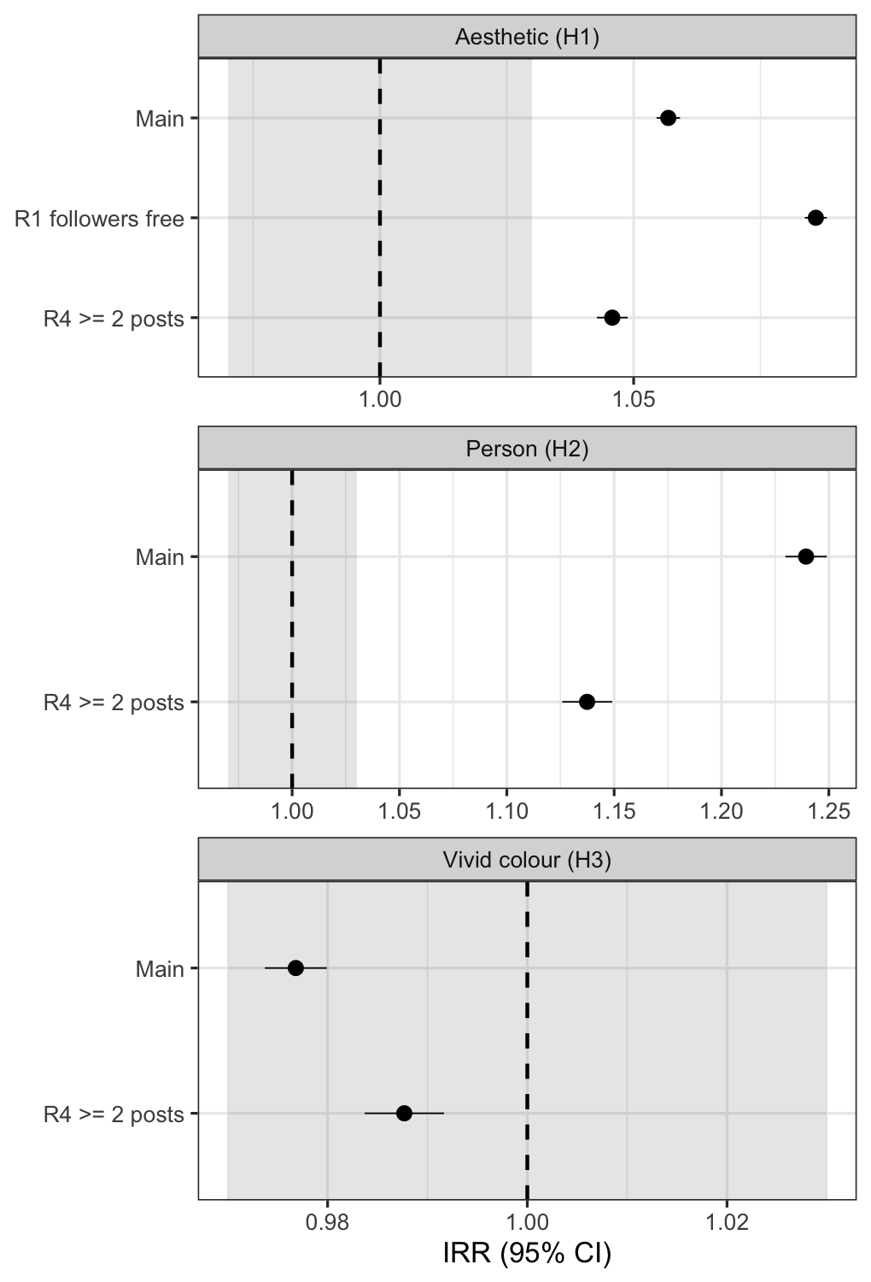
Figure 12. Focal estimates across robustness specifications. Grey band: SESOI.
Model adequacy and calibration
All 14 fitted models converged with positive-definite Hessians; M1 reported a false-convergence warning from nlminb; re-optimisation from its own estimates with an independent optimiser (BFGS) converged to the same optimum (identical log-likelihood and coefficients; D20). The NB2 dispersion and the account SD are similar across models (Table 7). In the main model M2, $\hat{θ}$ = 6.110 and ${\hat{σ}}_{u}$ = 0.900. On multi-post accounts only (R4), ${\hat{σ}}_{u}$ = 1.014, so the account variance is not an artefact of single-post accounts. Calibration on held-out accounts is adequate but not perfect (Table 6, Figure 13). Central 50% and 90% prediction intervals cover 0.515 and 0.903 of observations for M2 (0.509 and 0.904 for M0). Both PIT histograms show the same mild excess of observations below the predictive distribution and a deficit in the extreme upper tail. Calibration is nearly identical for M0 and M2, so the H5 gain reflects sharper predictions rather than a calibration difference. Conditional randomised quantile residuals [28] are under-dispersed (Figure 14). This is expected when the predicted account effect absorbs the single post of most accounts, so the held-out PIT is the more informative check.
Table 6. Calibration on held-out accounts (single-post marginal predictive distributions).
Model | Coverage 50% | Coverage 90% | PIT mean | PIT SD | KS D
M0 | 0.509 | 0.904 | 0.503 | 0.285 | 0.031
M2 | 0.515 | 0.903 | 0.503 | 0.284 | 0.031
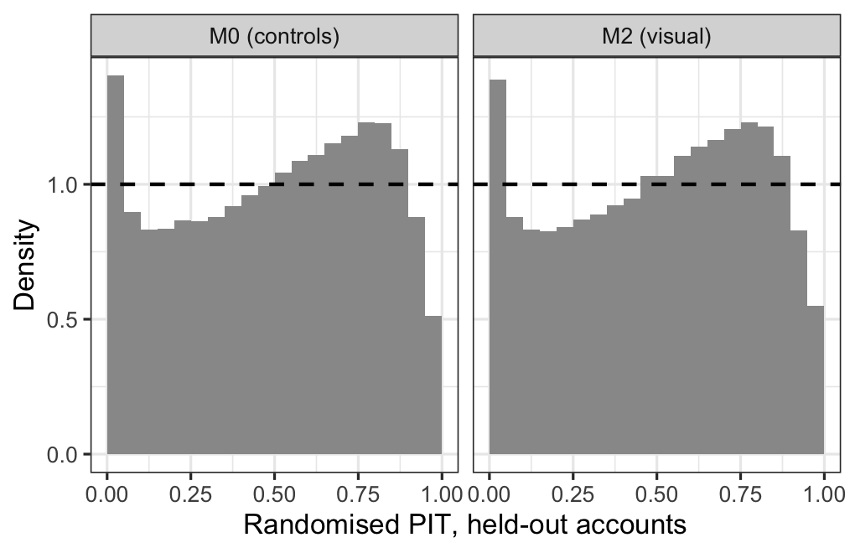
Figure 13. Randomised PIT histograms on held-out accounts. A uniform histogram (dashed line) indicates calibration.
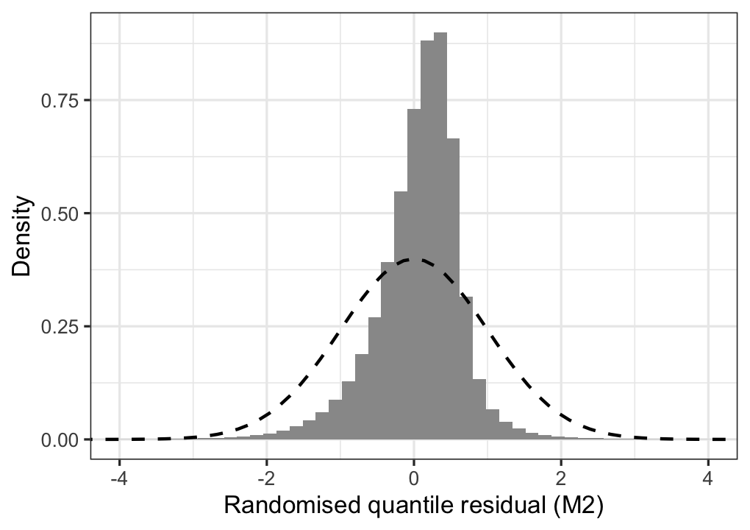
Figure 14. Conditional randomised quantile residuals of M2 with the standard normal density (dashed).
Table 7. Fitted models: sample, NB2 dispersion θ, account SD σ_u, and convergence checks.
Model | Posts | Accounts | θ | σ_u | Converged | pd Hessian
M0_train | 466,555 | 375,158 | 5.996 | 0.916 | true | true
M1 | 583,830 | 469,330 | 5.993 | 0.913 | true | true
M1W | 583,830 | 469,330 | 6.154 | 0.908 | true | true
M1W_A | 291,091 | 234,390 | 6.137 | 0.905 | true | true
M1W_B | 292,739 | 234,940 | 6.176 | 0.911 | true | true
M1_A | 291,091 | 234,390 | 5.956 | 0.910 | true | true
M1_B | 292,739 | 234,940 | 6.032 | 0.917 | true | true
M2 | 583,830 | 469,330 | 6.110 | 0.900 | true | true
M2_A | 291,091 | 234,390 | 6.090 | 0.896 | true | true
M2_B | 292,739 | 234,940 | 6.138 | 0.903 | true | true
M2_train | 466,555 | 375,158 | 6.147 | 0.900 | true | true
R1_M1 | 583,830 | 469,330 | 6.063 | 0.742 | true | true
R4_M1 | 164,772 | 50,272 | 6.513 | 1.015 | true | true
R4_M2 | 164,772 | 50,272 | 6.757 | 1.014 | true | true
Discussion
What the evidence supports
Two visual properties pass every criterion: significance after multiplicity correction, a practically meaningful size, and internal replication. Photographs with a higher overall aesthetic score, and photographs that contain a detected person, receive more likes per recorded follower. The person association (about +22% for one person against none) is four times the aesthetic association per SD (+5.7%). It is also about the same size as the differences between shot scales and image genres (Figure 10). For a creator choosing what to photograph, this suggests that content and framing carry more weight than polish on any single aesthetic attribute. In the M2 model, no individual attribute exceeds +4% per SD.
The person result is consistent in direction with the face effect reported by Bakhshi et al. [8] but smaller (+22% against +38%). Three differences can explain the gap: the indicator here is a general person detector, not a face detector; the outcome is normalised by followers; and the model conditions on shot scale, genre, and the aesthetic attributes. The aesthetic result agrees with experimental-aesthetics evidence that Instagram likes track aesthetic appeal [5] and with the professional-quality effect in [7]. Our design adds that the association is mostly a within-account phenomenon. H4 found a statistically detectable but practically negligible difference between between-account and within-account associations, and the within-account association alone (+4.2% per SD) clears the SESOI band. The aesthetic “driver” is therefore not mainly an artefact of better-resourced accounts posting better-looking photographs. Within one account, the better-scored photographs earn more likes per follower.
What it does not support
Vivid colour, the attribute most often recommended in practitioner advice and studied in tourism marketing [3], shows no practically meaningful association. Its conditional association is slightly negative, and the equivalence test bounds it inside ±3% per SD. This is a conditional estimate. Vividness correlates 0.61-0.75 with colour harmony, lighting, content, and the overall score (Figure 5), so its unique contribution, holding those fixed, is small. That does not contradict findings that specific colour schemes matter in specific genres [3]. It does indicate that “more vivid” is not, in itself, a general lever.
H3 and H4 illustrate the large-sample p-value problem [9]. Both coefficients are “significant” at conventional levels, H3 in the unexpected direction, yet both are bounded inside ±3% with Holm-adjusted equivalence tests. Without the pre-registered SESOI and the equivalence test, both would probably have been reported as findings.
Audience normalisation
The free follower elasticity of 0.629 is a substantive finding in its own right. Likes grow sublinearly with recorded followers, so likes-per-follower engagement rates systematically favour small accounts. For research, an offset is a convenient normalisation, but its implied elasticity of one should be tested rather than assumed. In our data, freeing it strengthened the aesthetic association (R1), so the offset results are conservative for H1. For practitioners, engagement-rate comparisons across accounts of very different size need a size adjustment.
Prediction
Visual features improve out-of-sample prediction for unseen accounts by a modest but reliable 0.0160 nats per post (a 1.61% gain in geometric-mean predictive probability). The rank correlation of predicted and observed likes per follower rises from 0.172 to 0.254. Most of the remaining variation sits in the account effect (${\hat{σ}}_{u}≈$ 0.900, about a 2.5-fold difference in expected likes per follower between accounts one SD apart) and in post-level noise. Visual features alone therefore cannot forecast an individual post’s performance well, consistent with earlier findings that social context dominates popularity prediction [17, 18].
Limitations
Unvalidated feature provenance. The image features were supplied without documentation. Their names match AADB [21] and COCO [22], but the generating models and their accuracy on Instagram imagery are unknown. Three scores were numerically degenerate, and depth-of-field scores agree only partly with shot scale (Figure 4). For a single error-prone predictor such as the overall score, classical measurement error biases the IRR towards one. In M2 the attributes are correlated, so the direction of bias for any one attribute is not guaranteed. The negligible findings (H3) concern these proxies, not colour vividness as perceived by viewers.
Follower snapshot and exposure. Followers were recorded once per account, at collection. They are not impressions, and the time between posting and collection is unknown. Month fixed effects absorb average differences but not account-specific follower growth.
Observational design. Mundlak within-account estimates remove stable account-level confounding under the stated assumptions, but not time-varying confounding. For example, an account may post its best-produced photographs alongside important announcements. All estimates are associations, not effects of changing a photograph.
Sample and generalisability. The sampling process behind the dataset is undocumented. The data are English-language only and 70.7% from 2019, before the platform’s shift towards Reels and short video, and videos were excluded. Instagram’s ranking and visual culture have changed since. Replication is internal (split halves of one dataset), not an independent replication on new data.
Calibration. Predictive distributions are adequately but not perfectly calibrated, with mild misfit in the tails (Figure 13). A model with a more flexible dispersion structure, such as dispersion varying by genre, may improve this.
Conclusion
In 583,830 Instagram photographs, two visual properties are robustly associated with more likes per recorded follower: higher overall aesthetic quality (+5.7% per SD) and the presence of a person (about +22%). Both pass Holm-corrected significance, a pre-registered ±3% practical threshold, and split-half replication. The aesthetic association holds within accounts, not only between them. Colour vividness, often recommended to creators, has a practically negligible association, bounded by an equivalence test. Visual features add a small but reliable improvement to predictions for unseen accounts. Methodologically, the study shows how pre-registration, an explicit smallest effect size of interest, and equivalence testing turn “significant at n = 583,830” into claims that can be checked. It also shows that audience normalisation by follower count should be tested: the estimated elasticity is 0.629, not 1. Future work should validate the image features against human ratings, use exposure data (impressions) where platforms provide them, and test whether the associations hold for short video.
Reproducibility Statement
All code, the decision log and protocol (tags prereg-v1 and amend-A1), aggregate outputs, and the full git history are in the project repository, https://github.com/gikonomova/instagram-visual-engagement. run_all.sh downloads the dataset, verifies its SHA-256 checksum, and reproduces every table and figure. Every number in this manuscript is inserted from the output tables by paper/fill.py. Partitions are deterministic salted hashes. The bootstrap seed is 20261008.
Software: Python 3.9.6 (pyarrow 21.0.0, pandas 2.3.3, numpy 2.0.2, matplotlib 3.9.4), R 4.1.2 (glmmTMB 1.1.9, TMB, data.table, nanoparquet, ggplot2), and pandoc for the manuscript. The full R session information is in outputs/tables/03_sessionInfo.txt. Raw data and fitted model objects are not redistributed because they contain account identifiers.
Ethical Considerations
This is a secondary analysis of a dataset of public Instagram posts that was already publicly available. No data were collected from, and no contact was made with, any individual. Usernames, biographies, and captions were never written to disk after loading. Captions were reduced to three counts, and only aggregate statistics are published. No account is identified.
The dataset is distributed without a licence or documented provenance. We therefore cannot verify the conditions under which it was collected. This is a limitation for any reuse, and it is why we redistribute neither the data nor derived post-level records. No institutional ethics review was obtained for this study. The analysis involves no interaction with human participants, uses only data that were already public, and reports only aggregate results.
Data Availability Statement
The source data are publicly available from Hugging Face [23] (revision and checksum in Section 3.2). Analysis code, the registered protocol, and all aggregate outputs underlying the tables and figures are available at https://github.com/gikonomova/instagram-visual-engagement (tags prereg-v1, amend-A1). Post-level derived data are not redistributed because they contain account identifiers. They can be regenerated exactly from the public source with run_all.sh.
Author Contributions (CRediT)
Galya Aymalieva: Conceptualization, Methodology, Software, Formal analysis, Data curation, Validation, Visualization, Writing – original draft, Writing – review & editing.
Conflict of Interest
The author declares no conflict of interest.
Funding
This research received no specific grant from any funding agency in the public, commercial, or not-for-profit sectors.
Declaration of Generative AI and AI-Assisted Technologies in the Writing Process
During the preparation of this work the author used Claude (Anthropic) to assist with code generation for the analysis pipeline, literature search, and drafting of manuscript sections. After using this tool, the author reviewed and edited all content and takes full responsibility for the content of the published paper.
References
[1] Argyris, Y. A., Wang, Z., Kim, Y., & Yin, Z. (2020). The effects of visual congruence on increasing consumers’ brand engagement: An empirical investigation of influencer marketing on Instagram using deep-learning algorithms for automatic image classification. Computers in Human Behavior, 112, 106443. https://doi.org/10.1016/j.chb.2020.106443
[2] Philp, M., Jacobson, J., & Pancer, E. (2022). Predicting social media engagement with computer vision: An examination of food marketing on Instagram. Journal of Business Research, 149, 736–747. https://doi.org/10.1016/j.jbusres.2022.05.078
[3] Yu, J., & Egger, R. (2021). Color and engagement in touristic Instagram pictures: A machine learning approach. Annals of Tourism Research, 89, 103204. https://doi.org/10.1016/j.annals.2021.103204
[4] Son, H., & Park, Y. E. (2024). Predicting user engagement with textual, visual, and social media features for online travel agencies’ Instagram post: Evidence from machine learning. Current Issues in Tourism, 27(22), 3608–3622. https://doi.org/10.1080/13683500.2023.2278087
[5] Thömmes, K., & Hübner, R. (2018). Instagram likes for architectural photos can be predicted by quantitative balance measures and curvature. Frontiers in Psychology, 9, 1050. https://doi.org/10.3389/fpsyg.2018.01050
[6] Xie, Z., Deng, S., Liu, P., Lou, X., Xu, C., & Li, D. (2024). Characterizing anti-vaping posts for effective communication on Instagram using multimodal deep learning. Nicotine & Tobacco Research, 26(Suppl. 1), S43–S48. https://doi.org/10.1093/ntr/ntad189
[7] Li, Y., & Xie, Y. (2020). Is a picture worth a thousand words? An empirical study of image content and social media engagement. Journal of Marketing Research, 57(1), 1–19. https://doi.org/10.1177/0022243719881113
[8] Bakhshi, S., Shamma, D. A., & Gilbert, E. (2014). Faces engage us: Photos with faces attract more likes and comments on Instagram. In Proceedings of the SIGCHI Conference on Human Factors in Computing Systems (pp. 965–974). ACM. https://doi.org/10.1145/2556288.2557403
[9] Lin, M., Lucas, H. C., & Shmueli, G. (2013). Too big to fail: Large samples and the p-value problem. Information Systems Research, 24(4), 906–917. https://doi.org/10.1287/isre.2013.0480
[10] Nosek, B. A., Ebersole, C. R., DeHaven, A. C., & Mellor, D. T. (2018). The preregistration revolution. Proceedings of the National Academy of Sciences, 115(11), 2600–2606. https://doi.org/10.1073/pnas.1708274114
[11] Mundlak, Y. (1978). On the pooling of time series and cross section data. Econometrica, 46(1), 69–85. https://doi.org/10.2307/1913646
[12] Bell, A., & Jones, K. (2015). Explaining fixed effects: Random effects modeling of time-series cross-sectional and panel data. Political Science Research and Methods, 3(1), 133–153. https://doi.org/10.1017/psrm.2014.7
[13] Wirth, R., & Hipp, J. (2000). CRISP-DM: Towards a standard process model for data mining. In Proceedings of the 4th International Conference on the Practical Applications of Knowledge Discovery and Data Mining (pp. 29–39).
[14] Schröer, C., Kruse, F., & Marx Gómez, J. (2021). A systematic literature review on applying CRISP-DM process model. Procedia Computer Science, 181, 526–534. https://doi.org/10.1016/j.procs.2021.01.199
[15] Lakens, D. (2017). Equivalence tests: A practical primer for t tests, correlations, and meta-analyses. Social Psychological and Personality Science, 8(4), 355–362. https://doi.org/10.1177/1948550617697177
[16] Gneiting, T., & Raftery, A. E. (2007). Strictly proper scoring rules, prediction, and estimation. Journal of the American Statistical Association, 102(477), 359–378. https://doi.org/10.1198/016214506000001437
[17] Khosla, A., Das Sarma, A., & Hamid, R. (2014). What makes an image popular? In Proceedings of the 23rd International Conference on World Wide Web (pp. 867–876). ACM. https://doi.org/10.1145/2566486.2567996
[18] Gayberi, M., & Gunduz Oguducu, S. (2019). Popularity prediction of posts in social networks based on user, post and image features. In Proceedings of the 11th International Conference on Management of Digital EcoSystems (pp. 9–15). ACM. https://doi.org/10.1145/3297662.3365812
[19] Purba, K. R., Asirvatham, D., & Murugesan, R. K. (2020). Instagram post popularity trend analysis and prediction using hashtag, image assessment, and user history features. The International Arab Journal of Information Technology, 18(1). https://doi.org/10.34028/iajit/18/1/10
[20] Carta, S., Podda, A. S., Reforgiato Recupero, D., Saia, R., & Usai, G. (2020). Popularity prediction of Instagram posts. Information, 11(9), 453. https://doi.org/10.3390/info11090453
[21] Kong, S., Shen, X., Lin, Z., Mech, R., & Fowlkes, C. (2016). Photo aesthetics ranking network with attributes and content adaptation. In Computer Vision – ECCV 2016, Lecture Notes in Computer Science (pp. 662–679). Springer. https://doi.org/10.1007/978-3-319-46448-0_40
[22] Lin, T.-Y., Maire, M., Belongie, S., Hays, J., Perona, P., Ramanan, D., Dollár, P., & Zitnick, C. L. (2014). Microsoft COCO: Common objects in context. In Computer Vision – ECCV 2014, Lecture Notes in Computer Science (pp. 740–755). Springer. https://doi.org/10.1007/978-3-319-10602-1_48
[23] vargr. (2023). ig_train_dataset [Data set]. Hugging Face. https://huggingface.co/datasets/vargr/ig_train_dataset (revision cb6e88ac, accessed 8 October 2026).
[24] Brooks, M. E., Kristensen, K., van Benthem, K. J., Magnusson, A., Berg, C. W., Nielsen, A., Skaug, H. J., Mächler, M., & Bolker, B. M. (2017). glmmTMB balances speed and flexibility among packages for zero-inflated generalized linear mixed modeling. The R Journal, 9(2), 378–400. https://doi.org/10.32614/RJ-2017-066
[25] Holm, S. (1979). A simple sequentially rejective multiple test procedure. Scandinavian Journal of Statistics, 6(2), 65–70. https://www.jstor.org/stable/4615733
[26] Kim, S., Jiang, J.-Y., Nakada, M., Han, J., & Wang, W. (2020). Multimodal post attentive profiling for influencer marketing. In Proceedings of The Web Conference 2020 (pp. 2878–2884). ACM. https://doi.org/10.1145/3366423.3380052
[27] Czado, C., Gneiting, T., & Held, L. (2009). Predictive model assessment for count data. Biometrics, 65(4), 1254–1261. https://doi.org/10.1111/j.1541-0420.2009.01191.x
[28] Dunn, P. K., & Smyth, G. K. (1996). Randomized quantile residuals. Journal of Computational and Graphical Statistics, 5(3), 236–244. https://doi.org/10.1080/10618600.1996.10474708

