**HW1**

**Reinforcement Learning**

**044203**

May 2023

Ayala Luz, 318298452

Gil Kapel, 305323776

1. Solving 8-Puzzle with Dijkstra’s Algorithm:
   1. Denote the size of a board $n^{2}$, we would have $n^{2}!$ different states for a single puzzle (for a board of 3x3 we have 9! Options (362,880) (– 9 places to locate the hole (‘0’), then 8 options to locate ‘1’ and so on. Because the search graph would be enormous, we would run Dijkstra algorithm one step at a time, build the next nodes from the current node’s possible actions and finish building when we get to the goal state (we can use BFS algo to ensure optimality)
   2. Code
2. Solving 8-Puzzle with A* Algorithm:
   1. We can use the Manhattan distance between two states as a heuristic function – by flattening each state to a vector and find the sum of Manhattan distances between each cell. This function is admissible because in the best situation the shortest path is exactly the sum of Manhattan distances between each cell, and in other situations the Manhattan distance is smaller (if we must use a circulate path to get to the destination) 🡪
   2. Code
   3. ***2,931*** nodes were expanded using ***incorrect tiles count heuristic*** vs ***351*** nodes in ***Manhattan distance heuristic***. The *incorrect tiles heuristic* is admissible because as before, it would take at least n steps to go if n tiles are incorrect, but most of the times it would take a longer path  
       🡪 .
   4. ***Code*** – Dijkstra took 23 seconds vs A* that takes 0.3 second – both with the same solution ‘ddrrullurrdlulddrruulldrr’
   5. Heuristic function analysis:
      1. For $α=0$ we get that the heuristic function doesn’t contribute to the algorithm, and we collapse to the Dijkstra algorithm.   
         For $α=1$ we get the exact definition of A* demonstrated in the lecture.  
         If $α →∞$ the algorithm won’t use the real distance between two nodes   
           
         at all, this could accelerate the execution time (if there are obstacles on the graph, it could expand unnecessary nodes) but make the search sub-optimal.

In general, for $α>1$ we give more weight to the heuristic values, that could accelerate the time to solve the problem with cost of harming the optimality.

* + 1. Comparison:

|  |  |  |  |  |
| --- | --- | --- | --- | --- |
|  | $$α=0$$ | $$α=1$$ | $$α=1.5$$ | $$α →∞ \\ (α =1e6)$$ |
| Path length | 25 | 25 | 25 | 45 |
| Plan time | 23.2 seconds | 0.3 seconds | 0.05  seconds | 0.01 seconds |
| Explored nodes | 166,159 | 3,589 | 769 | 242 |

The results demonstrate what we explained in section 5.1 – $α=1$ is optimal and fast, $α=0$ is optimal but slow and $α →∞$ is sub-optimal and fast.

We added a test for $α=1.5$ and as it appears, for this specific case the algorithm found the best path one scale faster than the regular A*.

**Wet1.Q3**

1. As shown in class:

The equation of motion:

$$\left\{\begin{aligned}\left(M+m\right)\ddot{x}-ml\ddot{θ}cosθ+mlθ^{2}sinθ=F \\ l\ddot{θ}-gsinθ=\ddot{x}cosθ\end{aligned}\right.$$

After linearizing around $θ=0:$

$\left\{\begin{aligned}\left(M+m\right)\ddot{x}-ml\ddot{θ}=F \\ l\ddot{θ}-gθ=\ddot{x}\end{aligned}\right.$ => $\left\{\begin{aligned}\ddot{x}=\frac{m}{M}gθ+\frac{1}{M}F \\ \ddot{θ}=\frac{g}{l}\left(1+\frac{m}{M}\right)θ+\frac{1}{Ml}F\end{aligned}\right.$

Define: $u=F , X=\left(\begin{matrix}\begin{matrix}x \\ \dot{x} \\ θ\end{matrix} \\ \dot{θ}\end{matrix}\right)$

Then: $X=\left(\begin{matrix}\begin{matrix}x \\ \dot{x} \\ θ\end{matrix} \\ \dot{θ}\end{matrix}\right)=\left(\begin{matrix}0 & 1 & 0 & 0 \\ 0 & 0 & \frac{m}{M}g & 0 \\ 0 & 0 & 0 & 1 \\ 0 & 0 & \frac{g}{l}\left(1+\frac{m}{M}\right) & 0\end{matrix}\right)X+\left(\begin{matrix}0 \\ \frac{1}{M} \\ 0 \\ \frac{1}{Ml}\end{matrix}\right)u_{t}=\overline{A}X+\overline{B}u_{t}$

$=> \overline{A}=\left(\begin{matrix}0 & 1 & 0 & 0 \\ 0 & 0 & \frac{m}{M}g & 0 \\ 0 & 0 & 0 & 1 \\ 0 & 0 & \frac{g}{l}(1+\frac{m}{M}) & 0\end{matrix}\right)$, $\overline{ B}=\left(\begin{matrix}0 \\ \frac{1}{M} \\ 0 \\ \frac{1}{Ml}\end{matrix}\right)$

First order approximation:

$$X_{t+dt}=X_{t}+dt⋅\dot{X_{t}}=X_{t}+dt⋅\left(\overline{A}X+\overline{B}u_{t}\right)=\left(I+dt⋅\overline{A}\right)X_{t}+dt⋅\overline{B}u_{t}$$

$X_{t+dt}=AX_{t}+Bu_{t}$

* **define: $A=I+dt⋅\overline{A} , B=dt⋅\overline{B}$**

1. As shown in class, we have chosen:

$$Q=\left(\begin{matrix}w1 & 0 & 0 & 0 \\ 0 & 0 & 0 & 0 \\ 0 & 0 & w2 & 0 \\ 0 & 0 & 0 & 0\end{matrix}\right) , R=w3$$

W1 determines how far we can move from x=0, while W2 determines how far we can move from θ=0. The parameter W3 is used to regulate the strength of the actions so that they are not too strong.

To achieve pole stabilization, W2 should be set to the highest value. After several attempts, the parameters that provided the best results were selected. $w_{1}=0.5 , w_{2}=1, w_{3}=0.5$

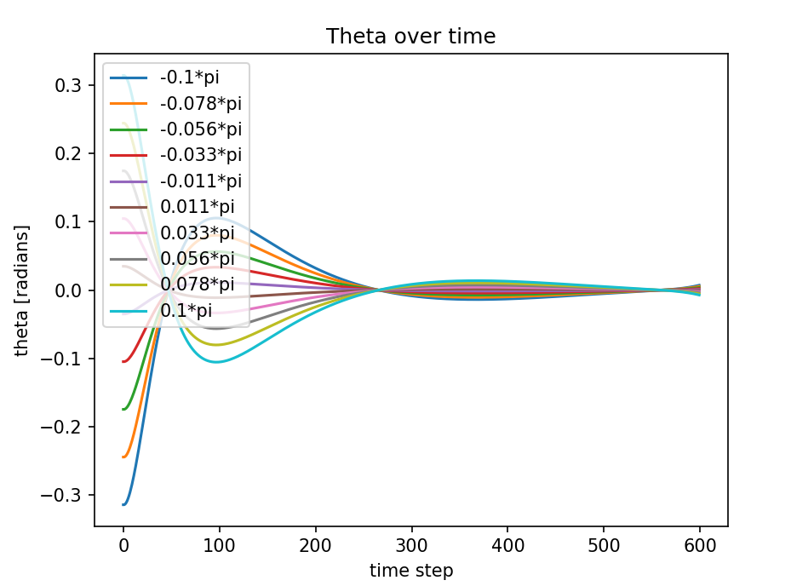In the following graph, the pole was stabilized for different initial positions in the range of [-π/10, π/10].

1. For the chosen parameters: $θ_{unstable}=0.363π$

It can be seen in the graph below that the pole is stabilize at $\frac{π}{10}and\frac{θ_{unstable}}{2}.$

However, at $θ_{unstable}=0.362π$ the pole does not stabilize.

In this angle the linearization around $θ_{0}=0$ is no longer valid.

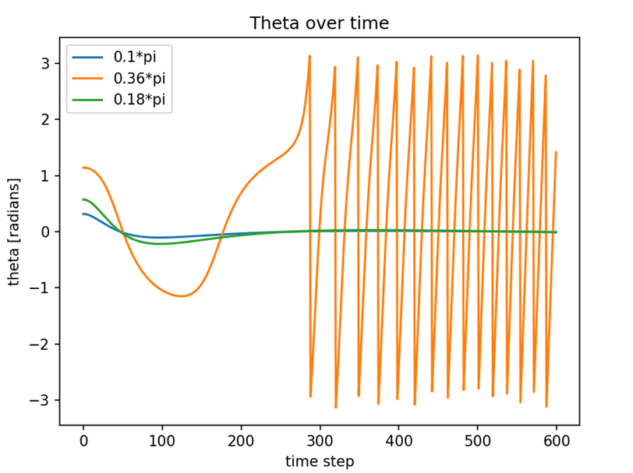

1. 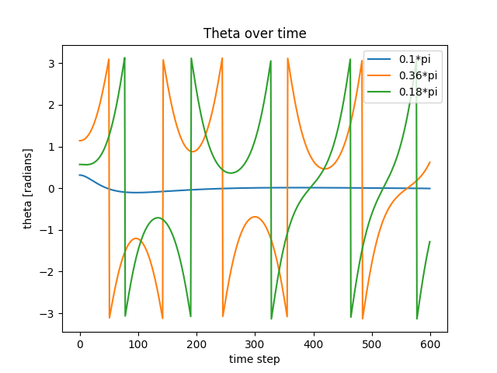When using feedforward control $: θ_{unstable}= 0.1π$

$Θunstable=$ is smaller than in feedback case.

This is because feedback control considers the current state of the system and uses this information to calculate the control action. By doing so, feedback control can adapt to changes in the system, which allows it to achieve better stability compared to feedforward control. In contrast, feedforward control relies only on predicted states, which can lead to larger errors and less stability in the system.

1. In this case, there is a limit on the force F, which is set to 4.0. To satisfy this condition, we increased w3 to restrict the force while keeping w2 high to stabilize the pole. After several attempts we chose: $w_{1}=0.2 , w_{2}=1, w_{3}=1$

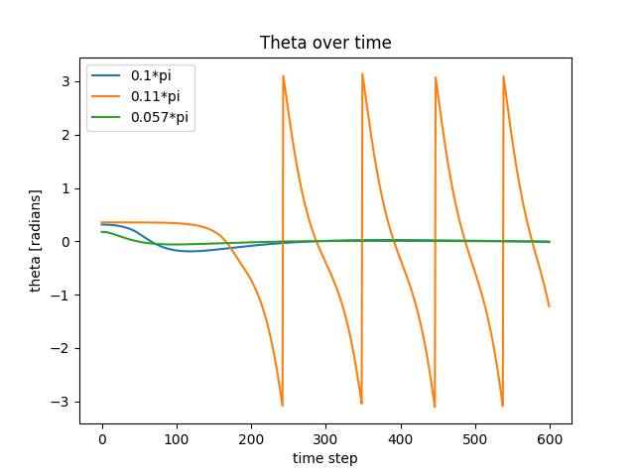 It can be seen in the graph below that the pole is stabilize at $\frac{π}{10}and\frac{θ_{unstable}}{2}.$

However, at $θ_{unstable}=0.11π$ the pole does not stabilize.